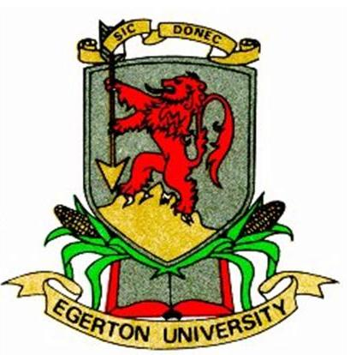
EGERTON UNIVERSITY

UNIVERSITY EXAMINATIONS
NJORO CAMPUS
FIRST SEMESTER 2013/2014
THIRD YEAR EXAMINATION FOR THE AWARD OF DEGREE OF BACHELOR SCIENCE,
BACHELOR OF EDUCATION AND BACHELOR OF ARTS

MATH 318: CALCULUS 111

STREAM: ICEN Y3S1 TIME: 2 HRS

DAY: THURSDAY: 12.00 - 2.00 P.M DATE: 5/12/2013

INSTRUCTIONS:
- Answer Question ONE and any other TWO Questions.
- Solutions of new Questions must be started on a Fresh page.

QUESTION ONE (30 Marks)

f) Find the equation of the tangent plane and the equations of the normal to the surface

b) Find $\frac{∂z}{∂x}$ and $\frac{dz}{dx}$ given that x³ + y³ + z³ – 6xyz + 3 =0 (6 marks)
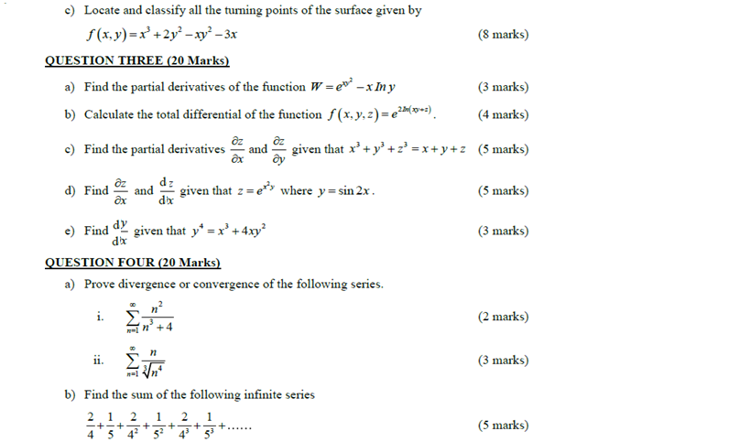

c) Use the differentials to estimate the values of $\sqrt{\sqrt{35 }+\sqrt{99}}$ (5 marks)
