NAME ........................................................... SCHOOL .........................ADM.NO. .....................

INDEX NO. ...................................................DATE .........................SIGN. .................................

232/2
PHYSICS
PAPER 2
KASSU JET – JUNE 2014
TIME: 2 HOURS

INSTRUCTIONS
- Write your name and index number is the spaces provided above.
- Sign and write the date of examination in the spaces above.
- This paper consists of two section A and B. Answer all questions in the spaces provided.
- All working MUST be clearly shown.
- Non-programmable silent electronic calculators and KNEC mathematical tables may be used.
- This paper consists of 14 pages.
- Candidates should check the question paper to ascertain that ALL the pages are printed and that no questions are missing.

FOR EXAMINER’S USE ONLY.

SECTION | QUESTIONS | MAX. SCORE | CANDIDATE’S SCORE
A | 1 -13 | 25
B | 14 | 8
 | 15 | 13
 | 16 | 11
 | 17 | 13
 | 18 | 10
 | TOTAL | 80

SECTION A (25 MARKS)

- Differentiate between nuclear fission and nuclear fusion as used in the study of physics. (2 marks)

…………………………………………………………………………………………………
…………………………………………………………………………………………………..
…………………………………………………………………………………………………..
…………………………………………………………………………………………………..
- The diagram below shows an electrical appliance connected to the mains.

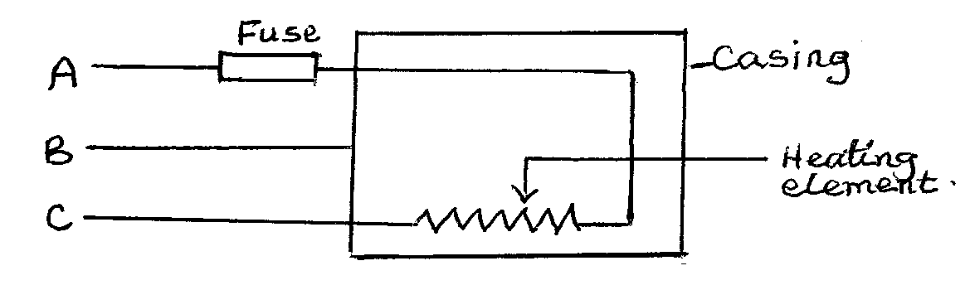

Name the colour codes for the leads A, B and C and state the purpose of the fuse. (3 marks)

A……………………………………………………………………………………………..
B………………………………………………………………………………………………..
C………………………………………………………………………………………………..
Purpose for fuse: (1 mark)
…………………………………………………………………………………………………..
…………………………………………………………………………………………………..
…………………………………………………………………………………………………..
- The figure below shows a circuit diagram for a photocell.

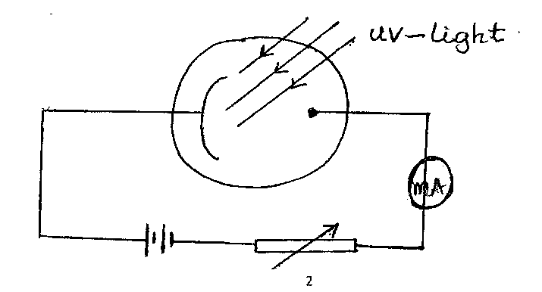

State the variation in the UV-light that will cause a decrease in the reading of the milliameter. (1 mark)
…………………………………………………………………………………………………..
…………………………………………………………………………………………………..
…………………………………………………………………………………………………..
- Diagram (a) below shows the position of the bright spot on the screen of a C.R.O when there is no signal on both Y and X – plate. Indicate on the diagram (b) when the Y-plate is connected to a.c signal and for (c) the X-plate is connected to d.c. signal i.e. the display on the screen. (2 marks)

- Using the band theory, differentiate between conductor and a semi conductor. (1 mark)

…………………………………………………………………………………………………..
…………………………………………………………………………………………………..
…………………………………………………………………………………………………..
- The following is a decay series of Uranium -238.

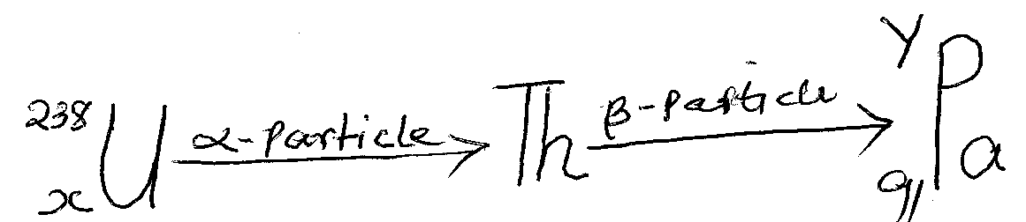
Determine the values of X and Y. (2 marks)

X…………………………………… Y……………………………………
- A girl stands 2m infront of plane mirror, the mirror is then moved 0.6m away from the girl. Determine the distance from the first position of the image to the second position of the image. (2 marks)

…………………………………………………………………………………………………..
…………………………………………………………………………………………………..
…………………………………………………………………………………………………..
…………………………………………………………………………………………………..
- What is the ‘direction of the magnetic field’ at a point in the field. (1 mark)

…………………………………………………………………………………………………..
…………………………………………………………………………………………………..
- State with a reason which type of reflector would be preferred for: (2 marks)
- Underground parking area
…………………………………………………………………………………………………..
…………………………………………………………………………………………………..
- Solar concentrators.
…………………………………………………………………………………………………..
…………………………………………………………………………………………………..
- Polarization and local action are two common defects in a simple cell. How are these defects minimized in the cell? (2 marks)

…………………………………………………………………………………………………..
…………………………………………………………………………………………………..
…………………………………………………………………………………………………..
…………………………………………………………………………………………………..
- A man standing between two parallel walls fires a gun. He hears an echo after 1.5 seconds. Determine the distance of separation of the walls. (Velocity of sound is 340 m/s). (2 marks)

…………………………………………………………………………………………………..
…………………………………………………………………………………………………..
…………………………………………………………………………………………………..
…………………………………………………………………………………………………..
- A highly negatively charged rod is brought slowly towards the cap of a positively charged leaf electroscope. It is observed that the leaf initially collapses and then diverges. Explain the observations. (2 marks)

…………………………………………………………………………………………………..
…………………………………………………………………………………………………..
…………………………………………………………………………………………………..
…………………………………………………………………………………………………..

- The figure below shows ray B, incident through a glass block to air interface.

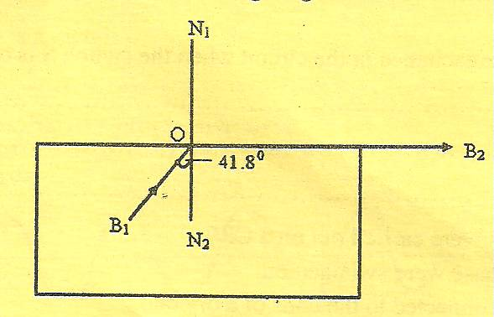

B₂ is the emergent ray of B₁. Determine the refractive index of the glass block. (2 marks)

…………………………………………………………………………………………………..
…………………………………………………………………………………………………..
…………………………………………………………………………………………………..
…………………………………………………………………………………………………..

SECTION B (55 MARKS)

- (a) Distinguish between threshold frequency and threshold wavelength. (1 mark)

…………………………………………………………………………………………………..
…………………………………………………………………………………………………..
…………………………………………………………………………………………………..

(b) Below shows a plot of the graph of stopping potential Vs against the reciprocal
of the wavelength $\frac{1}{⋋}$. The work function of the metal used was 2.08 x 10⁻¹⁹J and velocity of electromagnetic waves is 3.0 x 10⁸ m/s.

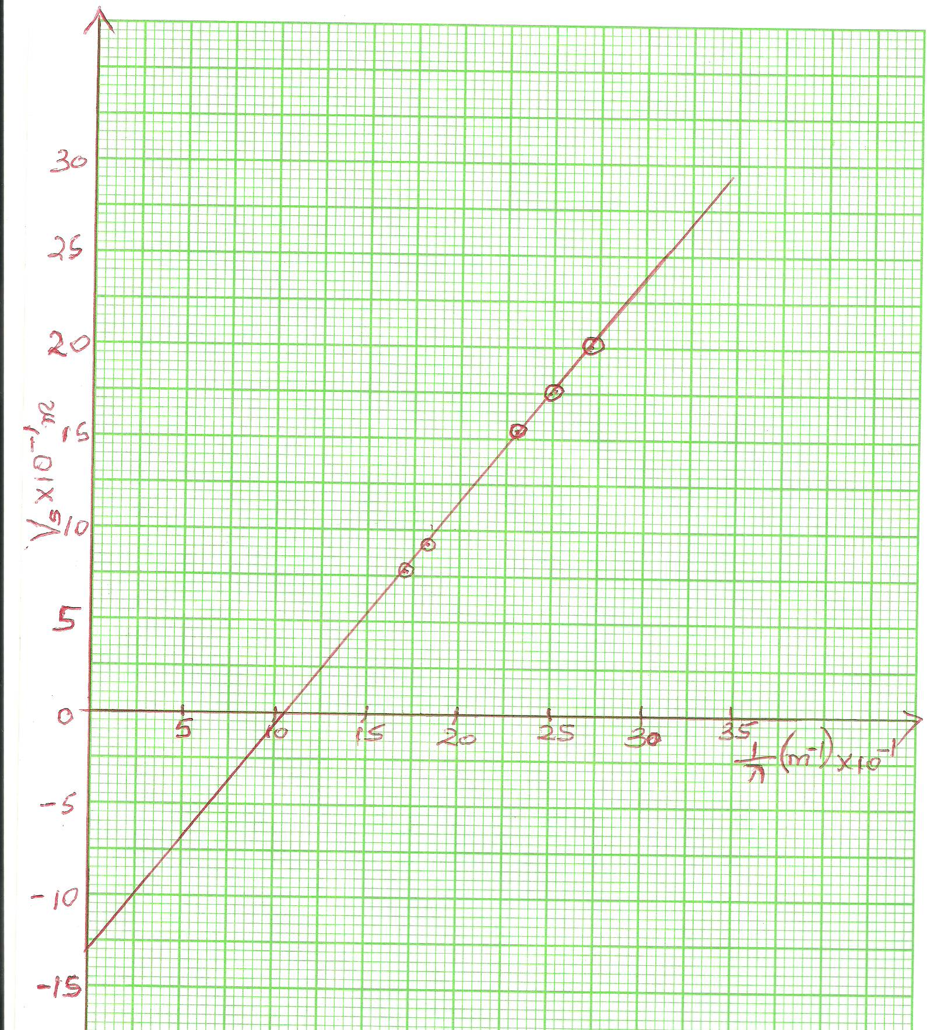

The equation of the graph is given by $Vs= \frac{hc}{eλ} - \frac{Wo}{e}$

Use the graph to determine:
- The threshold frequency (f_{ə}). (1 mark)

…………………………………………………………………………………………………..
…………………………………………………………………………………………………..
…………………………………………………………………………………………………..
…………………………………………………………………………………………………..
- The charge of an electron (e-) (2 marks)

…………………………………………………………………………………………………..
…………………………………………………………………………………………………..
…………………………………………………………………………………………………..
…………………………………………………………………………………………………..
- The slope. (2 marks)

…………………………………………………………………………………………………..
…………………………………………………………………………………………………..
…………………………………………………………………………………………………..
…………………………………………………………………………………………………..
- The value of planks constant. (2 marks)

…………………………………………………………………………………………………..
…………………………………………………………………………………………………..
…………………………………………………………………………………………………..
…………………………………………………………………………………………………..
- (a) (i) Explain why carbon-14 (${}_{6}^{14}C)$ is radioactive while carbon ${}_{6}^{12}C$ is not. (1 mark)

…………………………………………………………………………………………………..
…………………………………………………………………………………………………..
…………………………………………………………………………………………………..
(ii) A radioactive isotope showed a count rate of 82 counts per second initially. After a time of 210 seconds, the count rate dropped to 19 counts per second. The average background count remained constant at 10 counts per second. What is the half life of the material? (2 marks)

…………………………………………………………………………………………………..
…………………………………………………………………………………………………..
…………………………………………………………………………………………………..
…………………………………………………………………………………………………..
…………………………………………………………………………………………………..

(b) The figure below shows features of a diffusion cloud chamber used for detecting
radiations from a radioactive source.

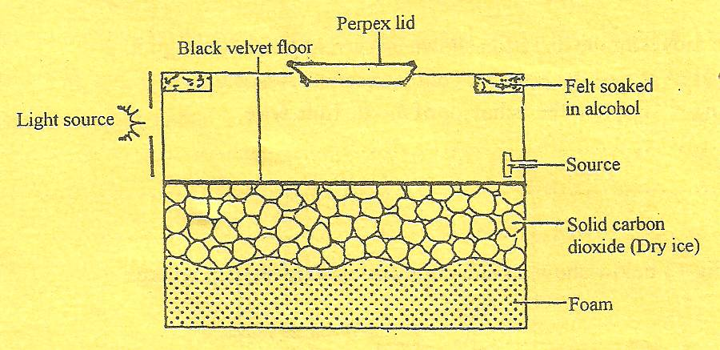

Explain how the chamber works when a radioactive particle is introduced at the source. (2 marks)

…………………………………………………………………………………………………..
…………………………………………………………………………………………………..
…………………………………………………………………………………………………..
…………………………………………………………………………………………………..
(c) (i) What is the purpose of solid carbon (iv) oxide. (1 mark)

…………………………………………………………………………………………………..
…………………………………………………………………………………………………..
…………………………………………………………………………………………………..
(ii) State one advantage of the cloud chamber over a G.M. tube as a detector of
radioactive radiations. (1 mark)

…………………………………………………………………………………………………..
…………………………………………………………………………………………………..
- (i) Using a diagram explain how doping produces a p-type semi-conductor. (3 marks)

…………………………………………………………………………………………………..
…………………………………………………………………………………………………..
…………………………………………………………………………………………………..
…………………………………………………………………………………………………..

(ii) What is biasing? (1 mk)

…………………………………………………………………………………………………..
…………………………………………………………………………………………………..
(iii) The diagram below shows a circuit with a p-n junction and a very low power
bulb.

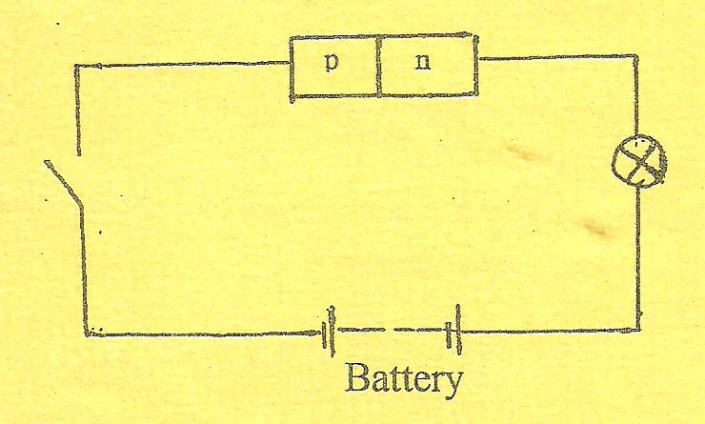
State with reason the observations made on the bulb when the switch is closed.
(2 marks)
…………………………………………………………………………………………………..
…………………………………………………………………………………………………..
…………………………………………………………………………………………………..
…………………………………………………………………………………………………..
- Some plane water waves were produced in a ripple tank. They pass from a region of deep water into a region of shallow water. The figure shows what the waves look like from above.

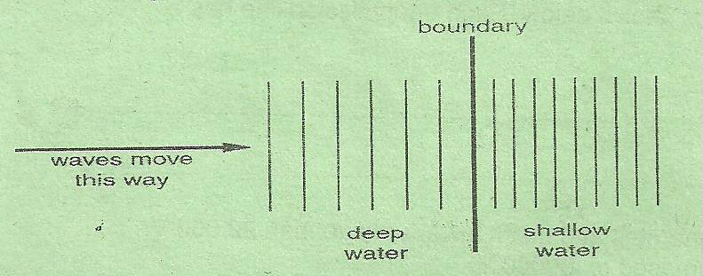

- State what happens at the boundary to:

- The frequency of the waves. (1 mark)

…………………………………………………………………………………………………..
…………………………………………………………………………………………………..

- The speed of the waves (1 mark)

…………………………………………………………………………………………………..
…………………………………………………………………………………………………..
- The wavelength of the waves (1 mark)

…………………………………………………………………………………………………..
…………………………………………………………………………………………………..
- The waves have a speed of 0.12 m/s in the deep water. Wave crests are 0.08m apart in the deep water. Calculate the frequency of the source producing the waves. (2 marks)

…………………………………………………………………………………………………..
…………………………………………………………………………………………………..
…………………………………………………………………………………………………..
…………………………………………………………………………………………………..
- Arrange the following electromagnetic waves in order of their increasing wavelength.
X-rays, Gamma rays, Ultraviolet, Visible light, Microwaves, Infra red (2 marks)

…………………………………………………………………………………………………..
…………………………………………………………………………………………………..
- State two differences between a stationary wave and a progressive wave. (2 marks)

…………………………………………………………………………………………………..
…………………………………………………………………………………………………..
…………………………………………………………………………………………………..
…………………………………………………………………………………………………..
- The figure below represents crests of straight waves produced in a ripple tank.

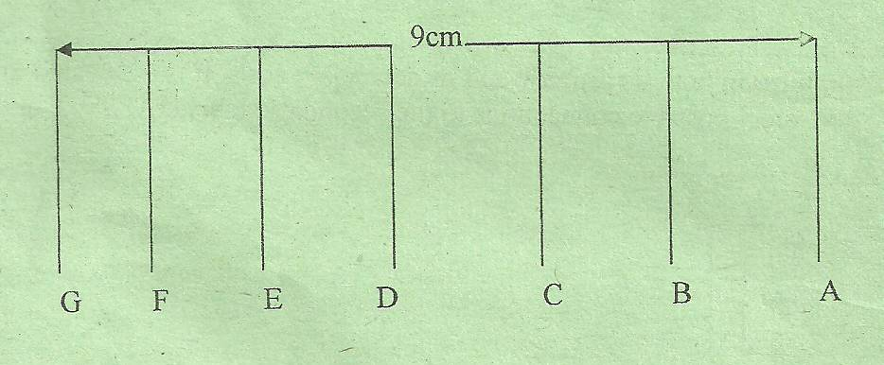

Determine the wavelength of the waves. (2 marks)

…………………………………………………………………………………………………..
…………………………………………………………………………………………………..
…………………………………………………………………………………………………..
…………………………………………………………………………………………………..
- (a) The figure below shows how an image is formed by a converging lens.

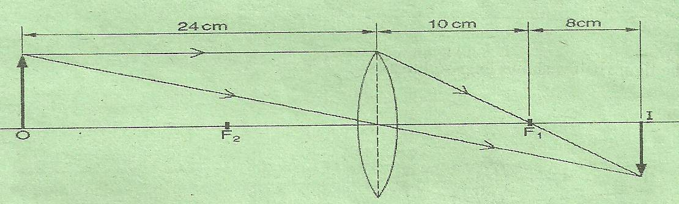

- State the value of the focal length of the lens. (1 mark)

…………………………………………………………………………………………………..
…………………………………………………………………………………………………..
- Calculate the magnification of the image produced. (2 marks)

…………………………………………………………………………………………………..
…………………………………………………………………………………………………..
…………………………………………………………………………………………………..
…………………………………………………………………………………………………..
(b) The figure shows a glass lens in air and its two focal points F₁ and F₂.

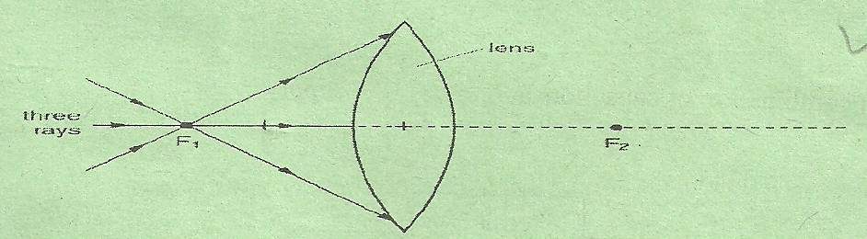

Three rays of light pass through F₁ to the lens.

- On the figure continue the three rays through the lens and into the air. (2 marks)

- State what happens to the speed of light on entering the glass lens from air.
(1 mark)

…………………………………………………………………………………………………..
…………………………………………………………………………………………………..
(c) A ray of light passes through one surface of a glass prism at right angles to the surface, given that the critical angle of the glass material is 42⁰, complete the ray to show how it travels until it leaves the prism. (2 marks)

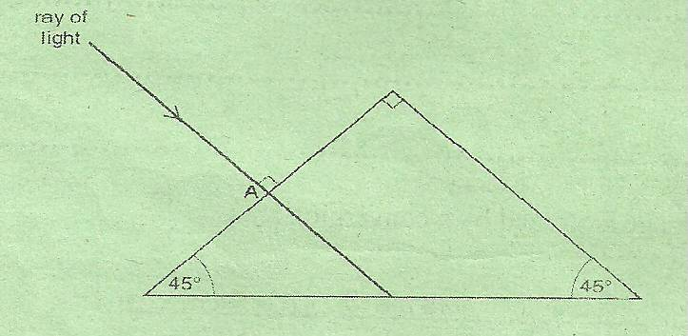
- An object is placed 30cm infront of a convex mirror of focal length 20cm. Determine the image distance. (2 marks)

…………………………………………………………………………………………………..
…………………………………………………………………………………………………..
…………………………………………………………………………………………………..
…………………………………………………………………………………………………..
…………………………………………………………………………………………………..
- (i) State two possible causes of long sightedness. (2 marks)

…………………………………………………………………………………………………..
…………………………………………………………………………………………………..
…………………………………………………………………………………………………..
(ii) What type of lens is used to correct long sightedness? (1 mark)

…………………………………………………………………………………………………..
…………………………………………………………………………………………………..
- The figure below shows a section of a flexible wire carrying current perpendicularly out of the paper.
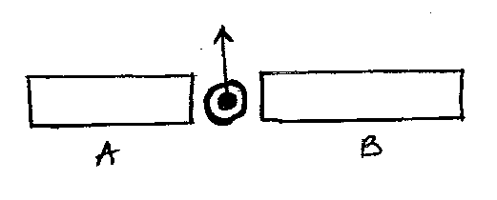

The wire moves in the direction shown as current passes through it.

- Label the polarities of the magnets A and B. ( 1 mark)

- Explain the behaviour of the flexible wire. (2 marks)

…………………………………………………………………………………………………..
…………………………………………………………………………………………………..
…………………………………………………………………………………………………..
…………………………………………………………………………………………………..
(b) The figure below shows an induction coil used to step up voltage.

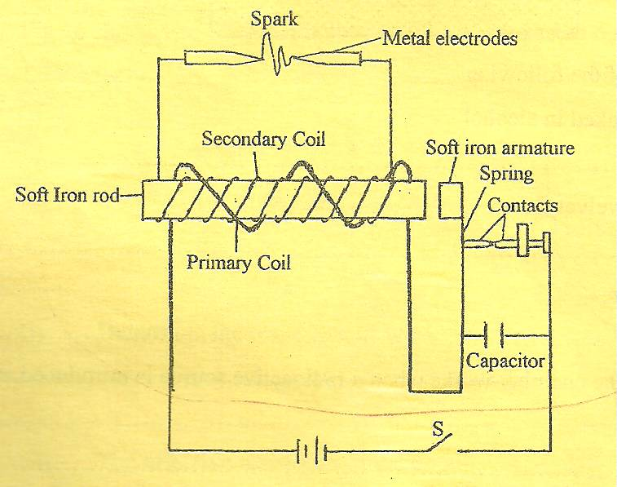
(i) State the difference between the induction coil and a step-up transformer.
(1 mark)

…………………………………………………………………………………………………..
…………………………………………………………………………………………………..
(ii) Explain how voltage is stepped up by the induction coil. (3 marks)

…………………………………………………………………………………………………..
…………………………………………………………………………………………………..
…………………………………………………………………………………………………..
…………………………………………………………………………………………………..
(iii) The voltage is stepped up from 12V to 15kV. Determine the ratio of the
secondary to primary coils in the induction coil. (1 mark)

…………………………………………………………………………………………………..
…………………………………………………………………………………………………..
…………………………………………………………………………………………………..
…………………………………………………………………………………………………..
(iv) The function of the capacitor is to eliminate sparking at the contacts. State why
sparking occurs at the contacts. (1 mark)

…………………………………………………………………………………………………..
…………………………………………………………………………………………………..
(v) State how the capacitor eliminates sparking. (1 mark)

…………………………………………………………………………………………………..
…………………………………………………………………………………………………..

