NAME:…………………………………………….……CLASS:….…….ADM No.:…………..
SIGNATURE:………………………………… INDEXNO:………………………… DATE………………………………………

233/1
CHEMISTRY
Paper 1
THEORY
July 2014
2 Hours

Kenya Certificate of Secondary Education
CHEMISTRY
PAPER 1

INSTRUCTIONS TO THE CANDIDATES:-

- Write your Name and Index number in the spaces provided.
- Answer all the questions in the spaces provided.
- Mathematical tables and electronic calculators may be used
- All working MUST be clearly shown where necessary.

For Examiner’s Use Only
Question | Maximum score | Candidate’s score
1-27 | 80

- Using equations only differentiate the bleaching effect of Chlorine and SO₂ (2mks)
…………………………………………………………………………………………………..
…………………………………………………………………………………………………..
…………………………………………………………………………………………………..
…………………………………………………………………………………………………..
- The diagram below shows some steps used in the manufacture of sodium carbonate by
the Solvay process.
Ammonium chloride
Ammonia

Concentrated sodium chloride
Step I Step II
Carbonator
CO_{2 (g)}
Sodium Hydrogen Carbonate

Substance D

Step III
Sodium carbonate

(a) Name substance D (1mk)

................................................................................................................................................
(b) What process takes place in (2mks)

- Step II.......................................................................................................................

- Step III......................................................................................................................

(c ) Write an equation for the reaction taking place in step I. (1mk) ................................................................................................................................................................................................................................................................................................
- Natural Gallium consists of two isotopes, with atomic masses 69 and 71 in the atomic
ratio of 3: 2 respectively. Calculate the relative atomic mass of Gallium. (2mks)

- 10 molecules of an unknown gas have a mass of 1.0667 × 10⁻²¹ g. Determine the relative molecular mass of the gas. (L=6.0×10²³) (2mks)

- Calcium Hypochlorite is usually added to water when washing.
- Why is it necessary to add to water (1mk)
......................................................................................................................................................
- Give one disadvantage of adding the substance to water when washing (1mk)
......................................................................................................................................................
......................................................................................................................................................
- In temperate countries, salt is sprayed on roads to defrost and clear roads but the long term effect on this practice is costly to motorist.
- Explain the role of salt in defrosting the ice. (1mk)

...................................................................................................................................................... ......................................................................................................................................................

- Explain why the long term effect is costing to motorist. (1mk)
......................................................................................................................................................
......................................................................................................................................................

- Describe how you would prepare crystals of sodium nitrate starting with 200 cm³ of 2M sodium hydroxides. (3 mks)

...................................................................................................................................................... ...................................................................................................................................................... ...................................................................................................................................................... ...................................................................................................................................................... ...................................................................................................................................................... ......................................................................................................................................................
- 10 cm³ of gaseous hydrocarbon was mixed with 90 cm³ of oxygen and sparked. The resulting volume at r.t.p was 70 cm³ which was reduced by 30 cm³ on shaking with sodium hydroxide. Find the empirical formula of the hydrocarbon. (3mks)

- Study the diagram below and answer questions that follow.

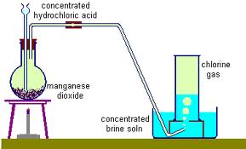 Warm water

Dilute HCl +
Solid A
Hydrogen Sulphide

- Identify solid A. (1mk)
................................................................................................................................................
- Give a reason why warm water is used. (1mk)
................................................................................................................................................
................................................................................................................................................

- What observation would be made if hydrogen sulphide gas was bubbled into a solution of lead (II) nitrate. (1mk).

................................................................................................................................................
................................................................................................................................................
- Some average bond energies are given below.
Bond | Energy in kJ mol⁻¹
C – C | 348
C – H | 414
Cl – Cl | 243
C – Cl | 432
H – Cl | 340

Calculate the energy change for the reaction below. (3 mks)
C₂H_{6 (g)} + Cl_{2 (g)} CH₃CH₂Cl_{(g)} + HCl_{(g)}

- The equation below shows a reversible reaction
H₃O⁺_{(aq)} + HSO₄⁻ _{(aq)} H₂ O_{(l)} + H₂ SO₄

- Identify the acid in the forward reaction and explain. (2mks)

................................................................................................................................................
................................................................................................................................................
................................................................................................................................................
- (a) Define graham’s gas law. (1mk)

................................................................................................................................................
................................................................................................................................................
(b) Two containers, one with Nitrogen (IV) oxide and other with bromine simultaneously
develop leaks, after 30 minutes, the smell of Nitrogen (VI) oxide is detected. How much longer will it take before bromine is detected. (N = 14, O = 16, Br = 80) (2mks)

- (a) Give one advantage and one disadvantage of nuclear fusion as a source of energy
compared to nuclear fission. (2mks)

................................................................................................................................................
................................................................................................................................................
................................................................................................................................................
................................................................................................................................................
(b) List two applications of radioactivity in agriculture (1mk)

................................................................................................................................................
................................................................................................................................................
(c) 10g of Chlorine -39 decays to 1.25g in 165 minutes. What is its half life? (2mks)

- The diagram below shows industrial manufacture of hydrochloric acid.

A

Glass Beads

B
HCl
C

Name the substance: (3mks)
A................................................................................................................................................
B................................................................................................................................................
C................................................................................................................................................
- Study the diagram below and answer the questions given below.

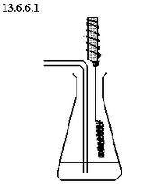
Oxygen
Conc. Ammonia solution
Hot Catalyst X

- The reaction between ammonia and oxygen in the presence of the catalyst continues without further heating. Explain. (1mk)

................................................................................................................................................
................................................................................................................................................
................................................................................................................................................
................................................................................................................................................
- Name catalyst X. (1mk)

................................................................................................................................................
................................................................................................................................................
- Write an equation for the reaction which takes place in the flask. (1mk)

................................................................................................................................................
................................................................................................................................................
- Some sodium chloride was found to be contaminated with Copper (II) oxide. Describe how a sample of sodium chloride can be separated from the mixture. (2mks)

................................................................................................................................................
................................................................................................................................................
................................................................................................................................................
................................................................................................................................................

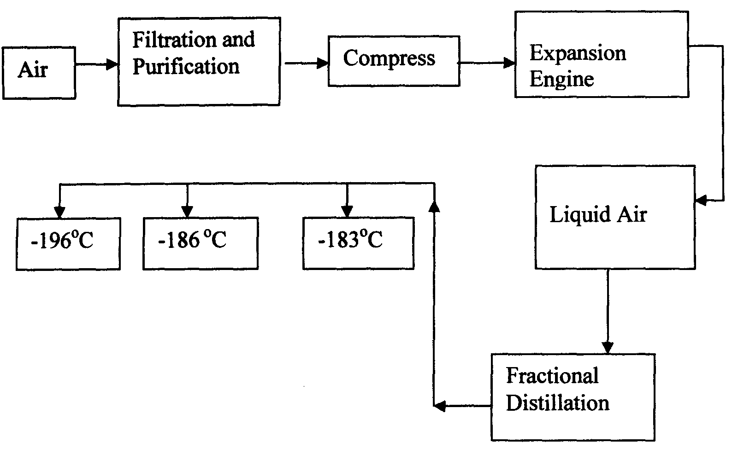
- Oxygen is obtained on large scale by the fractional distillation of air as shown on the flow chart below.

a) Explain why air is considered as a mixture (1mk)

................................................................................................................................................
................................................................................................................................................
b) Identify the substance that is removed at the filtration stage (1mk)

................................................................................................................................................
c) Explain why Carbon (IV) oxide and water are removed before liquefaction of air (1mk)

................................................................................................................................................
................................................................................................................................................
d) Identify the component that is collected at -186°C (1mk)

................................................................................................................................................
................................................................................................................................................
- Study the table below and answer the questions that follow:-
Substance  Melting Point (ºC )  Boiling point (ºC) |  | A | B | C | D | E | F
 |  | 801 | 113 OR 119 | -39 | 5 | -101 | 1356
 |  | 1410 | 445 | 457 | 54 | -36 | 2860
Electrical  Conductivity | Solid | Poor | Poor | Good | Poor | Poor | Poor
 | liquid | Good | Poor | Good | Poor | Poor | Poor

Identify with reasons the substances that:
(i) Have a metallic structure (2mks)

................................................................................................................................................
................................................................................................................................................
(ii) Have a molecular structure (2mks)
................................................................................................................................................
................................................................................................................................................
(iii) Suggest a reason why substance B has two melting points (1mk)
................................................................................................................................................
................................................................................................................................................
(iv) Substances A and C conduct electric current in the liquid state. State how the two
substances differ as conductors of electric current (2mks)

................................................................................................................................................
................................................................................................................................................
................................................................................................................................................
- Describe how you can distinguish a solution of sodium sulphite from a solution of sodium sulphate in the laboratory. (2mks)

................................................................................................................................................
................................................................................................................................................
................................................................................................................................................
................................................................................................................................................
- Sodium Hydrogen Carbonate was heated strongly in the laboratory by a student.

- Write a balanced chemical equation for the above equation. (1mk)

................................................................................................................................................
................................................................................................................................................
- Using an equation show how sodium carbonate is used to soften hard water. (1mk)

................................................................................................................................................
................................................................................................................................................

- State and explain the observation made when a solution of Hydrochloric acid in methylbenzene is added Magnesium Carbonate powder? (2mks)

…………………………………………………………………………………………………..
…………………………………………………………………………………………………..
…………………………………………………………………………………………………..
…………………………………………………………………………………………………..
- The paper chromatography of a plant extract gave the following results with different solvents

Solvent | Number of spots
X | 6
Y | 2
Z | 3

- Which is the most suitable solvent for purifying the extract? Explain. (2mks)

................................................................................................................................................
................................................................................................................................................
................................................................................................................................................
- Ball pen cannot be used to mark baseline in the above chromatography. Explain (1mk)

................................................................................................................................................
................................................................................................................................................
- State 2 chemical differences between:
- Carbon (IV) oxide and carbon (II) oxide (2mks)

................................................................................................................................................
................................................................................................................................................
................................................................................................................................................
................................................................................................................................................
- Explain how carbon (IV) oxide has contributed to the green house effect. (2mks)

................................................................................................................................................
................................................................................................................................................
- Calculate the number of Al³⁺ ions released when 30cm³ of 0.1M of Aluminium Sulphate is dissolved in water. (L = 6.024 x 10²³). (3mks)

................................................................................................................................................
................................................................................................................................................
................................................................................................................................................
................................................................................................................................................
................................................................................................................................................
................................................................................................................................................
................................................................................................................................................
- (a) Give 2 reasons why most laboratory apparatus are made of glass. (1mk)

................................................................................................................................................
................................................................................................................................................
(b) The diagrams below are some common laboratory apparatus. Name each apparatus and
state its use. (2mks)

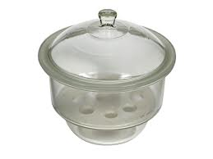
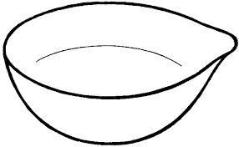

Name ………………………………….. Name …………………………..

Use ……………………………………. Use ……………………………...

- The grid below represents part of periodic table. Study it and answer the questions that follow. The letters give do not represent the actual symbols of the elements.

 |  |  |  |  |  |  |  | P
 | Q |  |  | R |  | S |  |  | T
- Write the formula of the compound formed when R reacts with oxygen. (1mk)

................................................................................................................................................
................................................................................................................................................
- Write an equation of the reaction taking place when Q and P react. (1mk)

................................................................................................................................................
................................................................................................................................................
- State one use of element T. (1mk)

................................................................................................................................................
- Draw the structural formula and name possible isomers of organic compounds with the following molecular formula. C₃H₇Br (2mks)

