**Name: ……………………………………………Index no ……..…...................................**

**Candidate’s sign ………………….Date: ………………………**

**231/1**

**BIOLOGY**

**EAGLE TEAM EDUCATION CENTRE**

**PAPER 1**

**OCTOBER/NOVEMBER**

**TIME: 2 HOURS**

**INSTRUCTIONS TO CANDIDATES:**

* *Write your* ***name*** *and* ***index number*** *in the spaces provided.*
* *Sign and write* ***date*** *of examination in the spaces provided above*
* *Answer* ***all*** *the questions in spaces provided*

***For Examiner’s Use Only:***

|  |  |  |
| --- | --- | --- |
| **QUESTIONS** | **MAXIMUM SCORE** | **CANDIDATE’S SCORE** |
| **1- 30** | **80** |  |

*This paper consists of* ***10***  *printed pages. Candidates should check to ascertain that all papers are*

*printed as indicated and that no questions are missing*

*Answer* ***ALL*** *the questions in this paper in the spaces provided*

1. (a) What is meant by the term sex-linkage? (1 mark)

……………………………………………………………………………………………………………………….

b) State the first law of inheritance. (2 marks)

……………………………………………………………………………………………………………………….

2.State the role of the following bacteria in the nitrogen cycle. (3mks)

(a) Nitrosomonas

…………………………………………………………………………………………………………

(b) Nitrobacter

………………………………………………………………………………………………………

(c) Azotobacter

……………………………………………………………………………………………………

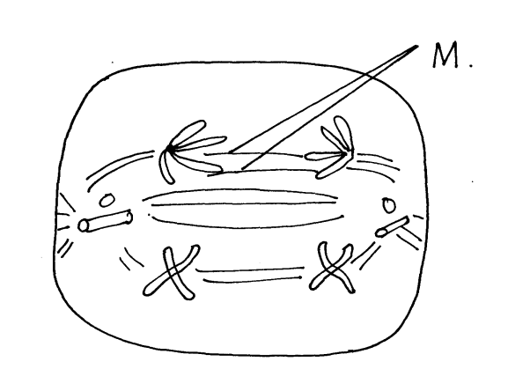3. The diagram below represents a stage during cell division.

a )(i) Identify the stage of cell division. (1mk)

……………………………………………………………………………………………………..

ii) Give **two** reasons for your answer in **a(i)** above. (1mk)

……………………………………………………………………………………………………

……………………………………………………………………………………………………

4. Below is the diagram of a bone. Study it and answer the questions that follow.

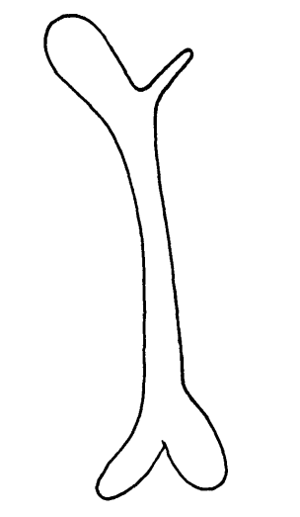

(a) Identify the bone. (1mk)

…………………………………………………………………………………………………………

(b) Name the joints that would be formed in the posterior and anterior end of this bone. (2mks)

Posterior end ………………………………………………………………………..

Anterior end……………………………………………………………………….

5.Give necessity of support in plants. (3mks)

……………………………………………………………………………………………………………………………………………………………………………………………………………………………………………………………………………………………………………………………………………………………………………………………………………………………………………………………………………………………

6.Name two structures in herbaceous stems that enhance their support. (2mk)

…………………………………………………………………………………………………………………………………………………………………………………………………………………………………………………………………………………………………………………………………………………………………………………………………………………………………………………….

7. a) Define the term immunity. (1mk)

……………………………………………………………………………………………………………………………………………………………………………………………………………………………………………………………………………………………………………………………………..

b) Distinguish between natural immunity and acquired immunity. (1mk)

………………………………………………………………………………………………………………………………………………………………………………………………………………………………………………………………………………………………………………………………………………………………………………………………………………………………

c). Identify one immunizable disease in Kenya. (1mk)

…………………………………………………………………………………………….

8. State three differences between osmosis and active transport. (3mk)

9. The diagram below illustrates part of a nephron from a mammalian kidney.

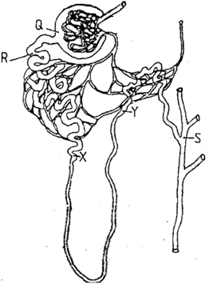

a) Name the fluid found in the part labeled Q.(1mk)

……………………………………………………………………………………………………….

b) Identify the process responsible for the formation of the fluid named in (a) above.(1mk)

………………………………………………………………………………………………………….

c) Which two hormones exert their effect in the nephron? (2mk)

10.State three characteristics of members of kingdom Monera that are not found in other

kingdoms.

11 An experiment set-up shown below were to investigate a certain process

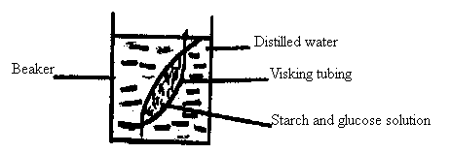

After 20 minutes; a student tested the sample from the beaker for starch and glucose. The results were recorded in the table below.

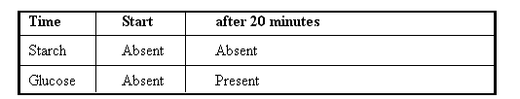

a) Explain the presence of glucose in the water sample. (1 mark)

b) What change occurred in volume of liquid in:-

i) Beaker

(1 mark)

ii) Visking tubing (1 mark)

12. Write the sequence of messenger RNA (M-RNA) that would be coded from the DNA strand shown below. (1 mark)

_____C_____A______T_____G______A_______A_____G_____T

Sequence of RNA.

13 Give the role of the following parts of the male reproductive system. (3 marks)

a) Epididymis

b) Prostrate gland

c) Urethra

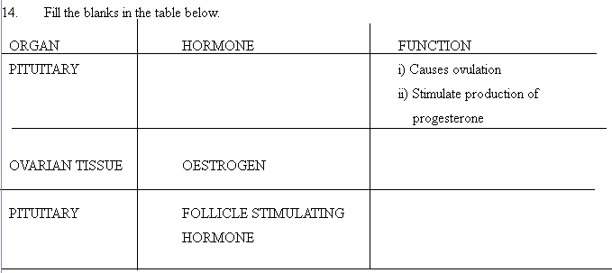

(3mks)

15. Name the fins that prevent the following movements of fish during swimming. (3mks)

i) Yawing…………………………………………………………………………………………….....

ii) Pitching………………………………………………………………………………………………

iii) Rolling…………………………………………………………………………………………….

16.a) Name **two** disorders in humans caused by gene mutation. (2mks)

……………………………………………………………………………………………………....

……………………………………………………………………………………………………….…

b) Describe the following chromosomal mutations; (2mks)

i) Inversion………………………………………………………………………………………………

………………………………………………………………………………………………………..

ii) Translocation…………………………………………………………………………………………

…………………………………………………………………………………………………………

17. State **three** reasons for loss of energy from one trophic level to another in a food chain. (3mks)

18 a) Name the part of the eye where image is formed. (1mk)

b) State **two** characteristics of the image formed on the retina. (2mks)

19. Name a support tissue in plants that is thickened with cellulose. (1mk)

……………………………………………………………………………………………………….....

20. State **two** functions of luteinizing hormone in reproduction. (2mks)

……………………………………………………………………………………………………………………………………………………………………………………………………………………………………………………………………………………………………………………………………………………………………………………………………………………………………………………

21. Give the meaning of the following terms. (2mks)

i)Protandry……………………………………………………………………………………………….

………………………………………………………………………………………………………...

ii) Self-sterility…………………………………………………………………………………………

………………………………………………………………………………………………………

22.a) State the difference between ball and socket and hinge joint. (1mk)

…………………………………………………………………………………………………………

………………………………………………………………………………………………………

b) State the functions of synovial fluid. (2mks)

…………………………………………………………………………………………………………..

…………………………………………………………………………………………………………...

23.The diagram below shows the teeth of a certain animal. Use it to answer the questions that follow.

**

a).Identify the mode of feeding exhibited the animal shown above. (1 mark)

……………………………………………………………………………………………………………

b). Give a reason for your answer in (a) above. (1 mark)

…………………………………………………………………………………………………………………………………………………………………………………………………………………………

24. Enzymes are important in various physiological processes in living things

a). Differentiate between an enzyme and a hormone. (2 marks)

…………………………………………………………………………………………………………………………………………………………………………………………………………………………………………………………………………………………………………………………………………………………………………………………………………………………………………………………………………………………………………………………………….

b). Name the property of an enzyme exhibited by the Lock and Key Hypothesis. (1 mark)

………………………………………………………………………………………………………………………………………………………………………………………………………………

25. State the role of each of the following features found in the human gaseous exchange system (2mks)

a). Goblet cells

…………………………………………………………………………………………………………………………………………………………………………………………………………………………

b). Rings of cartilage

…………………………………………………………………………………………………………………………………………………………………………………………………………………………

26. The diagram below show a blood vessel

**

a) Giving a reason, identify the blood vessel shown above. (2 marks)

………………………………………………………………………………………………………………………………………………………………………………………………………………

b) Name the enzymes present in A and D. (2 marks)

…………………………………………………………………………………………………… ……………………………………………………………………………………………………

27. Oil is one of the pollutants of water in major water bodies

a). In what ways is oil as a pollutant affect the following organisms:

i. Fish (1 mark)

………………………………………………………………………………………………………………………………………………………………………………………………………………………………………………

ii. Mosquito larvae (1 mark)

……………………………………………………………………………………………………………………………………………………………………………………………………………………………………………..

iii. Aquatic birds (1 mark)

…………………………………………………………………………………………………………………………………………………………………………………………………………………………

28. Name two sites for gaseous exchange in floating aquatic plants. (2 marks)

………………………………………………………………………………………………………………………………………………………………………………………………………………

29.Explain what happens to a tadpole when there is insufficient iodine. (2 marks)

………………………………………………………………………………………………………………………………………………………………………………………………………………………………………………………………………………………………………………………………………

30. Name the diseases caused by the following organisms.

a) Wucheraria bancrofti (1 mark)

……………………………………………………………………………………………….

b) Treponema pallidum (1 mark)

…………………………………………………………………………………………………..