HEIGHTS SECONDARY SCHOOL-THIKA
MID-TERM EXAMINATION 2017
FORM FOUR
CHEMISTRY
- a ) Distinguish between exothermic and endothermic reactions. (2mks)
b)Using the equation below draw an energy level diagram for the reaction’
2SO₂ + O₂ 2SO₃ $∆$H$=-$189kg/mol
(g) (g) (g)
(3mks)
- A)Define molar heat of solution (2mks)
b) 2g of sodium hydroxide(NAOH) was dissolved in 100cm³ of distilled water. the temperature rises by 5⁰C
(Na=23 O=16 H=1) .calculate S.H.C =4.2kj/kg/mol
the molar heat of solution of sodium (3mks)
- i) Name the ion responsible for causing both cat ions and anions
a) Temporary hardnes
Cation Anion
(2mks)
b)Permanent hardness
Cation Anion
(2mks
c) using a well labeled diagram explain how an ion exchanges method to remove hardness in water.(3mks)
d)Give two advantages of hard water (2mks)
- (a)What are the amphoteric oxides (2mks)
b)Using the equation below identify the species acting as an acid.
Al₂O₃ + 2NAOH-------------------------2NaAlo₂ +H₂O
(s) (aq) (aq) (l)
(1mk)
- Distinguish between weak and strong acid (2mks)
- Identify the following as Basic .Neutral, or acidic oxide
sulphur (iv)oxide water, potassium hydroxide (3mks)
- Use the table below to answer the given questions.
BOND | BOND ENERGY KJ/MOL
C-H | 414
CL-CL | 244
C-Br | 311
H-Br | 450
Calculate the enthalpy change for the reaction
CH₄ + Br₂----------------------------CH₃Br + HBr
(g) (g) ( g)
(3mks)
- Differentiate between the following terms.
i)atomic number and mass number (2mks)
ii) cation and anion (2mks)
iii)deliquescence and hygroscopic (2mks)
- An element x has atomic number 17 it consists of
${}_{4}^{3}{x-35 and }{}_{4}^{1}{of x-37}$ isotopes
a) define
i) atomic number (1mk)
ii)isotopes (1mk)
b) calculate relative atomic mass of x (3mks)
c) what is the mass number of the most abundant isotopes ? explain (2mks)
d) write down the electron configuration of x (1mk)
- (a)What is rusting? (1mk)
b)identify two condition necessary for rusting to take place (2mks)
c)State and explain three methods used to prevent rusting (3mks)
d) Explain why cars in Mombasa rust faster than those in Nairobi? (1mk)
- States the boyle’s law (1mk)
a) At 57 ⁰C fixed mass of nitrogen gas occupies 750cm³.At what temperature will the gas occupy 100cm³ if pressure remains constant?(3mks)
- The diagram below shows the reaction between copper (ii) oxide and hydrogen gas.
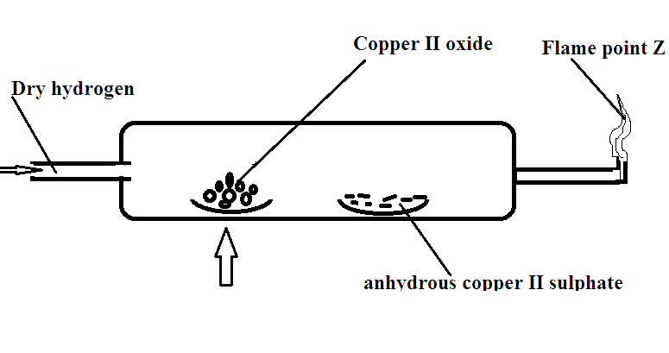
a) hydrogen gas was passed for 1 minute before being lit at the jet .Explain(1mk)
b)State the observation made in the combustion tube (2mks)
c) What property of hydrogen is being investigated?(1mk)
- A) Sample of chalk contained 2.0g of calcium 0.6 g of carbon and 2.24 g of oxygen
determine the formula of chalk.(ca=40 c=12 o=16) (3mks)
- Study the table below and use it to answer the question that follows NB: the letters does not represent the actual symbol of the element.
ELEMENT | ATOMIC NUMBER
A | 11
B | 12
C | 13
D | 14
E | 15
F | 16
G | 17
H | 18
A)To which period of the periodic table do elements belong?(2mks)
b)Select the most reactive metal from the table (1mk)
c)Write the formula of the compound formed between element A and F(2mks)
- Explain why an organic compound with formula C₃H₆ burns with a more sooty flame than C₃H₈. (2mks)
- Explain the following
a) Atomic radii of elements decreases across the period but increases down the group. (2mks)
b)Though aluminum is a reactive metal it is used to make cooking pans. Explain (1mk)
c)Potassium and sodium metals are stored in paraffin . explain (1mk)
d) the ionic radii of halogens are lager than the respective atomic radius(1mk)
- When carbon iv oxide gas was passed through aqueous sodium hydroxide a white suspension was formed?
a) write the equation of the reaction taking place (2mks)
b)State and explain the changes that takes place when excess carbon (iv)oxide was bubbled through the suspension. (2mks)
- A fixed mass of gas has a volume of 250cm³ at a temperature of 27⁰c and 750mmHg pressure ,calculate the volume of the gas that would occupy at 47⁰c and 750mmHg pressure(0⁰C=273K) (3mks)

