HEIGHTS SECONDARY SCHOOL-THIKA
MID-TERM EXAMINATION 2017
FORM ONE BIOLOGY
- A) What is meant by term biology?(2mks)
b)Give the meaning of the following branches of biology.
i) Ecology
ii)genetics
iii)entomology
iv)parasitology (8mks)
- State four reasons why we study biology(4mks)
- List four differences between plants and animals.(4mks)
- Name six characteristics of living things(6mks)
- List five professional occupation that requires the study of biology(5mks)
- Use the diagram below to answer the question that follows .
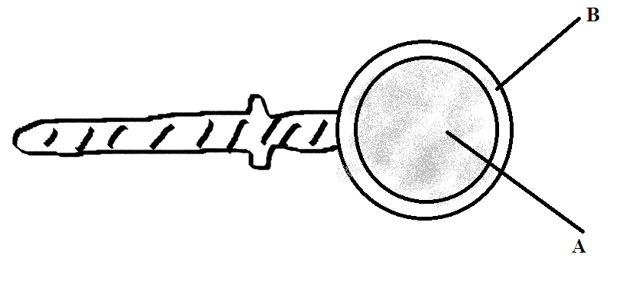
a)What name do we give to the apparatus?(1mk)
b)Label part A,B and C(3mks)
c)What ids the function of the apparatus?(2mks)
- State three precautions during collection and observation of the specimen (3mks)
- Define the following terms.
a) classifications(2mks)
b) Taxon(2mlks)
c)Species(2mks)
- Give two in each case
a) External features of a plant(2mks)
b)Internal features of an animal(2mks)
- Name the seven taxonomical units of classification starting with the largest (7mks)
- Living organism are grouped into five kingdoms name them(5mks)

