HEIGHTS SECONDARY SCHOOL-THIKA
MID-TERM EXAMINATION 2017
FORM THREE BIOLOGY
- Define the following terms.
a) Taxonomy(2mks)
b) TAxon(2mlks)
c)Species(2mks)
- A) Define the term binomial nomenclature.(2mks)
b)State the rules used in writing scientific names of a given organism.(2mks)
c)State three reasons why classification is important.(3mks)
- Use the diagram below to answer the following questions.
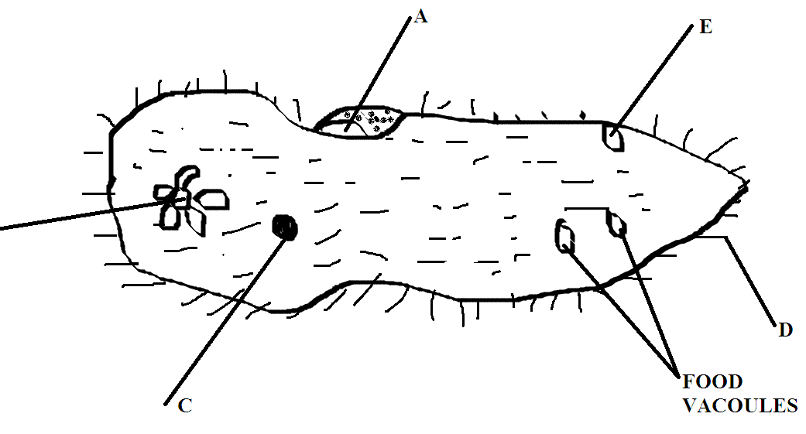
a) Name the organism.(1mk)
b)To which kingdom does the organism belong.(1mk)
c ) Label the parts A,B,C,D and E .(3mks)
d) Give the functions of the parts labeled B,C and D(3mks)
e)Give the process by which the following substances enters the organism body.(3mks)
i)Water
ii)oxygen
iii) Sodium ions
f) Name two other organism that belong in the same kingdom as the one shown.(2mks)
- Alongside is a diagram of a plant.
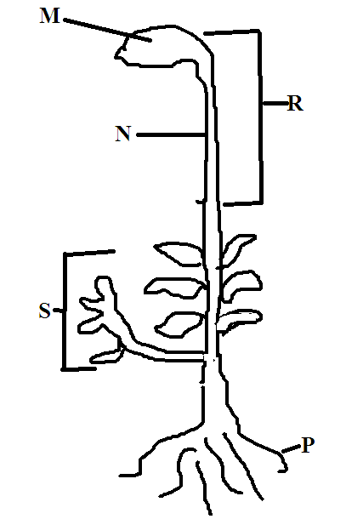
a)Identify the plant(1mk)
b)Label the parts M,R,N,S and P(5mks)
c)Give the function of the part label P(1mk)
- Below are diagrams of leaves labeled F,G,H,K,L and M
examine the and study the dichotomous key below to answer the questions that follows,
1 a) Leaf simple-------------------go to 2
b)leaf compound --------------go to 5
2a)leaf with parallel venation-------zea
b)leaf with compound venation----------go to 3
3a) Leaf with smooth margin--------------go to 4
b)Leaf with serrated margin---------------------Balsam
4a)Leaf shape Lencolate-------------------------mangifera
b)Leaf ovate ----------------------------------Bougainvillea
5a) Leaflet arising from the same point at the tip of petiole----------------------------------got to 7
b) Leaflets arising from different points along a common stalk-----------------------go to 6
6a) leaf pinnate ---------------------------------------------------cassia
b)Leaf bipinnete---------------------------------jacaranda
7a)Leaf trifoliate--------------------------------------soya bean
b)Leaf digitate----------------------------------------silk cotton
a) Use the key to arrive at the right identity for each of the leaves ,in each case show the steps you followed to arrive at the identity.
Step followed Identity
F…………………………………. ……………………………………..
G………………………………… ………………………………………
H………………………………… ………………………………………
J…………………………………. ……………………………………….
K……………………………….. ……………………………………….
L……………………………….. ……………………………………….
M………………………………. ……………………………………….
N………………………………. ……………………………………….
(16MKS)
b) Name the classes of the plants from which the leaves M and L were obtained .and give a reason in each case.(4mks)
- Name two kidney diseases(2mks)
- State one economic importance of each of the following plants excretory products
a) Tannin
b) Papain
c) Quinine
d) Caffeine (4mks)
- Give four roles of liver in homeostasis’s(4mks)
- Name three factors that affects the rate of respiration.(3mks)
- Give three differences between aerobic and anaerobic respiration(3mks)
- Give three characteristics of gaseous exchange sites(3mks)
b)Name three main gaseous exchange sites in.
i) Mammals
ii)Fishes
iii) Leaves
iv) Amoeba (4mks)
- Give three functions of blood plasma.(3mks)
- Give two adaptation of red blood cells.(2mks)
- Describe how environmental factors increase the rate of transpiration(10mks)

