HEIGHTS SECONDARY SCHOOL-THIKA
MID-TERM EXAMINATION 2017
FORM THREE BIOLOGY
SECTION A(40marks)
Answer ALL questions in this section in the space provided
- When the offspring of red and white flowered pea plants were crossed the produce a red and white flowered plant in the ration of 3:1
Using letter R to represent the gene for red colour.
a)(i) State the genotype of the parent.
……………………………………………………………………………………………………………………………………………………………………………………………………………………………….(2mks)
ii) F₁generation
……………………………………………………………………………………………………………………………………………………………………………………………………………………………………….(1mk)
b)Work out the cross between plants in F₁ generation (4mks)
c)Account for the colors of the flowers in plant of the F₁ generation (1mk)
……………………………………………………………………………………………………………………………………………………………………………………………………………………………………………….
- The diagram below represents the lower jaw of the mammal;
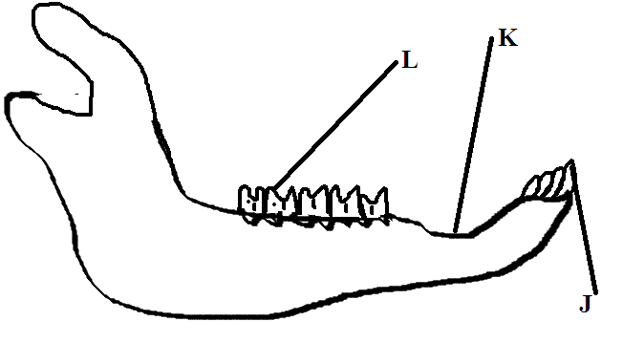
a) Name the mode of nutrition of the mammal whose jaw is shown above (1mk)
………………………………………………………………………………………………………………………
b )State one structural and one functional differences of the teeth label J and L
Structural
…………………………………………………………………………………………………………………………………………………………………………………………………………………………………………(1mk)
functional
…………………………………………………………………………………………………………………………………………………………………………………………………………………………………………(1mk)
c (i) Name the toothless gap labeled K (1mk)
……………………………………………………………………………………………………………………….
(ii)State the function of the gap in c(i)above(1mk)
………………………………………………………………………………………………………………………
d) Name the substances that is responsible for hardening of teeth (1mk)
………………………………………………………………………………………………………………………………………………………………………………………………………………………………………………
- A) what is meant by the term biology? (1m,k)
……………………………………………………………………………………………………………………………………………………………………………………………………………………………………………..
b)Give the two main branches of biology (1mk)
………………………………………………………………………………………………………………………………………………………………………………………………………………………………………………
- What is binomial nomenclature? (2mks)
- What are the importances of classification? (3mks)
.
- Name the smallest taxonomical unit (1mk)
.
- I) Give two examples of discontinuous variation (2mks)
.
ii)Give two examples of sex linked traits (2mks)
.
- What is organic evolution? (2mks)
.
b) Give two examples of homologous structures. (2mks)
.
- a ) Name a support tissue in plants thickened with
i)Cellulose (1mk)
ii)lignin (1mk)
- State the function of each of the following hormones in human reproduction (2mks)
a)luteinizing hormone
b) Progesterone
SECTION B(40mks)
Answer question 11 (compulsory ) and either 12 0r 13 in the space provided
- An experiment was carried out to investigate the effect of temperature on the rate of reaction of calalyst by enzymes the result are shown on the table below
Temperature(ºC) | Rate of reaction in mg of product per unit time
5 | 0.2
10 | 0.8
15 | 0.8
20 | 1.1
25 | 1.5
30 | 2.1
35 | 3.0
40 | 3.7
45 | 3.4
50 | 2.8
55 | 2.1
60 | 1.1
a) on the grid provided draw the graph of rate of reaction against temperature(6mks)
b)What was the rate of reaction2.6mg of product per unit time? (2mk)
c)Account for the shape of the graph. Between
i) 5ºC and 40ºC (2mks)
.
ii) 45ºC and 60ºC (2mks)
.
d) Other than temperature name two ways in which the rate of reaction 5ºC and 40ºC could be increased (2mks)
.
e) (i) Name one digestive enzyme in human body which works best in acidic condition (1mk)
.
(ii)How is the acidic condition for enzymes named I e(i)above attained? (2mks)
- Using diagrams explain any three types of chromosomal mutation. (6mks)
.
- A cross between a normal male and carrier female .Work out the cross between the two and give phenotypic ratio of their offspring’s(4mks)
.
SECTION C Answer only one question
- Describe the various evidences which support the theory of organic evolution. (20mks)
- Describe how mammalian heart is adapted n to its function (20mks)

