HEIGHTS SECONDARY SCHOOL –THIKA
FIRST-TERM 2017 FORM THREE
MID-TERM EXAMINATION
AGRICULTURE
TIME: 2HOURS
ANSWER ALL QUESTIONS
- Define the following terms as used in livestock production
(i) calf (1mk)
(ii) sow (1mk)
(iii) capon (1mk)
- List down any 3 importance’s of keeping proper farm records (3mks)
- Give any 3 characteristics of a fertile soil (3mks)
- Highlight any 4 importance’s of keeping livestock’s (4mks)
- What are the two main methods of soil sampling? (1mk)
- State the use of the following tools and equipments (4mks)
(i) ball pein hammer
(ii) strip cup
(iii) marking gauge
(iv) secateurs
- Highlight any 4 factors that influence soil formation (4mks)
- Give any 3 importance of primary cultivations (3mks)
- Write down any 3 factors that determines the choice of irrigation type (3mks)
- Give any two reasons of staking tomatoes (2mks)
SECTION B
- Define the following terms as used in livestock production (2mks)
(a) breeding
(b) reproduction
- How does the scrotum regulate the temperature of the testes? (1mk)
- (a) what is the meaning of the term ‘Epistasis’? (1mk)
(b) distinguish between hybrid and hybrid vigous as used in livestock production (2mks)
- Give the 3 main method of service to the livestock in a farm (3mks)
- (a) what is the duration of the oestrus cycle of a cow? (1mk)
(b) list down any 4 signs of a heifer on heat (4mks)
- Give any 3 advantages of artificial insemination (3mks)
- Write down any 3 signs of parturition in a sow (3mks)
SECTION C
- (a) define the term flushing (1mk)
(b) give the 3 importance of flushing in sheep production (3mks)
- (a) what is hoof trimming (1mk)
(b)give 3 reasons for hoof trimming? (3mks)
- List down any 4 reasons of culling livestock productions animals (4mks)
- Highlight 3 reasons for castration of livestock animals (3mks)
- The illustration below shows a method of identifying pigs. Study the diagram and answer the questions that follows
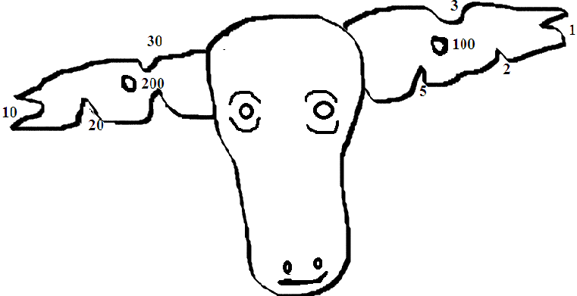
(a) what is the identification number of the animal (1mk)
(b) on the space provided below, draw notches marks to indicate pig number 367 (2mks)
(c) state the type of identification (2mks)
(d) state any 3 importance of identification in livestock animals (3mks)
- (a) define the term ‘Apiary’ (1mk)
(b) list down any 3 factor to consider when sitting apiary (3mks)
- State and explain five roles of agriculture in economic growth in Kenya (10mks)
- Highlight any 4 function of a worker bee (4mks)

