HEIGHTS SECONDARY SCHOOL –THIKA
FIRST-TERM 2017 FORM ONE
MID-TERM EXAMINATION
PHYSICS
TIME: 2HOURS
ANSWER ALL QUESTIONS
- Define the term physics.
(2mks)
- Complete the table below by filling the blank spaces .
Basic Physical Quantity | SI UNITS | Symbol of Units
 | Metre | M
Mass |  | Kg
 | seconds
Electric current | Ampere
Thermo dynamic temperature
Luminous intensity | Candela
 | Mole
(10mks)
- Define the term area and give its SI unit.
(2mks)
b)Express the following in cm² (6mks)
i) 25m²
ii) 0.009m²
iii)0.000005km²
- Calculate the area of a circle of radius 7cm.
(3mks)
- Calculate the area of the figures below.
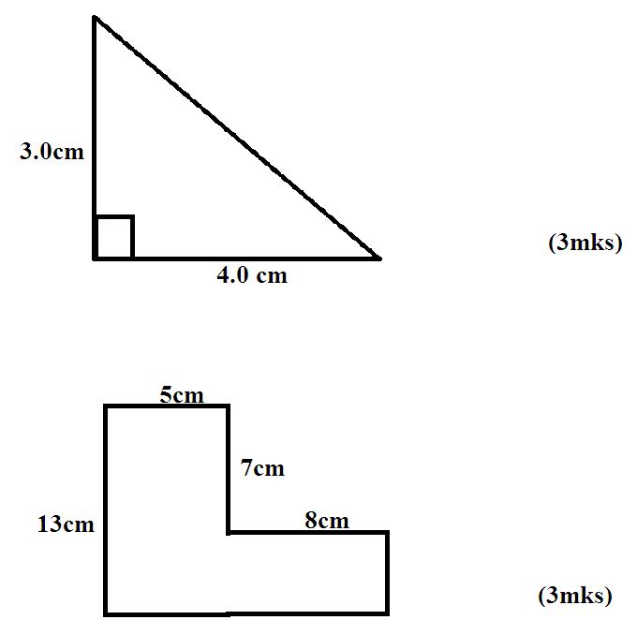
- a) Define the term volume and give the SI unit.
(2mks)
b) Express the following in M^{3.}
i) 90,000cm2 (2mks)
ii) 270,000cm² (2mks)
iii)3000000 cm² (2mks)
- A block of wood is 5cm long 4 cm wide and 2.5 cm high. Calculate its volume.
(3mks)
- Find the volume of a cylinder of radius 7 cm and height 5 cm.
(3mks)
- Find the volume of the sphere whose radius is 3.0 cm.
(3mks)
- Determine the area of a map of a plot shown below.
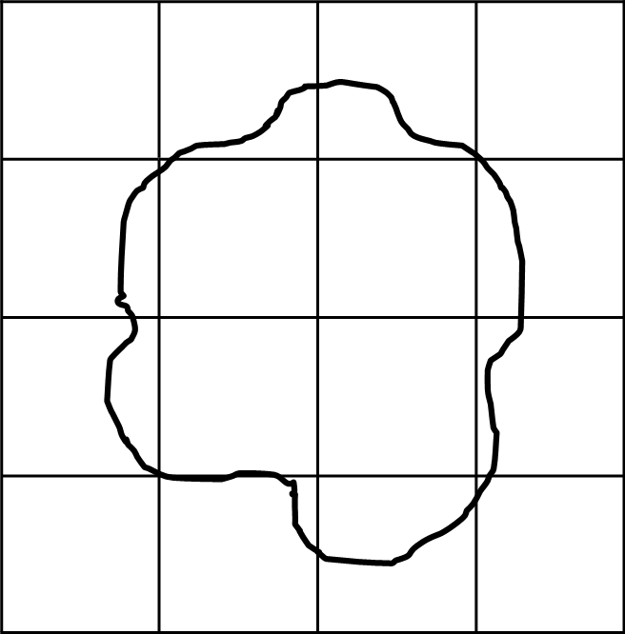
(4mks)

