SHULE YA UPILI YA SUNSHINE

102/2
FORM 4
KISWAHILI
KARATASI YA PILI
LUGHA
MACHI 2014
MUDA: SAA 2$\frac{1}{2}$

JINA………………………………………………….. NAMABARI………………….

SAHIHI YA MTAHIRIRWA…………………

MTIHANI WA KABLA YA MWIGO 2014
MAAGIZO:
- Jibu maswali yote
- Majibu yote yaandikwe katika nafasi ulizoachiwa katika kijitabu hiki cha maswali. Majibu yatakayoandikwa kwingine hayata sahihishwa
- Makosa ya sarufi nahijani yataadhibiwa

KWA MATUMIZI YA MTAHINIWA PEKEE

SWALI | UPEO | ALAMA
1
2
3
4
JUMLA

UFAHAMU

Soma taarifa ifuatayo kasha ujibu maswali.

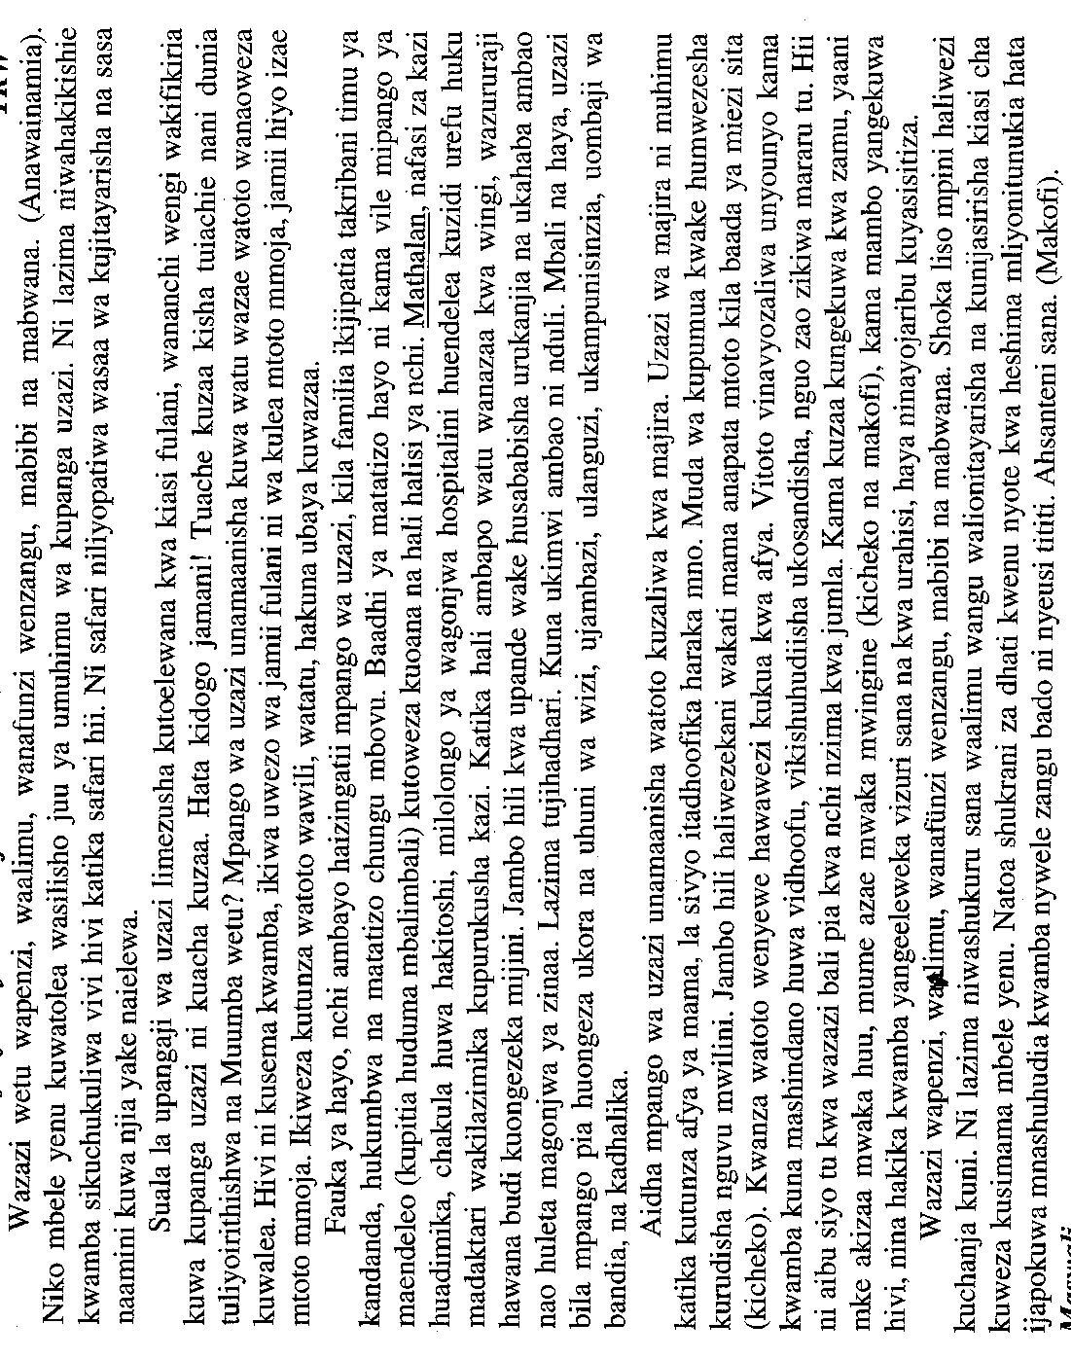

- Kulingana na taarifa hii kupanga uzazi kunamaanisha mambo matatu. Yataje. (al 3)
………………………………………………………………………………………………..
………………………………………………………………………………………………..
………………………………………………………………………………………………..
………………………………………………………………………………………………..
- Katika methali ya shoka liso mpini halichanji kuni, kama ilivyotumiwa na mwandishi, ni nani ‘shoka’ na ni nani ‘mpini’? (al 2)

………………………………………………………………………………………………..
………………………………………………………………………………………………..
………………………………………………………………………………………………..
- Mwandishi anamaliza hotuba yake kwa kuishukuru hadhira kwa kumtunukia heshima, hata ijapokuwa nywele zake ni nyeusi tititi.
- Amatunukiwa heshima gani? (al 2)

………………………………………………………………………………………………..
………………………………………………………………………………………………..
………………………………………………………………………………………………..
………………………………………………………………………………………………..
- Ni ujumbe gani hasa anaonuia kutoa katika kusema kuwa nywele zake ni nyeusi tititi? (al 2)

………………………………………………………………………………………………..
………………………………………………………………………………………………..
………………………………………………………………………………………………..
………………………………………………………………………………………………..
- Katika habari hii, mwandishi anajitokeza kama msemaji wa mizaha ya mara kwa mara kupitia matumizi yake ya lugha. Taja mifano mitatu ya mizaha hiyo. (al 3)

………………………………………………………………………………………………..
………………………………………………………………………………………………..
………………………………………………………………………………………………..
………………………………………………………………………………………………..
- Eleza matumizi ya lugha yafuatayo kama yanavyodhihirika katika taarifa hii. (al 3)
- Mathalan…………………………………………………………………………..…………………………………………………………………………………………..
- kupurukusha………………………………………………………………………………………………………………………………………………………………….
- Mararu ………………………………………………………………………………..
………………………………………………………………………………………..
MUHTASARI

Soma kifungu kifuatacho kwa makini kasha ujibu maswali.

Sayansi ya lugha kwa mujibu wa matumizi yake katika jamii ni taaluma mpya sana katika silabasi ya somo la Kiswahili kwa shule za sekondari. Taaluma hii imeibuka na kuibua hali ya taharuki si kwa wanafunzi, si kwa walimu na si kwa washikadau wote wa kitengo maalam cha kukuza lugha nchini.
Wanapoulizwa sababu ya taharuki yao, jibu huwa ni moja, “Kuku mgeni hakosi kamba mguuni” Jambo la kimsingi ni kuwa mahuluki hutumia lugha katika shughuli ainati. Aidha ni dhahiri shahiri kwamba katika shughuli hizi kuna matumizi ya lugha ama maneno kwa sauti au ishara kama zile za vipofu na viziwi.
Lugha itumiwapo katika shughuli au taaluma Fulani mahsusi, huwa pana msamiati Fulani wa kipekee unaotawala katika shughuli hiyo. Istilahi hizi ndizo huunda sajili. Mathalani, katika taaluma ya zaraa kuna istilahi kama vile kulima, kupalilia, kuchimba makoongo, kuandaa weu, kupiga matuta, miche, mbegu, mbolea, jembe, koleo, mundu, mifugo, mazao na istilahi nyinginezo. Msamiati kama huu ndio huunda istilahi za sajili ya zaraa.
Mbali na zaraa, kuna sajili nyingine kama sajili ya matangazo ya mpira utabibu, mazungumzo ya watoto wa mitaani; biashara, sheria na mahakama, dini ya Kikristo, Kiislamu na ya Kihindi na sajili nyinginezo.
Waama, bila lugha matendo yote ya wanadamu yangegonga mwamba na kudorora. Je, viongozi wangetawala vipi? Wafanya biashara wangenadi vipi bidhaa zao? Walimu wangefunzaje’? Bila shaka jibu ni moja tu: ingekuwa vigumu sana.
Hivyo basi lugha ni chombo muhimu sana. Katika maisha ya waja. Shime kila mtu, tuendeleze lugha yetu ya Kiswahili. Tusiwe wendaguu kwani makofi hayalii ila kwa viganja viwili.

Maswali:

(a) Fupisha aya tatu za mwanzo kwa maneno yasiyozidi 60. (al 7)
Matayarisho
………………………………………………………………………………………………
………………………………………………………………………………………………
………………………………………………………………………………………………
………………………………………………………………………………………………
………………………………………………………………………………………………
………………………………………………………………………………………………
………………………………………………………………………………………………
………………………………………………………………………………………………
………………………………………………………………………………………………
Nakala safi
………………………………………………………………………………………………
………………………………………………………………………………………………
………………………………………………………………………………………………
………………………………………………………………………………………………
………………………………………………………………………………………………
………………………………………………………………………………………………
………………………………………………………………………………………………………………………………………………………………………………………………
(b) Fupisha aya tatu za mwisho kwa maneno yasiyozidi 40. (al 6) (mtiririko 2)

Matayarisho

………………………………………………………………………………………………
………………………………………………………………………………………………
………………………………………………………………………………………………
………………………………………………………………………………………………
………………………………………………………………………………………………
………………………………………………………………………………………………………………………………………………………………………………………………
………………………………………………………………………………………………………………………………………………………………………………………………
Nakala safi
………………………………………………………………………………………………
………………………………………………………………………………………………
………………………………………………………………………………………………
………………………………………………………………………………………………
………………………………………………………………………………………………………………………………………………………………………………………………
………………………………………………………………………………………………………………………………………………………………………………………………

SARUFI
- Taja kikwamizo ghuna cha menoni (al 1)
....................................................................................................................................................
- Tofautisha sentensi zifuatazo kwa kutia shadda (al 2)
Wataka kazi
....................................................................................................................................................
....................................................................................................................................................
Wataka kazi
....................................................................................................................................................
....................................................................................................................................................
- Bainisha viambishi (al 3)
Waliowasafirisheni
……………………………………………………………………………………………………………………………………………………………………………………………………
....................................................................................................................................................
....................................................................................................................................................
....................................................................................................................................................
....................................................................................................................................................
- Ainisha aina ya vitenzi katika sentensi ifuatayo (al 2)
Tutakapofika watakuwa wangali wanapika chakula hicho
....................................................................................................................................................
....................................................................................................................................................
....................................................................................................................................................
- Tunga sentensi ukitumia neno ganda katika kauli ya kutendana. (al 1)
....................................................................................................................................................
....................................................................................................................................................
- Tunga sentensi kwa kutumia nomino zifuatazo
- Kiwavi (al 1)
....................................................................................................................................................
....................................................................................................................................................

- Mwangi (al 1)
....................................................................................................................................................
....................................................................................................................................................
- Kanusha
Watakapofika hospitalini watatibiwa (al 1)
....................................................................................................................................................
....................................................................................................................................................
- Tofautisha maana kwa kutunga sentensi (al 2)
a) mjuzi………………………………………………………………………………………..
b) mjusi………………………………………………………………………………………..
i) Unda nomino kutokana na maneno haya (al 2)
a) Vuka……………………………………………………………………………………….
b) Uza …………………………………………………………………………………………
j) Geuza sentensi hii hadi usemi wa taarifa:
“Sitakuja shuleni kesho,” mwalimu mkuu akasema, “Nitaenda kuhudhuria mkutano mjini.” (al 3)
....................................................................................................................................................
....................................................................................................................................................
....................................................................................................................................................
....................................................................................................................................................
....................................................................................................................................................
k) Eleza maana ya sentensi hii (al 1)
Ningalimwona ningalisafiri naye
......................................................................................................................................................
......................................................................................................................................................
....................................................................................................................................................
....................................................................................................................................................
....................................................................................................................................................

l) Andika sentensi hii upya kwa urejeshi tamati (al 2)
Mwanamichezo ambaye hushinda ni yule ambaye anajitahidi
…....................................................................................................................................................
…....................................................................................................................................................
…....................................................................................................................................................
…....................................................................................................................................................
m) Tumia neno zima kama: (al 2)
i) Kivumishi
....................................................................................................................................................
....................................................................................................................................................
ii) Nomino
....................................................................................................................................................
....................................................................................................................................................
n) Kirai ni nini? (al 1)
…....................................................................................................................................................
…....................................................................................................................................................
o) Tambulisha virai katika sentensi ifuatayo
Kitabu chenye picha za kupendeza kimekuwa kikipendelewa kila mwaka (al 4)
…....................................................................................................................................................
…....................................................................................................................................................
…....................................................................................................................................................
…....................................................................................................................................................
…....................................................................................................................................................
p) Tambua aina ya vishazi katika sentensi hii (al 2)
Mkiambiaji aliyeshinda Ulaya juzi alipokelewa kwa furaha
…....................................................................................................................................................
…....................................................................................................................................................
…....................................................................................................................................................
…....................................................................................................................................................
q) Ainisha shamirisho katika sentensi ifuatayo (al 3)
Mtoto alipikiwa uji na mamake jana jioni kwa jiko
…....................................................................................................................................................
…....................................................................................................................................................
…....................................................................................................................................................
…....................................................................................................................................................
. …...................................................................................................................................................
r) Changanua kwa kielezo matawi (al 4)
Nitapika halafu nitakwenda sokoni
…....................................................................................................................................................
…....................................................................................................................................................
…....................................................................................................................................................
……………………………………………………………………………………………………
……………………………………………………………………………………………………
……………………………………………………………………………………………………
s) Tumia kitenzi – Wa – Katika sentensi katika kauli ya kutendeana (al 2)
…....................................................................................................................................................
…....................................................................................................................................................
…....................................................................................................................................................

ISIMU JAMII
- Eleza matatizo matatu yaliyokumba tu maenezi ya lugha ya Kiswahili kabla ya Uhuru. (al 3)

…………………………………………………………………………………………………………………………………………………………………………………………………………………………………………………………………………………………………………………………………………………………………………………………………………………………………………………………………………………………………………………………………………………………………………………………………………….
2. Fafanua sababu zozote zinazosababisha makosa katika matumizi ya lugha ya Kiswahili. (al 3)
…………………………………………………………………………………………………………………………………………………………………………………………………………………………………………………………………………………………………………………………………………………………………………………………………………
…………………………………………………………………………………………………
…………………………………………………………………………………………………
- Tofautisha istilahi zifuatazo:
a) Lingua Franka na lugha ya Taifa (al 2)
……………………………………………………………………………………………………………………………………………………………………………………………………
…………………………………………………………………………………………………
b) Pijini na Krioli (al 2)
……………………………………………………………………………………………………………………………………………………………………………………………………
…………………………………………………………………………………………………

