**NGALA MEM. GIRLS SEC SCHOOL CHEMISTRY FORM 1 MID TERM 111 EXAM 2016**

**NAME……………………………………………….CLASS……ADM. NO:…….**

1. The diagram below shows the set-up of the apparatus used to separate methanol (boiling point 65°C) and water (boiling point 100°C)



a). Identify

Apparatus R (1 mark)

Apparatus M (1 mark)

Liquid Z (1 mark)

b). State one function of the glass bead in apparatus labelled R (1 mark)

1. Solutions may be classified as strongly basic, weakly basic, neutral, weakly acidic, strongly acidic. The information below gives solution and their pH values. Study it and answer the questions that follow.

|  |  |
| --- | --- |
| Solution | pH value |
| B | 0.5 |
| C | 6 |
| D | 14.5 |

Classify the solution in the table above using the stated classification B, C & D (3 marks)

B………………………………………..C…………………………………..

D………………………………………..

1. (a) Below is a paper chromatogram of pure substances W, X and Y

   The mixture K contains substances W and X only. Indicate on the diagram the chromatogram of K. (2 marks)

  (b) State two application of chromatography. (2 marks)

1. The following diagram shows the effects of heat on the physical states of substances.



(a) Identify the processes represented by the letters A, B, C, D, E and F (3 marks)

A…………………………..B…………………………..C…………………………………..

D…………………………..E……………………………F………………………………….

  (b) Name two substances that undergo the process labelled E and F. (2 marks)

(c) Name a method that can be used to extract the following:-

 (i) Common salt from a salt solution. (1 mark)

(ii) Paraffin from crude oil. (1 mark)

1. State two reasons why most of the laboratory apparatus are transparent. (2 marks)

6. What is meant by the terms:

(i) Compound (1 mark)

(ii) saturated solution (1 mark)

7. A pH of a sample of soil was found to be 5.5. An extension officer advised the farmer to add calcium oxide. State two functions of calcium oxide in the soil. (2 Marks)

8. (i) State two differences between non-luminous and luminous flames. (2mks)

(ii) Give two reasons why non luminous flame is more preferred for heating that luminous flame. (1mk)

9. Use the diagram below to answer the questions that follow.



a) Why is sodium hydroxide solution preferred to water in the above set-up. (1 mark)

b) state and explain two observation made in this set up (2 marks)

c) Name the main component of air not used in the above set-up. (1 mark)

10.  **a)** Name two commonly abused drugs in Kenya. (1 mark)

**b)** Differentiate between drug and drug abuse (2 marks)

11. The diagrams below are some common laboratory apparatus. Name each apparatus and state its use. (4 marks)

  (i) (ii)



12. State two methods of preparing oxygen gas in the laboratory ( 2 marks)

13. In countries which experience snow, crude salt is poured on the roads. Give a reason for this ( 2 mks)

14. State two applications of crystallization (2 mks)

15. Complete the table below to show the colour of the given indicator in ( 2 mks)

|  |  |  |
| --- | --- | --- |
| Indicator | Colour in | |
| Acid solution | Basic solution |
| Methyl orange | ……………. | Yellow |
| Phenolpthalein | Colourless | ……………… |

1. The diagram below shows a Bunsen burner when in use.

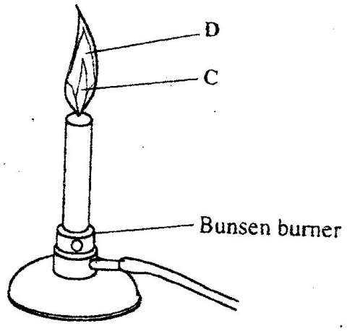

Name the regions labeled C and D. (2mks)

C …………………………………………………………………………..

D ………………………………………………………………………….

1. Classify the following processes as either chemical or physical. (3 mks)

|  |  |
| --- | --- |
| Process | Type of change |
| a) Heating copper (II) sulphate crystals |  |
| b) Obtaining kerosene from crude oil |  |
| c) Souring of milk |  |

1. What is meant by the terms: (2 marks)
   * + - 1. element
         2. air
2. The curve below represents the variation of temperature with time when pure and impure samples of a solid were heated separately.

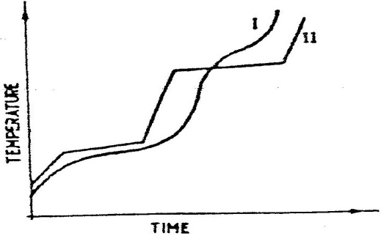

Which curve sows the variation in temperature for the pure solid? Explain (2mks)

1. Write the symbols of the following elements ( 5 mks)
2. Carbon
3. Lithium
4. Copper
5. Magnesium
6. sodium
7. write the name of the elements whose symbol is given
8. K
9. Fe
10. Be
11. Pb
12. Zn
13. List two differences between temporary and permanent change ( 2 mks)
14. Name the apparatus found in the laboratory that are used for measuring the following
15. Accurate volume
16. Mass
17. Time