**NAME:………………………………………………………………………..………………INDEX NO…………………………………………**

**SCHOOL…………………………………………………………….………………………CANDIDATE’S SIGN…………………………….**

**DATE…………………………………………...**

**231/2**

**BIOLOGY**

**PAPER 2**

**MARCH 2017**

**TIMR: 2 HOURS**

**MALIET EVALUATION TEST**

***Kenya Certificate of Secondary Education (K.C.S.E)***

**Biology**

**Paper 2**

INSTRUCTIONS TO CANDIDATES

* Write your name and index number in the spaces provided above
* Sign and write the date of the examination in the spaces provided above
* Answer all the questions in Section A in the spaces provided
* In section B answer questions 6 (compulsory) and either question 7 of 8 in the spaces provided

**FOR EXAMINER’S USE ONLY**

|  |  |  |  |
| --- | --- | --- | --- |
| SECTION | QUESTION | MAXIMUM SCORE | CANDIDATE’S SCORE |
| A | 1 | 8 |  |
|  | 2 | 8 |  |
|  | 3 | 8 |  |
|  | 4 | 8 |  |
|  | 5 | 8 |  |
| B | 6 | 20 |  |
|  | 7 | 20 |  |
|  | 8 | 20 |  |
|  | TOTAL | 80 |  |

*This paper consists of 10 printed pages. Candidates should check to ascertain that all pages are printed and that no questions are missing.*

1. a) What is meant by the term sex linked genes? (1 mark)

……………………………………………………………………………………………………………………………………………………………………………………………………………………………………………………………………………………

b) Name two sex linked traits in humans. (2mks)

……………………………………………………………………………………………………………………………………………………..……………………………………………………………………………………………………………………………

c) In drosophila melanongaster, the inheritance of the eye colour is sex linked. The gene is dominant. A cross was made between a heterozygous red eyed female and a white eyed male. Work out the phenotypic ratio of F1 generation. (Use R to represent the gene for red eye colour). (5mks)

1. The diagram below shows an organism obtained from an aquatic ecosystem

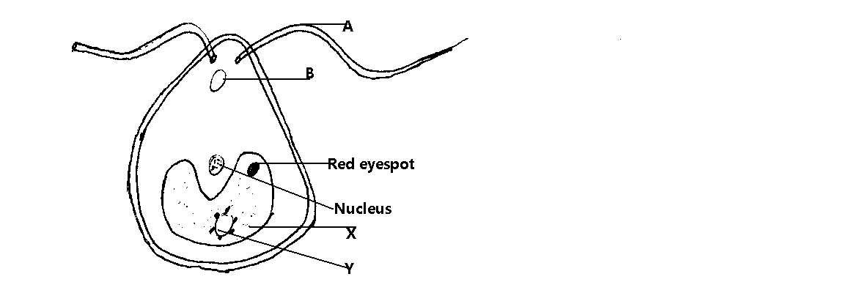

(a) **State** the kingdom in which the organism belongs. (1mk)

………………………………………………………………………………………………

(b) **Name** the parts labeled B and Y

B……………………………………………………………………………………..(1mk)

Y…………………………………………………………………………………….(1mk)

(c) **State** the functions of the following parts A , X and Z (3 mks)

A……………………………………………………………………………………………………………………………………………………………………………………………

X……………………………………………………………………………………………………………………………………………………………………………………………

Z……………………………………………………………………………………………………………………………………………………………………………………………

(d) Explain briefly why the organism is described as eukaryotic (2mks)

………………………………………………………………………………………………………………………………………………………………………………………………………………………………………………………………………………………………

1. The figure below shows parts of a food web for the south Atlantic ocean.



a) i)Name the producer in this food web. (1 mark)

...............................................................................................................................................

ii) Name the top carnivore in this food web. (1 mark)

...............................................................................................................................................

b) Construct a food chain in which leopard seal is a tertiary consumer. (1 mark)

...............................................................................................................................................

c) In the future, the extraction of mineral resources in the Antarctic might occur on a large scale. This could destroy the breeding-grounds of the Ross seal.

i) State and explain the effects this might have on the population of leopard seal. (2 marks)

...............................................................................................................................................

...............................................................................................................................................

ii) List two human activities that can affect the population of organisms in the ecosystem represented by food web. (2mks)

………………………………………………………………………………………………………………………………………………………………………………………………………………………………………………………………………………………………………………………………………………………………………………………………………………………………

d) Name the organism with the highest number of predators. (1mk)

…………………………………………………………………………………………………………………………………………………………………………………………………………………………………………………………………………………….

1. The diagram below represents part of a gaseous system in a grasshopper.

P Q

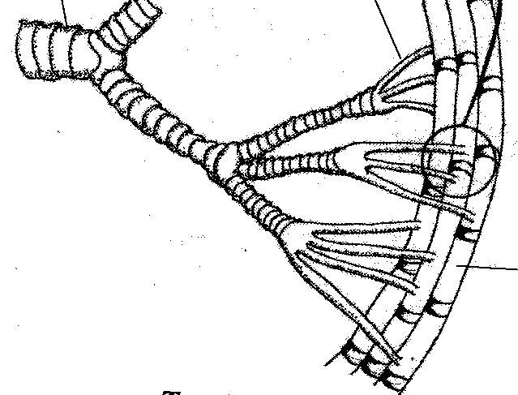

a) Name the structures labeled P and Q

P……………………………………………………………………………………………………………………………(1mk)

Q……………………………………………………………………………………………………………………………(1mk)

b) State the function of the structure labeled P (1mk)

……………………………………………………………………………………………………………………………………

c) Describe the path taken by carbon (IV) oxide from the tissues of the insect the atmosphere (3mks)

……………………………………………………………………………………………………………………………………………………………………………………………………………………………………………………………………………………………………………………………………………………………………………………………………………………………………………………………………………………………………………………………………………………………………………………………………………………………………………………………………………………………………………………

d) How is the structure labeled Q adapted to its functions (2mks)

………………………………………………………………………………………………………………………………………………………………………………………………………………………………………………………………………………………………………………………………………………………………………………………………………………………………

1. a) A potted plant was destarched by keeping it in the dark for 24 hours. Both surfaces of all leaves were smeared with Vaseline and the plant placed in light. After 6 hours, the leaves were tested for starch.
2. What was the expected observation? (1mk)

……………………………………………………………………………………………………………………………………………………………………………………………………………………………………………………………………………………

1. Explain the observation. (2mks)

………………………………………………………………………………………………………………………………………………………………………………………………………………………………………………………………………………………………………………………………………………………………………………………………………………………………

b) Name the carbohydrate that is

1. Stored in the plant seeds (1mk)

……………………………………………………………………………………………………………………………………………………………………………………………………………………………………………………………………………………

1. Most abundant in mammalian human blood. (1mk)

……………………………………………………………………………………………………………………………………………………………………………………………………………………………………………………………………………………

1. Stored in the human liver (1mk)

……………………………………………………………………………………………………………………………………………………………………………………………………………………………………………………………………………………

c) i) State **two** differences between competitive and non-competitive inhibitors. (2mks)

……………………………………………………………………………………………………………………………………………………………………………………………………………………………………………………………………………………………………………………………………………………………………………………………………………………………………………………………………………………………………………………………………………………………………………………………………………………………………………………………………………………………………………………

**SECTION B: 40MARKS.**

**Answer question 6 (compulsory) and either question 7 or 8 in the spaces provided after**

**question 8**

1. In an investigation, two persons A and B took the same amount of a meal rich in carbohydrates. Their blood sugar levels were immediately determined and thereafter at intervals. The results were as shown in the table below.

|  |  |  |
| --- | --- | --- |
| Time (minutes) | Glucose level in blood (mg/100cm3) | |
|  | Person A | Person B |
| 0 | 92 | 80 |
| 15 | 90 | 76 |
| 30 | 105 | 90 |
| 40 | 116 | 105 |
| 60 | 140 | 162 |
| 80 | 138 | 210 |
| 120 | 100 | 202 |
| 135 | 96 | 194 |
| 160 | 90 | 180 |
| 180 | 90 | 162 |

1. On the grid provided, plot graphs of glucose level in blood against time on the same axis. (7mks)
2. i) When was the glucose level of person A equal to that of person B. (1mk)

……………………………………………………………………………………………………………………………………………………………………………………………………………………………………………………………………

ii) What was the concentration of glucose in the blood of A and B at the 20th minute? (2mks)

…………………………………………………………………………………………………………………………………………………………………………………………………………………………………………………………………………………………………………………………………………………………………………………………………………………………………………………………………………………………………………………………………………

1. i) Account for the blood sugar level in person A and person B between 0 and 15. (2mks)

………………………………………………………………………………………………………………………………………………………………………………………………………………………………………………………………………………………………………………………………………………………………………………………………………

In man, the normal blood sugar level is about 90mg/100cm3 of blood. Explain the change in the blood sugar level in person A between 15 and 60 minutes. (4mks)

…………………………………………………………………………………………………………………………………………………………………………………………………………………………………………………………………………………………………………………………………………………………………………………………………………………………………………………………………………………………………………………………………………………………………………………………………………………………………………………………………………

1. i) Suggest a possible reason for the high blood sugar level in person B. (2mks)

……………………………………………………………………………………………………………………………………………………………………………………………………………………………………………………………………………………………………………………………………………………………………………………………………….

ii) How can the high sugar level in person B be controlled? (1mk)

…………………………………………………………………………………………………………………………………………………………………………………………………………………………………………………………………..

1. Name the compound that stores energy released during oxidation of glucose. (1mk)

…………………………………………………………………………………………………………………………………

1. Describe how the following types of plants are adapted to their habitats:
2. Mesophytes (10mks)
3. Halophytes (5mks)
4. Hydrophytes (5mks)
5. a) Explain the main homeostatic function of mammalian liver. (18mks)

b) State any two liver diseases. (2mks)

………………………………………………………………………………………………………………………………………………………………………………………………………………………………………………………………………………………………………………………………………………………………………………………………………………………………………………………………………………………………………………………………………………………………………………………………………………………………………………………………………………………………………………………………………………………………………………………………………………………………………………………………………………………………………………………………………………………………………………………………………………………………………………………………………………………………………………………………………………………………………………………………………………………………………………………………………………………………

………………………………………………………………………………………………………………………………………………………………………………………………………………………………………………………………………………………………………………………………………………………………………………………………………………………………………………………………………………………………………………………………………………………………………………………………………………………………………………………………………………………………………………………………………………………………………………………………………………………………………………………………………………………………………………………………………………………………………………………………………………………………………………………………………………………………………………………………………………………………………………………………………………………………………………………………………………………………

………………………………………………………………………………………………………………………………………………………………………………………………………………………………………………………………………………………………………………………………………………………………………………………………………………………………………………………………………………………………………………………………………………………………………………………………………………………………………………………………………………………………………………………………………………………………………………………………………………………………………………………………………………………………………………………………………………………………………………………………………………………………………………………………………………………………………………………………………………………………………………………………………………………………………………………………………………………………

………………………………………………………………………………………………………………………………………………………………………………………………………………………………………………………………………………………………………………………………………………………………………………………………………………………………………………………………………………………………………………………………………………………………………………………………………………………………………………………………………………………………………………………………………………………………………………………………………………………………………………………………………………………………………………………………………………………………………………………………………………………………………………………………………………………………………………………………………………………………………………………………………………………………………………………………………………………………

……………………………………………………………………………………………………………………………………………………………………………………………………………………………………………………………………………………………………………………………………………………………………………………………………………………………………………………………………………………………………………………………………………………………………………………………………………………………………………………………………………………………………………………………………………………………………………………………………………………………………………………………………………………………………………………………………………………………………………………………………………………………………………………………………………………………………………………………………………………………………………………………………………………………………………………………………………………………………………………………………………………………………………………………………………………………………………………………………………………………………………………………………………………………………………………………………………………………………………………………………………………………………………………………………………………………………………………………………………………………………………………………………………………………………………………………………………………………………………………………………………………………………………………………………………………………………………………………………………………………………………………………………………………………………………………………………………………………………………………………………………………………………………………………………………………………………………………

………………………………………………………………………………………………………………………………………………………………………………………………………………………………………………………………………………………………………………………………………………………………………………………………………………………………………………………………………………………………………………………………………………………………………………………………………………………………………………………………………………………………………………………………………………………………………………………………………………………………………………………………………………………………………………………………………………………………………………………………………………………………………………………………………………………………………………………………………………………………………………………………………………………………………………………………………………………………………………………………………………………………………………………………………………………………………………………………………………………………………………………………………………………………………………………………………………………………………………………………………………………………………………………………………………………………………………………………………………………………………………………………………..

END.