NAME: ………………………………………………………….…...ADM NO………………
DURATION 2 ½ HOURS
FORM 3 2017
MAU LINK EXAMINATION FORM THREE (MALIET)
(Kenya Certificate of Secondary Education)
INSTRUCTIONS TO CANDIDATES
- Write your name and Adimission number in the spaces provided above.
- This paper consists of two sections: Section I and Section II.
- Answer all the questions in Section I and only five from section II
- All answers and working must be written on the question paper in the spaces provided below each question.
- Show all the steps in your calculations, giving your answers at each stage in the spaces below each question..
- Non- programmable silent electronic calculators and KNEC Mathematical tables may be used except where stated otherwise.
For Examiner’s Use Only
SECTION I
1 | 2 | 3 | 4 | 5 | 6 | 7 | 8 | 9 | 10 | 11 | 12 | 13 | 14 | 15 | 16 | Total
SECTION II
17 | 18 | 19 | 20 | 21 | 22 | 23 | 24 | Total
Grand
Total

(SECTION I 50 MARKS )
1.Work out the following, giving the answer as a mixed number in its simplest form (3mks

2.Evaluate without using mathematical tables (4mks)

3 Solve the equation $\frac{1}{4x}$ = $\frac{5}{6x}$ - 7

4.Use logarithms to evaluate ( 3 marks)

5 It takes 30 workers 6 days working 8 hours a day to harvest maize in a farm. How many days would 50 workers working 6 hours a day take to harvest the maze? (3mks)

6 In the figure below PQRS is a rhombus, < SQR = 55⁰ < QST is a right angle and TPQ is a straight line (3mks )
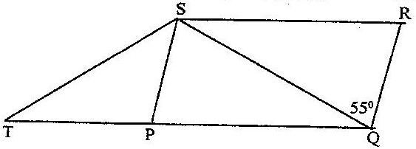

Find the size of the angle STQ

7 .Factorize completely a² – 15ab + 36b² (2marks)

8 A perpendicular is drawn from a point (3, 5) to the line 2y + x = 3. Find the equation of the perpendicular. (3marks)

9. a) Solve the inequalities 2x -5> -11 and 3 + 2x ≤ 13, giving the answer as a combined inequality. ( 3 mks)

b) List the integral values of x that satisfy the combined inequality in (a) above ( 1 mk)

10. Simplify (3marks)

11.A building and a flag post are on the same level ground. The height of the building is 19m and the flag post is 5m from the building. The angle of elevation of the top of the building from the top of the flagpost is 63⁰. Calculate the height of the flagpost (3 marks)

12.The two diagonals of a parallelogram are 20cm and 28.8cm. The acute angle between them is 62⁰.Calculate the of the parallelogram. (3 marks)

13. Find the values of x that satisfies the equation
Log(x + 5) = log 4 – log (x + 2 ) ( 3 marks )

14 The size of each interior angle of a regular polygon is five times the size of the exterior
angle. Find the number of sides of the polygon. ( 3 marks )

15.During a certain month, the exchange rates in a bank were as follows;
 | Buying (Ksh.) | Selling (Ksh.)
1 US $ | 91.65 | 91.80
1 Euro | 103.75 | 103.93

A tourist left Kenya to the United States with Ksh.1 000,000.On the air port he exchanged all the money to dollars and spent 190 dollars on air ticket. While in US he spent 4500 dollars for upkeep and proceeded to Europe. While in Europe he spent a total of 2000 Euros. How many Euros did he remain with? (3marks)

16. Rationalize the denominator of (3mks)
$$\frac{3+ \sqrt{5}}{2- \sqrt{5}}$$

SECTION II
Answer ONLY FIVE questions in this section in the spaces provided
17)The vertices of quadrilateral OPQR are O(0,0), P(2,0), Q(4,2) and R(0,3). The vertices of its image under a rotation are O'(1, -1), P'(1, -3) Q'(3, -5) an R'(4, -1).
(a) On the grid provided draw the quadrilateral and its image (2marks)

- (ii) By construction, determine the centre and angle of rotation. (2marks)

- On the same grid as (a) (i) above, draw O''P''Q''R'', the image of O'P'Q'R' under a reflection in the line y = x (2marks)

- From the quadrilaterals drawn, state the pairs that are:
- Directly congruent; (2marks)

- Oppositely congruent (2marks)

18. A Surveyor recorded the imformation about a tea farm in his field book as in the table below

p
600 90 to C
To A 180 420
300 90 To D
To B 50 50
P

- Given that PQ =650,Make a sketch of the field (5marks )
- Hence find the area of the field in hectares ( 5marks)

19.The table below shows the height measured to the nearest cm of 101 pawpaw tress
Height in cm | 20-24 | 25-29 | 30-34 | 35-39 | 40-44 | 45-49 | 50-54 | 55-59
Frequency | 2 | 15 | 18 | 25 | 30 | 6 | 3 | 2
- State the modal class 1mk
- Calculate to 2 decimal places
i)The mean height 4mks
ii)The differences between the median height and the mean height 5mks

20.Use a ruler and compasses only in this question.
(a) Construct triangle ABC such that AB=6cm, AC=8.5cm and <BAC=120⁰ (3mks)

(b) Draw a bisector of line AB from M on AB to meet BC at N. (2mks)

(c) Determine the areas;
- MBN
- AM NC (4mks)

(d) Express the ratio of the area MBN to AMNC in the form 1:n (1mk)

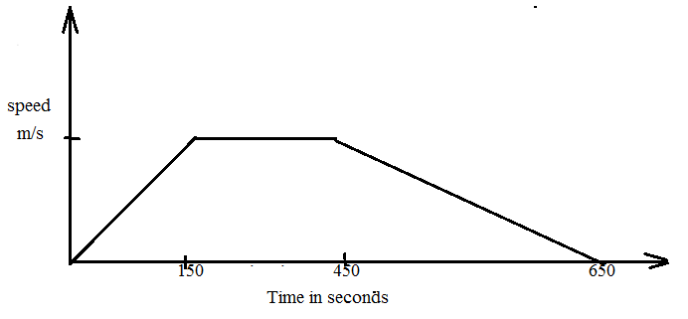
21.The diagram below shows the time graph for a train travelling between two stations. The train starts from rest and accelerates uniformly for 150 seconds. It then travels at a constant speed for 300 seconds and finally decelerates uniformly for 200 seconds.

Given that the distance between the two stations is 10450m, calculate the:
- maximum speed , in Km/h the train attained (3 marks)

- Acceleration (2 marks)

c) Distance the train travelling during the last 100 seconds (2 marks)

d) Time the train takes to travel the first half of the journey (3 marks)

22.A village Q is 7 km from village P on a bearing of 045⁰. Village R is 5 km from village Q on a bearing of 120⁰ and village S is 4 km from village R on a bearing of 270⁰.
a.)Taking a scale of 1 m to represent 1 Km, locate the three villages. (3 mks)

b.Use the scale drawing to find the:
i.)Distance and bearing of the village R from village P. (2 mks)

ii.Distance and bearing of village P from village S. (2 mks)

iii.)Area of the polygon PQRS to the nearest 4 significant figures. (3 mks

23.Samatha and Meshi entered into a business partnership in which they contributed Kshs. 120,000 and Kshs. 150,000 every year respectively. After one year Fuki joined the business and contributed Kshs. 90,000
- Calculate the ratio of their investment after 3 years of business (3mks)

- It was agreed that 30% of the profits after 3 years be used to cater for the cost of running the business, while the remaining would be shared proportionally. Calculate each persons share if the profit made after three years was Kshs, 187,000. (4mks)

- If each of them invested their shares in the business, find their new individual investments at the beginning of the fourth year. (3mks)

24. The figure below shows a cone with water filled as shown below.
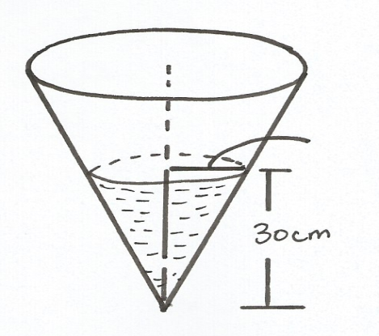
30cm
21cm
Water

- Calculate the volume of water in the vessel. (2mks)

- Metal hemisphere is completely submerged in the water, causing the water level to rise by 6cm. calculate
- The radius of the new water surface. (2mks)

- The volume of the hemisphere. (4mks)

