NAME……………………………………………………….INDEX NO…………………
MATHEATICS
121/2
PAPER 2 TIME 2 ½ Hours
MAU LINK EVALUATION TEST PREMOCK (MALIET 3)
FORM 4 FIRST TERM
MATHEMATICS
PAPER 2
Instruction to candidates
a) Write your name and index number in the spaces provided above
b) The paper consist Two sections;Section I and Section II
c) Answer all questions in Section I and five in Section II
d) Mathematical tables may be used except where stated otherwise
SECTION I
1 | 2 | 3 | 4 | 5 | 6 | 7 | 8 | 9 | 10 | 11 | 12 | 13 | 14 | 15 | 16 | Total
SECTION II
17 | 18 | 19 | 20 | 21 | 22 | 23 | 23 | Total

SECTION I (50MARKS )
ANSWER ALL THE QUESTION FROM THIS SECTION

1.Use logarithim to evaluate (4mks)

2 The diameter and height of a cylinder are stated as 21.7cm and 15.6cm respectively.Find the percentage error in calculating its volume. (3mks)

3.Given that Find the values of a and b (3mrks)

4.Make A the subject of the formula (3mks ).

5 In the figure below ,line AB=4cm,BE=8cm and DE=4cm.Find the value of y (2mrks)

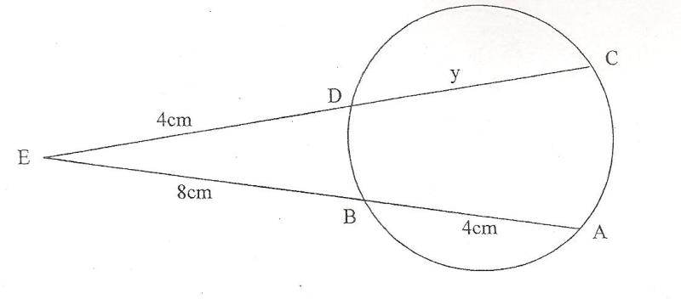

6 Find the integral values of x which satisfy ; 6≤ 2x + 1 and 5x – 29 < -4 (3mrks)

7 A mixture contain two powders Pand Q with masses in the ratio 3:11 .If the mixture costs shs.670per kg and the powder P costs shs 560 per kg,Find the cost of a kg of powder Q (3mks)

8 (a) Expand (1 – 2x) ⁶ in ascending powers of x up to the term in x³. (2 Marks)

(b) Hence evaluate (1.02)⁶ to 4 d.p. (2 mrks)

9 The equation of a circle is given as 3x² + 3y² – 12x + 18y -9 = 0. Find the centre and radius of this circle. (4 mks)

10 . Given that the matrix has no inverse, find x. (2mks)

11.The figure below shows a sector of a circle centre O
A

O 15.75 cm

Determine B
- The radius OA of the circle (1mk)

- The perimeter of the sector (2mks)

12.A car was valued at shs 500,000 in january 2010.Each year its value depreciated at 12% p.a .After how long would the value depreciate to kshs 250,000? (3mks)

13. Find the value of x that satisfies the equation. (3mks)
Log(x + 5) =Log₄ – Log (x – 2)

14.Find the values of ᴓ from 0⁰ to 450⁰ .Give that cosᴓ=0.4695 (3 mks)

15 The area of a triangle is 42 cm².The triangle ABC is transformed using the matrix to obtain the image of triangle ABC whose area is 168cm².Determine the value of x (3mks)

16.Use method of completing squares to find the positive valu of x in the equation (3mks)
3x² - 2x – 5 = 0

SECTION II (50 marks)
Answer only five question from this section
17 A bag contains 5 red, 4 white and 3 blue beads. Two beads are selected at random.
- Draw a tree diagram and list the probability space. (3 Mks)

b) Find the probability that
(i) The last bead selected is red. (2 Mks)

(ii) The beads selected were of the same colour (2 Mks)

(iii) At least one of the selected beads is blue (3 Marks)

18)The table below shows marks obtained by 60 form four students in an English test.
Marks | 40-44 | 45-49 | 50-54 | 55-59 | 60-64 | 65-69 | 70-74
No of students | 5 | 10 | 20 | 15 | 5 | 3 | 2

(a) State the modal class (1mark)

(b) Using an assumed mean of 52,
Calculate:
(i) The actual mean (3marks)

(ii) The standard deviation (3marks)

(c) Estimate the median mark (3marks)

19.A group of investors decided to contribute shs 600,000 equally to buy a 5 acre piece of land.However five members pulled out of the projects and so the remaining members were to contriute an extra shs 6000.
a)Taking x to be the original number of the members in the group,write n expression in x for
i)The amount that each member was to contribute initially (1mk)

ii)The amount that was contributed by each of the remaining members (1mk)

b) Form an equation in x and hence find the number of peple who contribute the money (4mks)

c) Theylater sub-divided the land into small pieces of 0.125 acres and sold each at sh 18000.
i.Find the number of plots they had (1mk)

ii.The percentge profit they made from the sale of the plot (3mks)

20.The table below gives the income tax in a particular year
Monthly tax rate in kshs. | Tax rates in %
Under 9681 | 10%
From 9681 but under 18801 | 15%
From 18801 but under 27921 | 20%
From 27921 but under 37041 | 25%
Excess over 37041 | 30%
In the month of june that year,Monti, Acivil servant earned basic salary of kshs 30000.He also received house allowances worth 20% of the basic pay ,medical allowance,kshs 960 and commuter allowance of kshs 2250.He is entitled to atax relief of ksh.1056
a)Calculate
i)His taxable income for the month of june 2mks

ii)The tax Monti paid in june 4mks

b) In the month of july,he received a 15% increment in the basic salary as a results of a promotion.Calculate the percentage increase in the amount of tax he paid in july correct four significant figures 4mks

21.The first three consecutive numbers in ageometric sequence are 36, 2x and 9
Find
- The possible values of x 3mks

- The possible values of the common ratio 2mks

- The sum of the first four terms if
i)The coomon ratio is positve 2mk)

ii)The common ratio is negative ( 2mks)

d)The absolute difference of the two sums in ( c ) above (1mk)

22 Three quantities P, Q and R are such that P varies directly as Q and inversely as the square root of R.
- Given that P = 2250 when Q = 450 and R = 64. Write down an equation connecting P,Q and R (4 marks)

b)If Q increased by 20% and R decreased by 45%, find the percentage change in P (3 marks)

c)The number of goals G scored in a penalty shoot-out in a soccer competititon is partly constant and depends partly on the skill (S) of a player.Given that G= 8 when S=2 and G= 12 when S=4,find the G when S=6 ( 3mks)

23. A matatu left town K at 7.00am and travelled towards town M at an average speed of 60km/hr. A car left town M at 9.00am and travelled towards K at an average speed of 80km/hr. The distance between the two towns is 324km.Find.
- The time each vehicle arrived at their destination.
(i)Matatu. (2 marks)

(ii) Car. (2 marks)

(b)(i)The distance the matatu covered before the car started to move from town
M to town K. (2mks)

(ii)The time the two vehicles met on the way. (2mks)

(iii) How far from town k did the two vehicles meet? (2mks)

B
24a) Complete the table below for y=x³-3x²-x +2 for -1.5≤ x ≤ 3.5 2mks
X | -1.5 | -1 | -0.5 | 0 | 1.0 | 1.5 | 2.0 | 2.5 | 3.0 | 3.5
Y
b)Hence draw the graph of y=x³-3x²-x +2 on the grid provide below 2mks
c) Use the graph to solve the equation

i) x³ -3x² - x+2=0 2mks
ii) x³ - 3x² - 1.5x +3=0 3mks

