NAME: ………………………………………………………… ADM. No: ……………………..……………
Candidate’s Signature: …………………………………… Date: ……………….……………….…
443/1
AGRICULTURE
PAPER 1
MARCH/APRIL 2017
TIME: 2 HOURS
MALIET JOINT EXAMINATION
Kenya Certificate of Secondary Education
INSTRUCTIONS TO CANDIDATES:
- This paper contains three sections A, B and C
- Answer ALL the questions in section A and B
- Answer any Two questions from section C
- All answers should be written in the spaces provided.
FOR EXAMINERS USE ONLY
SECTION | QUESTIONS | MAX SCORE | CANDIDATES SCORE
A | 1-14 | 30
B | 15-18 | 20
C |  | 20
 |  | 20
TOTAL |  | 90

1. List four climatic factors other than rainfall that influence crop production and distribution. (2mks)
…………………………………………………………………………………………………………………………………………………...
……………………………………………………………………………………………………………………………………………………
……………………………………………………………………………………………………………………………………………………
……………………………………………………………………………………………………………………………………………………
2. Explain the following terms as used in fertilizer Chemistry.
(i) Fertilizer grade. (1mk)
……………………………………………………………………………………………………………………………………………………
……………………………………………………………………………………………………………………………………………………
(ii) Fertilizer ratio. (1mk)
…………………………………………………………………………………………………………………………………………………..
……………………………………………………………………………………………………………………………………………………
3. State four functions of calcium in plant growth. (2mks)
……………………………………………………………………………………………………………………………………………………
……………………………………………………………………………………………………………………………………………………
…………………………………………………………………………………………………………………………………………………….
……………………………………………………………………………………………………………………………………………………
4. State four factors to consider when grading tomatoes for fresh market. (2mks)
……………………………………………………………………………………………………………………………………………………
……………………………………………………………………………………………………………………………………………………
…………………………………………………………………………………………………………………………………………………….
………………………………………………………………………………………………………………………………………………….
……………………………………………………………………………………………………………………………………………………
5. State four factors that contribute to the competitive ability of weeds. (2mks)
……………………………………………………………………………………………………………………………………………………
……………………………………………………………………………………………………………………………………………………
……………………………………………………………………………………………………………………………………………………
…………………………………………………………………………………………………………………………………………………….
6. Define the following terms as used in crop production.
(a) Trellishing (1mk)
……………………………………………………………………………………………………………………………………………………
……………………………………………………………………………………………………………………………………………………
(b) Stooking (1mk)
……………………………………………………………………………………………………………………………………………………
……………………………………………………………………………………………………………………………………………………
7. State four advantages of mixed pasture. (2mks)
…………………………………………………………………………………………………………………………………………………….
……………………………………………………………………………………………………………………………………………………
……………………………………………………………………………………………………………………………………………………
……………………………………………………………………………………………………………………………………………………
8. State five activities that a farmer should carry out on the storage facility before
Storing farm produce. (2 ½ mks)
…………………………………………………………………………………………………………………………………………………….
…………………………………………………………………………………………………………………………………………………….
……………………………………………………………………………………………………………………………………………………
……………………………………………………………………………………………………………………………………………………
……………………………………………………………………………………………………………………………………………………
9. State any four disadvantages of intensive system of farming. (2 mks)
……………………………………………………………………………………………………………………………………………………
…………………………………………………………………………………………………………………………………………………..
…………………………………………………………………………………………………………………………………………………….
…………………………………………………………………………………………………………………………………………………….
10. Define the following terms.
(a) Nitrogen fixation (1 mk)
……………………………………………………………………………………………………………………………………………………
……………………………………………………………………………………………………………………………………………………
(b) Phosphorus fixation (1 mk)
……………………………………………………………………………………………………………………………………………………
………………………………………………………………………………………………………………………………………………….
11. State three effects of HIV/Aids on agriculture production. (1½ mks)
……………………………………………………………………………………………………………………………………………………
……………………………………………………………………………………………………………………………………………………
…………………………………………………………………………………………………………………………………………………
12. (a) What is Land reform. (2 mks)
……………………………………………………………………………………………………………………………………………………
……………………………………………………………………………………………………………………………………………………
…………………………………………………………………………………………………………………………………………………
(b) State any four methods of land reform. (2 mks)
…………………………………………………………………………………………………………………………………………………….
……………………………………………………………………………………………………………………………………………………
…………………………………………………………………………………………………………………………………………………….
…………………………………………………………………………………………………………………………………………………
13. Give four conditions of land which may make it necessary to carry out reclamation
practices. (2 mks)
……………………………………………………………………………………………………………………………………………………
…………………………………………………………………………………………………………………………………………………
……………………………………………………………………………………………………………………………………………………
……………………………………………………………………………………………………………………………………………………
14. State two Mechanical methods of separating soil particles according to size during soil
analysis. (1 mk)
……………………………………………………………………………………………………………………………………………………
…………………………………………………………………………………………………………………………………………………….
15.State four factors that should be considered when classfying crop pests. (2 mks)
……………………………………………………………………………………………………………………………………………………
……………………………………………………………………………………………………………………………………………………
……………………………………………………………………………………………………………………………………………………
……………………………………………………………………………………………………………………………………………………
……………………………………………………………………………………………………………………………………………………

SECTION B (20 MARKS)
Answer all the questions
16. Below is a diagram of nursery for raising cabbage seedlings.
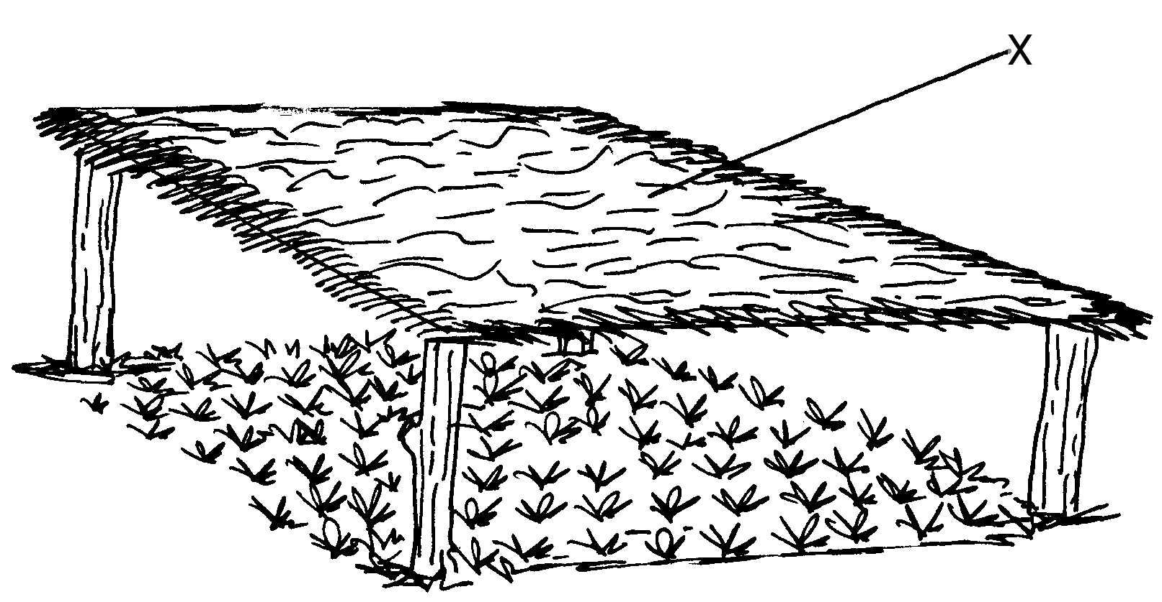
- State four advantages of the part labeled X (4mks)
……………………………………………………………………………………………………………………………………………………
……………………………………………………………………………………………………………………………………………………
……………………………………………………………………………………………………………………………………………………
……………………………………………………………………………………………………………………………………................
- State four management practices that should be carried out on the nursery from the time seedlings emerge to the stage of transplanting. ( 2mks)
……………………………………………………………………………………………………………………………………………………
……………………………………………………………………………………………………………………………………………………
……………………………………………………………………………………………………………………………………………………
……………………………………………………………………………………………………………………………………………………

(iii) At what stage of growth should cabbage seedlings be transplanted. (2mks)
……………………………………………………………………………………………………………………………………………………
……………………………………………………………………………………………………………………………………………………
…………………………………………………………………………………………………………………………………………...........

(iv) How would the damage to the seedlings be minimized when uprooting them during transplanting. (1mk)
……………………………………………………………………………………………………………………………………………………
……………………………………………………………………………………………………………………………………………………

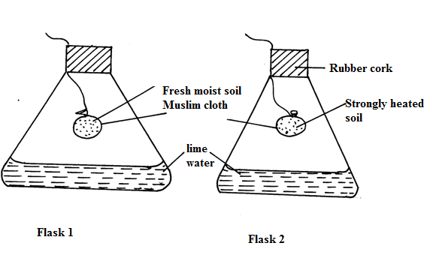
17.The diagrams below shows an experiment carried out by Masiki a form four student.

- What is the aim of the experiment? (1mk)
…………………………………………………………………………………………………………………………………
…………………………………………………………………………………………………………………………………

- What observation did the student make in the two flasks at the end of the experiment (2mks)
…………………………………………………………………………………………………………………………………………
…………………………………………………………………………………………………………………………………………
- Give a reason for the observation made in the flask 1 (1mk)
…………………………………………………………………………………………………………………………………………
…………………………………………………………………………………………………………………………………………
- Why did Masaki heat this garden soil in flask II strongly (1mk)
…………………………………………………………………………………………………………………………………………
…………………………………………………………………………………………………………………………………………
18 .Study the diagrams below and answer questions that follow .
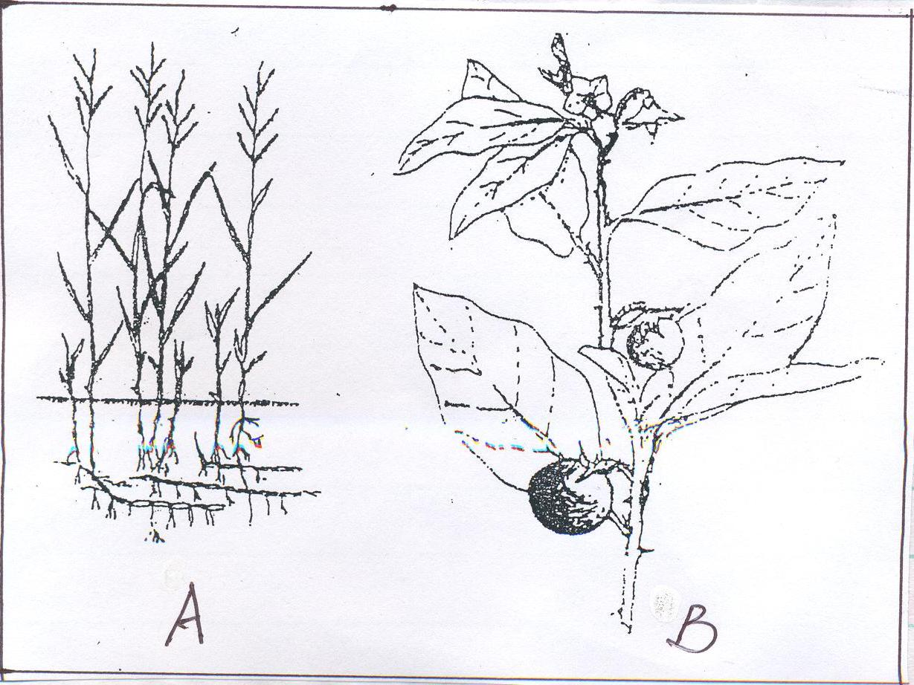
[a]Identify the above weeds . [ 2 marks ]
A………………………………………………………………………………………………………………………………………………….
B ……………………………………………………………………………………………………………………………………………………
[b]State two economic importance of the weed shown in diagram A [2marks]
………………………………………………………………………………………………………………………………………………
……………………………………………………………………………………………………………………………………………………
[c]Why is it difficult to control the weed in diagram A ? [1 mark ]
……………………………………………………………………………………………………………………………………………………
…………………………………………………………………………………………………………………………………………………….
(d) Give one effect of weed B in livestock. (1 mk)
…………………………………………………………………………………………………………………………………………………..

SECTION C ANSWERS ANY TWO QUESTIONS
19. (a) Discuss the importance of irrigation in farming. (12 marks)
(b) Explain the factors that influence the type of irrigation to be used in a farm. (8 marks)
20. (a) Describe ten cultural methods used in controlling crop pests. (10 marks)
- Describe production of paddy rice under the following sub headings:
(i) Land preparation. (3 marks)
(ii) Water control. (3 marks)
(iii) Role of irrigation water. (3 marks)
(iv) Signs of maturity. (1 mark)
21. (a) Describe the procedure of soil sampling using traverse methods. (10 mks)
(b) Explain five reasons for pruning. (10 mks)

……………………………………………………………………………………………………………………………………………………
……………………………………………………………………………………………………………………………………………………
……………………………………………………………………………………………………………………………………………………
……………………………………………………………………………………………………………………………………………………
……………………………………………………………………………………………………………………………………………………
…….………………………………………………………………………………………………………………………………………………
……………………………………………………………………………………………………………………………………………………
……………………………………………………………………………………………………………………………………………………
……………………………………………………………………………………………………………………………………………………
……………………………………………………………………………………………………………………………………………………
………….…………………………………………………………………………………………………………………………………………
……………………………………………………………………………………………………………………………………………………
……………………………………………………………………………………………………………………………………………………
……………………………………………………………………………………………………………………………………………………
……………………………………………………………………………………………………………………………………………………
……………….……………………………………………………………………………………………………………………………………
……………………………………………………………………………………………………………………………………………………
……………………………………………………………………………………………………………………………………………………
……………………………………………………………………………………………………………………………………………………
……………………………………………………………………………………………………………………………………………………
……………………………………………………………………………………………………………………………………………………
……………………………………………………………………………………………………………………………………………………
……………………………………………………………………………………………………………………………………………………

