NAME _______________________________INDEX NO________________

SCHOOL_______________________________ DATE__________SIGN_____

312/2
GEOGRAPHY
FORM FOUR
TERM I 2017

MAU LINK JOINT EVALUATION EXAM 2017
Kenya Certificate of Secondary Education (K.C.S.E)
312/2
GEOGRAPHY
Paper II
2017
2 ³/₄ Hours

INSTRUCTIONS TO CANDIDATES

- This paper consists of TWO Sections A and B.
- Answer all questions in section A.
- Answer 6 and any other TWO questions from section B.
- All questions must be written in the answer sheets provided
- This paper consists of 4 printed pages.
- Candidates should check the question papers to ensure that all pages are printed as indicated and no questions are missing.

SECTION A: Answer ALL questions from this section (25 marks)

1. a) Give 3 social factors that influence agriculture (3mks)
b) Name two provinces in Canada where wheat is grown in large scale (2mks)

2. a) Define forest (2mks)
b) Give 3 softwood species in Kenya (3mks)

3. a) Apart from water pollution, name three other types of pollution (3mks)
b) Give two effects of water pollution (2mks)

4. a) Differentiate between inland and marine fishing (2mks)
b i) What is demersal fishing? (1mk)
ii) Give two methods commonly used in catching demersal fish (2mks)

5. a) What is the difference between statistics and data (2mks)
b) Name three methods of recording statistical data (3mks)

SECTION B
Answer question 6 and any other two questions
6. The table below shows the sale of some major crops to marketing board in ‘000’ of tonnes in Kenya between 1999 and 2000.

CROP | 1999 | 2000
Wheat | 53 | 132
Tea | 248 | 294
Coffee | 64 | 55

- Draw proportional circles to represent data above. (10mks)
- Explain three advantages of using the above technique in data representation.(6mks)
- State three problems facing coffee farmers in Kenya (3mks)
- Explain three ways in which coffee contributes to the economy of Brazil (6mks)

7. a) Differentiate fishing and fisheries (2mks)
b) Explain three human factors which have favoured large scale fishing in the North East Atlantic fishing ground (6mks)
c) Describe long-lining as a method of commercial fishing (4mks)
d i) Differentiate marine fisheries from fresh water fisheries (2mks)
ii) Explain four problems facing marine fishing in East Africa (8mks)
e) Give three reasons why the Kenya Government is keen on promoting the conservation of fish as a resource (3mks)

8. Study the photograph below and answer question

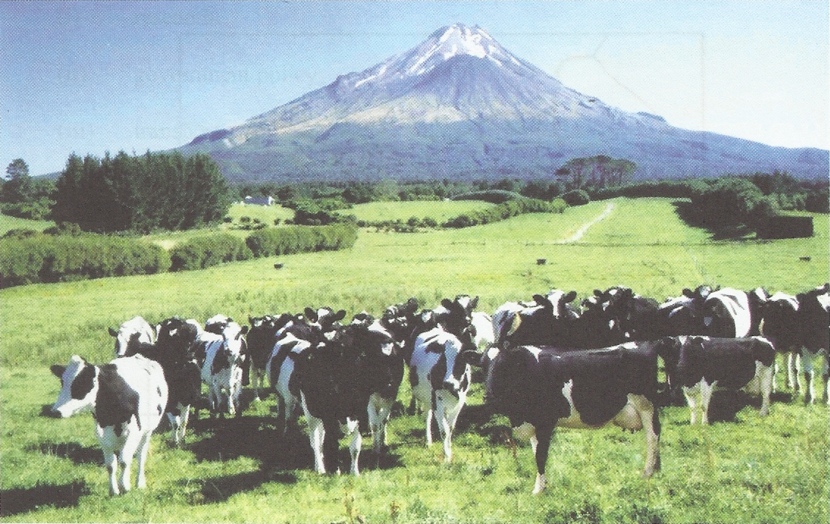
Source: Internet

a) i) Identify the type of photograph shown above. (1 mark)

ii) Draw a rectangle measuring 15 cm by 10 cm to represent the area covered by the
photograph. (1 mark)

iii) On the rectangle, sketch and label four main features shown on the photograph.
(4 marks)

iv) Using evidence from the photograph, identify two indicators which show that
the area receives high rainfall. (2 marks)

b) i) Name three exotic types of dairy cattle reared in Kenya.
(3 marks)

ii) Explain three human factors that favor dairy farming in the Kenya Highlands.
(6 marks)

c) Explain four ways in which dairy farming in Kenya is different from dairy farming in Denmark. (8 marks)

9. a i) Define the term Land Reclamation (2mks)
ii) State four benefits of delta plan projects (4mks)

b i) Apart from irrigation name three other ways land can be reclaimed (3mks)
ii) State four advantages of irrigation over natural water suppliers (4mks)

c i) State two methods of reclaiming land in Kenya (2mks)
ii) Give three benefits of land reclamation in Netherlands (3mks)

d i) Give three methods used in control of tsetse fly in Kenya (3mks)
ii) State four problems faced in the control of tsetse fly in Kenya (4mks)

10. a) Differentiate forestry and afforestation (4mks)

b i) Give three softwood trees which grow in the forest reserves of Canada (3mks)
ii) State four characteristics of planted forests in Kenya (4mks)

c) Compare forestry in Kenya and Canada under the following sub-topics
- Growth (2mks)
- Harvesting (2mks)
- Marketing (2mks)
d) State four measures taken by the Kenyan Government to conserve forest (4mks)

- The Students of Mau secondary school are planning to carry out a field study on forestry in the Mau forest in Bomet County.
i) State two objectives for their study (2mks)
ii) Formulate two hypothesis for their study (2mks)

