**NAME……………..………………………………………… INDEX NO……...........………………………………………………….**

**SCHOOL…………………………………… CANDIDATE’S SIGNATURE…………………………..…DATE………..…………**

**231/1**

**BIOLOGY**

**PAPER 1**

**(THEORY)**

**APRIL 2017**

**TIME: 2 HOURS**

**MALIET EVALUATION TEST-2017**

***Kenya Certificate of Secondary Education***

**BIOLOGY**

**PAPER 1**

**INSTRUCTIONS TO CANDIDATES:**

1. Write your **Name**, **Index Number** and **School** in the spaces provided above.

2. **Sign** and write the **date** of examination in the spaces provided above.

3. Answer **all** the questions in the spaces provided.

4. Answers must be written in the spaces provided in the question paper.

5. Additional pages must not be inserted.

6. Check the question paper to ascertain that all the pages are printed and that no

questions are missing.

**FOR EXAMINER’S USE ONLY:**

|  |  |  |
| --- | --- | --- |
| **Question** | **Maximum**  **Score** | **Candidate’s**  **Score** |
| **1 - 25** | **80** |  |

1. State **two** ways in which the xylem vessels are adapted to their function. (2mks)

………………………………………………………………………………………………………………………………………………………………………………………………………………………………………………………………………………………………………….

1. State **three** reasons why classification is important. (3mks)

………………………………………………………………………………………………………………………………………………………………………………………………………………………………………………………………………………………………………………………………………………………………………………………………………………………………………………………………

1. a) State **two** functions of golgi apparatus. (2mks)

………………………………………………………………………………………………………………………………………………………………………………………………………………………………………………………………………………………………………….

b) A student observed a row of 16 epidermic cells in a microscopic field that was 8mm in diameter. Calculate the average length of each cell in micrometers. (1mk)

1. a) Differentiate between **essential** and **non-essential** amino acids. (2mks)

………………………………………………………………………………………………………………………………………………………………………………………………………………………………………………………………………………………………………….

b) Name **two** constituents of food that are absorbed without digestion. (2mks)

………………………………………………………………………………………………………………………………………………………………………………………………………………………………………………………………………………………………………….

1. The diagram below illustrates the behaviour of red blood cells when placed in two different solutions X and Y.



i) Name the process represented by letter A and B. (2 marks)

..............................................................................................................................................

ii) Identify the type of solution that would prevent processes A and B from taking place when the cells are placed in it. (1 mark)

.....................................................................................................................................................

iii) Draw a diagram to illustrate how a plant cell would appear if placed in solution Y.

(2 marks)

1. a) Distinguish between respiratory quotient and oxygen debt. (1mark)

……………………………………………………………………………………………………………………………………

b) Name the site where anaerobic respiration occur in a cell. (1 mark)

………………………………………………………………………………………………………………………………………….

c) The following equation represents a certain biological process in living organism.

a) i) Calculate the respiratory quotient (1 mark)

  .............................................................................................................................................

ii) Identify the type of food substrate broken down. (1 mark)

..............................................................................................................................................

1. Name the hormones responsible for regulation of glucose level in the blood.(2 marks)

………………………………………………………………………………………………………………………………………………………………………………………………………………………………………………………………………………………………………….

1. a) Name **two** products of light stage during photosynthesis. (2marks)

..............................................................................................................................................

..............................................................................................................................................

*Energy*

*O*

*H*

*CO*

*O*

*O*

*H*

*C*





→



2

2

2

6

98

51

98

102

145

2

*Energy*

*O*

*H*

*CO*

*O*

*O*

*H*

*C*





→



2

2

2

6

98

51

98

102

145

2

b) State **three** differences between light stage and dark stage of photosynthesis. (3marks)

………………………………………………………………………………………………………………………………………………………………………………………………………………………………………………………………………………………………………………………………………………………………………………………………………………………………………………………………………………………………………………………………………………………………………………………………………………………………………………………………………………………………………………………………………………………………………………………………………………………………………………………….....

1. state the function of the following apparatus:
2. Bait trap (1 mark)

……………………………………………………………………………………………………………………………..

1. Pooter (1 mark)

…………………………………………………………………………………………………………………………….

1. The table below show two mammalian hormones. For each hormone state the site of production and its function in the body. (2marks)

|  |  |  |
| --- | --- | --- |
| Hormone | Site of production | Function |
| Oestrogen |  |  |
| Aldosterone |  |  |

1. a) Define the term natural selection. (1mark)

……………………………………………………………………………………………………………………………………………………………………………………………………………………………………………………………………………………

b) Why are some viruses able to resist the effect of antiretroviral drugs. (2marks)

……………………………………………………………………………………………………………………………………………………………………………………………………………………………………………………………………………………

1. The process below represents the build-up of a disaccharide in living cells.

i) Give the name of process represented by letter Y. (1 mark)

.....................................................................................................................................................

ii) Name the bond marked X. (1 mark)

.....................................................................................................................................................

1. a) What is meant by
2. Autecology (1 mark)

…………………………………………………………………………………………………………………………………………

1. Synecology (1 mark)

………………………………………………………………………………………………………………………………………

b) To estimate the population size of fish in a certain pond, traps were laid at random and 600 fish were caught marked and released back into the pond. 3 days later traps were laid and 240 fish were caught out of which 80 of them had a mark. Calculate population size of the fish in the pond. (3marks)

1. a**)**State **two** advantages of breathing through the nose rather than the mouth.(2 marks)

............................................................................................................................................................................................................................................................................................

b) Define tidal volume (1 mark)

 ............................................................................................................................................

1. a) Differentiate between hypogeal and epigeal germination. (2 marks)

…………………………………………………………………………………………………………………………………………………………………………………………………………………………………………………………………………………...

b) State **one** cause of dormancy in seeds. (1 mark)

…………………………………………………………………………………………………………………………………………

1. State **two** ways in which white blood cells carry out their functions. (2 marks)

………………………………………………………………………………………………………………………………………………………………………………………………………………………………………………………………………………………………………………………………………………………………………………………………………………………………

1. Study the following diagram showing longitudinal section of a kidney.

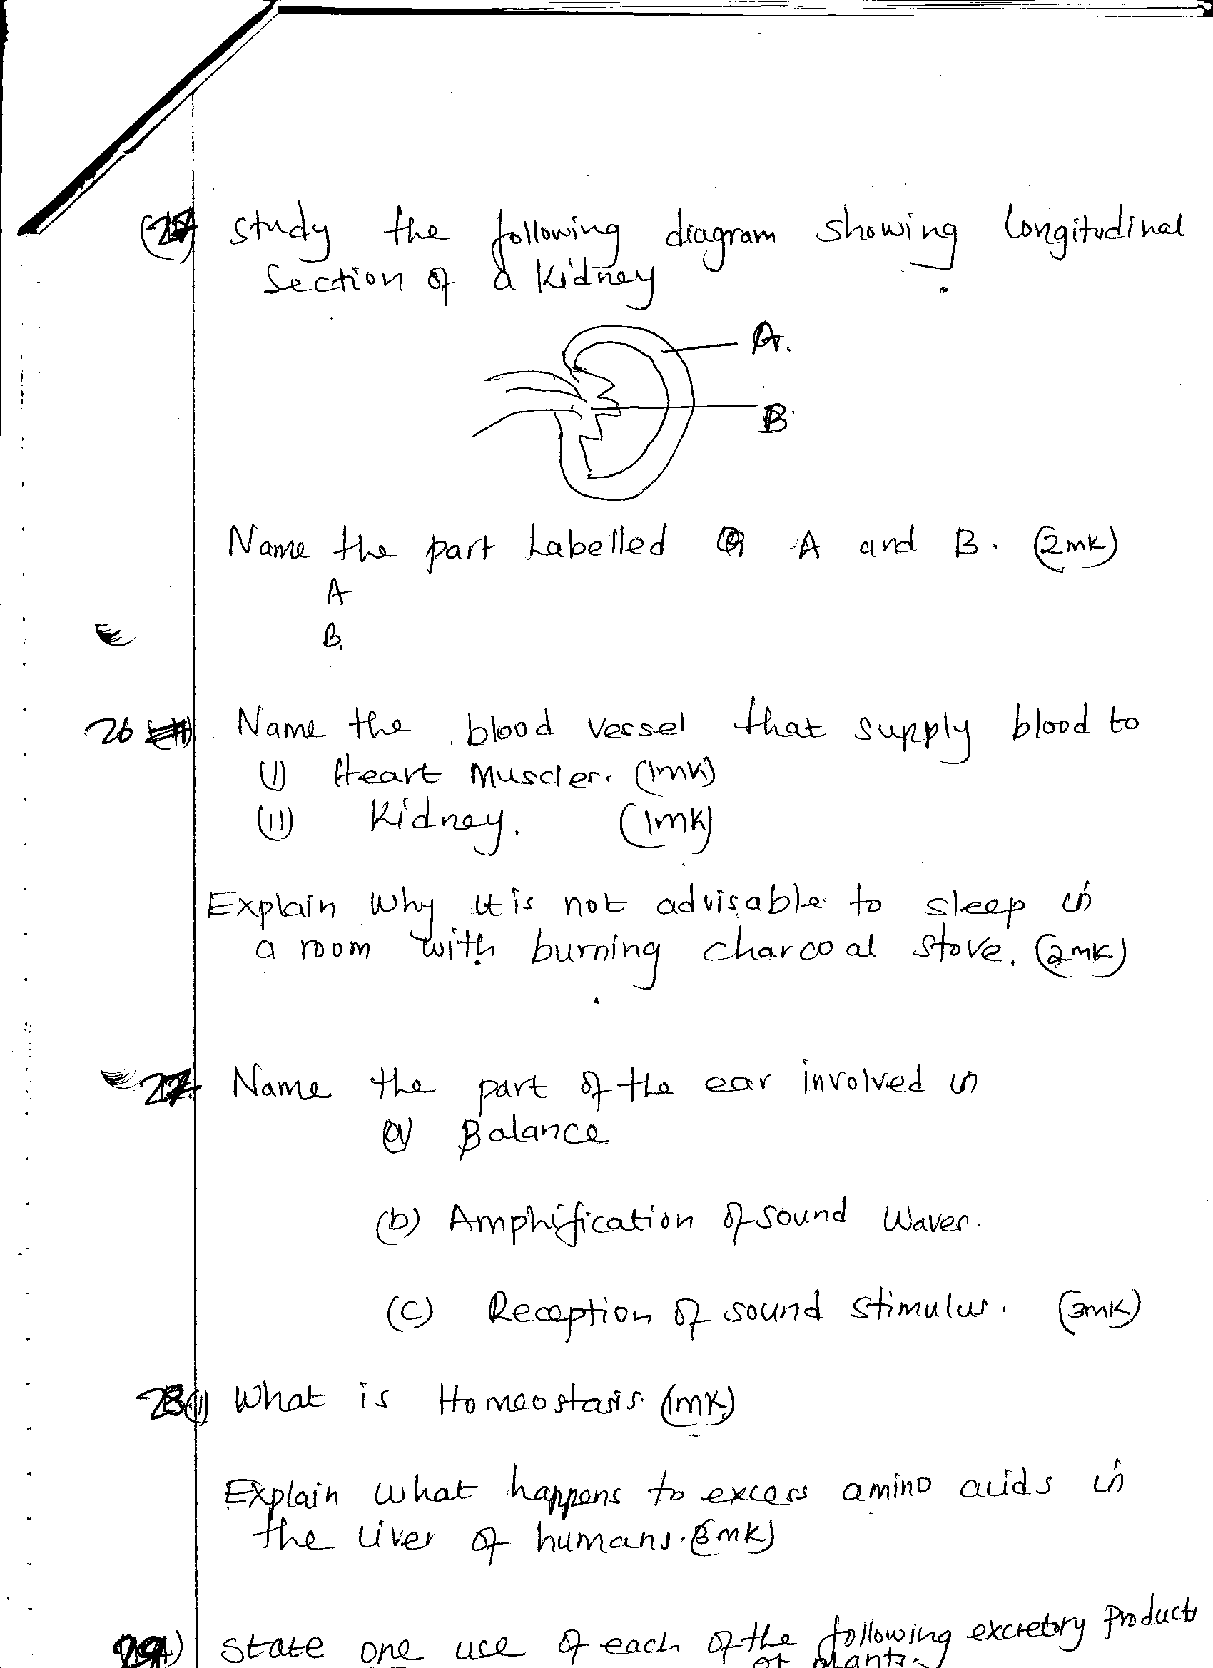

Name the parts labeled A and B. 2mks

A:______________________________________________________

B:______________________________________________________

1. Name the blood vessel that supplies blood to:
2. Heart muscles. (1mk)

………………………………………………………………………………………

1. Kidney (1mk)

………………………………………………………………………………………

1. a) Explain why plants do not require specialized excretory organs. (4mks)

……………………………………………………………………………………………………………………………………………………………………………………………………………………………………………………………………………………………………………………………………………………………………………………………………………………………………………………………………………………………

b)State **one** use of each of the following excretory products of plants.

1. Tannin (1mk)

……………………………………………………………………………………..

1. Latex (1mk)

……………………………………………………………………………………..

1. The diagram below represents a transverse section of a lower leaf epidermis.

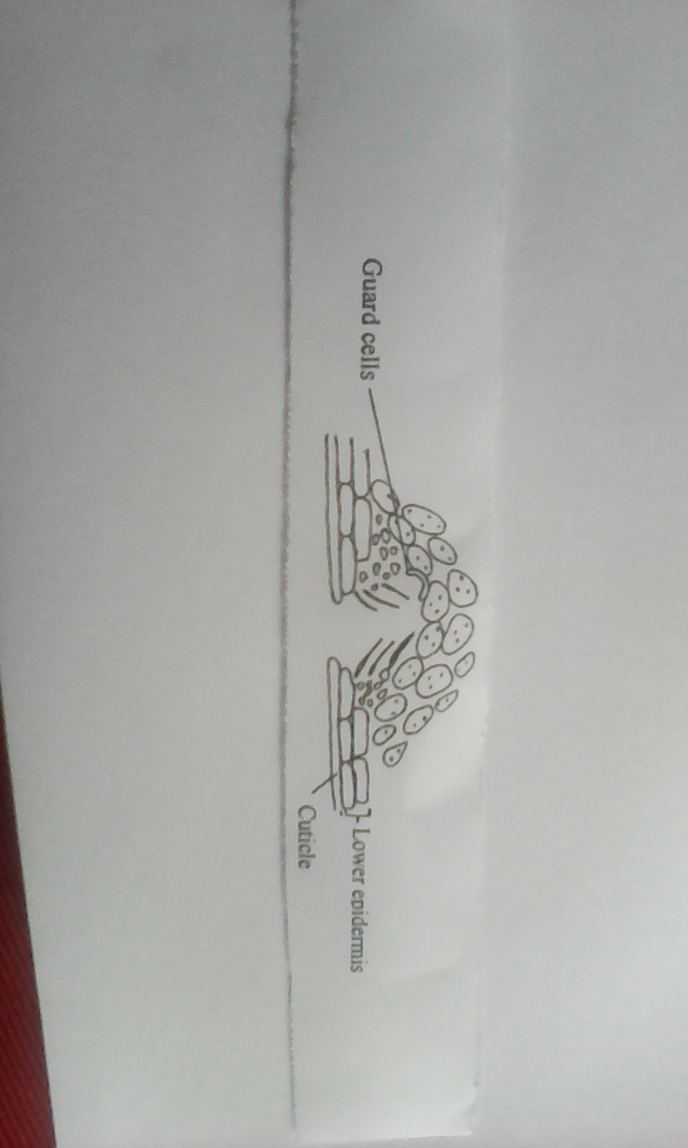

1. Suggest the habitat of the plant from which the leaf section was made. (1mk)

…………………………………………………………………………………………..

1. Give a reason for your answer. (1mk)

……………………………………………………………………………………………………………………………………………………………………………………

1. Explain any **two** observable features that adapt the plant to the habitat named in (a) above. (2mks)

………………………………………………………………………………………………………………………………………………………………………………………………………………………………………………………………………………

1. a) Pure lines of black and white mice were crossed. All the F 1 generation were grey. Explain the absence of white and black mice in the F 1 generation. (1mk)

………………………………………………………………………………………………………………………………………………………………………………………………

b) Define multiples alleles. (2mks)

………………………………………………………………………………………………………………………………………………………………………………………………………………………………………………………………………………………………

1. a) What is the role of diastema in herbivores? (1mk)

………………………………………………………………………………………………

b) Name the **two** types of periodontal diseases. (2mks)

………………………………………………………………………………………………………………………………………………………………………………………………

c) What is the significance of emulsification? (1mk)

………………………………………………………………………………………………………………………………………………………………………………………………

1. The diagram below illustrate part of a nephron from a mammalian kidney.



1. Name the fluid found in the part labeled Q. (1mk)

…………………………………………………………………………………………………………………………………

1. Identify the process responsible for the formation of the fluid named in (a) above. (1mk)

…………………………………………………………………………………………………………………………………………………………………………………………………………………………………………………………………….

1. Which **two** hormones exert their effect in the nephron? (2mks)

……………………………………………………………………………………………………………………………………………………………………………………………………………………………………………………………………

1. A flower was found to have the following characteristics:

* Inconspicuous petals
* Long feathery stigma
* Small, light pollen grains

1. What is the likely agent of pollination of the flower? (1mk)

…………………………………………………………………………………………………………………………………..

1. What is the significance of the long feathery stigma in the flower? (1mk)

…………………………………………………………………………………………………………………………………………………………………………………………………………………………………………………………………….

1. State **three** differences between members of division Byrophyta and Pteridophyta. (3mks)

………………………………………………………………………………………………………………………………………………………………………………………………………………………………………………………………………………………………………………………………………………………………………………………………………………………………

END.