SECTION A (40 Marks)

- a) Define the term mutation. (1 mark)
............................................................................................................................................................................................................................................................................................................................................
b) State two human disorders resulting from gene mutation. (2 marks)

............................................................................................................................................................................................................................................................................................................................................
c) The diagram below represents a nucleotide

U A G U U A A G
Name the nucleic acid shown above. (1 mark)

......................................................................................................................................................................
d) Colour blindness is a sex linked trait caused by a recessive gene on the X chromosome. Using the symbol X^{N} to represent the gene for normal colour vision and X^{n} to represent the gene for colour blindness, work out the phenotype of the children born to a normal man and a carrier woman. (4 marks)

- The experiment below was set up to investigate a certain physiological process. The glucose solution was first boiled then cooled. The set was left for 24 hours.

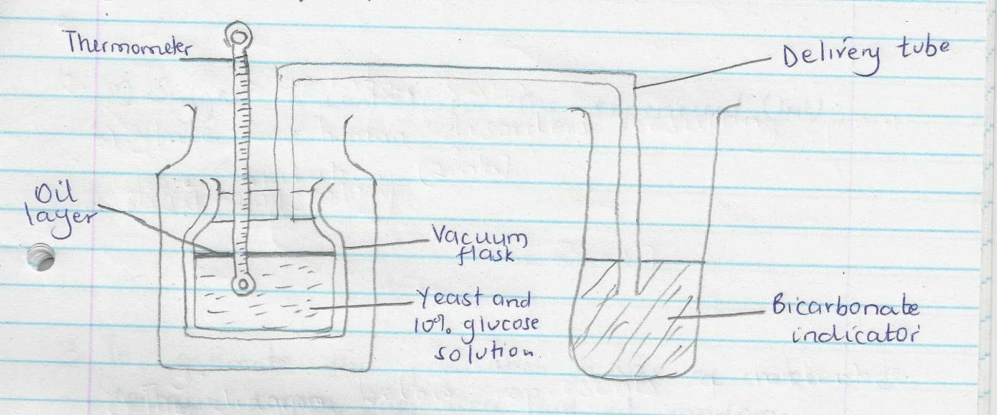
- Suggest two aims of experiment. (2 marks)
............................................................................................................................................................................................................................................................................................................................................
......................................................................................................................................................(b) (i) State the expected observations after 24 hours. (2 marks)
............................................................................................................................................................................................................................................................................................................................................
......................................................................................................................................................................
(ii) Explain your observations in a(i) above. (2 marks)
............................................................................................................................................................................................................................................................................................................................................
......................................................................................................................................................................
(iii) Why was glucose solution boiled then cooled? (1 mark)

............................................................................................................................................................................................................................................................................................................................................
(iv) Suggest a control for the experiment. (1 mark)

............................................................................................................................................................................................................................................................................................................................................
- To estimate the population in size of crabs in a certain lagoon, traps were laid at random. 400 crabs were caught, marked and released back into the lagoon. Four days later, traps were laid again and 374 crabs were caught. Out of the 374 crabs, 80 were found to be marked.

  - Calculate the population size of the crabs in the lagoon. (3 marks)
b. State two assumptions that were made during the observation. (2 marks)
......................................................................................................................................................................
............................................................................................................................................................................................................................................................................................................................................
C What is the name given to this method of estimating the population size? (1 mark)
............................................................................................................................................................................................................................................................................................................................................
D Below is an example of a food chain.

Napier grass Mouse Snake Hawk
Identify the tropic level occupied by

- Napier grass (1 mark)
............................................................................................................................................................................................................................................................................................................................................
- Hawk (1 mark)
............................................................................................................................................................................................................................................................................................................................................
- a) Birds have beaks which are structurally modified to different modes of feeding.

    - What is the name given to such structures in evolution? (1 mark)
............................................................................................................................................................................................................................................................................................................................................
    - What is the name given to the evolution of beaks of birds? (1 mark)
............................................................................................................................................................................................................................................................................................................................................
  - (i) What is meant by “vestigial structures”?(1 mark)
............................................................................................................................................................................................................................................................................................................................................
- Name two vestigial structures present in man. (1 mark)
............................................................................................................................................................................................................................................................................................................................................
  - Bacteria tend to develop resistance to antibiotics after they have been subjected to them for a long period of time. Explain. (2 marks)
............................................................................................................................................................................................................................................................................................................................................
......................................................................................................................................................................
  - Explain continental drift as an evidence of evolution. (2 marks)
............................................................................................................................................................................................................................................................................................................................................
......................................................................................................................................................................

- a) Name the type of circulatory system found in the members of the class insecta. (1 mark)
............................................................................................................................................................................................................................................................................................................................................
b) Name the blood vessels that transport blood from:

    - Small intestines to the liver. (1 mark)
............................................................................................................................................................................................................................................................................................................................................
    - Lungs to the heart. (1 mark)
............................................................................................................................................................................................................................................................................................................................................
  - The diagram below shows gaseous exchange in tissues

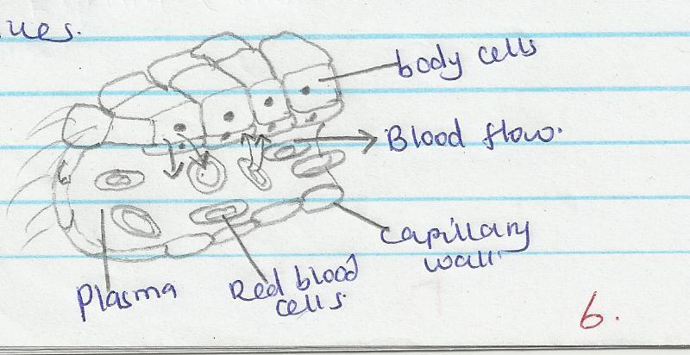

    - Name the gas that diffuses

      - to the body cells (1 mark)
............................................................................................................................................................................................................................................................................................................................................
      - from the body cells (1 mark)
............................................................................................................................................................................................................................................................................................................................................
    - Which compound dissociates to release the gas named in (i) I above (1 mark)
............................................................................................................................................................................................................................................................................................................................................
    - What is tissue fluid (2 marks)
............................................................................................................................................................................................................................................................................................................................................

SECTION B (40 Marks)
Answer question 6 (Compulsory) and either question 7 or 8 in the spaces provided.

- The cells of Tradescantia plant were found to have an average diameter of 2.5ΏM. The cells were placed in varying concentrations of sugar solution. The diameter of the cells in each solution was determined and results obtained were as shown below.

Percentage of sugar concentration | Diameter of cell (MM)
1 | 5.0
5 | 4.0
10 | 3.0
15 | 2.0
20 | 1.5
25 | 1.0

- Draw a graph of diameter of cells against percentage of sugar concentration on the graph provided. (6 marks)

- From the graph determine the concentration of the cell sap. (1 mark)

- Give an explanation for the average diameter of cells placed in 2.5% sugar solution. (4 marks)

- Describe the difference in appearance between cytoplasm before and after cells being placed in 25% sugar solution. (2 marks)

- Account for the appearance of red blood cells when viewed under light microscope
after they were placed in 25% sugar solution and left for 10 minutes. (3 marks)

- State the importance of the process under investigation to the plants. (4 marks)

- Describe the process of fertilization in a flowering plant. (20 marks)
- Describe the structure and functions of the various parts of the human ear. (20 marks)
............................................................................................................................................................................................................................................................................................................................................
............................................................................................................................................................................................................................................................................................................................................
............................................................................................................................................................................................................................................................................................................................................
............................................................................................................................................................................................................................................................................................................................................
............................................................................................................................................................................................................................................................................................................................................
............................................................................................................................................................................................................................................................................................................................................
............................................................................................................................................................................................................................................................................................................................................
............................................................................................................................................................................................................................................................................................................................................
............................................................................................................................................................................................................................................................................................................................................
............................................................................................................................................................................................................................................................................................................................................
............................................................................................................................................................................................................................................................................................................................................
............................................................................................................................................................................................................................................................................................................................................
............................................................................................................................................................................................................................................................................................................................................
............................................................................................................................................................................................................................................................................................................................................
............................................................................................................................................................................................................................................................................................................................................
............................................................................................................................................................................................................................................................................................................................................
............................................................................................................................................................................................................................................................................................................................................
............................................................................................................................................................................................................................................................................................................................................
............................................................................................................................................................................................................................................................................................................................................
............................................................................................................................................................................................................................................................................................................................................
............................................................................................................................................................................................................................................................................................................................................
............................................................................................................................................................................................................................................................................................................................................

