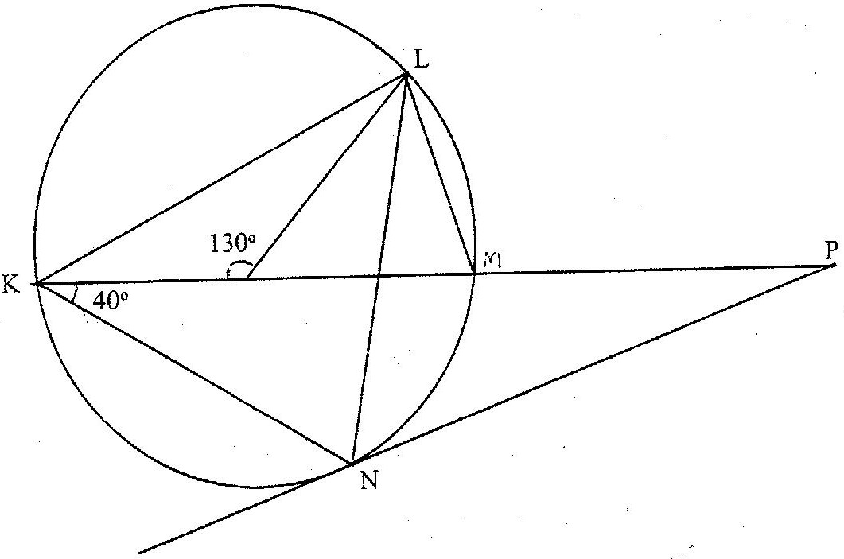
NAME……………………………………….. INDEX NO……………………….
SCHOOL………………………………. SIGN……………………………...
DATE………………………………
MATHEMATICS MALIET 2
FORM THREE
JULY/AUGUST – 2016
TIME: 2 ½ HOURS

MAU LINK EVALUATION TEST (MALIET 2)
Kenya Certificate of Secondary Education (K. C.S.E.)

INSTRUCTIONS TO CANDIDATES
1. Write your name and index number in the spaces provided
2. Answer all questions in section I and any five questions in Section II
3. All markings and answers must be clearly written in the spaces below
4. Marks may be awarded for correct working even if the answer is wrong.
5. Non programmable silent electronics and KNEC Mathematical tables may be use, except where otherwise.

FOR EXAMINERS USE ONLY

SECTION I
Question | 1 | 2 | 3 | 4 | 5 | 6 | 7 | 8 | 9 | 10 | 11 | 12 | 13 | 14 | 15 | TOTAL
Marks

SECTION II
QUESTION | 16 | 17 | 18 | 19 | 20 | 21 | 22 | 23 | TOTAL
MARKS

GRAND

This paper consists of 15 printed pages.
Candidates should check the question paper to ascertain that all pages are printed as indicated and that no questions are missing.

SECTION I:50 MARKS

1. Work out the following, giving the answer as a mixed number in its simplest form.
²/₅ ÷ ½ of ⁴/₉ – 1¹/₁₀
¹_{/8} -^{1/}₆ x ³/₈ (3mks)

2.The length and width of a rectangle measured to the nearest millimeter are 7.5mm and 5.2mm respectively.Find to four significant figures, the percentage error in the area of the rectangle. (3 mks)

3.Simplify 4 - 3
√5 + √2 √5 - √2 (3mks)

4. Make h the subject of the formula (3mks)
q = 1+rh
l-ht

5. Line AB given below is one side of triangle ABC. Using a ruler and a pair of compasses only;
(i) Complete the triangle ABC such that BC=5cm and ∠ABC=45⁰ (2mks)

A
B

(ii) On the same diagram construct a circle touching sides AC,BA produced and BC produced. (3mks)

6. The length of a rectangle is (3x + 1) cm, its width is 3 cm shorter than its length. Given that the area of the rectangle is 28cm², find its length. (3mks)

7. A straight line passes through points A(-3,8) and B(3, -4).Find the equation of the straight line through(3,4) and parallel to AB. Give the answer in the form y = mx +c, m and c are constants. (3mks)

8. A Kenyan bank buys and sells foreign currencies as shown below
Buying (Kshs) Selling(Kshs)
1 Hong Kong dollar 9.74 9.77
1 South African rand 12.03 12.11

A tourists arrived in Kenya with 105 000 Hong Kong dollars and changed the whole amount to Kenyan shillings. While in Kenya, she pent Kshs 403 897 and changed the balance to South African rand before leaving for South Africa. Calculate the amount, in South African rand that she received. (4mks)

9. The equation of line L₁ is 2y-5x-8=0 and line L₂ passes through the points (-5, 0) and (5,-4). Without drawing the lines L₁ and L₂ show that the two lines are perpendicular to each other. (3mks)

10. Use tables of reciprocals only to work out
3 + 13 (3mks)
0.6735 0.156

11. Evaluate without using mathematical tables, the expression (3mks)
2 log₁₀ 5 – ½ log₁₀ 16 + 2 log₁₀ 40

12. Given that sin (90 – x)⁰ = 0.8, where x is an acute angle, find without using
mathematical tables the value of tan x⁰. (3mks)

13. The volumes of two similar solid cylinders are 4752 cm³ and 1408 cm³. If the area of the curved surface of the smaller cylinder is 352 cm², find the area of the curved surface of the larger cylinder. (4mks)

14. Solve the equations
x + y = 17
xy - 5x = 32 (4 mks)

15. The sum of the interior angles of two regular polygons of sides n and n+2 are in the ratio 3:4.Calculate the sum of the interior angles of the polygon with n sides.
(3mks)

SECTION II (50 marks)
Answer any five questions in this section in the spaces provided.
16. A solid consists of a cone and a hemisphere. The common diameter of the cone and the hemisphere is 12 cm and the slanting height of the cone is 10 cm. (π=3.142)
(a) Calculate correct to two decimal places:

- the surface area of the solid; (3mks)
(ii) the volume of the solid. (4 mks)
(b) If the density of the material used to make the solid is 1.3 g/cm³, calculate its mass in kilograms.
(3 marks)

17. The table below shows monthly income tax rates for the year 2003.

Monthly taxable income in Ksh. | Tax rates(Percentage)
1 - 9860  9681 - 18800  18801 - 27920  27921 - 37040  37041 and above | 10%  15%  20%  25%  30%

In the year 2003.Odhiambo’s monthly earnings were as follows:-
Basic salary Ksh 20600
House allowance ksh 12000
Medical allowance Ksh 2880
Transport allowance Ksh 340.
Odhiambo was entitled to a monthly tax relief of Ksh 1056.
a)Calculate:
i) His monthly taxable income (2mks)

ii) The monthly tax paid by Odhiambo. (6mks)

b) Apart from income tax,he also contributes monthly NHIF ksh.1600 and WCPS ksh.1000. Calculate his net monthly pay. (2mks)

18. (a) Find the inverse of the matrix A= 9 8 ( 2 marks) 7 6

- In a certain week a businessman bought 36 bicycles and 32 radios for total of Kshs 227 280. In the following week, he bought 28 bicycles and 24 radios for a total of Kshs 174 960
Using matrix method, find the price of each bicycle and each radio that he bought ( 4 marks)

- In the third week, the price of each bicycle was reduced by 10% while the price of each radio was raised by 10%. The businessman bought as many bicycles and as many radios as he had bought in the first two weeks.
Find by matrix method, the total cost of the bicycles and radios that the businessman bought in the third week. ( 4 marks)

19. A group of people planned to contribute equally towards a water project which needed Ksh 200 000 to complete, However, 40 members of the group without from the project.
As a result, each of the remaining members were to contribute Ksh 2500.
a) Find the original number of members in the group. (5mks)

b) Forty five percent of the value of the project was funded by Constituency Development Fund (CDF). Calculate the amount of contribution that would be made by each of the remaining members of the group. (3mks)

c) Member’s contributions were in terms of labour provided and money contributed. If the ratio of the value of labour to the money contributed was 6:19; calculate the total amount of money contributed by the members. (2mks)

20. In the figure below, K M and N are points on the circumference of a circle centre O. The points K, O, M and P are on a straight line.
PN is a tangent to the circle at N.Angle KOL = 130⁰ and angle MKN = 40⁰

Find the values of the following angles, stating the reasons in each case:
a) <MLN (2mks)

b) <OLN (2mks)

c) < LNP (2mks)

d) <MPN (2mks)

e) <LMN (2mks)
21. The diagram below represents a rectangular swimming pool 25m long and 10m wide. The sides of the pool are vertical.
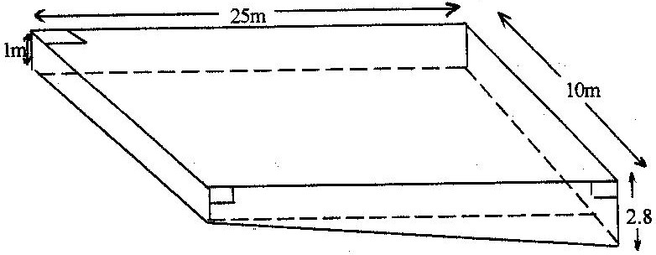

The floor of the pool slants uniformly such that the depth at the shallow end is 1m at the deep end is 2.8 m.
- Calculate the volume of water required to completely fill the pool. (4mks)

- Water is allowed into the empty pool at a constant rate through an inlet pipe. It takes 9 hours for the water to just cover the entire floor of the pool.

Calculate:
- The volume of the water that just covers the floor of the pool ( 3mks)

- The time needed to completely fill the remaining part of the pool ( 3 marks)

22. In a triangle ABC, BC =8 cm, AC= 12 cm and angle ABC = 120°.
(a) Calculate the length of AB, correct to one decimal place. (4 marks)
(b) If BC is the base of the triangle, calculate, correct to one decimal place:

(i) the perpendicular height of the triangle; (2mks)

(ii) the area of the triangle; (2mks)

iii) the size of angle ACB. (2 marks)

23.i)Fill the table, below of the function 4 (2mks)

X | -8 | -7 | -6 | -5 | -4 | -3 | -2 | -1 | 0 | 1 | 2 | 3 | 4
Y | 76 |  |  |  |  | -9 |  |  |  | -5 |  |  | 40
ii)Using the table draw the graph of the function Use the scale of 1cm to 1 unit for x – axis and 1cm for 10units for y-axis. (3mks)

(b) Using the graph drawn above to solve the following equations.
(i) (2mks)

(ii) (3mks)

