NAME:………………………………………………………………Adm No………………

CLASS:………… Date…………………..
Candidate’s Signature………
Form Three MALIET 2 Physics.
August 2016.

MALIET JOINT EXAMINATION
2016
Kenya Certificate Of Secondary Education
Physics Theory Paper.
Time: 2 hours

INSTRUCTIONS TO CANDIDATES

- Write your name, admission number and class in the spaces provided above.
- Sign and write the date of examination in the spaces provided above.
- This paper consists of TWO sections: A and B.
- Answer ALL the questions in sections A and B in the spaces provided.
- ALL working MUST be clearly shown.
- Non-programmable silent electronic calculators and KNEC mathematical tables may be used.
- Candidates should check the question paper to ascertain that all the pages are printed as indicated and that no questions are missing.
For Examiner’s Use Only
Section | Question | Maximum Score | Candidate’s Score
A | 1 – 12 | 25
B | 13 | 10
 | 14 | 9
 | 15 | 10
 | 16 | 8
 | 17 | 9
 | 18 | 9
 | Total Score | 80

SECTION A: (25MARKS)
Answer all questions in this section.

1. Ten glass marbles, each of mass 6.0 g, were gently lowered into a 100cm³ measuring cylinder containing water to the level marked A. The water level rose to the level marked B as shown in Fig. 1 below
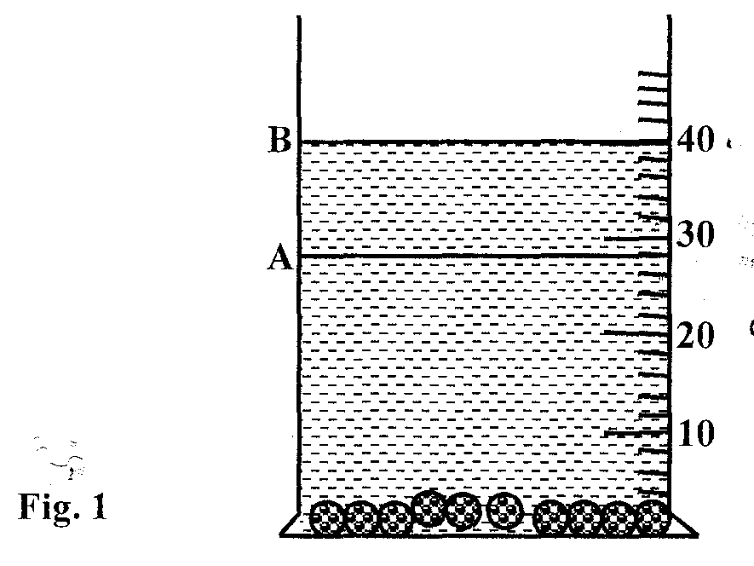
Determine the density of the glass. (3mks)
…………………………………………………………………………………………………………………………………………………….
…………………………………………………………………………………………………………………………………………………….
……………………………………………………………………………………………………………………………………………………
2. A bag of sugar is found to have the same weight on planet earth as an identical bag of dry sawdust on planet Jupiter. Explain why the masses of the two bags must be different. (2mks)
……………………………………................................................................................................
……………………………………………………………………………………………………

3. In the set up shown in Figure 2, it is observed that the level of the water initially drops before starting to rise.

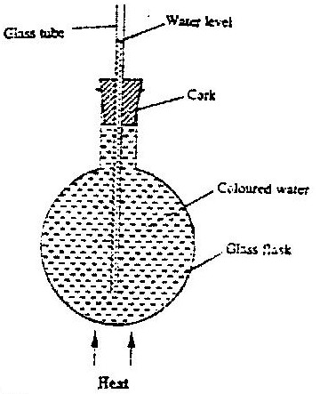

Figure 2
Explain this observation. (2mks)
………………………………………………………………………………………………………………………………………………..
………………………………………………………………………………………………………………………………………………..
4. Give a reason why a clinical thermometer should never be sterilized with boiling water.(1mk)
………………………………………………………………………………………………………………………………………………..

5.In an experiment to determine the thickness of an oil molecule, an oil drop of volume 3.60 x 10 ⁻⁶ m³ was observed to form a circular patch of diameter 0.016m on the surface of water covered with lycopodium powder
i) Explain why the oil drop forms a circular patch. (1mks)
…………………………………………………………………………………………………………………………...............
ii) Determine the thickness of the oil molecule (2mks)
………………………………………………………………………………………………………………………………………………………………………………………………………………………………………………………………………………………………………………………………………………………………………………………………………………………………
6. In an experiment to determine the acceleration due to gravity g, a student measured the period, T and length L, of a simple pendulum. For a length L = 70.5 cm, the period T obtained as 1.7s. Given that T = 2π √ L/g, determine the value of g correct to two significant figures (2 mks)
…………………………………………………………………………………………………………………………………………..
………………………………………………………………………………………………………………………………………….
………………………………………………………………………………………………………………………………………….
7. Name one state of matter in which Brownian motion occurs. (1mk)
……………………………………………………………………………………………………………………………………………………….
8. Fig 6 below shows a uniform plank of weight 20N and length 1.0m balanced by a 0.5kg mass at a distance x from the pivot point O.
Figure 6
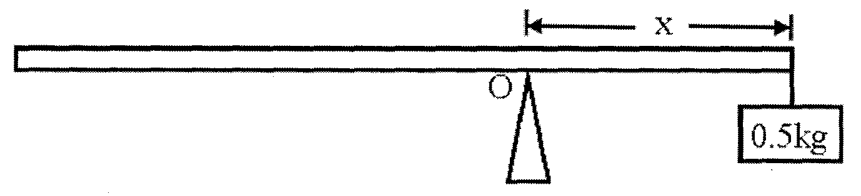
Determine the value of x (2mks)
………………………………………………………………………………………………………………………………………………………….
………………………………………………………………………………………………………………………………………………………….
9.The circuit set up shown below makes a current of 1A to flow through the 4Ω resistor

2Ω
1Ω
4Ω
2Ω
Calculate;
i) The current through the resistor (2mks)
2Ω
………………………………………………………………………………………………………………………………………………..
…………………………………………………………………………………………………………………………………………….....
ii) The E.M.F of the cell given that the internal resistance is negligible (2mks)
………………………………………………………………………………………………………………………………………………..
………………………………………………………………………………………………………………………………………………..
10.Fig.3 below shows a stretched spring held in position by two identical spring balances P and Q.
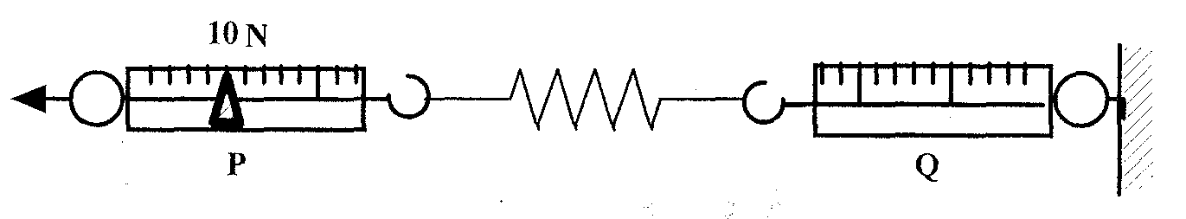
What will be the reading on spring balance Q? (1mk)
…………………………………………………………………………………………………………………………………………………….

11.a ) Distinguish between longitudinal and transverse waves. (2mks)
…………………………………………………………………………………………………………………………………………
…………………………………………………………………………………………………………………………………………
b) Fig 5 shows wave fronts in a ripple tank approaching a shallow region in the tank.

Figure 5

Complete the diagram to show the wave front as they pass over the shallow region and after leaving the regions (1mk)

12.If a tent is touched with a finger on inner surface, when it is raining, it allows the rain water to leak through. Give a reason for this observation. (1mk)
…………………………………………………………………………………………………………………………………………………………
SECTION B (55mks)
Answer all questions
13.(a) A trolley is moving with uniform velocity on a friction compensated track. When a piece
of plasticine is dropped on the trolley, the velocity of the trolley decreases. Explain this
observation. (2mks)
………………………………………………………………………………………………………………………………………………………
……………………………………………………………………………………………………………………………………………………..
(b) The graph in Fig. 7 shows the variation of velocity with time for a bullet of mass 20g moving through the trunk of a tree until it comes out on the other side.
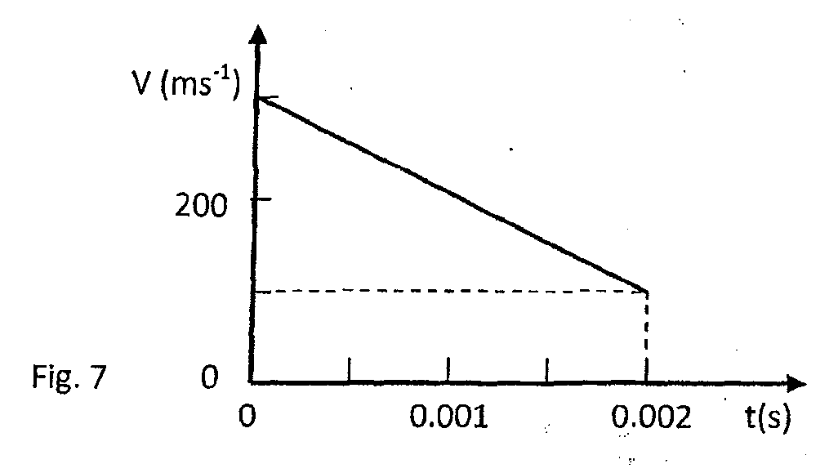
Determine:
(i) The diameter of the tree trunk. (2mks)
………………………………………………………………………………………………………………………………………………………
………………………………………………………………………………………………………………………………………………………
(ii) The change of momentum of the bullet. (2mks)
………………………………………………………………………………………………………………………………………………………
………………………………………………………………………………………………………………………………………………………

(iii) The retarding force on the bullet. (2mks)
………………………………………………………………………………………………………………………………………………………
……………………………………………………………………………………………………………………………………………………..
…………………………………………………………………………………………………………………………………………………….
14. a) Define the term efficiency of a machine (1mk)
…………………………………………………………………………………………………………………………………………
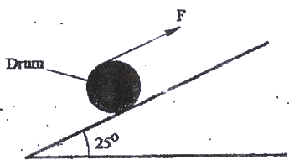 (b) Figure 6 shows a drum of mass 90 kg being rolled up a plane inclined at 25⁰ to the horizontal. The force F applied is 420N and the distance moved by the drum along the plane is 5.2 m

Determine:
(i) The work done by the effort ( 3 mks)
………………….........................................................................................................................
………………………………………………………………………………………………………………………………………..
………………………………………………………………………………………………………………………………………..
(ii) The work done in raising the drum ( 3 mks)
…………………………………………………………………………………………………………………………………………
…………………………………………………………………………………………………………………………………………
…………………………………………………………………………………………………………………………………………
(iii) The efficiency of the inclined plane as a machine ( 2 mks)
……………………………………………………………………………………………………………………………………….
……………………………………………………………………………………………………………………………………….
(iv) Give two reasons why efficiency is not 100% (2mks)
………………………………………………………………………………………………………………………………………………….
…………………………………………………………………………………………………………………………………………………
15. Fig. 7 shows a block of a mass 30.0 kg being pulled up a slope by a force P at a constant speed. The friction force on the block is 20.0N.
30.0kg
Mg
Fig. 7
P
10⁰

a)
i) On the same figure name and indicate the other forces acting on the block. (2mks)
ii) Determine the component of the weight acting on the trolley down the slope. (3mks)

………………………………………………………………………………………

………………………………………………………………………………………

……………………………………………………………………………………...

iii) Determine the value of P. (2mks)

………………………………………………………………………………………

……………………………………………………………………………………...

b) On reaching the top of the slope, the block is left to run freely down the slope.
i) Which one of the forces previously acting on the block would then act in the opposite? (1mk)
……………………………………………………………………………………..
ii) Determine the acceleration of the block down the slope. ( 2mks)
………………………………………………………………………………………………………………………………………………………………………………………………………………………………………………………………………………………………………………………………………………………………

16. A ball of mass 200 g is thrown vertically upwards with velocity of 5 ms"¹. The air resistance is 0.4 N.
Determine;
(i) The net force on the ball as it moves up;
(Take acceleration due to gravity g = 10 m⁻²) (2 marks)
......................................................................................................................................
(ii) The acceleration of the ball; (3 marks)
…………………………………………………………………………………………...............................................
………………………………………………………………………………………………………………………………………..
………………………………………………………………………………………………………………………………………… iii) The maximum height reached by the ball. (3 marks)
…………………………………………………………………………………………………………………………………………
…………………………………………………………………………………………………………………………………………..
……………………………………………………………………………………………………………………………………………
17.(a) An electric crane lifts a load of 2000kg through a vertical distance of 3.0m in 6s.
Determine:
- Work done (1mk)
……………………………………………………………………………………………………………………………………..
……………………………………………………………………………………………………………………………………..
……………………………………………………………………………………………………………………………………..
- Power developed by the crane (2mks)
…………………………………………………………………………………………………………………………………………

………………………………………………………………………………………………………………………………………..

iii) Efficiency of the crane if it is operated by an electric motor rated 12.5 Kw. (2mks)
……………………………………………………………………………………………………………………………………
……………………………………………………………………………………………………………………………………
b) A bob of mass 20kg is suspended using a string of 4m from a support and swings through a vertical height of 0.9m as shown below:
4m
0.9m

Determine:
- The potential energy of the body at its position. (2mks)
………………………………………………………………………………………………………………………………………
……………………………………………………………………………………………………………………………………..
ii)Speed of the body when passing through the lowest point. (2mks)
……………………………………………………………………………………………………………………………........
…………………………………………………………………………………………………………………………………..
…………………………………………………………………………………………………………………………………..

18. a) Give two conditions necessary for total internal reflection to occur. (2mks)
………………………………………………………………………………………………………………………………………………….
………………………………………………………………………………………………………………………………………………….
b) Figure below shows the path of a ray of light passing through a rectangular block of Perspex to air.
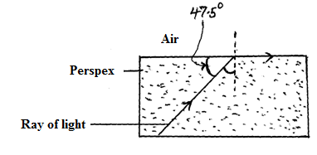
Calculate the refractive index of Perspex. (3marks)

…………………………………………………………………………………………………..

………………………………………………………………………………………………….

………………………………………………………………………………………………….
c) Give one use of an optical fibre (1 mark)

………………………………………………………………………………………………….

d) In a transparent liquid container, an air bubbles appears to be 18cm when viewed from end A and 12cm when viewed from end B as shown in figure below. Where exactly is the air bubble. If
the length of the tank is 40cm? 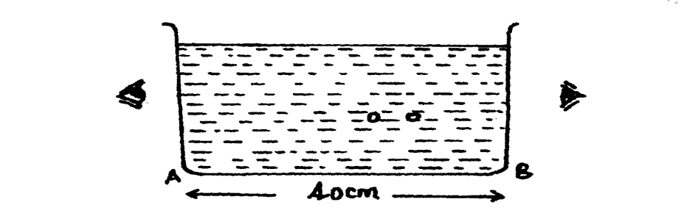 (3marks)

……………………………………………………………………………………………….

……………………………………………………………………………………………….

