Name: ………………………………………………………………………………….Candidate’s Target …....
451/1
COMPUTER STUDIES
Form One
(THEORY)
2017
TIME 2 HOURS.
KISUMU GIRLS’ HIGH SCHOOL
END TERM EXAMINATION, T1, 2017
Kenya Certificate of Secondary Education (K.C.S.E.)

Computer Studies

Form 1

INSTRUCTION TO CANDIDATES

- Write your name and Admission number, Stream and Class in the spaces provided above
- All answers should be written in the spaces provided on the question paper.

FOR OFFICIAL USE ONLY

QUESTION’S ACTUAL SCORE  CANDIDATES MAX SCORE | QUESTION’S ACTUAL SCORE  CANDIDATES SCORE
40
TOTAL SCORE
INSTRUCTION:
This paper consists of FIVE (5) printed pages. Answer All Questions in This Question paper on the spaces provided.
- Give THREE characteristics of a computer 3mks
…………………………………………………………………………………………………………………………………………………………………………………………………………………………………………………………………………………………………………………………………………………………………………………………………………………………………………………………………………………………………………………………………………………………………………………………………………
- Give FOUR characteristics of 4mks
(i) Data
…………………………………………………………………………………………………………………………………………………………………………………………………………………………………………………………………………………………………………………………………………………………………………………………………………………………………………………………………………………………………………………………………………………………………………………………………………
(ii) Program
…………………………………………………………………………………………………………………………………………………………………………………………………………………………………………………………………………………………………………………………………………………………………………………………………………………………………………………………………………………………………………………………………………………………………………………………………………
(iii) Data processing
…………………………………………………………………………………………………………………………………………………………………………………………………………………………………………………………………………………………………………………………………………………………………………………………………………………………………………………………………………………………………………………………………………………………………………………………………………
(iv) Information
…………………………………………………………………………………………………………………………………………………………………………………………………………………………………………………………………………………………………………………………………………………………………………………………………………………………………………………………………………………………………………………………………………………………………………………………………………
- State any three functions of a computer. 3mks
…………………………………………………………………………………………………………………………………………………………………………………………………………………………………………………………………………………………………………………………………………………………………………………………………………………………………………………………………………………………………………………………………………………………………………………………………………
……………………………………………………………………………………………………………………………………………………………………………………………………………………………………………………………………………………………………
……………………………………………………………………………………………………………………………………………………………………………………………………………………………………………………………………………………………………
- Explain the term system Unit. 2mks
…………………………………………………………………………………………………………………………………………………………………………………………………………………………………………………………………………………………………………………………………………………………………………………………………………………………………………………………………………………………………………………………………………………………………………………………………………

- Below is a diagram of computer keyboard. Use it to answer the following questions
R P M
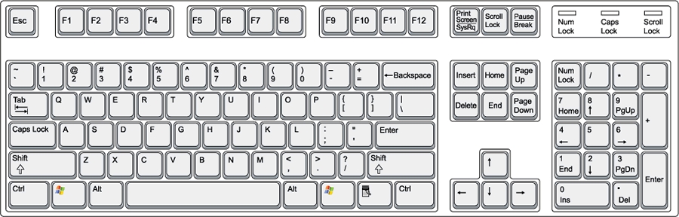

X
- List any four examples of special PC keys on the keyboard. 4mks
………………………………………………………………………………………………………………………………………………………………………………………………………………………………………………………………………………………………………………………………………………………………………………………………………………………………………………………………………………………………………………………………………………………………………………………………………………………………………………………………………………………………………………………………………………………………………………………………………………………………………………………………………………………………………………
……………………………………………………………………………………………………………………………………………………………………………………………………………………………………………………………………………………………………
- Identify the following groups of keys from the above diagram. 4mks
R
P
M
X
- Name TWO keyboard keys used to delete 2mks
………………………………………………………………………………………………………………………………………………………………………………………………………………………………………………………………………………………………………………………………………………………………………………………………………………………………………………………
- What is a Computer Laboratory? (2mks)
…………………………………………………………………………………………………………………………………………………………………………………………………………………………………………………………………………………………………………………………………………………………………………………………………………………………………………………………………………………………………………………………………………………………………………………………………………
- State FOUR factors to be considered when building a Computer Lab 4mks
………………………………………………………………………………………………………………………………………………………………………………………………………………………………………………………………………………………………………………………………………………………………………………………………………………………………………………………………………………………………………………………………………………………………………………………………………………………………………………………………………………………………………………………………………………………………………………………………………………………………………………………………………………………………………………

- Give TWO reasons why powdered and liquid based fire extinguishers are not encouraged to be used in the Computer Laboratory 2mks
………………………………………………………………………………………………………………………………………………………………………………………………………………………………………………………………………………………………………………………………………………………………………………………………………………………………………………………………………………………………………………………………………………………………………………………………………………………………………………………………………………………………………………………………………………………………………………………………………………………………………………………………………………………………………………

- List any four characteristics of first generation computer 4mks
………………………………………………………………………………………………………………………………………………………………………………………………………………………………………………………………………………………………………………………………………………………………………………………………………………………………………………………………………………………………………………………………………………………………………………………………………………………………………………………………………………………………………………………………………………………………………………………………………………………………………………………………………………………………………………
……………………………………………………………………………………………………………………………………………………………………………………………………………………………………………………………………………………………………

- Give any three differences between a super computer and a micro computer 3mks
Supercomputer Microcomputer

- Differentiate between cold booting and warm booting. 2mks
…………………………………………………………………………………………………………………………………………………………………………………………………………………………………………………………………………………………………………………………………………………………………………………………………………………………………………………………………………………………………………………………………………………………………………………………………………
……………………………………………………………………………………………………………………………………………………………………………………………………………………………………………………………………………………………………
- State the meaning of the following acronyms 4mks
- CMOS –
- BIOS –
- POST –
- ICT -
- Differentiate between special purpose computers and general purpose computers giving one example in each. 1mk
……………………………………………………………………………………………………………………………………………………………………………………………………………………………………………………………………………………………………………………………………………………………………………………………………………………………………………………………………………………………………………………………………………………………………………………………………………………………………………………………………………………………………………………………………………………………………………………………………………………………………………………………………………………………………………………………………………………………………………………………………………………………………………………………………………………………………………………………………………………………………………………………………………………
- Mention the difference between a system and a computer system (1mk)
…………………………………………………………………………………………………………………………………………………………………………………………………………………………………………………………………………………………………………………………………………………………………………………………………………………………………………………………………………………………………………………………………………………………………………………………………………
- Name and Explain THREE components of a computer system (6mks)

…………………………………………………………………………………………………………………………………………………………………………………………………………………………………………………………………………………………………………………………………………………………………………………………………………………………………………………………………………………………………………………………………………………………………………………………………………
…………………………………………………………………………………………………………………………………………………………………………………………………………………………………………………………………………………………………………………………………………………………………………………………………………………………………………………………………………………………………………………………………………………………………………………………………………

End

