Name…………………………………… …………………………..………… Index No:………………………….

231/1 Candidate’s Signature …………..……………
BIOLOGY Date: …………………………
PAPER 1
THEORY
MARCH
TIME: 2 HOURS

PCEA JITEGEMEA HIGH SCHOOL
Kenya Certificate of Secondary Education (K.C.S.E.)

231/1
Biology
Paper 1
2 hours

INSTRUCTIONS TO CANDIDATES
- Write your name, Index number and school in the spaces provided above.
- Answer All questions in the spaces provided on the question paper.
- Sign and write the date of examination in the spaces provided above.
- Additional pages must NOT be inserted.
- This paper consists of 7 printed pages.
- Do not remove any pages from this booklet
- Candidates should check to ascertain that all pages are printed as indicated and that no questions
are missing.

FOR EXAMINER’S USE ONLY
Question | Maximum Score | Candidate’s Score
1-29 | 80

1. Name the cell organelles responsible for:
(i) Protein synthesis. (1mk)
……………………………………………………………………………………………………….
(ii) Destroying worn-out organelles and cells. (1mk)
……………………………………………………………………………………………………….
2. State the roles of placenta during pregnancy. (3mks)
……………………………………………………………………………………………………….
……………………………………………………………………………………………………….
3. The diagram below shows the appearance of a plant cell after it had been placed in a strong salt
solution.
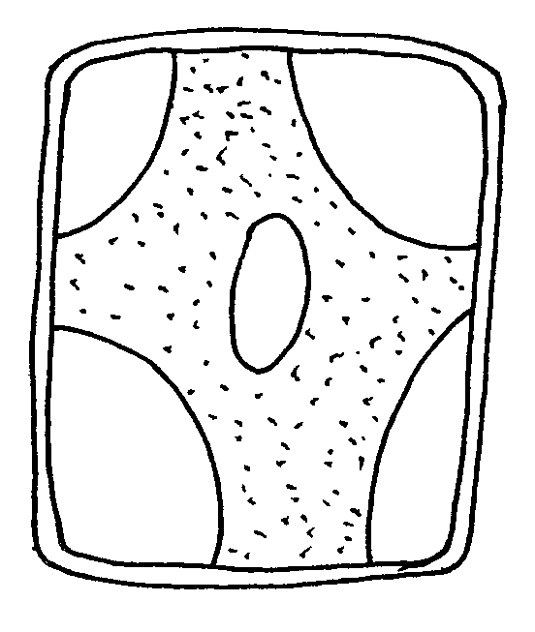
2
1
1
1
1

(a) Name the process that is observed in the cell. (1mk)
……………………………………………………………………………………………………….
(b) (i) Name the substances present in the region marked 2. (1mk)
……………………………………………………………………………………………………….
(ii) Explain your answer in (b) above. (2mks)
……………………………………………………………………………………………………….
……………………………………………………………………………………………………….
4. (a) State the phylum where all members have open circulatory system. (1mk)
………………………………………………………………………………………………………….
(b) Explain the advantages of closed circulatory system over open circulatory system. (2mks)
………………………………………………………………………………………………………….
………………………………………………………………………………………………………….
5. When exposed to light maggots move to dark areas. State the advantages of this response to maggots.
(2mks)
…………………………………………………………………………………………………….…….
………………………………………………………………………………………………………….
6. What is a test cross? (2mks)
………………………………………………………………………………………………….……….
…………………………………………………………………………………………………….…….

7. What is the importance of the following excretory products from plants. (3mks)
(a) Nicotine
……………………………………………………………………………………………………….
(b)Quinine
……………………………………………………………………………………………………….
(c) Rubber
……………………………………………………………………………………………………….
8. The equation below show respiration of a chemical of life use it to answer the questions that follow.
2C₅₁H₉₈O₆ + 145O₂ 102CO₂ + 98H₂O + Energy
(a) Calculate the respiratory quotient. Show your workings. (2mks)
……………………………………………………………………………………………………….
……………………………………………………………………………………………………….
(b) Identify the substrate being respired in the above equation. (1mk )
……………………………………………………………………………………………………….
9. Give two reasons why study of biology is important. (2mks)
……………………………………………………………………………………………………….
……………………………………………………………………………………………………….
10. What is the importance of the following parts of a seed.
(a) (i) Micropyle. (1mk )
……………………………………………………………………………………………………….
(ii) Cotyledons. (1mk)
……………………………………………………………………………………………………….
(b) Name two factors inside the seed that causes seed dormancy. (2mks)
……………………………………………………………………………………………………….
……………………………………………………………………………………………………….
11. Below is a diagram that represents a certain stage of cell division.
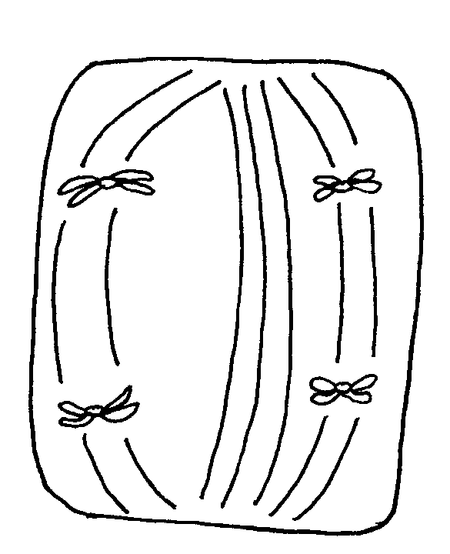

(a) Name two organs in the animal body where this cell division takes place. (2mks)
……………………………………………………………………………………………………….
……………………………………………………………………………………………………….
(b) Name the stage of cell division represented by the diagram. (1mk)
……………………………………………………………………………………………………….
12. Differentiate between the following ecological terms
(a) Population (1mk)

(b) Community (1mk)

(c) Niche (1mk)
13. State the changes that occur in arterioles in human skin during thermoregulation. (2mks)
……………………………………………………………………………………………………….
……………………………………………………………………………………………………….
14. State three factors that contribute to the deceleration phase in the population curve of an
organism. (3mks)
……………………………………………………………………………………………………….
……………………………………………………………………………………………………….
……………………………………………………………………………………………………….
15. (a) What is meant by the term non-disjunction? (1mk)
……………………………………………………………………………………………………….
(b) Give an example of a genetic disorder caused by:
(i) Non-disjunction (1mk)
……………………………………………………………………………………………………….
(ii) Gene mutation (1mk)
……………………………………………………………………………………………………….
16. (a) State two ideas proposed by Lamark in his theory of evolution. (2mks)
……………………………………………………………………………………………………….
……………………………………………………………………………………………………….
(b) Why is Larmark’s theory not acceptable. (1mk)
……………………………………………………………………………………………………….
17. (a) Name two tissues in plants which are thickened with lignin. (2mks)
……………………………………………………………………………………………………….
………………………………………………………………………………………………………
(b) How is support attained in herbaceous plants. (1mk)
……………………………………………………………………………………………………….

18. (a) State two functions of bile juice in the digestions of food. (2mks )
……………………………………………………………………………………………………….
……………………………………………………………………………………………………….
(b) Why does starch digestion stop when the food reaches the stomach? (2mks)
……………………………………………………………………………………………………….
……………………………………………………………………………………………………….
19. (a) Explain how the following prevent self pollination
(i) Protogyny (1mk)
……………………………………………………………………………………………………….
(ii) Self-sterility (1mk)
……………………………………………………………………………………………………….
(b) Give two advantages of cross-pollination. (2mks )
……………………………………………………………………………………………………….
……………………………………………………………………………………………………….
20. State two sites used for gaseous exchange in sub-merged aquatic plants (2mks)
……………………………………………………………………………………………………
……………………………………………………………………………………………………
21. What causes diabetes insipidus? (1mk )
……………………………………………………………………………………………………….
22. (a) Name two structures for gaseous exchange in aquatic plants. (2mks )
……………………………………………………………………………………………………….
……………………………………………………………………………………………………….
(b) What is the effect of contraction of the diaphragm muscles during breathing in mammals? (3mks)
……………………………………………………………………………………………………….
……………………………………………………………………………………………………….
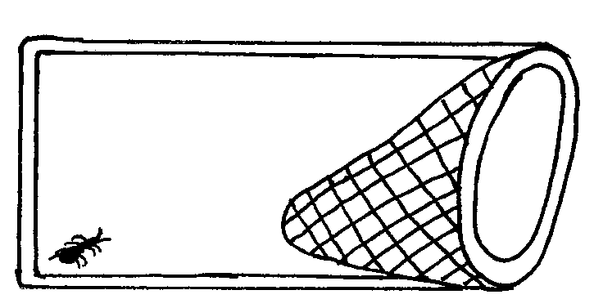
23. Give the name of the apparatus shown below and its use. (2mks)

Name……………………………….…………………………………………………………………….
Use ……………………………………………………………………………………………………….

24. Name the tissues in plants responsible for:
(a) Transport of carbohydrates. (1mk)
……………………………………………………………………………………………………….
(b) Primary growth. (1mk)
……………………………………………………………………………………………………….
(c) Transport of water and mineral salts. (1mk)
……………………………………………………………………………………………………….
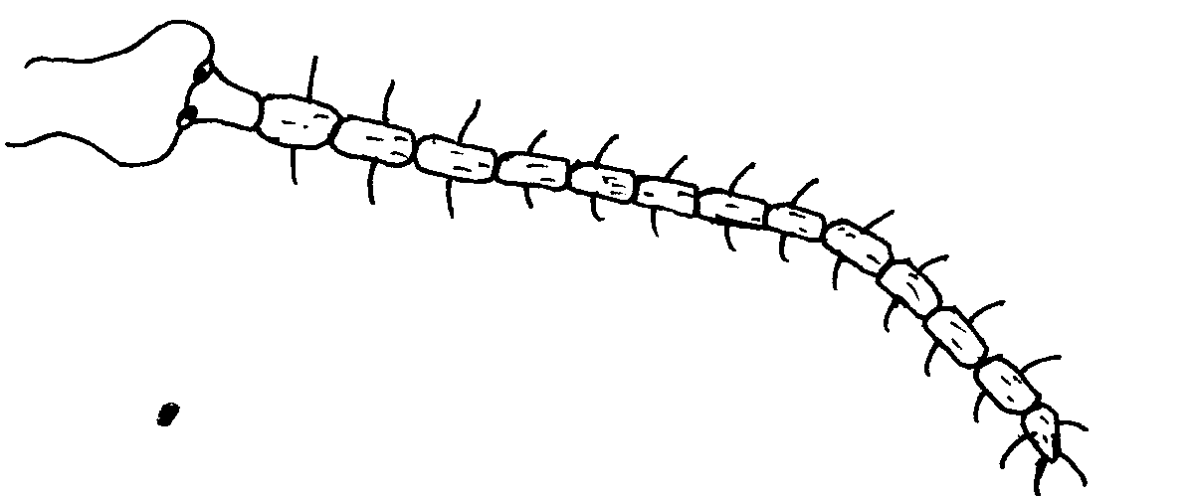
25. Study the diagram and answer the questions that follow.

(a) Identify the class to which the organism belongs. (1mk)
……………………………………………………………………………………………………….
(b) Give reasons for your answer in (a) above. (1mk)
……………………………………………………………………………………………………….
26. State two functions of cell sap. (2mks)
……………………………………………………………………………………………………….
……………………………………………………………………………………………………….
27. Distinguish between convergent and divergent evolution. (2mks)
……………………………………………………………………………………………………….
……………………………………………………………………………………………………….
28. Explain how oil as a pollutant may affect aquatic plants and animals? (3mks)
……………………………………………………………………………………………………….
……………………………………………………………………………………………………….
……………………………………………………………………………………………………….
29. Give two forms in which carbon (IV) oxide is transported in tissues of mammals. (2mks)
……………………………………………………………………………………………………….
……………………………………………………………………………………………………….

JITEGEMEA HIGH SCHOOL
BIOLOGY PAPER 1
MARKING SCHEME

- (i) Ribosomes;
(ii) Lysosomes;

- Shields foetus from pathogens from the mother;
Holds foetus in position by umblical cord;
Prevents direct connection of blood vessels of mother and foetus;

- (a) Plasmolysis;
(b) (i) (strong) salt solution;
(ii) Water moved out of the vacuole by osmosis;

- (a) Arthropoda; Rej. Anthropoda; Arthropods;
(b) - Oxygenated and deoxygenated blood are completely separated/do not mix;
- Animals tend to be more active due to efficient transport of gases and nutrients;
- Blood circulates over longer distances at faster rate due to high blood pressure;
- Blood flow to organs is well regulated based on demand;

- – avoid descication/drying/dehydration;
- Escaping predators;

- Cross done to determine an unknown genotype;
By use of recessive parents;

- (a) Manufacture of insecticides
Used as a mild stimulant in cigarettes
(b) Treatment of malaria
(c) Manufacture of rubber tyres/shoes/insulators

- (a) RQ = $\frac{{CO}_{2 Produced}}{O_{2 Used/Consumed}}$

(b) Lipids

- – Help in solving environmental problems;
- Enables entry into careers;
- Enables one to develop scientific skills;
- Useful in international co-operation;

- (a) (i) Allows water and air into the embryo;
(ii) Cotyledons – Contain stored food for the growing plumule and radical;
(b) - Very low concentration of hormones and enzymes;
Accept gibberellins hormones
- Presence of chemical inhibitors that inhibit germination/abscisic acid;
- Embryo not yet fully developed;

- (a) Ovary;
Testes;

(b) Anaphase 1

12. (a) All members of the same species in a given habitat at a given time;
(b) All members belonging to different species interacting in a given habitat;
(c) Is the specific position occupied by an organism in the ecosystem and its role;

- Increase in body temperature leads to vasodilation of arterioles;
Decrease in body temperature leads to vasoconstriction of arterioles;

- Predation;
Diseases/parasites;
Drought/floods/excess cold;

- (a) It is where there is addition or loss of one or more whole chromosomes during anaphase of meiosis II
(b) (i) Down’s syndrome;
Klinefelter’s syndrome;
Turner’s syndrome;

(ii) Sickle cell anaemia;
Albinism;
Haemophilia
Colourblindness

- (a) The law of use and disuse (organisms developed certain features which were required by the environment);
The acquired characteristics were inherited by the offsprings;

(b) Characteristics in organisms are passed on to offspring through genes in gametes;

- (a) Sclerenchyma;
Xylem;
(b) When parenchyma cells become turgid;

- (a) – Neutralizes acidic chyme from the stomach;
- Emulsifies fats
- Provides an alkaline medium for enzyme activities;
(b) Salivary amylase acts in alkaline environment; the stomach is acidic hence it is denatured/ it stops working;
- (a) (i) The stigma matures earlier and is ready to receive pollen grains before the anthers are
- ripe enough to shed the pollen grains;
(ii) The pollen grains are sterile to the stigma of the same plant;
(b) There is mixing of genetic characteristics between different plants;

There is a wide range of variations between offsprings and parents;

The rods | The cones
Sensitive to dim light | Sensitive to bright light

- Stem; Leaf surface;
-Roots
- (a) Aerenchyma tissues;
Stomata;
Pneumatophores;
(b) The diaphragm is pulled down causing it to flatten; this increases the volume of the chest cavity and the pressure reduces;

- Bait trap; used for attracting and trapping small animals;

- (a) Phloem tissue;
(b) Meristems
(c) Xylem tissue;

- (a) Chilopoda;
(b) Has one pair of walking legs per segment;

- Cell cap – offers turgidity of the cell contributing to mechanical support;
- Regulates the osmotic pressure of the cell, of the plant;
- Contains sugar ions and waste products;

- Convergent evolution – Is where structures with different embryonic origin have evolved to perform similar functions due to exploitation of a common habitat/ecological niche;
While Divergent evolution/adaptive radiation is where structures with common embryonic origin and similar basic pattern have been modified in different species to perform different functions;

- Reduces oxygen supply; (Leading to suffocation).
Oxygen is required for respiration
Clog the respiratory surfaces (gills and stomata); hindering circulation of respiratory gases; leading to death of plants and animals;

- Bicarbonate ions;
Carbaminohaemoglobin;
Weak carbonic acid

