NAME ………………………………………………………………. INDEXNO…………

SCHOOL ……………………………………………………………………………………..

451/1
COMPUTER STUDIES
TIME 2 ½ HOURS

MAKADARA JET - 2016

INSTRUCTIONS TO CANDIDATES:

- Write your name and Index number in the spaces provided above.
- This paper consists of TWO sections A and B.
- Answer ALL the questions in section A.
- Answer question 16and any other THREE questions from section B.
- All answer should be written in the spaces provided
- This paper consists of 13 printed pages.
- Students should check the question paper to ascertain that all the pages are printed as indicated and no question is missing.
- Candidates should answer the questions in English.

SECTION | QUESTIONS | CANDIDATE’S SCORE
A | 1-25
B | 16
 | 17
 | 18
 | 19
 | 20
 | TOTAL SCORE

SECTION A
ATTEMPT ALL THE QUESTIONS IN THIS SECTION
- Differentiate between ROM and RAM (2mks)
……………………………………………………………………………………………………………………………………………………………………………………………………………………………………………………………………………………………………………………………………………………………………………………………………………………………………………………..

2 a) Arrange the following data units in ascending order of size (2mks)
BYTE, FILE, BIT, NIBBLE
……………………………………………………………………………………………………………
……………………………………………………………………………………………………………

b) For each of the following give one reason why they are not allowed in a
computer laboratory. (2mks)
i) Smoking
……………………………………………………………………………………………………………………………………………………………………………………………………………………………………………………………………………………………………………………………………….
ii) Eating food
……………………………………………………………………………………………………………………………………………………………………………………………………………………………………………………………………………………………………………………………………………………………………………………………………………………………………………………
3.(a) Define the following terms with reference to computer crime
i) Cracking (1mk)
…………………………………………………………………………………………………………………………………………………………………………………………………………………………
ii) Hacking (1mk)
…………………………………………………………………………………………………………………………………………………………………………………………………………………………
(b) State any two laws governing protection of information (2mks)
………………………………………………………………………………………………………………………………………………………………………………………………………………………………………………………………………………………………………………………………………

4. What is meant by the term dry running as used in program development? (2mks)
………………………………………………………………………………………………………………………………………………………………………………………………………………………………………………………………………………………………………………………………………

5. List any three differences between while…..do and Repeat…….Until control structures (3mks)
………………………………………………………………………………………………………………………………………………………………………………………………………………………………………………………………………………………………………………………………………………………………………………………………………………………………………………………………………………………………………………………………………………………………………………………………………………………………………………………………………………
6. Match the computer generation with the technology associated with it. (2mks)

Generation Technology
Third Thermionic valves
First Integrated circuits
Fourth Transistor
Second Large scale integration
7. Differentiate between a computer operator and computer technician. (2mks)
……………………………………………………………………………………………………………………………………………………………………………………………………………………………………………………………………………………………………………………………………………………………………………………………………………………………………………………
8.State two consequences of a poorly implemented system change over strategy (2 mks)
………………………………………………………………………………………………………………………………………………………………………………………………………………………………………………………………………………………………………………………………………………………………………………………………………………………………………………………………………………………………………………………………………………………………………………………………………………………………………………………………………………
9 Define the following terms (2 marks)
- Password
………………………………………………………………………………………………………………………………………………………………………………………………………………………………………………………………………………………………………………………………………

- Authentication
……………………………………………………………………………………………………………………………………………………………………………………………………………………………………………………………………………………………………………………………………….
10. Explain the meaning of backup. (2 mks)
………………………………………………………………………………………………………………………………………………………………………………………………………………………………………………………………………………………………………………………………………
11. State the following types of transcription errors. (2 mks)

(a) 3455 instead of 3456……………………………………………………………..

(b) Simth instead of Smith. …………………………………………………………..

12. Briefly explain any three application areas of ICT (Information and Communication Technology) (3mks)
…………………………………………………………………………………………………………………………………………………………………………………………………………………………………………………………………………………………………………………………………………………………………………………………………………………………………………………..
13. List any two types of
  - Optical disk (1mk)
……………………………………………………………………………………………………………………………………………………………………………………………………………………………………………………………………………………………………………………………………………………………………………………………………………………………………………………
  - Magnetic disk (1mk)
……………………………………………………………………………………………………………………………………………………………………………………………………………………………………………………………………………………………………………………………………………………………………………………………………………………………………………………

14. Name six steps in program development cycle in their logical sequence. (3mks)
………………………………………………………………………………………………………………………………………………………………………………………………………………………………………………………………………………………………………………………………………

15. (a) State and define any three types of computer processing file (3mks)
………………………………………………………………………………………………………………………………………………………………………………………………………………………………………………………………………………………………………………………………………

(b) List any two file organization methods (2mks)
………………………………………………………………………………………………………………………………………………………………………………………………………………………………………………………………………………………………………………………………………

SECTION B (60 MARKS)
Answer questions 16 (Compulsory) and any other three questions from this section
16. (a) Consider the module flow charts extracts below
(i)

(ii)

State the looping structure demonstrated in i and ii above (2mks)

…………………………………………………………………………………………………………………………………………………………………………………………………………

…………………………………………………………………………………………………………………………………………………………………………………………………………

(b) State four examples of third generation languages (2mks)
- ………………………………………………………………………………………………………………………………………………………………………………………….
- ………………………………………………………………………………………………………………………………………………………………………………………….
- …………………………………………………………………………………………………………………………………………………………………………………………
- …………………………………………………………………………………………………………………………………………………………………………………………

(c) Define the following terms as used in programming (2mks)
    - Assembler
………………………………………………………………………………………………………………………………………………………………………………………………………………………………………………………………………………………………………………
    - Compiler
………………………………………………………………………………………………………………………………………………………………………………………………………………………………………………………………………………………………………………
    - Translator
………………………………………………………………………………………………………………………………………………………………………………………………………………………………………………………………………………………………………………
    - Interpreter
………………………………………………………………………………………………………………………………………………………………………………………………………………………………………………………………………………………………………………

d) Joykim retailers has two categories of customers (Silver and Gold).Processing category ‘Silver’ obtain 10% discount on all orders up to Ksh. 50,000. Otherwise the discount is 20% on entire order. Category ‘Gold’ obtains 30% on all orders if the debt payment records is good otherwise the discount is 15%.
  - Draw a flowchart that will display the discount on processing order. (9mks)

17. (a) Define the term network topology and explain the two types of topology. (5mks)
………………………………………………………………………………………………………………………………………………………………………………………………………………………………………………………………………………………………………………………………………
………………………………………………………………………………………………………………………………………………………………………………………………………………………………………………………………………………………………………………………………………
………………………………………………………………………………………………………………………………………………………………………………………………………………………………………………………………………………………………………………………………………

(b) Define the following terms as used in networking. (4mks)
- Routers
………………………………………………………………………………………………………………………………………………………………………………………………………………………………………………………………………………………………………………………………………
- Repeaters
………………………………………………………………………………………………………………………………………………………………………………………………………………………………………………………………………………………………………………………………………
(c) Name the parts labeled A, B, C and D in the diagram below. (2mks)

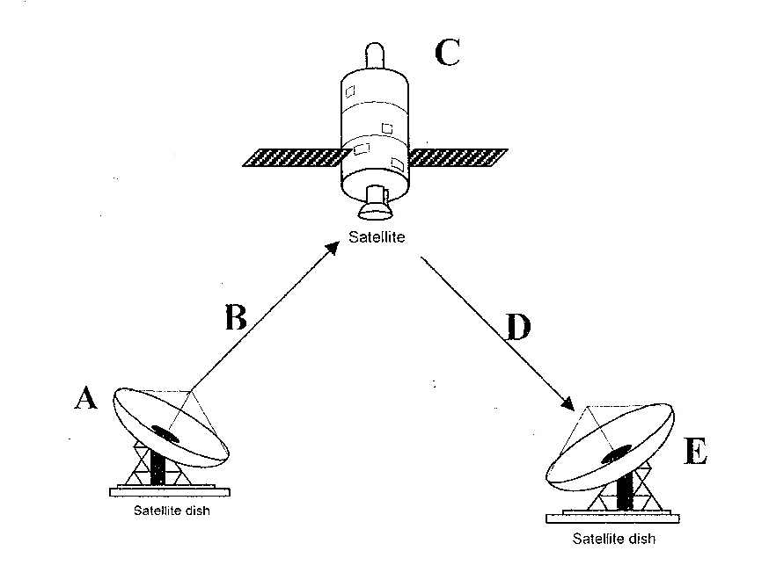

A
B
C
D
(d) Explain the meaning of the following terms as used in signal transmission. (2mks)

- Attenuation
………………………………………………………………………………………………………………………………………………………………………………………………………………………………………………………………………………………………………………………………………
- Noise
………………………………………………………………………………………………………………………………………………………………………………………………………………………………………………………………………………………………………………………………………
(e) State two advantages of using fiber optic cables. (2mks)

………………………………………………………………………………………………………………………………………………………………………………………………………………………………………………………………………………………………………………………………………

18. a) Distinguish between (2mks)
(i) A widow and an orphan in word processing
………………………………………………………………………………………………………………………………………………………………………………………………………………………………………………………………………………………………………………………………………
(ii) Cut and copy commands
………………………………………………………………………………………………………………………………………………………………………………………………………………………………………………………………………………………………………………………………………
b) i) What is a section break as used in word processing? (2mks)
………………………………………………………………………………………………………………………………………………………………………………………………………………………………………………………………………………………………………………

  - State two section breaks that can be used in a word processor (2mks)
………………………………………………………………………………………………………………………………………………………………………………………………………………………………………………………………………………………………………………

c) State two advantages of word processors over manual typewriters (2mks)
……………………………………………………………………………………………………………………………………………………………………………………………………………………………………………………………………………………………………………………………………..

d) List three editing features used in word processor. (3mks)
………………………………………………………………………………………………………………………………………………………………………………………………………………………………………………………………………………………………………………………………………

e) Name two reasons that would make the relationship between tables fail to work? (2mks)
…………………………………………………………………………………………………………………………………………………………………………………………………………………………
(f) In databases, the field properties specify finer details related to the fields and the table entries expected. State four field properties. (2mks)
………………………………………………………………………………………………………………………………………………………………………………………………………………………………………………………………………………………………………………………………………………………………………………………………………………………………………………………………………………………………………………………………………………………………………………………………………………………………………………………………………………

19. (a) Subtract 0111₂ from 1001₂ (2 mks)
…………………………………………………………………………………………………………………………………………………………………………………………………………………………………………………………………………………………………………………………………………………………………………………………………………………………………………………………………………………………………………………………………………………………………………………………………………………………………………………………………………………………………………………………………………………………………………………………………………………………………………………………………………………………………
(b) Using two’s compliment, subtract 4 from 7 and give the answer in
decimal notation (4mks)
……………………………………………………………………………………………………………………………………………………………………………………………………………………………………………………………………………………………………………………………………………………………………………………………………………………………………………………………………………………………………………………………………………………………………………………………………………………….…………………………………………………………………………………………………………………………………………………………………………………………………………………………………………………………………………
(c) Convert
(i) 91B₁₆ to octal (2mks)
………………………………………………………………………………………………………………………………………………………………………………………………………………………………………………………………………………………………………………………………………………………………………………………………………………………………………………………………………………………………………………………………………………………………….
(ii) 376₈ to hexadecimal (2mks)
………………………………………………………………………………………………………………………………………………………………………………………………………………………………………………………………………………………………………………………………………………………………………………………………………………………………………………………………………………………………………………………………………………………………
(iii) 9.625₁₀ to binary (2mks)
…………………………………………………………………………………………… ……………………………………………………………………………………………………………………………………………………………………………………………………………………………………………………………………………………………………………………………………………………………………………………………………………………………………………………………………
(d) Perform the following binary arithmetic giving the answers in decimal notation
1110.0111 + 1101001.011 (3mk)
…………………………………………………………………………………………………………………………………………………………………………………………………………………………………………………………………………………………………………………………………………………………………………………………………………………………………………………………………………………………………………………………………………………………………

20. (a) (i) Explain three communication services offered through internet (3mks)
…………………………………………………………………………………………………………………………………………………………………………………………………………………………………………………………………………………………………………………………………………………………………………………………………………………………………………………….
(ii) Describe the following internet terms (2mks)
Links
………………………………………………………………………………………………………………………………………………………………………………………………………………………………………………………………………………………………………………………………………
URL
……………………………………………………………………………………………………………………………………………………………………………………………………………………………………………………………………………………………………………………………………………………………………………………………………………………………………………………

(b) The following is a spreadsheet relating to a farmer.
 | A | B | C
1 | Crop | Amount
2 | Maize | 150
3 | Bean | 300
4 | Cashew nuts | 850
5 | Cabbages | 1036

A function =IF (B2<200, “Not Viable”, IF (B2>300, “Moderate”, IF (B2>1000, “Viable”))). Give the appropriate result returned in cells C2, C3, C4 and C5 (2mks)
………………………………………………………………………………………………………………………………………………………………………………………………………………………………………………………………………………………………………………………………………
(c) Text can easily be selected using a mouse in word processing. How do you select
    - Multiple paragraph (2mks)
……………………………………………………………………………………………………………………………………………………………………………………………………………………………………………………………………………………………………………………………………….
    - Vertical block of text
……………………………………………………………………………………………………………………………………………………………………………………………………………………………………………………………………………………………………………………………………….

(d) List three areas where virtual reality is used. (3mks)
………………………………………………………………………………………………………………………………………………………………………………………………………………………………………………………………………………………………………………………………………
(e) Outline three ways computers can be used to enhance marketing. (3mks)
…………………………………………………………………………………………………………………………………………………………………………………………………………………………………………………………………………………………………………………………………………………………………………………………………………………………………………………………………………………………………………………………………………………………………

