Name……………………………….. Index No …………………Adm.No ………………
Class…………………Candidate’s Signature…………………… Date ………………
447/2
POWER MECHANICS
PRACTICALS
TIME: 2 ½ HRS
KAMDARA JET - 2016
INSTRUCTION TO CANDIDATES
- Write your name and index number in the spaces provided
- Sign and write the date of examination in the spaces provided
- There are 10 stations in this examination
- At each station, candidates are not allowed to either review the previous station’s work or read instructions for the other stations
- Attempt all exercises in each station
- All dimensions are in millimeters

FOR EXAMINER’S USE ONLY
STATIONS | 1 | 2 | 3 | 4 | 5 | 6 | 7 | 8 | 9 | 10 | TOTAL  SCORE
CANDIDATE’S SCORE

STATION 1
- In the space provided sketch in good proportion an exploded view of drum brakes slave cylinder.10mks

STATION 2
- Use the materials, tools and equipment provided to make the sheet metal tray shown below 10mks

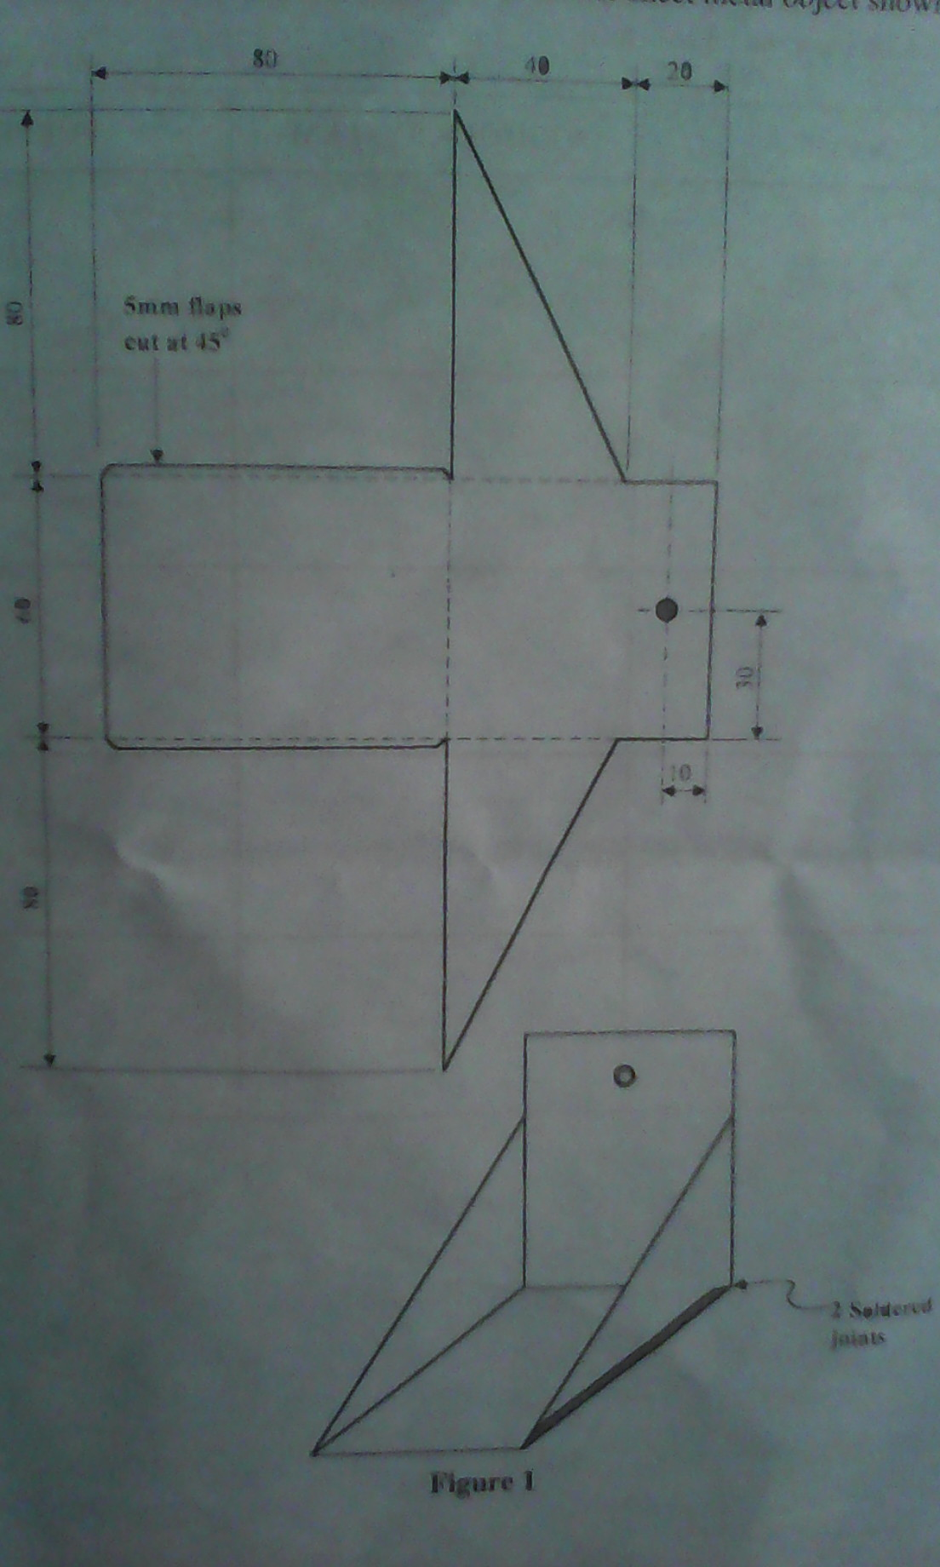

STATION 3
- Identify the substances in the containers labelled A to E and state the use of each in motor vehicle use (5mks)

Substance Name Application
A

B

C

D

E

(b). identify the fasteners F to K (5mks)

Fastener Name Unique feature (application)
F

G

H

J

K

STATION 4
- Identify the motor vehicle parts labelled L,M,N,P,Q,,identify one defect and cause (6mks)

Part Name Defect Cause
L

M

N

P

Q

(ii). Identify materials labelled 6,7,8,9 and state its application and property (4mks)

Material Name Application Property
6

7

8

9

STATION 5
- Using the starting system components and cables provided, connect up a complete starting circuit. Let examiner inspect your work. (10mks)
STATION 6
- Examine the tyre provided and complete the table below
- Diameter of the tyre
- Type of tyre construction
- Width of the tyre
- Aspect ratio
- Load rating
- State condition of tyre
(b). Name parts of tyre labelled 1,2,3,4

STATION 7
- Using measuring tools provided, carry out the following exercises
- Determine maximum compression of engine provided (6mks)
- Determine the torque at which the torque wrench gives way (2mks)
- Determine the diameter of gudgeon pin (2mks)

STATION 8
- Using the ignition system parts provided and cables, connect up a complete ignition system
10mks

STATION 9
- Carry out the overhaul of provided mechanical fuel pump
- Report condition of major parts

- Report general condition of pump

10mks

STATION 10
- Carry out the overhaul of provided oil pump 10mks
- Report condition of each component

- Test and report condition of the pump

