**Name:……………………………………..……Index. No. ………………Adm. No………..**

**Class ……………………..Candidate’s Signature:………………………Date………..….**

**232/3**

**PHYSICS - PRACTICAL**

**TIME: 2 ½ HRS**

**KAMDARA JOINT - 2016**

**Instructions**

* *Write your name, admission number, class and signature in the spaces provided at the top of the page.*
* *Answer* ***all*** *the questions in the spaces provided in this paper.*
* *You are supposed to spend the first 15 minutes of the 2 ½ hours allowed for this paper reading the whole paper carefully before your start.*
* *Marks will be given for clear record of observations actually made, for their suitability and accuracy, and the use made of them.*
* *Candidates are advised to record their observations as soon as they are made.*
* *Electronic calculators and mathematical tables may be used.*

**FOR EXAMINER’S USE ONLY**

|  |  |  |
| --- | --- | --- |
| **Question(s)** | **Maximum Score** | **Candidate’s Score** |
| **1** | 20 |  |
| **2** | **a)** 16 |  |
| **b)** 4 |  |
| **TOTAL** | **40** |  |

*This paper consists of* ***10*** *printed pages. Candidates are advised to check and to make sure all pages are printed.*

1. You are provided with the following;

* a rectangular glass block
* 4 optical pins
* a soft board
* a plain paper

Proceed as follows:

(a) Place the glass block on the plain paper with one of the largest face upper most. Trace round the glass block using a pencil as shown below.

A

P1

P2

i

B

L

b

r

eye

D

P4

P3

c

(b) Remove the glass block and construct a normal at B. Construct an incident ray AB of angle of incidence, i = 200.

(c) Replace the glass block and trace the ray ABCD using the optical pins.

(d) Remove the glass block and draw the path of the ray ABCD using a pencil. Measure length L and record it in the table below.

|  |  |  |  |  |
| --- | --- | --- | --- | --- |
| Angle *i0* | L (cm) | L2 (cm2) |  | Sin2*i* |
| 20 |  |  |  | 0.1170 |
| 30 |  |  |  | 0.2500 |
| 40 |  |  |  | 0.4132 |
| 50 |  |  |  | 0.5868 |
| 60 |  |  |  | 0.7500 |
| 70 |  |  |  | 0.8830 |

**(6 marks)**

(e) Repeat the procedure above for the angles of incidence given.

(f) Calculate the value of L2 and ; Record in the table.

(g) Plot a graph of $\frac{1}{L^{2}}$ (y-axis) against Sin2*i*.**(5 marks)**

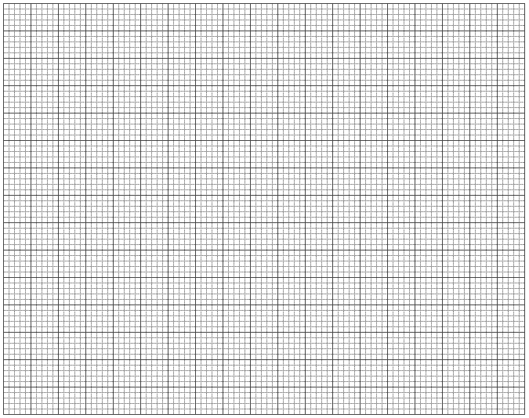

(h) Calculate the gradient, S. **(3 marks)**

**………………………………………………………………………………………………………**

**………………………………………………………………………………………………………**

**………………………………………………………………………………………………………**

**………………………………………………………………………………………………………**

Given that the equation of that graph is: $\frac{1}{L^{2}}=- \frac{1}{n^{2}b^{2}} ∙ {Sin}^{2}i+ \frac{1}{b^{2}}$

(i) Determine the $\frac{1}{L^{2}}$– intercept C and the Sin2*i –* intercept B.

C = _______________________________________ **(1 mark)**

B = _______________________________________ **(1 mark)**

(j) Calculate the value of Q given by; **(2 marks)**

$Q= -\left(\frac{C}{S}\right) ÷B$

(k) Hand in your constructions on the plain paper together with the answer script. **(2marks)**

**QUESTION 2**

**PART A**

You are provided with the following:

- Two dry cells and a cell holder

- One voltmeter (0 – 5V)

- One ammeter (0 – 1A) or (0 – 2.5A)

- Six resistors labeled AB

- One resistor labeled R

- A switch

- 7 connecting wires

(a) Set up the circuit as shown in figure 2

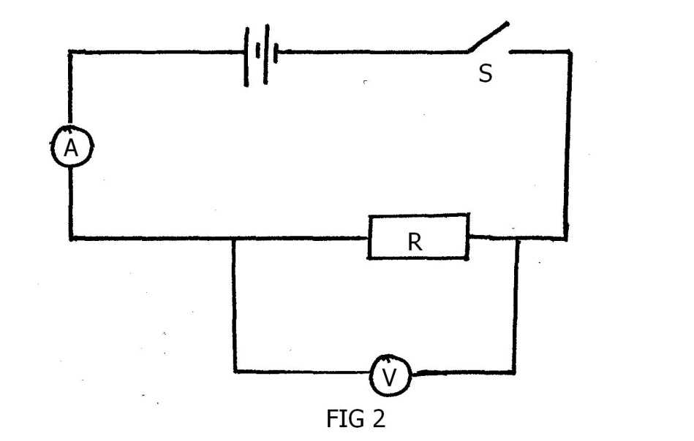

(i) Close the switch, s. Read and record the voltmeter and ammeter readings (1mks)

V = _______________________ volts

I = _________________________ Amperes

(ii) Determine the value of R given that  (1mk)

………………………………………………………………………………………………………………………………………………………………………………………………………………………………………………………………………………………………………………………………………………

(b) Set the circuit as shown in figure 3

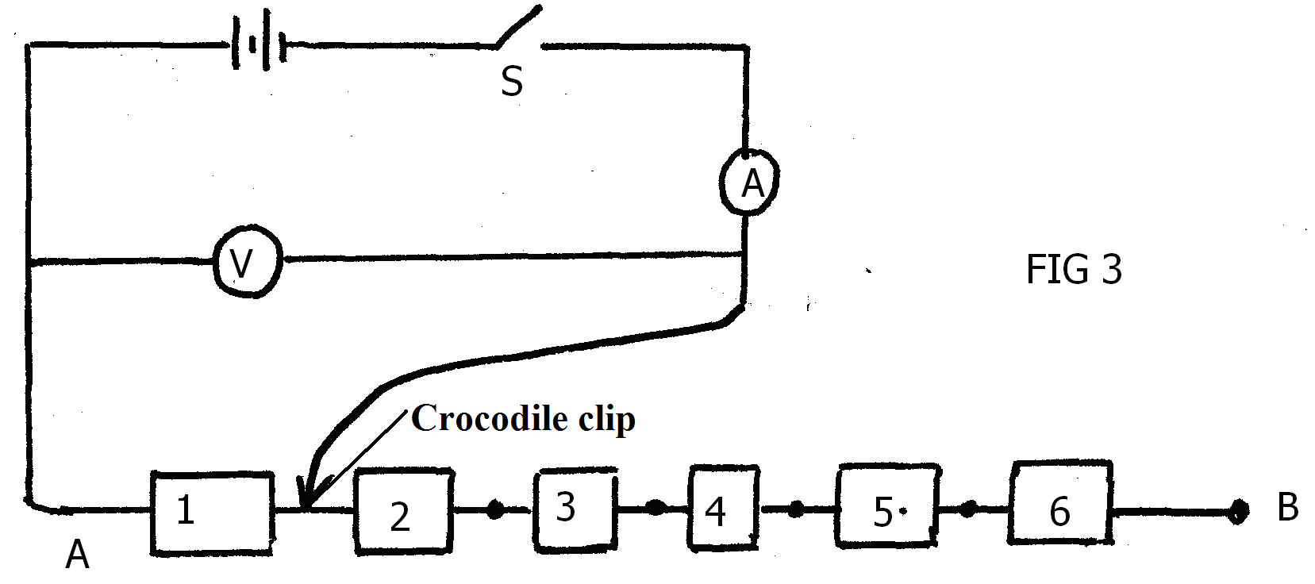

(i) With the crocodile clip across resistor 1 as shown in figure 3 above, close the switch, read and

record the ammeter and voltmeter readings in table.

(ii) Repeat the procedure b (i) with crocodile clips across resistors 2, 3, 4, 5 and 6 respectively, each time recording the corresponding values for V and I in table 2

|  |  |  |  |  |  |  |
| --- | --- | --- | --- | --- | --- | --- |
| Number of resistors | 1 | 2 | 3 | 4 | 5 | 6 |
| p.d. (volts) |  |  |  |  |  |  |
| Current I (Amperes) |  |  |  |  |  |  |

Table 2 (4mks)

(c) On the grid provided plot the graph of p.d (V) (y axis) against I (A) (5mks)



(d) Determine the slope of the graph at:

(i) p.d = 2.5V (2mks)

………………………………………………………………………………………………………………………………………………………………………………………………………………………………………………………………………………………………………………………………………………………………………………………………………………………………………………………………

(ii) p.d = 2.8V (2mks)

………………………………………………………………………………………………………………………………………………………………………………………………………………………………………………………………………………………………………………………………………………………………………………………………………………………………………………………………

(iii) What physical quantity is represented by the slope of your graph at any one point? (1mk)

………………………………………………………………………………………………………………..

**PART B**

You are provided with the following;

* Half-metre rule
* Knife edge (raised)
* A thread (approx. 20cm in form of a loop)
* 50g mass

1. Determine the c.o.g of the half-metre rule.

c.o.g. = _____________________ cm mark. **(1 mark)**

50cm

d1 d2 c.o.g

15 cm

0

Knife edge

50g

mass

1. Pivot the rule at 15cm mark and balance it with the mass as shown. When it is well balanced, note and record the position of the

50g mass; **(1 mark)**

Position of 50g mass = _________________ cm mark

1. Use your results to determine the weight of the rule. **(2 marks)**