Name ……………………………..………...…………. Adm. No …………………

Class ………………………………………………... Date ………………..........

232/1
PHYSICS FORM THREE
PAPER 1
(THEORY)
TIME: 2 HOURS

HOLA SECONDARY SCHOOL
Mid Term Examinations- Term Two 2016

INSTRUCTIONS:
• Write your name, class and admission number in spaces provided above
• Answer ALL the questions in the spaces provided
• Mathematical tables and electronic calculators may be used
• All working MUST be clearly shown where necessary.

FOR EXAMINERS USE ONLY

SECTION | QUESTION | MAXIMUM SCORE | CANDIDATES SCORE
A | 1-11 | 25
B | 12 | 11
 | 13 | 14
 | 14 | 9
 | 15 | 8
 | 16 | 13
TOTAL SCORE |  | 80

This paper consists of 8 printed pages.
Candidates should check to ensure that all pages are printed as indicated and no questions are missing
SECTION A (25 MARKS)
- Figure 1. Shows a glass beaker of cross sectional area 10.5cm²

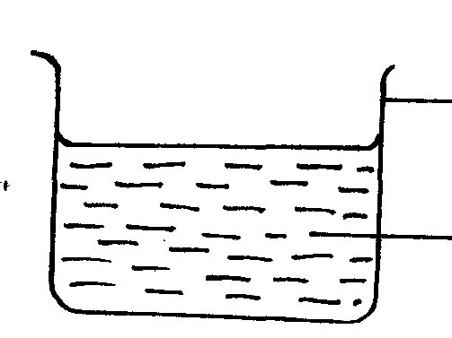
Beaker
Fig 1
Water

When a metal block of mass 250 g is immersed into the water, the level of water rises by 3.5 cm. Determine the density of the metal block. Express your answer in S.I unit (3 marks)
............................................................................................................................................................................................................................................................................................................................................................................................................................................................................................................................................................................................................................

- The figure 2 shows air flowing through a pipe of non-uniform cross sectional area. Two tubes A and B are dipped into the liquid as shown.
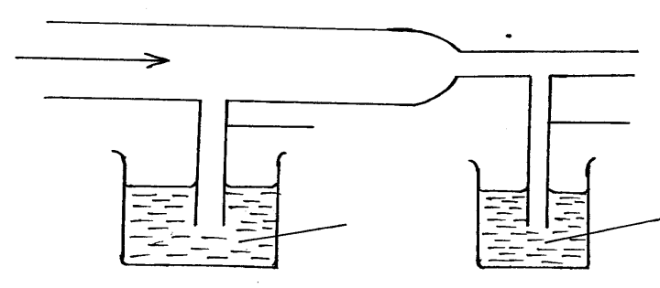
Air flow
Fig 2
Tube B
Tube A

Liquid
Liquid
- Indicate the level of the liquid in tubes A and B (1 mark)

- Explain your answer in part (a) above (1 mark)
.....................................................................................................................................................................................................................................................................................................................................................................................................................................................................
- A motor cyclist wears a helmet in the inside with sponge. Explain how this minimizes injuries to the motorists head when involved in an accident. (2 marks)

............................................................................................................................................................................................................................................................................................................................................................................................................................................................................................................................................................................................................................

- Why is it that boiling is not used for sterilization of clinical thermometer? (1 mark)
..............................................................................................................................................................................................................................................................................................................
- The figure 3 shows a device for closing a steam outlet.
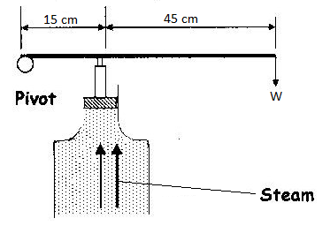
The area of the piston is 4.0 x 10⁻⁴ m² and the pressure of the steam in the boiler is
2.0 x 10⁵Nm⁻². Determine the weight W that just holds the bar in the horizontal position shown. (4 marks)
............................................................................................................................................................................................................................................................................................................................................................................................................................................................................................................................................................................................................................

- State two factors that lowers the stability of a body. (2 marks)
..............................................................................................................................................................................................................................................................................................................
- State two factors that govern the strengths of a spiral of given material. (2 marks)
............................................................................................................................................................................................................................................................................................................................................................................................................................................................................................................................................................................................................................

- A pupil blows a current of air over the surface of a sheet of paper held close to its mouth. State and explain what happens to the paper. (3 marks)
.....................................................................................................................................................................................................................................................................................................................................................................................................................................................................
- An object dropped from a height h attains a velocity of 6m/s just before hitting the ground, find the value of h. (g = 10 ms⁻²) (3 marks)
.....................................................................................................................................................................................................................................................................................................................................................................................................................................................................

- Figure 4 shows two corks P and Q fixed on a polished and a dull surface with wax.

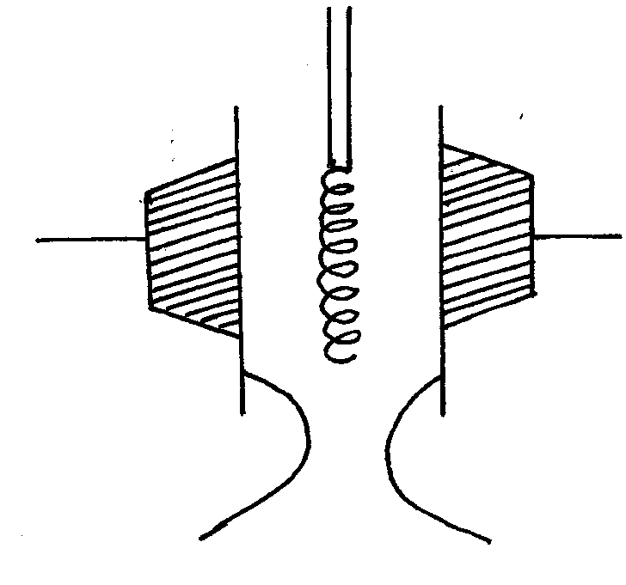

Cork fixed with wax
Cork fixed
with wax
Fig 5
2N
3N
Heater

Fig 4
Polished surface
Dull surface

Explain the observation, when the heater is switched on for a short time given that the heater is equidistant from the two surfaces. (2 marks)
.....................................................................................................................................................................................................................................................................................................................................................................................................................................................................
- State the reason why it is easier to separate water into drops than to separate a solid into smaller pieces. (1 mark)
..............................................................................................................................................................................................................................................................................................................

SECTION B (55 MARKS)

- (a) State the law of conservation of energy. (1 mark)
.....................................................................................................................................................................................................................................................................................................................................................................................................................................................................

- Define work and state its SI unit. (1 mark)
..............................................................................................................................................................................................................................................................................................................

(c) A load of 50N is raised by pulling it along an inclined plane of length 2.0m

F22N 2.0m 0.5m
Determine
- The work done by the force F (3 marks)
...............................................................................................................................................................................................................................................................................................................................................................................................................................................................................................................................................................................................
- The work done on the load. (3 marks)
...............................................................................................................................................................................................................................................................................................................................................................................................................................................................................................................................................................................................
- The efficiency of the system. (3 marks)
................................................................................................................................................................................................................................................................................................................................................................................................................................................................................................................................................................................................
- (a) Use the table below to answer the questions that follow:-

Mass m(g) | 50 | 100 | 150 | 200 | 250 | 300
Force F (N) | 0.5
Extension, e(cm) | 0.16 | 0.31 | 0.47 | 0.63 | 0.78 | 0.94

- Complete the table by filling in the values of force F. (2 marks)
- On the grid below plot the graph of force( y-axis) against extension
(4 marks)

- From the graph determine the spring constant. (3 marks)
.....................................................................................................................................................................................................................................................................................................................................................................................................................................................................
(iv) Why will the graph not be linear if a large mass is hung? (2 marks)
.....................................................................................................................................................................................................................................................................................................................................................................................................................................................................
(b) A spring with a spring constant of 25 Ncm⁻¹ extends by 5cm when a certain force acts on it. Determine the work done by the force. (3 marks)

.....................................................................................................................................................................................................................................................................................................................................................................................................................................................................
- a) i) A body is initially in motion. If no external force acts on the body, describe the subsequent motion. (2 marks)
..............................................................................................................................................................................................................................................................................................................

ii) A car of mass 1500 kg is initially moving at 25 m/s. Calculate the force needed to bring the car to the rest over a distance of 20 m. (3 marks)
............................................................................................................................................................................................................................................................................................................................................................................................................................................................................................................................................................................................................................

b) Two trolleys of masses 2 kg and 1.5 kg are travelling towards each other at 0.25m/s and 0.40 m/s respectively. The two trolleys combine on collision.
i) Calculate the velocity of the combined trolleys. (3 marks)
............................................................................................................................................................................................................................................................................................................................................................................................................................................................................................................................................................................................................................

ii) In what direction do the trolleys move after collision? (1 mark)
..............................................................................................................................................................................................................................................................................................................
- (a) Distinguish between solid and liquid states of matter in terms of intermolecular forces. (1 mark)
.................................................................................................................................................................................................................................................................................................................................................................................................................................................................
b) In an experiment to estimate the diameter of an oil molecule, an oil drop of diameter
0.06cm spreads over a circular patch whose diameter is 20cm. Determine:-
i) The volume of the oil drop (2mks)
....................................................................................................................................................................................................................................................................................................................................................................................................................................................................

ii) The area of the patch covered by the oil (2mks)
.....................................................................................................................................................................................................................................................................................................................................................................................................................................................................

iii) The diameter of the oil molecule (1mk)
..............................................................................................................................................................................................................................................................................................................

c) State any two assumptions made in b (iii) above (2mks)
..............................................................................................................................................................................................................................................................................................................

- a) The figure below shows a velocity-time graph for the motion of a certain body.

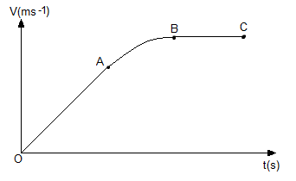

Describe the motion of the body in the region.
i) OA (1 mark)
..............................................................................................................................................................................................................................................................................................................

ii) AB (1 mark)
..............................................................................................................................................................................................................................................................................................................

iii) BC (1 mark)
..............................................................................................................................................................................................................................................................................................................

b) A car moving initially at 15ms-1 decelerates at 2.5ms-2
i) Determine
I its velocity after 1.5s: (2 marks)
.....................................................................................................................................................................................................................................................................................................................................................................................................................................................................

II the distance travelled in 1.5s (2 marks)
.....................................................................................................................................................................................................................................................................................................................................................................................................................................................................

III the time taken for the car to stop (2 marks)
.....................................................................................................................................................................................................................................................................................................................................................................................................................................................................

ii) Sketch the velocity-time graph for the motion of the car up to the time the car stopped. (2 marks)
............................................................................................................................................................................................................................................................................................................................................................................................................................................................................................................................................................................................................................

iii) From the graph, determine the distance the car travelled before stopping. (2 marks)

.....................................................................................................................................................................................................................................................................................................................................................................................................................................................................

