NAME______________________________________ ADM/NO___________

DATE_______________________________________ FORM______________

ENGLISH
TERM TWO 2016
FORM F3
PAPER 3
TIME:

HOLA SECONDARY SCHOOL
MID TERM EXAMINATION
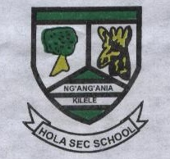

Instructions: Answer three questions (All are compulsory)

- Write a story to illustrate: “ Hard work pays” (20mks)

- The River and the Source. Highlight the virtue of courage, using Akoko, justify this statement. (20mks)

- The Government of Kafira is founded on corruptions. Using illustration from Francis Imbuga’s Betrayal in the city, write an essay in support of this statement.

