Name ……………………………..………...…………. Adm. No …………………

Class ………………………………………………... Date ………………..........

232/1
PHYSICS FORM THREE
PAPER 1
(THEORY)
TIME: 2 HOURS

HOLA SECONDARY SCHOOL
Mid Term Examinations- Term Two 2014

INSTRUCTIONS:
• Write your name, class and admission number in spaces provided above
• Answer ALL the questions in the spaces provided
• Mathematical tables and electronic calculators may be used
• All working must be clearly shown where necessary.

FOR EXAMINERS USE ONLY

SECTION | QUESTION | MAXIMUM SCORE | CANDIDATES SCORE
A | 1-11 | 25
B | 12-16 | 55
TOTAL SCORE |  | 80

This paper consists of 8 printed pages.
Candidates should check to ensure that all pages are printed as indicated and no questions are missing

SECTION A (25 MARKS)
- The number of molecules in 18cm³ of a liquid is 6 x 10²³. Assuming that the diameter of the molecules is equivalent to the side of a cube having the same length as the molecule. Determine the diameter of the molecule. (3 mks)

- Give a reason why the weight of a body varies from place to place. (1 mk)

- State why a pin floating on water sinks when a detergent is added. (1 mk)

- A drum which is 2m high contains water to a depth of 0.5 m and oil of density 0.5g/cm³ extends to the top. Find the pressure exerted at the bottom of drum by the two liquids. (3 mks)

- Why is it that boiling is not used for sterilization of clinical thermometer? (1 mk)

- What is the reading indicated by the scale of the vernier calliper below? (2 mks)
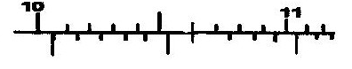

- The figure shows a device for closing a steam outlet.
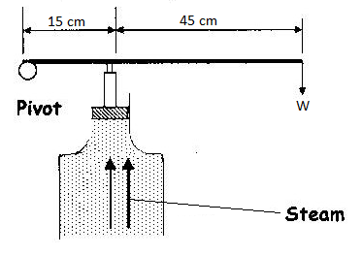
The area of the piston is 4.0 x 10⁻⁴ m² and the pressure of the steam in the boiler is
2.0 x 10⁵Nm⁻². Determine the weight W that just holds the bar in the horizontal position shown. (4 mks)

- State two factors that lowers the stability of a body. (2 mks)

- State two factors that govern the strengths of a spiral of given material. (2 mks)

- A pupil blows a current of air over the surface of a sheet of paper held close to its mouth. State and explain what happens to the paper. (3 mks)

- An object dropped from a height h attains a velocity of 6m/s just before hitting the ground, find the value of h. (g = 10 ms⁻²) (3 mks)

SECTION B (55 MARKS)
- (a) State two reasons why the efficiency of a machine is always less than 100% (2mks)

(b) A load of 50N is raised by pulling it along an inclined plane of length 2.0m

F22N 2.0m 0.5m
Determine
- The work done by the force F (3mks)

- The work done on the load (3mks)

- The efficiency of the system (3mks)

- Use the table below to answer the questions that follow:-
Mass m(g) | 50 | 100 | 150 | 200 | 250 | 300
Force F (N) | 0.5
Extension e(cm) | 0.16 | 0.31 | 0.47 | 0.63 | 0.78 | 0.94

- Complete the table by filling in the values of force F (2 mks)
- Plot a graph of force( y-axis) against extension (4mks)
- From the graph determine the spring constant. (3mks)

(iv) Why will the graph not be linear if a large mass is hung (2mks)

(b) A spring with a spring constant of 25 Ncm⁻¹ extends by 5cm when a certain force acts on it. Determine the work done by the force. (3mks)

- Distinguish between solid and liquid states of matter in terms of intermolecular forces. (1mk)

b) In an experiment to estimate the diameter of an oil molecule, an oil drop of diameter
0.06cm spreads over a circular patch whose diameter is 20cm. Determine:-
i) The volume of the oil drop (2mks)

ii) The area of the patch covered by the oil (2mks)

iii) The diameter of the oil molecule (1mk)

c) State any two assumptions made in b (iii) above (2mks)

- a) Figure 9 shows a velocity-time graph for the motion of a certain body.

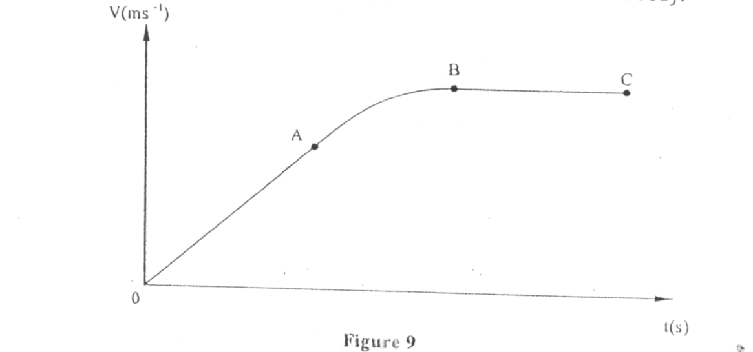

Describe the motion of the body in the region.
i) OA (1 mk)

ii) AB (1 mk)

iii) BC (1 mk)

b) A car moving initially at 10ms-1 decelerates at 2.5ms-2
i) Determine
I its velocity after 1.5s: (2 mks)

II the distance travelled in 1.5s (2 mks)

III the time taken for the car to stop (2 mks)

ii) Sketch the velocity-time graph for the motion of the car up to the time the car stopped. (2 mks)

iii) From the graph, determine the distance the car travelled before stopping. (2 mks)

- a) i) A body is initially in motion. If no external force acts on the body, describe the subsequent motion. (2 mks)

ii) A car of mass 800 kg is initially moving at 25 m/s. Calculate the force needed to bring the car to the rest over a distance of 20 m. (3 mks)

b) Two trolleys of masses 2 kg and 1.5 kg are traveling towards each other at 0.25m/s and 0.40 m/s respectively. Two trolleys combine on collision.
i) Calculate the velocity of the combined trolleys. (3 mks)

ii) In what direction do the trolleys move after collision? (1 mk)

