HOLA SECONDARY SCHOOL
MID- TERM EXAMINATIONS
PHYSICS FORM TWO
TERM TWO 2014
TIME: 2 HOURS
NAME………………………………………..……………………CLASS………… ADM/NO…………
INSTRUCTIONS:
- Write your name, class and admission number in the spaces provided above
- Answer ALL the questions in the spaces provided in the question paper

- The figure 1 shows a measuring cylinder which contains water initially at level A. A solid mass 11g is immersed in the water, the level rises to B.
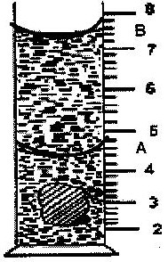
Cm³

Figure 1
Determine the density of the solid. (Give your answer to 1 decimal point) (3 mks)

- A small drop of oil has a volume of 5 x 10⁻⁸m³. When it is put on the surface of some clean water, it forms a circular film of 0.lm² in area;

(i) What is the size of a molecule of oil? (3 mks)

(ii) State two assumptions you make in your calculations? (2 mks)

- 1600 cm³ of fresh water of density 1 g/cm³ are mixed with 1400cm³ of seawater of density 1.25g/cm³. Determine the density of the mixture. (3 mks)

- Name two types of forces which can act between objects without contact. (2 mks)

- State why a pin floating on water sinks when a detergent is added. (1 mk)

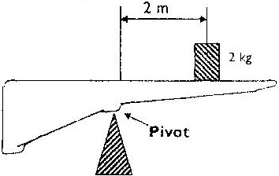
- Figure 2 below shows a non- uniform log of mass 100kg balanced on a pivot by a 2 kg mass placed as shown.

Figure 2
Determine the distance of the centre of gravity of the log from the pivot (3 mks)
- Give a reason why water is not a suitable liquid for use in a barometer (1 mk)

- The total weight of a car with passengers is 25,000N. The area of contact of each of the four tyres with the ground is 0.025m². Determine the minimum car tyre pressure. (3 mks)

- (a) Define center of gravity of a body. (1 mk)

(b)Figure 3 below shows a plastic lamina object
Fig. 3
Explain how its centre of gravity may be determined (3 mks)
- The reading on a mercury barometer at Mombasa is 760mm. Calculate the pressure at Mombasa (density of mercury = 1.36 x 10⁴ Kgm⁻³) (3 mks)

- The figure below shows two mirrors inclined at an angle of 30º to each other. A ray of light is incident on one mirror as shown
60º
30º

Fig. 4

Sketch the path of the ray to show its reflection on the two mirrors (2 mks)
- The figure below shows an object placed in front of a plane mirror. Draw appropriate rays to
locate the image as seen by the observer. (2 mks)

Object

Fig. 5

Observer
Plane mirror

- Define the following terms as used in curved mirrors:-
(a) Principal focus (F) (1 mk)

(b) Focal length (f) (1 mk)

(c) Center of curvature(C) (1 mk)

- An object 10 cm high is placed 30 cm from a concave mirror of focal length 20 cm. Determine graphically the position of the image. (4 mks)
- In an experiment to demonstrate Brownian motion, smoke was placed in air cell and observed
under a microscope. Smoke particles were observed to move randomly in the cell.
(i) Explain the observation (2 mks)

(ii) Give a reason for using small particles such as those of smoke in this experiment (1 mk)

(iii) What would be the most likely observation if the temperature in the smoke cell was
raised? (1 mk)

- Figure 6 shows a uniform wooden plank which weighs 10N. The plank is balanced at 0.8m
from one end by a mass of 2.5kg
2.5kg
0.8m

fig. 6

What is the length of the wooden plank in metres? (3 mks)

- (a) Draw a well labeled diagram of a vacuum flask (3 mks)

(b) Stating the specific parts in the flask explain how heat loss is reduced through:
(i) Conduction (1 mk)

(ii) Convection (1 mk
(iii) Radiation (1 mk)

- A glass rod can be charged positively by rubbing it with silk. Explain what happens when the glass rod is being charged. (2 mks)

- (a)Distinguish between a primary cell and a secondary cell. (1 mk)

(b)A current of 0.08 A passes in a circuit for 2.5 minutes. How much charge passes through a point in the circuit? (2 mks)

- Show the magnetic field pattern around the conductor shown below. (1 mk)
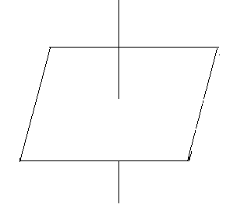
- The figure below shows a magnetic material being magnetized.
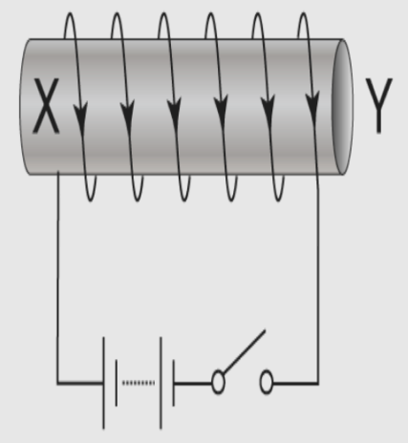

- Name the poles formed at X and Y (1 mk)
X---
Y---

- State two ways of increasing the strength of the magnetic field. (2 mks)

