HOLA SECONDARY SCHOOL
MID- TERM EXAMINATIONS
PHYSICS FORM ONE
TERM TWO 2014
TIME: 2 HOURS
NAME………………………………………..…………………...CLASS………ADM/NO………
INSTRUCTIONS:
- Write your name, class and admission number in the spaces provided above
- Answer ALL the questions in the spaces provided in the question paper

- The figure 1 shows a measuring cylinder which contains water initially at level A. A solid mass 11g is immersed in the water, the level rises to B.
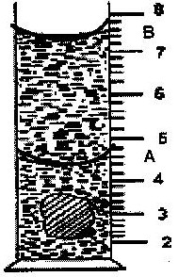
Cm³

Figure 1

Determine the density of the solid. (Give your answer to 1 decimal point) (3 mks)

- X cm³ of substance A which has a density of 800 kg/m³ is mixed with 1000cm³ of water with a density of 1000 kg/m³. The density of the mixture is 960 kg/m³. Determine the value of X. (3 mks)

- State five differences between mass and weight (5 mks)

Mass Weight

- A wooden block 6 cm long, 5 cm wide and 2 cm thick has a mass of 240g. Calculate:
- Its volume (1 mk)

- Density in kg/m³ (3 mks)

- Its maximum pressure it can exert on a surface (4 mks)

- Explain why a needle floats on water when placed gently with its flat surface (2 mks)

- Mercury on a clean glass slide collects into small spherical balls as shown in the figure below. Explain why the drops are spherical. (2 mks)
Drops of mercury
Clean glass slide

- An object has a mass of 25 kg. Calculate his weight (take g = 10 N/kg) (2 mks)

- An astronaut weighs 800 N on earth. On the moon, he weighs 133.6 N. Calculate the moon’s gravitational strength. (3 mks)

- Heavy commercial vehicles have many wheels. Explain (2 mks)

- A boy standing upright exerts a pressure of 13600 Nm⁻¹ on the floor. Given that the total area of contact of shoes and the floor is 0.0368 m². Determine,
- The mass of the boy. (3 mks)

- The pressure he would exert on the floor if he stood on one foot. (1 mk)

- State the factors that affect pressure in fluids. (2 mks)

- State the Pascal’s principle of transmission of pressure. (1 mk)

- a) State the possible reason why, if water is used as a barometric liquid, the glass tube required to hold the column of the liquid is longer. (1 mk)

- The height of mercury in a barometer in Nairobi is 72 cm. Determine the atmospheric pressure in Nairobi. (take density of mercury = 13600 kg/m³.) (2 mks)

- The figure shows a hydraulic machine used to lift a car in a garage. The cross-section areas of the effort and load piston are 0.2 m² and 5.0 m² respectively.
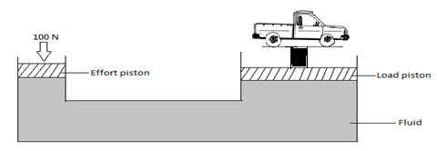
- State a property of the fluid that makes it suitable for use in the machine (1 mk)

- A mechanic applies a force of 100 N on the effort piston while raising the car. Determine the maximum load that can be raised (3 mks)

- a) What is atmospheric pressure? (1 mk)

b)The figure below shows a U-tube manometer filled with two liquids resting on mercury
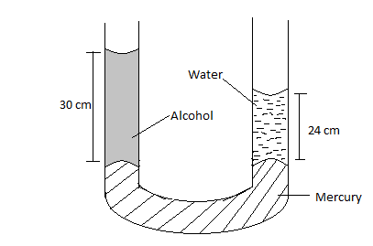

Determine the density of alcohol. (Take density of water = 1000 kgm⁻³) (3 mks)

- (a) In an experiment to demonstrate Brownian motion, smoke was placed in air cell and observed
under a microscope. Smoke particles were observed to move randomly in the cell.
(i) Explain the observation (1 mk)

(ii) Give a reason for using small particles such as those of smoke in this experiment. (1 mk)

(iii) What would be the most likely observation if the temperature in the smoke cell was
raised? (1 mk)

- When solids are heated they expand. State its effect on the following;
- Mass (1 mk)

- Density (1 mk)

- Explain briefly the working of a drinking straw (2 mks)

