SUNSHINE SCHOOL

121/1
FORM 3
MATHS PAPER 1
END TERM EXAM – OCT. 2015
TIME: 2 ½ HOURS

NAME:……………………………………………………CLASS:……….ADM NO:………..

INSTRUCTIONS TO CANDIDATES

- Write your name, admission no. and class in the spaces provided.
- Sign and write the date of examination in the spaces provided above
- The paper contains two sections; Section I and II.
- Answer all questions in Section I and II
- All answers and working must be written on the question paper in the spaces provided below each question.
- Show all the steps in your calculations, giving your answers at each stage in the spaces provided below each question
- KNEC Mathematical tables may be used, except where stated otherwise
- Silent or non-programmable calculators may be used

FOR EXAMINER’S USE ONLY

SECTION I

1 | 2 | 3 | 4 | 5 | 6 | 7 | 8 | 9 | 10 | 11 | 12 | 13 | 14 | 15 | 16 | TOTAL

SECTION II

17 | 18 | 19 | 20 | 21 | TOTAL

GRAND TOTAL
- Evaluate: (3 mks)

$\frac{2 3/4 x 8/{33}}{3+ \left(5 2/5 ÷ 9/{25}\right)}$

- Simplify: (2 mks)

$${ \left(\frac{64}{125}\right)}^{2/3} ÷ {\left(4/{25}\right)}^{3/2}$$

- Evaluate: (3 mks)

$$\frac{7 of 13-\left(18 ÷6+3\right)÷(9 x 3-25)}{61-\left\{63 ÷\left(30-7 x 3\right)\right\}}$$

- Simplify: (4 mks)

$$\frac{ 6-x- x^{2}}{x^{2}- 4}$$

- The interior angle of a regular polygon is 120⁰. Find the number of sides of the polygon. (2 mks)

- Simplify without using tables or calculator $\frac{\cos{{60}^{0}}}{\sin{{45}^{0}+\sin{{30}^{0}}}}$ leaving your answer in the form a + b$\sqrt{c}$. (3 mks)

- The length of a rectangle is 8cm and its area 48 cm². Find the length of a similar rectangle whose are is 192 cm² (3 mks)

- Using a ruler and compass only, construct a parallelogram PQRS with <QPS = 105⁰, PQ = 6 cm and PS = 4 cm.
Measure QS. (4 mks)

- Determine the value of the constant C, if the lines 3x + y = 0 and Cx + 3y – 4 = 0 are parallel. (3 mks)

- Jane is a sales executive earning a salary of Ksh 20,000 and a commission of 8% for the sales in excess of Ksh 100,000. If in January 2010 she earned a total of Ksh 480,000 in salaries and commissions. Determine the amount of sales she made in that month. (4 mks)

- A two digit number is such that the sum of the ones digit and the tens digit is 10. If the digits are reversed, the number formed exceeds the original number by 54. Find the number.
(3 mks)

- Three towns XWY are such that the bearing of X from W is 280⁰ and <WXY = 135⁰, WY = 34 km and WX = 18 km. by use of scale drawing find the bearing of Y from W. (3 mks)

- The area of a sector of a circle is 16 cm². Given the circle radius is 8 cm calculate the angle θ subtended by the sector. (3 mks)

- The following table shows marks students go in a test.

Marks | Frequency
20 – 29 | 3
30 – 39 | 8
40 – 49 | 9
50 – 59 | 6

Estimate the median to1 d.p. (3 mks)

- Line AB has A (4,-9) and B (7,15). Find the coordinates of K which is the mid point of AB hence calculate the modulus of KB to 4 s.f. (3 mks)

- Use table of reciprocals square and cube root solve and answer to 2 d. places. (4 mks)

$$\frac{5}{0.0829} + {0.4927}^{2}- \sqrt[3]{6479}$$

- A lorry travels from Nairobi to Lodwar and back. From Nairobi to Lodwar, the average speed of the lorry is 70 km/h and from Lodwar to Nairobi, the lorry averages 20 km/h slower and takes 4 hours longer than on the journey from Nairobi to Lodwar.

- Find the distance between Nairobi and Lodwar. (4 mks)

- Diesel consumption is 0.32 litres per kilometer on the journey from Nairobi to Lodwar. This rate of fuel consumption increases by 25% on the return journey. Calculate the amount of diesel the lorry consumes for the trip. (3 mks)

- The lorry makes 2 round trips per week. If diesel costs sh 65 per litre, determine the total cost of diesel required to run the lorry for a quarter a year. (3 mks)

- Town B is 180 km on a bearing of 050⁰ from town A. another town C is on a bearing of 110⁰ from town A and on a bearing of 150⁰ from town B. A fourth town D is 240 km on a bearing of 320⁰ from town A. without using a scale drawing, calculate to the nearest kilometer:

- The distance AC (4 mks)

- The distance CD (4 mks)

- The distance BC (2 mks)

- (a) Given the matrix Q = $\left[\begin{matrix}5 & 24 \\ 4 & 30\end{matrix}\right]$ , find its inverse matrix. (2 mks)

(b) Two friend, Kamara and Teso, bought bulls at sh b per bull and goats at sh g per goat. Kamara spent sh 96,000 in buying 5 bulls and 24 goats while Tero spent sh 93,000 in buying 4 bulls and 30 goats.

(i) Form a matrix equation to represent this information. (1 mk)

(ii) Use the inverse matrix Q⁻¹ in (a) above to find the cost of one bull and that of one goat. (3 mks)

(c) Karama sold all his animals at a profit of 30% per bull and 40% per goat. Teso sold his animals at a profit of 25% per bull and 50% per goat. Determine who made more profit and by how much. (4 mks)

- (a) Using a ruler and a pair of compasses only construct triangle ABC such that AB = 4 cm,
BC = 5 cm and <ABC = 120⁰. Measure AC. (3 mks)

(b) On the diagram, construct a circle which passes through the vertices of the triangle ABC.
Measure the radius of the circle. (4 mks)

(c) (i) Measure the shortest distance from the centre of the circle to the line BC.
(1 mk)

(ii) Calculate the area of the triangle to 2 d.p. (2 mks)

- In the figure below PR is diameter of the circle centre O. points P, Q, R and S are on the circumference of the circle. Angle PRQ =72⁰, QS = QP and line USV is a tangent to the circle at S.
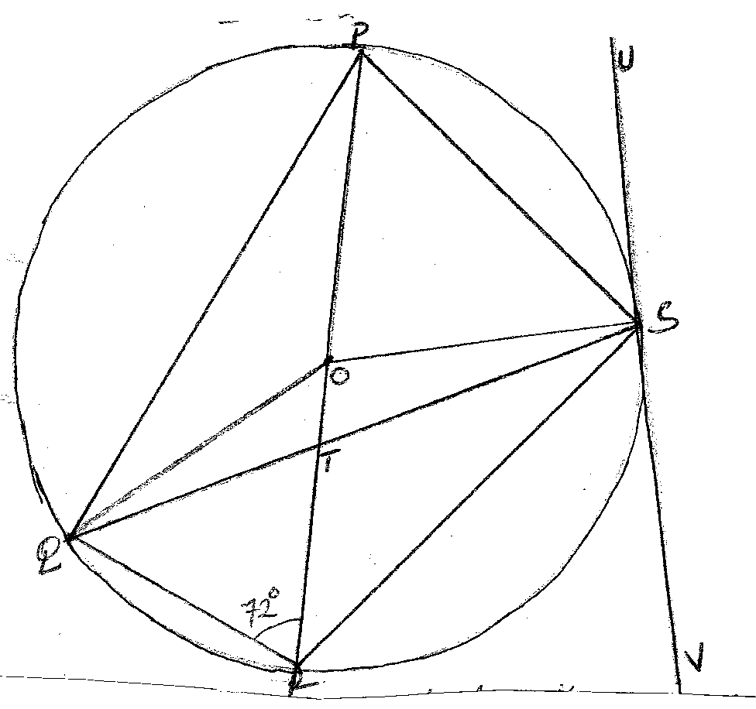

Giving reasons, calculate the size of:

- <QPR (2 mks)

- <PQS (2 mks)

- <OQS (2 mks)

- <RTS (2 mks)

- <RSV (2 mks)

