SUNSHINE SCHOOL

FORM 3
MATHS PAPER 2
END TERM EXAM – OCT. 2015
TIME: 2 ½ HOURS

NAME:……………………………………………………CLASS:……….ADM NO:………..

INSTRUCTIONS TO CANDIDATES

- Write your name, admission no. and class in the spaces provided.
- Sign and write the date of examination in the spaces provided above
- The paper contains two sections; Section I and II.
- Answer all questions in Section I and II
- All answers and working must be written on the question paper in the spaces provided below each question.
- Show all the steps in your calculations, giving your answers at each stage in the spaces provided below each question
- KNEC Mathematical tables may be used, except where stated otherwise
- Silent or non-programmable calculators may be used

FOR EXAMINER’S USE ONLY

SECTION I

1 | 2 | 3 | 4 | 5 | 6 | 7 | 8 | 9 | 10 | 11 | 12 | 13 | 14 | 15 | 16 | TOTAL

SECTION II

17 | 18 | 19 | 20 | 21 | TOTAL

GRAND TOTAL

- Use logarithm tables to evaluate: (3 mks)

$$\sqrt[4]{\frac{4.562 x 0.038}{0.82}}$$

- The sum of the fifth and sixth terms of an AP is 30. If the third term is 5, find the first term. (3 mks)

- Make h the subject of the formulae. (3 mks)

P = $\sqrt{\frac{n^{2}+ t^{2}}{h^{2}}}$

- Without using tables, find the value of $\frac{\log{128-\log{18}}}{\log{16-\log{6}}}$ (3 mks)

- Solve the following inequalities sand represent the range of values of x on a single number line. (3 mks)

5 - 3x > -7
x – 6 < 3x – 4

- The sides of a triangle were measured and recorded as 4cm, 6.2 cm and 9.50 am. Calculate the % error in its perimeter, correct to 2 dp. (3 mks)

- The figure below shows triangle ABC in which AB = 20 cm, angle BAC = 110⁰ and angle ACB = 30⁰.
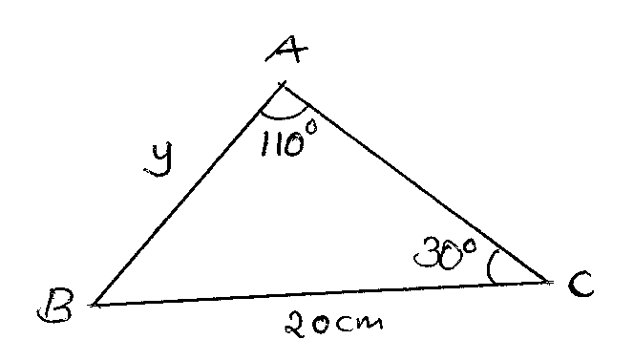

Calculate to one decimal place the length of AB and hence the area of triangle ABC.
(3 mks)

- Find the co-efficient of x³ in the binomial expansion of ${\left(x+ \frac{1}{4}\right)}^{4}$ (3 mks)

- $\vec{OA}$ = 3i + 4j – 6k and $\vec{OB}$ = 2i + 3j + k. Calculate the magnitude of AB correct t 2dp.
(3 mks)

- Solve for the value of M for which $\left(\begin{matrix}M & 4 \\ 1 & M- 3\end{matrix}\right)$ is a simpler matrix. (3 mks)

- If x:y = 9:11, find the ratio(5x – 3y) : (2x + 3y) (3 mks)

- A quantity p varies partly as t and partly as the square of t. when t = 20, p = 45 and when t = 24, p = 60. Find p when t = 32 and t when p = 75. (4 mks)

- Paint A and paint B are sold at sh 600 per litre and sh 250 per litre respectively. A painter bought the two grades of paint and mixed them in a ratio such that by selling the blend at sh 540 per litre, he made a profit of 35%. Determine the ratio in which he mixed paint A to paint B. (3 mks)

- Without using mathematical tables simplify. (4 mks)

$$\frac{2}{3- \sqrt{7}} - \frac{2}{3+ \sqrt{7}}$$

- The equation of a circle centre (a,b) is x² + y² – 6x – 10y + 30 = 0. Find the values of a and b. (3 mks)

- The cost of a minibus was sh 950,000. It depreciated in value by 5% per year of the first two years and 15% per year for the subsequent years. Calculate the value of the minibus after 5 years. (3 mks)

- Use the table below of taxation.

monthly taxable income (ksh) | rate of tax in % in each year
0 – 10164 | 10%
10165 – 19740 | 15%
19741 – 29316 | 20%
29317 – 38892 | 25%
over 38892 | 30%

James is employed as a manager in company x and earns basic salary of Ksh 44,000 per month and house allowance of Ksh 35,000. In addition, he has the following benefits:
- Night watchman Ksh 1,200
- House servant Ksh 1500
- Saloon car Ksh 5800
- Electricity Ksh 1500
- Water Ksh 400
He enjoys monthly personal relief of Ksh 1,162.
- Calculate the taxable pay per month. (2 mks)

- Calculate his monthly PAYE deduction. (6 mks)

- If all the benefits were deducted what would be his taxable income. (2 mks)

- Veterinary researchers were experimenting with a new drug on fowls in a research station. A sample of fowls which were known to have the disease was used. In this sample 30 fowls were treated with the drug and the remaining 18 fowls were not treated.

- Calculate the probability that a fowl selected at random from the sample is:
- Treated with the drug (1 mk)

- Not treated with the drug (1 mk)

- The probability that a fowl treated with the drug will die is ¹/₁₀ while the probability that one which is not treated will die is ⁷/₁₀. Calculate the probability that a fowl picked at random from the sample is:
- Treated with the drug and will die (2 mks)

- Not treated with the drug and will die. (2 mks)

- Not treated with the drug and will not die. (2 mks)

- (a) Complete the table below for the function y = 5x³ – 15x + 17 for -25 < x < 2. (2 mks)

x | -2.5 | -2 | -1.5 | -1 | -0.5 | 0 | 1 | 1.5 | 2
5x³ | -78.125 | -40 |  | -5 |  | 0 | 5 |  | 40
-15x | 37.5 |  | 22.5 |  |  | 0 |  | -22.5
+7 | 7 | 7 | 7 | 7 | 7 | 7 | 7 | 7 | 7
y | -33.625 |  |  | 17 |  | 7 |  |  | 17

(b) Using a scale of 1cm represent 2 on the x-axis and 1cm represent 5 units on the y-axis draw the graph of the function above. (3 mks)

- Use the graph to solve the equation 5x³ – 15x + 7 = 0 (2 mks)

- Find the gradient to the curve at x = +0.5.

- Find the capacity in litres of a bucket 24cm in diameter at the top, 16cm in diameter at the bottom and 18cm deep. (10 mks)

- A certain number of people agreed to contribute equally to buy books worth sh 12,000 for a school library. Five people pulled out so that others agreed to contribute an extra sh 100 each. Their contributions enabled them to buy books worth sh 2000 more than they originally expected.

- If the original number of people was x, write down:
- An expression of how much each was originally to contribute. (1 mk)

- Two distinct expressions of how much each contributed after the five pulled out. (2 mks)

- Calculate the value of x. (3 mks)

- Calculate how much each person was expected to contribute originally. (2 mks)

- (i) The number of people who actually made the contribution and how much per
person. (1 mk)

(ii) The ratio of the supposed original contribution to new contribution. (1 mk)

