SUNSHINE SECONDARY SCHOOL

233/1
FORM 3
CHEMISTRY PAPER 1
END TERM EXAM – OCT. 2015
TIME: 2 HRS

NAME:…………………………………………………….….CLASS:……..ADM NO:……….

For examiners use only

80

- Name the apparatus used to perform the following tasks in the laboratory.
- Keeping substances free from moisture. ……………………………………………….
- Separating immiscible liquids. ………………………………………………………….
- Transferring few drops of liquids to another container. ……………………………….
- The diagram below represents a type of a Bunsen burner flame.
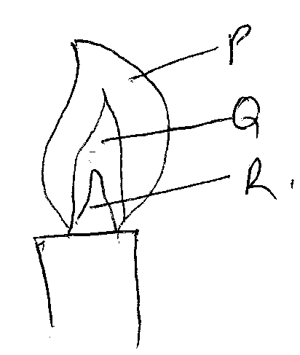
- Name the type of flame above. (1 mk)

…………………………………………………………………………………………………
- Which part is least hot? Explain. (2 mks)
…………………………………………………………………………………………………
………………………………………………………………………………………………….
…………………………………………………………………………………………………
…………………………………………………………………………………………………
- A mixture contains ammonium chloride copper (II) chloride and sodium chloride. Describe how each of the substances can be obtained from the mixture. (3 mks)

…………………………………………………………………………………………………
…………………………………………………………………………………………………
…………………………………………………………………………………………………
…………………………………………………………………………………………………
…………………………………………………………………………………………………
…………………………………………………………………………………………………
…………………………………………………………………………………………………
- (a) State kinetic theory of matter. (1 mk)
…………………………………………………………………………………………………
…………………………………………………………………………………………………
- The diagram shows a curve obtained when water at 20⁰C was heated for 15 minutes.

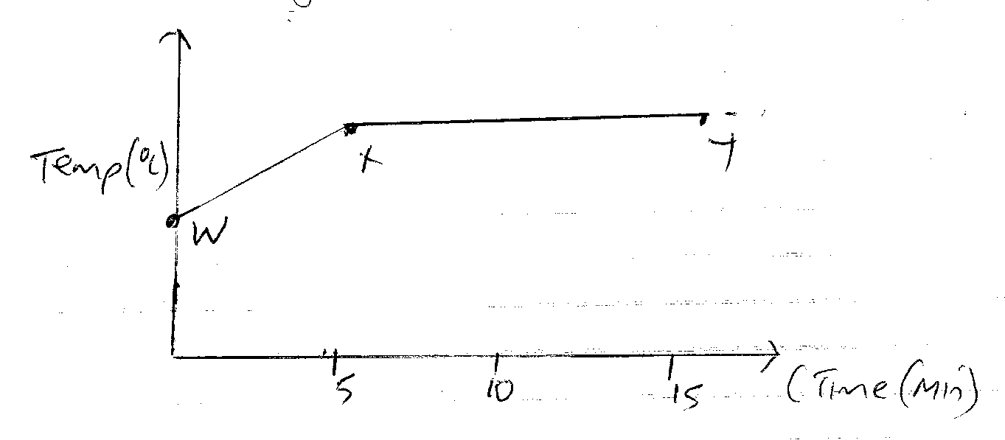
- What happens to water molecules between points W and X.? (1 mk)

…………………………………………………………………………………………………
…………………………………………………………………………………………………
- In which part of the curve does a change of state occur? (1 mk)

…………………………………………………………………………………………………
- Explain why the temperature does not rise between points X and Y. (1 mk)

…………………………………………………………………………………………………
…………………………………………………………………………………………………
- The diagram below shows preparation of oxygen gas. Identify two mistakes with the set up. (2 mks)
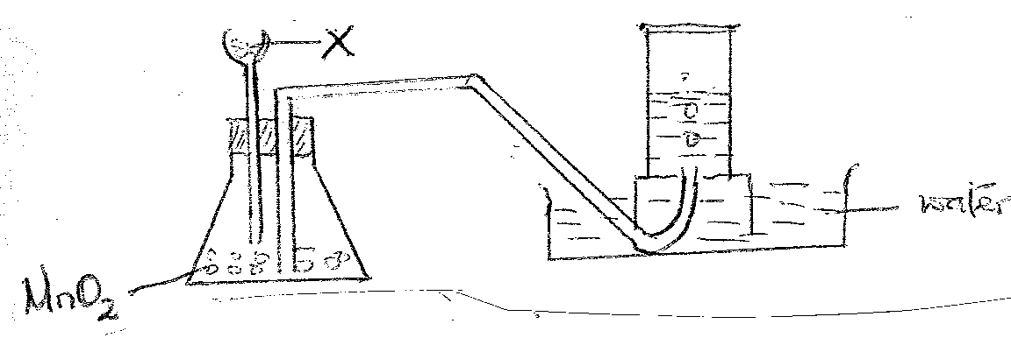

- Name liquid X. (1 mk)
…………………………………………………………………………………………………
- State two industrial uses of oxygen gas. (1 mk)
…………………………………………………………………………………………………
…………………………………………………………………………………………………
- Hydrogen can be prepared in the laboratory by the action of a dilute acid on a metal. Give reasons why the following cannot be used this way.

- Potassium (1 mk)
…………………………………………………………………………………………………
…………………………………………………………………………………………………
- Copper (1 mk)
…………………………………………………………………………………………………
…………………………………………………………………………………………………
- Lead with dilute sulphuric acid. (1 mk)
…………………………………………………………………………………………………
…………………………………………………………………………………………………
- State the confirmatory test for carbon (IV) oxide gas in the laboratory. (1 mk)

…………………………………………………………………………………………………
…………………………………………………………………………………………………
- The diagram below shows how acidic and basic oxides fit into the general family of oxides.

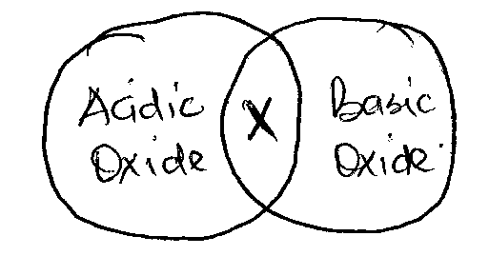

- Give the chemical name used to describe the type of oxides found in the region marked X. (1 mk)

- Name two such oxides that belong to the shaded region X. (1 mk)

…………………………………………………………………………………………………
…………………………………………………………………………………………………
- Name the acidic oxide which dissolves in water to form sulphuric acid. (1 mk)

…………………………………………………………………………………………………
- Write an equation for the reaction between sulphuric acid and the hydroxide used to neutralize soil acidity. (1 mk)

- Commercial hydrochloric acid is about 35% by mass. Calculate its molarity given that at 25⁰C the density of the acid is 1.08g /cm⁻³. (3 mks)

…………………………………………………………………………………………………
…………………………………………………………………………………………………
…………………………………………………………………………………………………
…………………………………………………………………………………………………
…………………………………………………………………………………………………
…………………………………………………………………………………………………
…………………………………………………………………………………………………
- Cynogen is a gaseous compound of carbon and nitrogen only. On complete combustion in oxygen, 250 cm³ of cynogens form 500cm³ of carbon (II) oxide and 250cm³ of nitrogen. Determine the formula of cyanogen. (3 mks)

…………………………………………………………………………………………………
…………………………………………………………………………………………………
…………………………………………………………………………………………………
…………………………………………………………………………………………………
…………………………………………………………………………………………………
…………………………………………………………………………………………………
…………………………………………………………………………………………………
- When 17.12g of sodium nitrate were created in an open test tube, the mass of oxygen gas produced was 1.72g. given the equation of the reaction as:

2NaNO_{3 (s)} 2HaNO_{3(s)} + O_{2 (s)}

Calculate the percentage of sodium nitrate that was converted to sodium nitrate
(Na = 23, N = 14, O = 16) (2 mks)

…………………………………………………………………………………………………
…………………………………………………………………………………………………
…………………………………………………………………………………………………
…………………………………………………………………………………………………
…………………………………………………………………………………………………

- A balloon contains 80 m³ of gas at 30⁰C and 4 atmospheres. Calculate the volume of the balloon at 50⁰C and 2 atmospheres. (2 mks)

…………………………………………………………………………………………………
…………………………………………………………………………………………………
…………………………………………………………………………………………………
…………………………………………………………………………………………………
…………………………………………………………………………………………………
- Determine the volume of 2M HaoH which when diluted to 250cm³ would produce a 0.8M NaoH solution. (2 mks)

…………………………………………………………………………………………………
…………………………………………………………………………………………………
…………………………………………………………………………………………………
…………………………………………………………………………………………………
…………………………………………………………………………………………………
- A volume of 120 cm³ of Nitrogen gas diffused through a membrane in 46 seconds how long will 240cm³ of carbon (VI) oxide diffuse through the same temperature.
(N = 14, C = 12, O = 16) (2 mks)

…………………………………………………………………………………………………
…………………………………………………………………………………………………
…………………………………………………………………………………………………
…………………………………………………………………………………………………
…………………………………………………………………………………………………
…………………………………………………………………………………………………
- A compound of carbon hydrogen and oxygen contains 57.15% carbon, 4.76% hydrogen and the rest oxygen. If its relative molecular mass is 126, find its molecular formula. (2 mks)

…………………………………………………………………………………………………
…………………………………………………………………………………………………
…………………………………………………………………………………………………
…………………………………………………………………………………………………
…………………………………………………………………………………………………
…………………………………………………………………………………………………
…………………………………………………………………………………………………
- Give the I.U.P.A.C. names of the following compounds. (4 mks)
- CH₃CHCHCH₂CH₃

…………………………………………………………………………………………………
…………………………………………………………………………………………………
…………………………………………………………………………………………………
…………………………………………………………………………………………………
…………………………………………………………………………………………………
- CH₃CH(CH₃)CHC₁CH₃

…………………………………………………………………………………………………
…………………………………………………………………………………………………
…………………………………………………………………………………………………
…………………………………………………………………………………………………
…………………………………………………………………………………………………
- CH₃CHBrCHBrCH₃

…………………………………………………………………………………………………
…………………………………………………………………………………………………
…………………………………………………………………………………………………
…………………………………………………………………………………………………
…………………………………………………………………………………………………

- CH₃C(CH₃)₂CHCHCH₃

…………………………………………………………………………………………………
…………………………………………………………………………………………………
…………………………………………………………………………………………………
…………………………………………………………………………………………………
…………………………………………………………………………………………………
- Draw the structural formulaes of the following compounds. (3 mks)
- 2-chloro-3-methlypentane

- Tetrachloromethane

- 1, 2-dibromo-5-methlyhex-3-ene

- Describe how lead carbonate crystals can be prepared from the laboratory. (3 mks)

…………………………………………………………………………………………………
…………………………………………………………………………………………………
…………………………………………………………………………………………………
…………………………………………………………………………………………………
…………………………………………………………………………………………………
…………………………………………………………………………………………………
…………………………………………………………………………………………………
…………………………………………………………………………………………………
…………………………………………………………………………………………………
…………………………………………………………………………………………………

- Give a chemical test that can be used to distinguish C₂H₄ from C₂H₆. (2 mks)

…………………………………………………………………………………………………
…………………………………………………………………………………………………
- The diagram below shows concentric pipes used in extraction of sulphur. (2 mks)
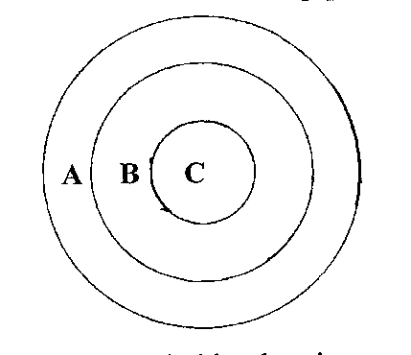
- Name the substance carried by the pipe. (2 mks)
A…………………………………………………………………………………………
C…………………………………………………………………………………………
- Using a diagram, show how sulphur atoms are bonded in sulphur molecule. (2 mks)

- Give two environmental effects of burning sulphur based compounds in the environment. (2 mks)

…………………………………………………………………………………………………
…………………………………………………………………………………………………
…………………………………………………………………………………………………
…………………………………………………………………………………………………
- (a) Complete the diagram below to show how you can electroplate a spoon using copper
sulphate solution.
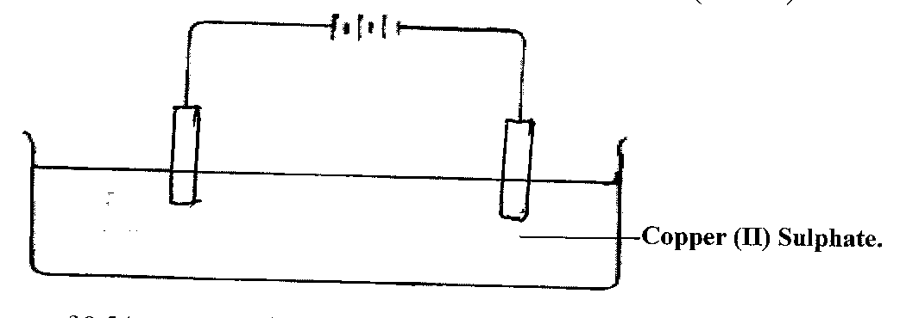
- When an electric current of 0.5A was passed through a molten chloride of J for 32 minutes and 10 seconds, a mass of 0.44g of j was deposited at the cathode. Determine the value of χ if the ion of metal J is represented as J^{x+}. (R.A.M. of J = 44, IF = 96500C)
(3 mks)

…………………………………………………………………………………………………
…………………………………………………………………………………………………
…………………………………………………………………………………………………
…………………………………………………………………………………………………
…………………………………………………………………………………………………
- (a) Give two uses of chlorine. (2 mks)

…………………………………………………………………………………………………
…………………………………………………………………………………………………
(b) Chlorine gas was passed through water and two acids were formed. Identify the acids.
(2 mks)

…………………………………………………………………………………………………
…………………………………………………………………………………………………
- Determine the relative atomic mass of the following elements, whose isotopic mixture occurs in the proportion given. (3 mks)

$${}_{18}^{36}{Ar} \left(0.37\%\right) {}_{ 18}^{38}{Ar} \left(0.06\%\right) {}_{18}^{80}{Ar} (99.6\%)$$

…………………………………………………………………………………………………
…………………………………………………………………………………………………
…………………………………………………………………………………………………
…………………………………………………………………………………………………
…………………………………………………………………………………………………
…………………………………………………………………………………………………
- Study the information below and answer the questions that follow.

Element | Electron Configuration | Ionization Energy
P | 2.1 | 519
Q | 2.8.1 | 494
R | 2.8.8.1 | 418

- What is meant by ionization energy? (1 mk)
…………………………………………………………………………………………………
…………………………………………………………………………………………………
- What is the general name given to group containing P, Q and R.? (1 mk)
…………………………………………………………………………………………………
…………………………………………………………………………………………………
…………………………………………………………………………………………………
- State and explain observations made when a piece of Q is placed on water. (3 mks)
…………………………………………………………………………………………………
…………………………………………………………………………………………………
…………………………………………………………………………………………………
…………………………………………………………………………………………………
…………………………………………………………………………………………………
…………………………………………………………………………………………………
- The atomic mass of element Y is 27. It has 14 neutrons where would you place it in the periodic table.

- Group – ……………………………… (2 mks)

Period – ………………………………

- Write the formula of the compound formed when Y reacts with oxygen. (1 mk)

- Using dots and crosses draw the structures in bonding in the following. (3 mks)
(Si = 14, cl = 17, mg = 12, F = 9, P = 15, H = 1)

- Sicl₄

- MgF₂

- ${pH}_{4}^{+}$

- How would the melting point of Sicl₄ compare to that of SiO₂. Explain your answer. (3 mks)

…………………………………………………………………………………………………
…………………………………………………………………………………………………
…………………………………………………………………………………………………
…………………………………………………………………………………………………
…………………………………………………………………………………………………

