SUNSHINE SCHOOL

233/2
FORM 3
CHEMISTRY PAPER 2
END TERM EXAMS – OCT / NOV 2015
TIME: 2HRS

NAME:…………………………………………………..…CLASS……..ADM NO:………

INSTRUCTIONS
- Write your name and admission number on the spaces provided
- Answer your questions on the spaces provided
- All working must be shown clearly where necessary
- silent electronic calculators may be used

FOR EXAMINERS ONLY

80

- The diagram below shows an experiment carried out by Karimi, a form three student.
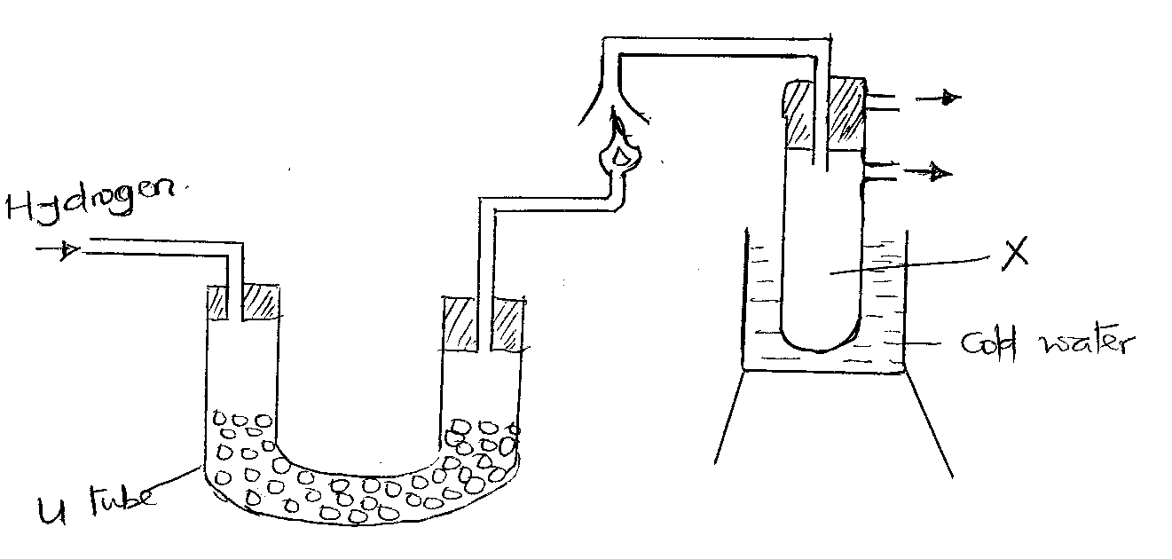
- Name substance X (1mk)
----------------------------------------------------------------------------------------------------------------
----------------------------------------------------------------------------------------------------------------
- Why is the hydrogen gas not lit immediately? (1mk)
------------------------------------------------------------------------------------------------------------------------------------------------------------------------------------------------------------------------------
- Name another substance that can be used instead of the substance in the u-tube for the same purpose. (1mk)
----------------------------------------------------------------------------------------------------------------
----------------------------------------------------------------------------------------------------------------
- State one chemical test for substance X (1mk)
----------------------------------------------------------------------------------------------------------------
----------------------------------------------------------------------------------------------------------------

- State two industrial sources of hydrogen gas on a large scale. (2mks)
--------------------------------------------------------------------------------------------------------------------------------------------------------------------------------------------------------------------------------

- Study the diagram below and use it to answer the questions that follow
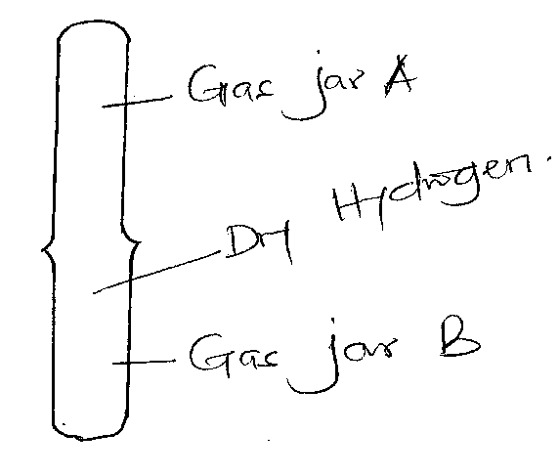
- State observations made when a burning splint after some time. (1mk)
----------------------------------------------------------------------------------------------------------------------------------------------------------------------------------------------------------------------------
- What conclusion can you make about the density of hydrogen gas. (1mk)
-------------------------------------------------------------------------------------------------------------------------------------------------------------------------------------------------------------------------------
- Study the diagram below and answer the questions that follow
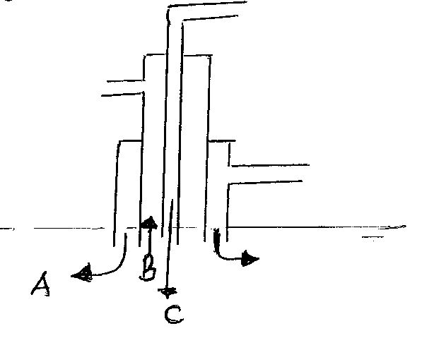
- State the substances that pass through tubes
A ------------------------------------------------------------------------------------------ (1mk)
B --------------------------------------------------------------------------------------------- (1mk)
C ---------------------------------------------------------------------------------------------- (1mk)
- At the tank water (froths and sulphur are collected. Suggest how the water is removed.
(1mk)
--------------------------------------------------------------------------------------------------------------------------------------------------------------------------------------------------------------------------------
- Explain how the molten sulphur is forced up (1mk)
--------------------------------------------------------------------------------------------------------------------------------------------------------------------------------------------------------------------------------
- The follow chart shows the industrial manufacture of sulphuric (vi) acid
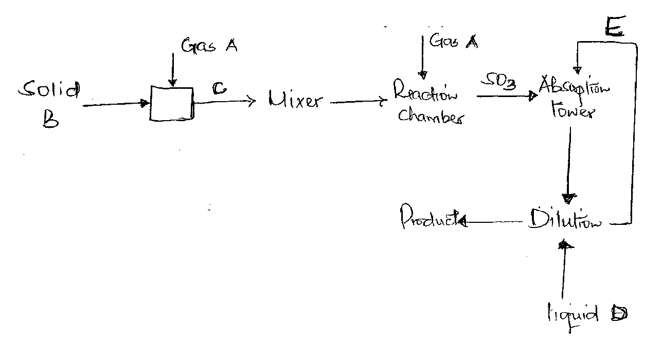
Identify (4mks)
- i) Solid B
-----------------------------------------------------------------------------------------------------------
ii) Gas C
---------------------------------------------------------------------------------------------------------
iii) substance E
---------------------------------------------------------------------------------------------------------
iv) Catalyst used in reaction chamber (1mk)
------------------------------------------------------------------------------------------------------------
- Write equations for reaction in (2mks)
- Reaction chamber
------------------------------------------------------------------------------------------------------------------------------------------------------------------------------------------------------------------------

- Dilution chamber
----------------------------------------------------------------------------------------------------------------------------------------------------------------------------------------------------------------------
- Explain what you observe when concentrated sulphuric acid is added to sugar. (2mks)
------------------------------------------------------------------------------------------------------------------------------------------------------------------------------------------------------------------------------------------------------------------------------------------------------------------------------------------------------------------------------------------------------------------------------------------------
- State two uses of sulphuric (vi) acid (2mks)
-------------------------------------------------------------------------------------------------------------------------------------------------------------------------------------------------------------------------------
- The set up below was used to study some properties of air
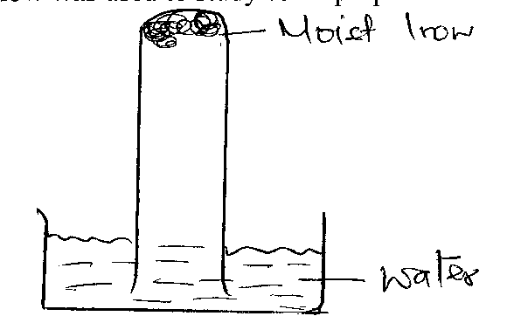
- Draw another diagram to show the level of water in the test tube after 24 hours. (2mks)

- Explain the observation made (1mk)
--------------------------------------------------------------------------------------------------------------------------------------------------------------------------------------------------------------------------------
- State and explain one observation made in moist iron after 24 hours. (1mk)
-------------------------------------------------------------------------------------------------------------------------------------------------------------------------------------------------------------------------------
- Study the flow chart and answer the questions that follow
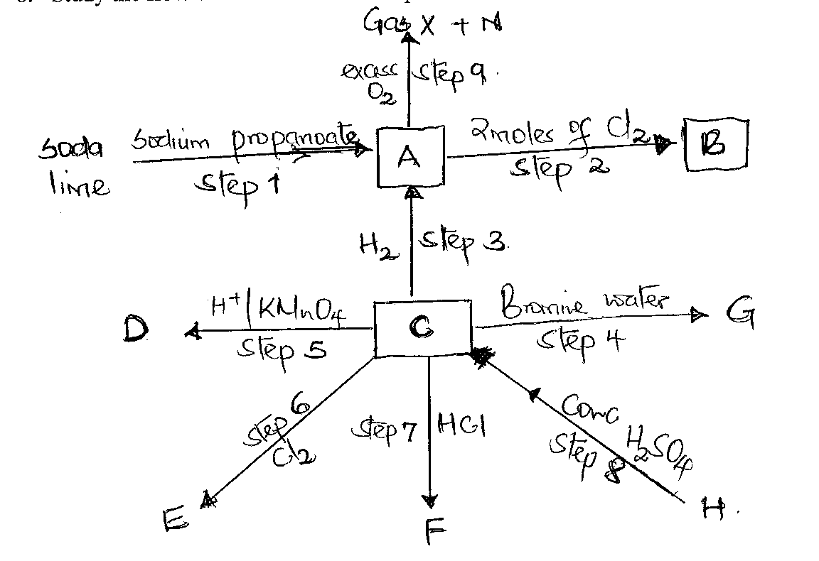
- Name the compounds (3mks)
- A -------------------------------------------------------------
- B -------------------------------------------------------------
- C --------------------------------------------------------------
- D ----------------------------------------------------------------
- H ---------------------------------------------------------------
- G ---------------------------------------------------------------
ii) Write a balanced equation for the reactions in (3mks)
- Step I---------------------------------------------------------------------------------------------------------------------------------------------------------------------------------------------------------------
- Step a --------------------------------------------------------------------------------------------------------------------------------------------------------------------------------------------------------------
Step 7 ---------------------------------------------------------------------------------------------------------------------------------------------------------------------------------------------------------------
Iii) Give the conditions for reactions in
- Step 3 (1mk)
---------------------------------------------------------------------------------------------------------------------------------------------------------------------------------------------------------
- Step 2 (1mk)
-----------------------------------------------------------------------------------------------------------------------------------------------------------------------------------------------------------------------
- Draw the structural formulae and give the I.U.P.A.C names of the positional isomers of hex-l-ene. (2mks)

- Give the name of the processes and reactions taking place in (4mks)
- step 9 ----------------------------------------------------------------------------------------------------
- step 3 --------------------------------------------------------------------------------------------------
- step 2 ------------------------------------------------------------------------------------------------
- step 6 -----------------------------------------------------------------------------------------------
- Describe a chemical test that can be used to test for Gas x in the laboratory. (2mks)
------------------------------------------------------------------------------------------------------------------------------------------------------------------------------------------------------------------------------------------------------------------------------------------------------------------------------------------------

- a) Study the chart below and answer the questions that follow
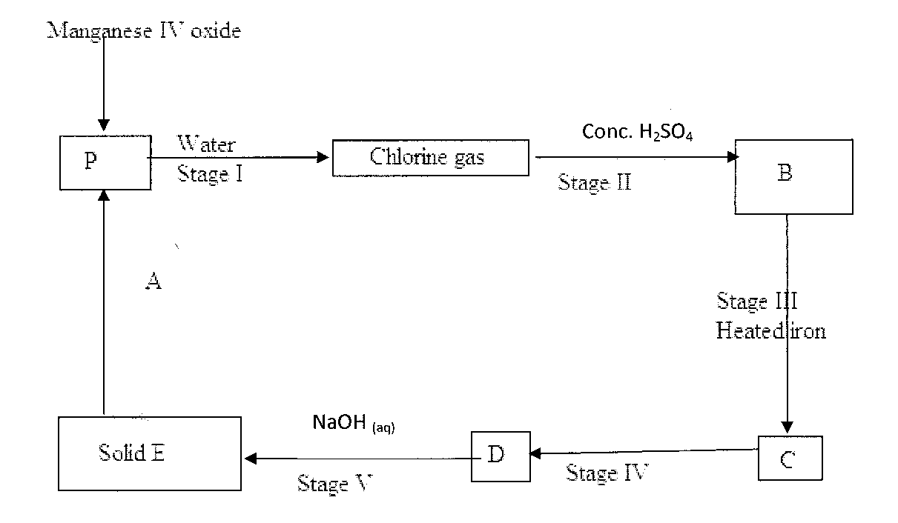
i) State the use of water in stage I (1mk)
-------------------------------------------------------------------------------------------------------------------
------------------------------------------------------------------------------------------------------------------
ii) identify substances (3mks)
A ---------------------------------------------------------------------------------------------------------------
C ---------------------------------------------------------------------------------------------------------------
E -----------------------------------------------------------------------------------------------------------------
iii) Write the equation for the formation of substance C (1mk)
------------------------------------------------------------------------------------------------------------------
------------------------------------------------------------------------------------------------------------------

- The flow chart below shows the processes involved in the manufacture of sodium carbonate
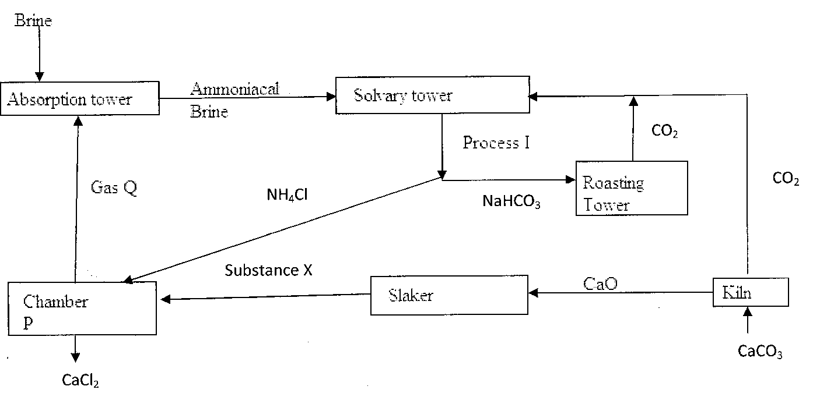
i) Name process I (1mk)
-----------------------------------------------------------------------------------------------------------
- identify
- Gas Q ---------------------------------------------------------------------------------
- Substance x ---------------------------------------------------------------------------------
- Carbon IV oxide is produced at the kiln by thermal decomposition of calcium carbonate. Other the decomposition of calcium carbonate, write an equation for the reaction that also produces carbon IV oxide at the kiln (1mk)
--------------------------------------------------------------------------------------------------------------------------------------------------------------------------------------------------------------
iv) Give two industrial uses of sodium carbonate (2mks)
-------------------------------------------------------------------------------------------------------------------------------------------------------------------------------------------------------------

- a) Why is it not advisable to use dilute sulphuric (vi) acid and calcium carbonate when preparing calcium sulphate. (2mks)
------------------------------------------------------------------------------------------------------------------------------------------------------------------------------------------------------------------------------------------------------------------------------------------------------------------------------------------------
b) Why is not advisable to heat saturated zinc sulphate solution to dryness when preparing zinc sulphate crystals. (2mks)
------------------------------------------------------------------------------------------------------------------------------------------------------------------------------------------------------------------------------------------------------------------------------------------------------------------------------------------------
- Describe how you can prepare a sample of lead (ii) chloride starting with lead (ii) oxide. (3mks)
-----------------------------------------------------------------------------------------------------------------------------------------------------------------------------------------------------------------------------------------------------------------------------------------------------------------------------------------------------------------------------------------------------------------------------------------------
9.
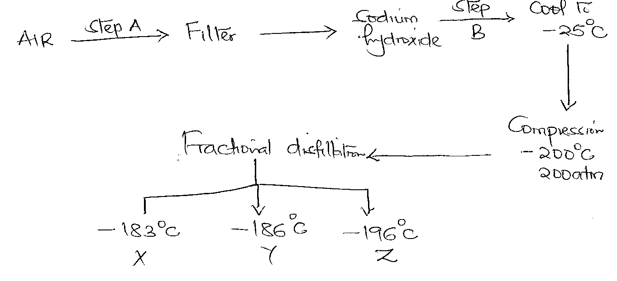
- Name the substances removed through steps (3mks)
A-----------------------------------------------------------------------------------------------------B ----------------------------------------------------------------------------------------------------
C-----------------------------------------------------------------------------------------------------

- Name one other substance that can be word in place of sodium hydroxide. (1mk)
------------------------------------------------------------------------------------------------------------------------------------------------------------------------------------------------------------
- Aqueous copper (ii) sulphate was electrolysed using the set up below
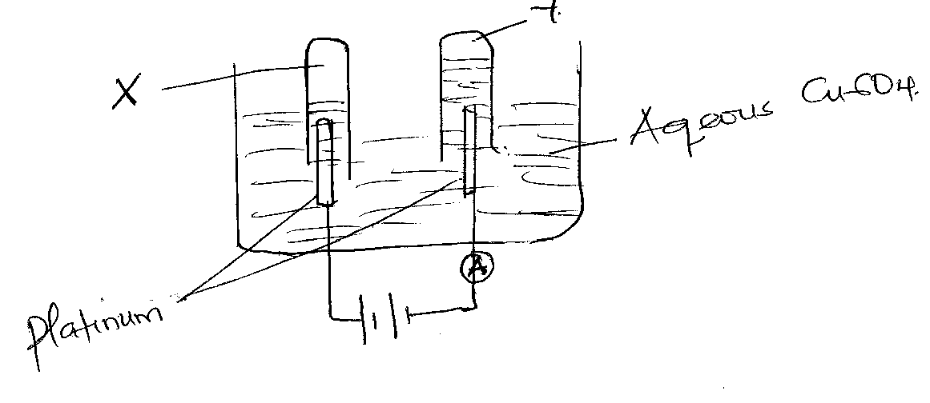
- Identify gas (2mks)
- X ----------------------------------------------------------------------------------------
- Y --------------------------------------------------------------------------------------
- Write the half equations for the production of
a)gas X-----------------------------------------------------------------------------------
b) gas Y --------------------------------------------------------------------------------
ii) An element P has relative atomic mass of 44 when current of 0.5 Amperes was passed through fused chloride of P for 32 minutes and 10 seconds 0.22 g of P were deposited at the cathode. Determine the charge on the ion of P ( If = 96500 C ). (3mks)

------------------------------------------------------------------------------------------------------------------------------------------------------------------------------------------------------------------------------------------------------------------------------------------------------------------------------------------------------------------------------------------------------------------------------------------------------------------------------------------------------------------------------------------------------------
iii) An iron spoon is to be electroplated with sil. Draw a labeled diagram to represent the apparatus that could be used to carry out the process. (4mks)

