**NAME: ………………………………………..……………….…… INDEX NO: …………………….……**

**SCHOOL: ………………………………………………………….. DATE: ……………..……….………**

**CANDIDATE’S SIGNATURE: ……………….….….……………**

**443/1**

**AGRICULTURE**

**PAPER 1**

**TIME: 2 HOURS**

**NZAUI SUB COUNTY FORM 4 ENTRANCE EXAM 2015**

***Kenya Certificate of Secondary Education (K.C.S.E)***

**443/1**

**AGRICULTURE**

**PAPER 1**

**TIME: 2 HOURS**

**INSTRUCTIONS TO CANDIDATES:**

* *Write your* ***name*** *and* ***index number*** *in the spaces provided above.*
* *Sign and write the date of examination in the spaces provided above.*
* *This paper consists of three section* ***A,B*** *and* ***C***
* *Answer* ***all*** *the questions in section* ***A*** *and* ***B***
* *Answer any* ***two*** *questions in section* ***C.***
* *Answers should be written in the spaces provided in this booklet.*
* *This paper consists of 10 printed pages. Candidates should check to ascertain that all pages are printed as indicated and that no questions are missing.*

**FOR EXAMINERS USE ONLY**

|  |  |  |  |
| --- | --- | --- | --- |
| **SECTION** | **QUESTIONS** | **MAX SCORE** | **CANDIDATES SCORE** |
| **A** | **1-15** | **30** |  |
| **B** | **16 - 19** | **20** |  |
| **C** |  | **20** |  |
|  | **20** |  |
| **TOTAL** | **Total score** | **90** |  |

**SECTION A (30 MARKS)**

Answer all the questions in this section in the spaces provide.

1. List down **four** aspects of rainfall that affect agriculture (2marks)

………………………………………………………………………………………………………………………………………………………………………………………………………………………………

1. State **three** objectives of land settlement in Kenya (1½ marks)

………………………………………………………………………………………………………………………………………………………………………………………………………………………………………………………………………………………………………………………………………………

1. Why is burning of vegetation not recommended when clearing land? Give **four** reasons (2marks)

………………………………………………………………………………………………………………………………………………………………………………………………………………………………………………………………………………………………………………………………………………

………………………………………………………………………………………………………………………………………………………………………………………………………………………………

1. State **two** effects of early defoliation (1mark)

………………………………………………………………………………………………………………………………………………………………………………………………………………………………

1. Identify **three** natural factors that influence soil erosion (1½ marks)

………………………………………………………………………………………………………………………………………………………………………………………………………………………………………………………………………………………………………………………………………………

1. Give **four** ways of controlling weeds in a maize field (2marks)

………………………………………………………………………………………………………………………………………………………………………………………………………………………………………………………………………………………………………………………………………………………………………………………………………………………………………………………………

1. Differentiate between agro forestry and organic farming (2marks)

………………………………………………………………………………………………………………………………………………………………………………………………………………………………………………………………………………………………………………………………………………

1. State **two** harmful effects of strong wind on crop production (1mark)

………………………………………………………………………………………………………………………………………………………………………………………………………………………………

1. Give **two** situations in which opportunity cost can be equal to zero (1mark)

………………………………………………………………………………………………………………………………………………………………………………………………………………………………

1. Why is it necessary to allow freshly cut sorghum (Columbus grass) to wilt before feeding it to livestock

(1mark)

………………………………………………………………………………………………………………………………………………………………………………………………………………………………

1. Give **two** roles of micro organisms in the soil that are beneficial to crops (1mark)

………………………………………………………………………………………………………………………………………………………………………………………………………………………………

1. State **two** causes of tomato wilting despite adequate watering (1mark)

………………………………………………………………………………………………………………………………………………………………………………………………………………………………

1. State **four** reasons why sub-soiling is carried out (2marks)

………………………………………………………………………………………………………………………………………………………………………………………………………………………………………………………………………………………………………………………………………………

………………………………………………………………………………………………………………………………………………………………………………………………………………………………

1. Give **four** characteristics of a good root stock for grafting (2marks)

………………………………………………………………………………………………………………………………………………………………………………………………………………………………………………………………………………………………………………………………………………

………………………………………………………………………………………………………………

1. Name **four** types of land which may require reclamation (2marks)

………………………………………………………………………………………………………………………………………………………………………………………………………………………………

………………………………………………………………………………………………………………………………………………………………………………………………………………………………

1. State **four** factors that influence the spacing of annual crop (2marks)

………………………………………………………………………………………………………………………………………………………………………………………………………………………………

………………………………………………………………………………………………………………………………………………………………………………………………………………………………

1. What factors would a farmer consider in identifying a farming system? Give **two (**1mark)

………………………………………………………………………………………………………………………………………………………………………………………………………………………………………………………………………………………………………………………………………………

1. Identify **one** reason why carrots should not be delayed in harvesting (1mark)

………………………………………………………………………………………………………………………………………………………………………………………………………………………………

1. List **two** categories of insect pests that affect crops (1mark)

………………………………………………………………………………………………………………………………………………………………………………………………………………………………

1. State **four** factors that may influence the quality of silage (2marks)

………………………………………………………………………………………………………………………………………………………………………………………………………………………………

………………………………………………………………………………………………………………………………………………………………………………………………………………………………

**SECTION B (20 MARKS**)

**(answer all the questions in this section in the spaces provided)**

21.The diagram illustrates a maize cob attacked by a disease study it carefully and answer the questions that follow;



1. Identify the disease (1mark)

………………………………………………………………………………………………………………………………………………………………………………………………………………………………

1. Name the causal organism of the above disease (1mark)

………………………………………………………………………………………………………………

………………………………………………………………………………………………………………

1. State three cultural methods of controlling the disease (3marks)

………………………………………………………………………………………………………………………………………………………………………………………………………………………………………………………………………………………………………………………………………………

22. a) Define the term plant population (1mark)

………………………………………………………………………………………………………………………………………………………………………………………………………………………………

………………………………………………………………………………………………………………

b) Calculate the plant population per hectare of a maize crop planted at a spacing of 100cmΧ50cm. (show your working) (3marks)

………………………………………………………………………………………………………………………………………………………………………………………………………………………………

………………………………………………………………………………………………………………………………………………………………………………………………………………………………

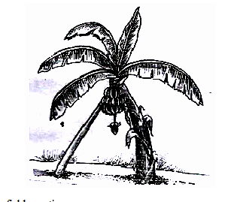23.The diagram below illustrates a field management practice carried out on some crops. Use it to answer the questions that follow.

Stick

a) Identify the field practice (1mark)

………………………………………………………………………………………………………………

………………………………………………………………………………………………………………

b) State two conditions that necessitate the use of the above practice. (2marks)

………………………………………………………………………………………………………………

………………………………………………………………………………………………………………

c) Apart from the above illustrated crop, give two other crops which the practice applies (2marks)

………………………………………………………………………………………………………………

………………………………………………………………………………………………………………

24. Below are methods of drainage labelled P and Q.Use the diagrams to answer the questions that follow.

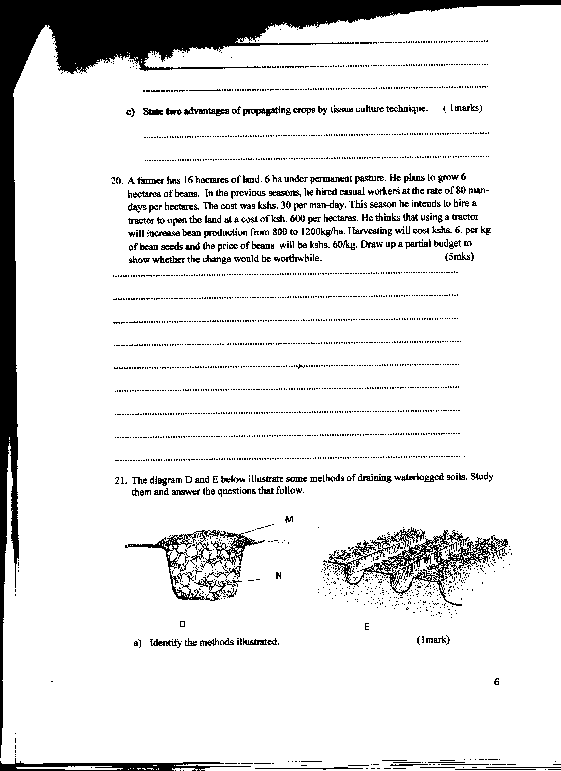

Q

P

b

a

a) Identify the diagrams marked P and Q respectively; (2marks)

P ……………………………………….………………………

Q ………………………………………………………………..

b) Name the parts in diagram P labelled a and b (2marks)

a ……………………………………….………………………

b ……………………………………….………………………

1. Apart from the above illustrated diagrams give two other methods of draining water from a

waterlogged area (2marks)

………………………………………………………………………………………………………………

………………………………………………………………………………………………………………

**SECTION C (40 MARKS)**

**Answer Any TWO Questions From This Section In The Spaces Provided**

25. a) Describe the factors which determine the stage of harvesting crops (5marks)

b) Discuss the factors contributing to competitive abilities of weeds. (6marks)

c) Explain **five** objectives of the million acre scheme (5marks)

d) Describe the role of phosphorus in crop production (4marks)

26. a) Describe the procedure of transplanting tomato seedlings. (8marks)

b) Discuss the harvesting of sugarcane (6marks)

c) Describe the stages followed in water treatment on the farm (6marks)

27. a) State and explain **five** cultural methods of diseases control in crop production (10marks)

b) Explain **five** advantages of mixed stand pastures (5marks)

c) Discuss the factors to consider before choosing an irrigation system (5marks)

………………………………………………………………………………………………………………………………………………………………………………………………………………………………

………………………………………………………………………………………………………………………………………………………………………………………………………………………………

………………………………………………………………………………………………………………………………………………………………………………………………………………………………

………………………………………………………………………………………………………………………………………………………………………………………………………………………………

………………………………………………………………………………………………………………………………………………………………………………………………………………………………

………………………………………………………………………………………………………………………………………………………………………………………………………………………………

………………………………………………………………………………………………………………………………………………………………………………………………………………………………

………………………………………………………………………………………………………………………………………………………………………………………………………………………………

………………………………………………………………………………………………………………………………………………………………………………………………………………………………

………………………………………………………………………………………………………………………………………………………………………………………………………………………………

………………………………………………………………………………………………………………………………………………………………………………………………………………………………

………………………………………………………………………………………………………………………………………………………………………………………………………………………………

………………………………………………………………………………………………………………………………………………………………………………………………………………………………

………………………………………………………………………………………………………………………………………………………………………………………………………………………………

………………………………………………………………………………………………………………………………………………………………………………………………………………………………

………………………………………………………………………………………………………………………………………………………………………………………………………………………………

………………………………………………………………………………………………………………………………………………………………………………………………………………………………

………………………………………………………………………………………………………………………………………………………………………………………………………………………………

………………………………………………………………………………………………………………………………………………………………………………………………………………………………

………………………………………………………………………………………………………………………………………………………………………………………………………………………………

………………………………………………………………………………………………………………………………………………………………………………………………………………………………

………………………………………………………………………………………………………………………………………………………………………………………………………………………………

………………………………………………………………………………………………………………………………………………………………………………………………………………………………

………………………………………………………………………………………………………………………………………………………………………………………………………………………………

………………………………………………………………………………………………………………………………………………………………………………………………………………………………

………………………………………………………………………………………………………………………………………………………………………………………………………………………………

………………………………………………………………………………………………………………………………………………………………………………………………………………………………

………………………………………………………………………………………………………………………………………………………………………………………………………………………………

………………………………………………………………………………………………………………………………………………………………………………………………………………………………