Name: …………………………………………………………… Index no ………....................................

School: …………………………………………………………. Candidate’s sign…….....…...…........…

Date: ……………………………………………………………

443/2
AGRICULTURE
PAPER 2
TIME: 2 HOURS

NZAUI SUB COUNTY FORM 4 ENTRANCE EXAM 2015

Kenya Certificate of Secondary Education (K.C.S.E.)

AGRICULTURE
PAPER 2
2 HOURS

INSTRUCTIONS TO CANDIDATES:

- Write your name, index number and the name of your school in the spaces provided.
- Sign and write the date of the examination in the spaces provided.
- This paper consists of three sections; A, B and C.
- Answer all questions in section A and B.
- Answer any two questions in section C in the spaces provided.
- This paper consists of 8 printed pages. Candidates should check the question paper to ascertain that all pages are printed as indicated and that no questions are missing

For Examiner’s Use Only

SECTION | QUESTION | MAXIMUM  SCORE | CANDIDATE’S SCORE
A | 1 – 16 | 30
B | 17 -20 | 20
C |  | 20
 |  | 20
 | TOTAL SCORE | 90

SECTION A. (30MARKS)
Answer ALL the questions in this section in the spaces provided.

- Name two pairs of farm tools which are used together during routine management practices in livestock. (2marks)
………………………………………………………………………………………………………………………………………………………………………………………………………………………………
- Name two dual purpose sheep breeds. (1mark)
………………………………………………………………………………………………………………………………………………………………………………………………………………………………
- Give four advantages of using thatch as a roofing material in farm structures (2marks)

………………………………………………………………………………………………………………………………………………………………………………………………………………………………………………………………………………………………………………………………………………………………………………………………………………………………………………………………

- State two characteristics of concentrates (1mark)

……………………………………………………………………………………………………………………………………………………………………………………………………………………………
- State the gestation period of the following animals. (1½ marks)
- Sow ……………………………………………….
- Cow ……………………………………………….
- Doe/nanny ………………………………………………..
- State four advantages of artificial calf rearing in dairy cattle management. (2marks) ………………………………………………………………………………………………………………………………………………………………………………………………………………………………………………………………………………………………………………………………………………………………………………………………………………………………………………………………
- How does isolation help in controlling diseases in livestock. (1marks) ………………………………………………………………………………………………………………………………………………………………………………………………………………………………
- List three biotic factors which affect livestock production in Kenya. (1½ marks)
………………………………………………………………………………………………………………………………………………………………………………………………………………………………………………………………………………………………………………………………………………………………………………………………………………………………………………………………

- State four signs of parturition shown by a sow ( 2marks) ………………………………………………………………………………………………………………………………………………………………………………………………………………………………………………………………………………………………………………………………………………………………………………………………………………………………………………………………
- State four physiological body processes used as indicators of ill health (2marks) ………………………………………………………………………………………………………………………………………………………………………………………………………………………………………………………………………………………………………………………………………………………………………………………………………………………………………………………………
- Name two diseases that affect bees. (1mark)
………………………………………………………………………………………………………………………………………………………………………………………………………………………………
- State four symptoms shown by poultry when suffering from Newcastle diseases. (2marks)
………………………………………………………………………………………………………………………………………………………………………………………………………………………………………………………………………………………………………………………………………………………………………………………………………………………………………………………………
- Give four factors that one should consider when sitting a fish pond on a farm. (2marks)
………………………………………………………………………………………………………………………………………………………………………………………………………………………………………………………………………………………………………………………………………………………………………………………………………………………………………………………………
- State four features of an ideal rabbit hutch. (2marks)
………………………………………………………………………………………………………………………………………………………………………………………………………………………………………………………………………………………………………………………………………………………………………………………………………………………………………………………………
- List four physical methods used to control ticks. (2marks)
………………………………………………………………………………………………………………………………………………………………………………………………………………………………………………………………………………………………………………………………………………………………………………………………………………………………………………………………
- Give three reasons for spreading a polythene paper on the slab of a building (1½ marks)
………………………………………………………………………………………………………………………………………………………………………………………………………………………………………………………………………………………………………………………………………………………………………………………………………………………………………………………………

- State two functions of the guard rails in a furrowing pen. (1mak)
………………………………………………………………………………………………………………………………………………………………………………………………………………………………
- Give two functions of a footbath in a plunge dip. (1mark)
………………………………………………………………………………………………………………………………………………………………………………………………………………………………
- What is flushing as used in livestock production? ( ½ mark)
………………………………………………………………………………………………………………………………………………………………………………………………………………………………
- Give two uses of a crush in livestock production. (1mark)
………………………………………………………………………………………………………………………………………………………………………………………………………………………………

SECTION B (20 MARKS)
Answer All Questions In This Section In The Spaces Provided.
21. a) Using the Pearson’s square method, compute a 300Kg ration with 24% DCP from wheat containing
64% DCP. Show your working. (4marks)

………………………………………………………………………………………………………………………………………………………………………………………………………………………………………………………………………………………………………………………………………………………………………………………………………………………………………………………………………………………………………………………………………………………………………………………………………………………………………………………………………………………………
b) Give two factors to consider when formulating livestock ration in a farm. (1mark) ………………………………………………………………………………………………………………………………………………………………………………………………………………………………
22. The diagram below shows a certain practice carried out on a pig.
50
40
20
10
4
3
1
2

- Identify the practice illustrated above (1mk)
………………………………………………………………………………………………………………………………………………………………………………………………………………………………
- Draw another illustration depicting pig number 37. (1mark)

- Name the tool used to carry out the practice illustrated above. (1mark)
………………………………………………………………………………………………………………………………………………………………………………………………………………………………
- State the other methods of identifying a piglet. (2marks)
………………………………………………………………………………………………………………………………………………………………………………………………………………………………
23.The diagram below shows the cross-section of a house under construction. Study it carefully and answer the questions that follow.
Y
Z

- Assuming that the wooden beams are strong enough to hold the root load, what is the most likely thing to happen when the root load effected pressure at point Y and Z (1mark)
……………………………………………………………………………………………………………………………………………………………………………………………………………………………
- On the diagram provided, draw and label two construction features you would add to this structure in order to make it more efficient. (2marks)
- State two importances of the fascia board in the farm building. (2marks)
………………………………………………………………………………………………………………………………………………………………………………………………………………………………
24. Diagrams M, N, P and Q represents farm tools.
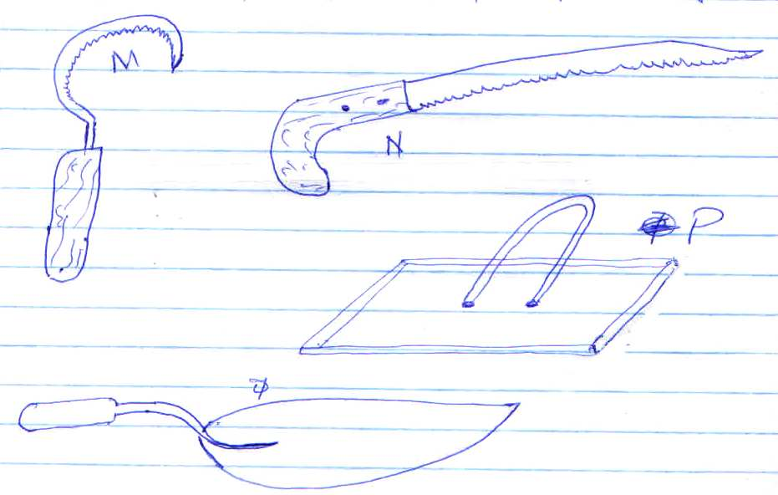
M

N
P

Q

a) Identify the tools shown above. (2marks) ………………………………………………………………………………………………………………………………………………………………………………………………………………………………………………………………………………………………………………………………………………………………………………………………………………………………………………………………
b) Give the use of each of the above named tools. (2marks)
M ………………………………………………………………………….….
N ………………………………………………………………………….….
P ………………………………………………………………………….….
Q ………………………………………………………………………….….
- State two maintenance practices carried out on tool M. (1mark)
………………………………………………………………………………………………………………………………………………………………………………………………………………………………

SECTION C (40 MARKS)
Answer any two questions from this section
25. (a) Describe the management practices carried out on an in calf cow during parturition. (10 marks)
(b) Explain five factors that one should consider when selecting materials for constructing a piggery
unit. (10marks)
26. (a) Outline TEN advantages of fences on a farm (10marks)
(b) Give TEN general characteristics of beef cattle (10marks)
27. (a) Outline management practices carried out in a fish pond to ensure maximum harvest of fish
(7marks)
(b) Explain SIX effects of parasites in livestock (6marks)
(c) Outline SEVEN control measure of tapeworms (7marks)

………………………………………………………………………………………………………………………………………………………………………………………………………………………………………………………………………………………………………………………………………………………………………………………………………………………………………………………………………………………………………………………………………………………………………………………………………………………………………………………………………………………………………………………………………………………………………………………………………………………………………………………………………………………………………………………………………………………………………………………………………………………………………………………………………………………………………………………………………………………………………………………………………………………………………………………………………………………………………………………………………………………………………………………………………………………………………………………………………………………………………………………………………………………………………………………………………………………………………………………………………………………………………………………………………………………………………………………………………………………………………………………………………………………………………………………………………………………………………………………………………………………………………………………………………………………………………………………………………………………………………………………………………………………………………………………………………………………………………………………………………………………………………………………………………………………………………………………………………………………………………………………………………………………………………………………………………………………………………………………………………………………………………………………………………………………………………………………………………………………………………………………………………………………………………………………………………………………………………………………………………………………………………………………………………………………………………………………………………………………………………………………………………………………………………………………………………………………………………………………………………………………………………………………………………………………………………………………………………………………………………………………………………………………………………………………………………………………………………………………………………………………………………………………………………………………………………………………………………………………………………………………………………………………………………………………………………………………………………………………………………………………………………………………………………………………………………………………………………………………………………………………………………………………………………………………………………………………………………………………………………………………………………………………………………………………………………………………………………………………………………………………………………………………………………………………………………………………………………………………………………………………………………………………………………………………………………………………………………………………………………………………………………………………………………………………………………………………………………………………………………………………………………………………………………………………………………………………………………………………………………………………………………………………………………………………………………………………………………………………………………………………………………………………………………………………………………………………………………………………………………………………………………………………………………………………………………………………………………………………………………………………………………………………………………………………………………………………………………………………………………………………………………………………………………………………………………………………………………………………………………………………………………………………………………………………………………………………………………………………………………………………………………………………………………………………………………………………………………………………………………………………………………………………………………………………………………………………………………………………………………………………………
………………………………………………………………………………………………………………………………………………………………………………………………………………………………………………………………………………………………………………………………………………………………………………………………………………………………………………………………

