Name: ………………………………………………………………… ADMIN No: …………………..……………
School: ………………………………………….……………………. Candidate’s Signature: ……...……………
Date: ……………….…………..……………….…………………….

232/2
PHYSICS
Paper 2
(THEORY)
Time: 2 Hours

NZAUI SUB COUNTY FORM 4 ENTRANCE EXAM 2015
Kenya Certificate of Secondary Education (K.C.S.E)

PHYSICS
Paper 2
Time: 2 Hours

INSTRUCTIONS TO CANDIDATES:-
- Write your name, Admin number and school in the spaces provided above.
- This paper consists of two sections; A and B
- Answer all the questions in section A and B in the spaces provided
- All working must be clearly shown.
- Mathematical tables and electronic calculators may be used
- Take the earth’s gravitational field strength g = 10 m/s².
- This paper consists of 10 printed pages. Candidates should check to ascertain that all pages are printed as
indicated and that no questions are missing.

For Examiner’s Use Only:
Section | Question | Maximum  Score | Candidate’s  Score
A | 1 – 14 | 25
 | 15 | 11
 | 16 | 10
B | 17 | 12
 | 18 | 11
 | 19 | 11
Total Score |  | 80

SECTION A (25 MARKS) Answer all the questions in this section.
- State one method of varying the size of the image formed by a pin hole camera. (1 Mark)
__________________________________________________________________________________________
__________________________________________________________________________________________
- Figure 1 shows a point O placed in front of a plane mirror, M
M
O
Figure 1

By use of two rays, complete the diagram to show the position of the image. (2 Marks)
- Give a reason why soft iron is used as the core of the coil of an electric bell. (1 Mark)
__________________________________________________________________________________________
__________________________________________________________________________________________
- An electric bulb is rated 75W, 240V. Determine the resistance of the bulb (3 Marks)
__________________________________________________________________________________________
__________________________________________________________________________________________
__________________________________________________________________________________________
__________________________________________________________________________________________
- Figure 2 shows a ray of light passing into a glass block ABC.
45⁰
45⁰
A
C
B

Sketch the path of the ray until it goes out of the block (critical angle of glass is 42⁰) (3 Marks)
- Recharging is one of the practices of one maintainance of accumulators. State measurement which need to be taken to help you decide when an accumulator is due for charging. (1 Mark)
__________________________________________________________________________________________
__________________________________________________________________________________________
- The figure 3 below shows how to magnetize a u-shaped magnetic bar by use of electric current.
+
-
Magnetic bar
X
Y

Figure 3
Draw the magnetic field pattern between poles X and Y (2 Marks)
- When a highly charged polythene rod is brought close to a positively charged leaf electroscope, it is observed that the leaf initially falls and then rises.
- State the charge on the polythene rod. (1 Mark)
________________________________________________________________________________________
________________________________________________________________________________________
- Explain your answer in (a) above. (1 Mark)
________________________________________________________________________________________
________________________________________________________________________________________
- In a certain pinhole camera the screen is 10cm from the pinhole. When the camera is placed 6m away from a tree, a sharp image of the tree 16cm high is formed on the screen. Determine the height of the tree. (3 Marks)
________________________________________________________________________________________
________________________________________________________________________________________
________________________________________________________________________________________
________________________________________________________________________________________
________________________________________________________________________________________
________________________________________________________________________________________
- Explain in terms of domain theory of magnetism what happens when a bar magnet is placed in a solenoid in which an alternating current flows. (1 Mark)
________________________________________________________________________________________
________________________________________________________________________________________
________________________________________________________________________________________
- The figure 4 below shows a transparent water tank water. An electric lamp surrounded by a shield with a narrow slit is fixed at corner A of the tank. A ray of light from the slit shines on the water surface BC at an angle of 48⁰. (Refractive index of water is 1.33)
B
C
A
D
48⁰
Water

Figure 4
Determine the angle of refraction (2 Marks)
________________________________________________________________________________________
________________________________________________________________________________________
________________________________________________________________________________________
- State how to minimize polarization in a simple cell. (1 Mark)
________________________________________________________________________________________
________________________________________________________________________________________
- What happens to the wavelength of water waves when it moves from deep part to shallow part of a ripple tank.
(1 Mark)
________________________________________________________________________________________
________________________________________________________________________________________
________________________________________________________________________________________

- Give two reasons why convex mirrors are preferred for use as driving mirrors in cars. (2 Marks)
________________________________________________________________________________________
________________________________________________________________________________________
________________________________________________________________________________________
________________________________________________________________________________________
SECTION B (55 MARKS) Answer all the questions in this section
- The diagram below shows an electrical circuit with three capacitors A, B and C of capacitance 4.0μF, 5.0μF and 3.0μF respectively connected to a 12V battery.
4.0μF
A
B
C
3.0μF
5.0μF
+ -
12V

- Determine
(i) The combined capacitance of the capacitors. (3 Marks)
_________________________________________________ _______________________________________
________________________________________________________________________________________
________________________________________________________________________________________
________________________________________________________________________________________
(ii) The charge on the capacitor A ( 3 Marks)
________________________________________________________________________________________
________________________________________________________________________________________
________________________________________________________________________________________
________________________________________________________________________________________
(iii) The potential difference across the capacitor B (3 Marks)
________________________________________________________________________________________
________________________________________________________________________________________
________________________________________________________________________________________
________________________________________________________________________________________
- State two factors that affect the capacitance of a capacitor (2 Marks)
________________________________________________________________________________________
________________________________________________________________________________________
________________________________________________________________________________________
________________________________________________________________________________________

- Figure 5 shows part of a waveform. The figures on the diagram show scales in centimeters.
6
12
18
24
30

Displacement (s)
cm
20
-20
Distance (cm)
0

Figure 5

- State the amplitude of the waveform. (1 Mark)
________________________________________________________________________________________
________________________________________________________________________________________
- If the speed of the wave is 20m/sec, determine the frequency of the wave. (3 Marks)
________________________________________________________________________________________
________________________________________________________________________________________
________________________________________________________________________________________
________________________________________________________________________________________
- On the same figure draw the waveform when its amplitude is halved and its frequency doubled. (2 Marks)
- Determine the speed of light in water given that light in air travels at 3.0 x 10⁸m/s and refractive index is $\frac{4}{3}$
(3 Marks)
________________________________________________________________________________________
________________________________________________________________________________________
________________________________________________________________________________________
________________________________________________________________________________________
________________________________________________________________________________________
________________________________________________________________________________________
- Give a difference between mechanical waves and electromagnetic waves. (1 Mark)
- The figure below shows the set up used to demonstrate interference of sound.
X
Y
C
Audio frequency
generator

O

Figure 6

- (i) An observer O moves along XY, state the observation (s) made (2 Marks)
________________________________________________________________________________________
________________________________________________________________________________________
________________________________________________________________________________________
________________________________________________________________________________________
(ii) What will an observer hear if he moves along the line OC (2 Marks)
________________________________________________________________________________________
________________________________________________________________________________________
________________________________________________________________________________________
________________________________________________________________________________________
(iii) Why are the loud speakers connected to the same audio-frequency generator (1 Mark)
________________________________________________________________________________________
________________________________________________________________________________________
________________________________________________________________________________________

- In an experiment to determine speed of sound in air, a drum at a point 150m away from a vertical wall was struck at varying frequency while listening to the echo.

The echo coincided with the sound from the drum at a time when 20 successive strikes were made within 18 seconds.
(i) Calculate the time taken for an echo to be heard. ( 2 Marks)
________________________________________________________________________________________
________________________________________________________________________________________
________________________________________________________________________________________
________________________________________________________________________________________
(ii) Determine the speed of sound in that place. (3 Marks)
________________________________________________________________________________________
________________________________________________________________________________________
________________________________________________________________________________________
________________________________________________________________________________________
- State two factors that affect the speed of sound in air. (2 Marks)
________________________________________________________________________________________
________________________________________________________________________________________
- (a) State the Ohm’s Law (1 Mark)
________________________________________________________________________________________
________________________________________________________________________________________

(b) A student was attempting to measure the resistance of resistor R as shown in figure 7.
S
R
E
+ -

Figure 7
(i) Insert the ammeter and voltmeter in the electric circuit. (2 Marks)
________________________________________________________________________________________
________________________________________________________________________________________
________________________________________________________________________________________
(ii) Name device S shown in the figure. (1 Mark)
(c)The graph below shows the variation of p.d with the current (I) for a certain cell.

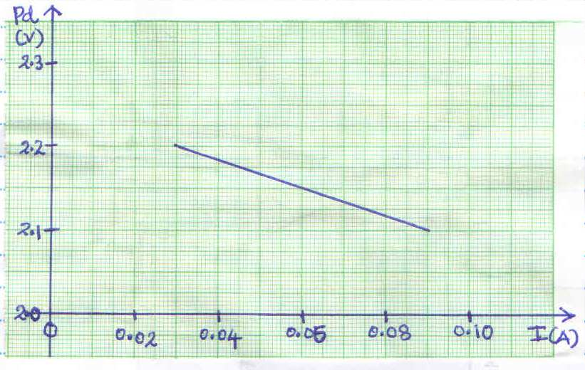

Given that V = -Ir + E holds true for the line, use the graph to determine:-
(i) the internal resistance, r of the cell. (3 Marks)
________________________________________________________________________________________
________________________________________________________________________________________
________________________________________________________________________________________
________________________________________________________________________________________
(ii) The E.M.F, E of the cell (1 Mark)
________________________________________________________________________________________
________________________________________________________________________________________
________________________________________________________________________________________

(d) Determine the current flowing in the circuit below when the switch, S is closed. (3 Marks)
10V

4Ω
2Ω

S

- An object is placed in front of a concave mirror of focal length 10cm as shown below.

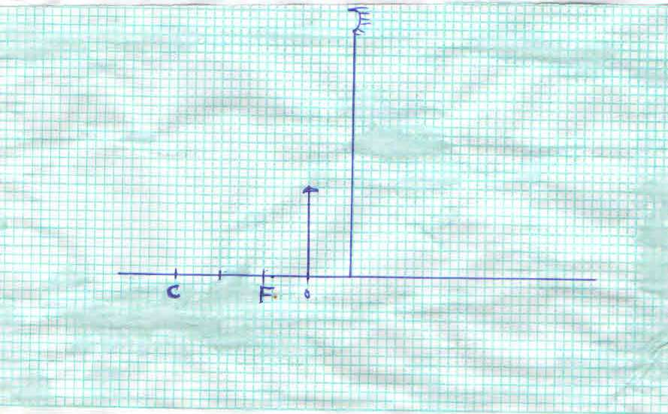

- On the same diagram draw a ray diagram showing the position of the image. (4 Marks)
(i) The image distance (2 Marks)
________________________________________________________________________________________
________________________________________________________________________________________
________________________________________________________________________________________
(ii) The magnification (3 Marks)
________________________________________________________________________________________
________________________________________________________________________________________
________________________________________________________________________________________
________________________________________________________________________________________
(iii) State the characteristics of the image (2 Marks)
________________________________________________________________________________________
________________________________________________________________________________________
________________________________________________________________________________________
________________________________________________________________________________________

