312/2
GEOGRAPHY
PAPER 2
TIME: 2 ¾ HOURS

NZAUI SUB COUNTY FORM 4 ENTRANCE EXAM 2015

Kenya Certificate of Secondary Education (K.C.SE)

312/2
GEOGRAPHY
PAPER 2
TIME: 2 ¾ HOURS

INSTRUCTIONS TO CANDIDATES:
- This paper has two sections A and B
- Answer All questions in Section
- In section B answer question 6 and any other two questions.
- All answers must be written in the answer booklet provided.
- Candidates should answer the questions in English
- This paper consists of 3 printed pages. Candidates should check to ascertain that all pages are printed as indicated and that no questions are missing.

SECTION A
Answer all the questions in the section
1. a) Define economic geography (2marks)
b) Give three natural economic factors of production exploited by man (3marks)

2. a) Give two hardwood tree species in Kenya (2marks)
b) Outline three characteristics of soft wood forests in Canada (3marks)

3. a) Name two methods of underground mining (2marks)
b) State there factors that influence mining (3marks)

4. a Give three ways in which sugarcane farmers benefits from the out growers scheme (3marks)
b) State two importance of sugar to Kenya’s economy (2marks)

5. a) Give two breeds of dairy cattle reared in Kenya (2marks)
b) State three factors which favour dairy farming in Denmark (3marks)

SECTION B
Answer question 6 and any other two from this section

6. The table below shows horticultural crops production in Kenya in the year 2010.
crop | Quantity in tones
Flowers  Oranges  Tomatoes  Carrots | 52,500  32,600  30,300  25,400

a. i) Draw a divided rectangle 15 cm long to represent horticultural crop production in Kenya in the year
2010 using the data above (8marks)
ii) Calculate the range of the above data (2marks)
iii) What is the percentage of the horticultural crop with the highest tonnage? (2 marks)
b. i) State three advantages of using divided rectangles to represent, geographical data (3marks)
ii) State two disadvantages of using a divided rectangle (2marks)
c. Explain four problems facing horticultural farming in Kenya (8marks)

7. a)
i) Name the main area where gold is mined in South Africa. (1mark)
ii) State four forms in which diamond exists in S. Africa (4marks)
b) Explain how Trona is Processed in Lake Magadi (6 marks)
c) Explain four factors hindering mining in Lake Magadi (8 marks)
d) A field study was conducted on mining of oil
i) Name four countries in Africa where the study would have been conducted (4marks)
ii) Identify 2 methods of mining the students would have found during the study. (2marks)

8. a) Name two counties in Kenya where sugarcane is grown in large scale (2marks)
ii) State three physical conditions that favour sugarcane growing in the lake region of Kenya (3marks)
b) Describe sugarcane cultivation from land preparation to harvesting (6marks)
c) Explain four problems facing sugarcane farming in Kenya (8marks)
d) Form three students from Kisumu high school visited a sugar factory for a field study on sugar
processing
- Outline four stages of sugar processing that the class may have observed. (4marks)
- Name two by products of sugar that the class may have identified during the study (2marks)

9. a) Differentiate between indigenous and exotic forest (2marks)
b) The map below shows Kenya’s forest zones
Study it to answer the questions that follow
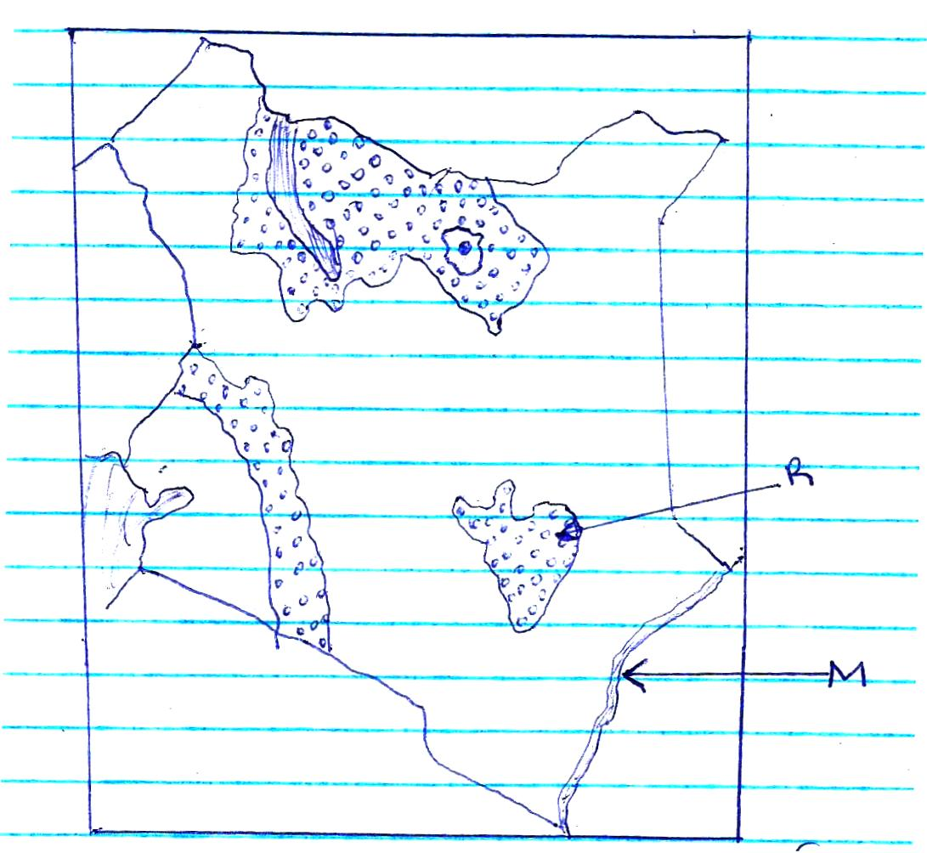

R

M

- Identify forests marked M and R. (2 marks)
ii) State three factors that lead to depletion of forests in Kenya (3marks)
b) Explain three factors that favours the growth of natural forests on the slopes of Mt Kenya (6 marks)
c) Compare forestry in Kenya and Canada under the following headings
i) Distribution of forests (2marks)
ii) Mode of exploitation (2marks)
iii) Transport (2marks)
d i) State three factors favoring the development of soft wood forests in Canada. (3marks)
ii) Give there measures used to conserve forests in Kenya. (3marks)

10 i) What is desertification? (1mark)
ii) A part from desertification, identify two other environmental hazards experienced in Kenya.
(2marks)
b i) State there causes of desertification (3marks)
ii) Explain three effects of desertification in Kenya (6marks)
c) i) In which four ways can the government of Kenya curb desertification? (3marks)
ii) State three human activities that may lead to soil erosion in Kenya (3marks)
d) Explain three methods used in Kenya to control soil erosion (6 marks)

