NAME …………………………………….. DATE ……………………….…………………..……

ADMN NO. …………….……….……..…..… CANDIDATE’S SIGNATURE ………..…..………..

443/2
AGRICULTURE
PAPER 2 (THEORY)
OCTOBER / NOVEMBER 2013
TIME: 2 HOURS

KILUNGU DISTRICT
FORM FOUR ENTRANCE JOINT EXAMINATION

Kenya Certificate of Secondary Education

443/2
AGRICULTURE
PAPER 2 (THEORY)
TIME: 2 HOURS

INSTRUCTIONS TO CANDIDATES
- Write your name and index number in the spaces provided above.
- This paper has THREE sections: A , B and C
- Answer ALL the questions in section A and B and any TWO questions in section C
- ALL answers MUST be written in the spaces provided.
- Do not remove any pages from this booklet.
- This paper consists of 8 printed pages.
Candidates should check to ensure that all pages are printed as indicated and no questions are missing

FOR EXAMINER’S USE ONLY

 | Questions | Maximum score | Candidate’s score
A | 01-17 | 30 marks
B | 18-22 | 20 marks
C | 23-25 | 40 marks
 |  | Total score

Kilungu District Form Four Entrance Joint Examination
443/2
Agriculture
Paper 2

SECTION A (30 MARKS)
Answer all the questions in this section in the spacer provided.
- Name the:
- Bacteria that causes anthrax in cattle (1mark)
……………………………………………………………………………………………………………………………………………………………………………………………………………………………..
- Protozoa that causes gall sickness in cattle (1mark)
……………………………………………………………………………………………………………………………………………………………………………………………………………………………..
- Give four qualities of creep feed (2marks)
……………………………………………………………………………………………………………………………………………………………………………………………………………………………..
………………………………………………………………………………………………………………………………………………………………………………………………………………………………
- Name the tool used together with each of the following tools (2marks)
- Canular
………………………………………………………………………………………………………………
- Wood chisel
…………………………………………………………………………………………………………
- Screw driver
………………………………………………………………………………………………………………
- Brace
………………………………………………………………………………………………………………
- Give two harmful effects of fleas in poultry (1mark)
……………………………………………………………………………………………………………………………………………………………………………………………………………………………..
- Name four structural features in a fish pond (2marks)
……………………………………………………………………………………………………………………………………………………………………………………………………………………………..
……………………………………………………………………………………………………………………………………………………………………………………………………………………………..
- (a) What is dry cow therapy (1mark)
……………………………………………………………………………………………………………………………………………………………………………………………………………………………..
(b) When is dry cow therapy carried out? (1mark)
……………………………………………………………………………………………………………………………………………………………………………………………………………………………..
- State four factors that determine the nutrient requirement in cattle (2marks)
……………………………………………………………………………………………………………………………………………………………………………………………………………………………..
…………………………………………………………………………………………………………………………………………………………………………………………………………………………….
- Give two reasons for carrying out each of the following routine management practices
- Docking in sheep rearing (1mark)
……………………………………………………………………………………………………………………………………………………………………………………………………………………
- Tooth clipping in piglet (1mark)
……………………………………………………………………………………………………………………………………………………………………………………………………………………
- Define the term hybrid vigour in livestock breeding (1mark)
………………………………………………………………………………………………………………………………………………………………………………………………………………………………
- State two functions of foot bath in cattle dip (1mark)
………………………………………………………………………………………………………………………………………………………………………………………………………………………………
- State two disadvantages of using barbed wire in the farm (1mark)
………………………………………………………………………………………………………………………………………………………………………………………………………………………………
- State three tools that are required when transplanting vegetable seedlings (1½ marks)
………………………………………………………………………………………………………………………………………………………………………………………………………………………………
………………………………………………………………………………………………………………
- Give three maintenance practices of knapsack sprayer (2marks)
………………………………………………………………………………………………………………………………………………………………………………………………………………………………
………………………………………………………………………………………………………………
- Name two factors that dictate the description of livestock in Kenya (1mark)
………………………………………………………………………………………………………………………………………………………………………………………………………………………………
- State two methods of bloodless method of castrating bull calves (1mark)
………………………………………………………………………………………………………………………………………………………………………………………………………………………………
- State six predisposing factors of livestock diseases other than injury (3marks)
………………………………………………………………………………………………………………………………………………………………………………………………………………………………
………………………………………………………………………………………………………………………………………………………………………………………………………………………………
………………………………………………………………………………………………………………………………………………………………………………………………………………………………

- Name two methods of mating (1mark)
………………………………………………………………………………………………………………………………………………………………………………………………………………………………
- (a) What is a notifiable disease? (1mark)
………………………………………………………………………………………………………………………………………………………………………………………………………………………………
(b) Name any two notifiable disease (1mark)
………………………………………………………………………………………………………………………………………………………………………………………………………………………………
- Give two uses of droppers in fencer (1mark)
………………………………………………………………………………………………………………………………………………………………………………………………………………………………
SECTION B (20 MARKS)
Answer all questions in this section.
- The illustration below shows a livestock production equipment. Study it carefully and answer questions that follow

Warm water

Collected semen

- Identify the equipment. (1mark)
……………………………………………………………………………………………………………………………………………………………………………………………………………………
- What is the importance of warm water in the equipment (1mark)
……………………………………………………………………………………………………………………………………………………………………………………………………………………
- Describe the procedure followed when using the equipment in collecting the semen. (2marks)
……………………………………………………………………………………………………………………………………………………………………………………………………………………
- The diagram below illustrates a bee hive. Study it carefully to answer questions that follow

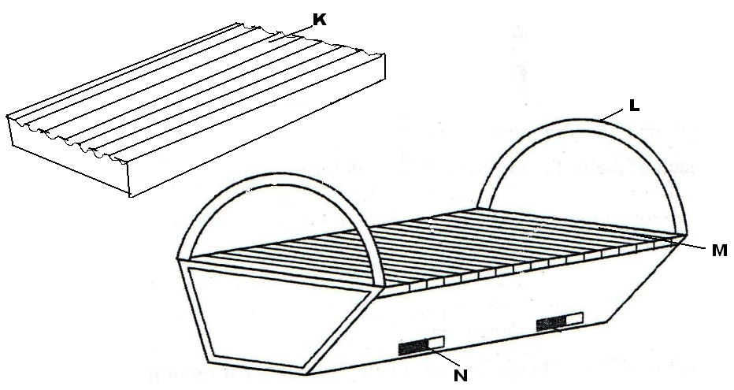
- Name the bee hive (1mark)
……………………………………………………………………………………………………………………………………………………………………………………………………………………
- Identify the parts labeled L and M (1mark)
……………………………………………………………………………………………………………………………………………………………………………………………………………………
(c) State the functions of the part labeled K and N (1mark)
………………………………………………………………………………………………………………………………………………………………………………………………………………………………
- Name the tool used for detaching honey combs during honey harvesting (1mark)
……………………………………………………………………………………………………………………………………………………………………………………………………………………
- Study the illustrations below and answer questions that follow.
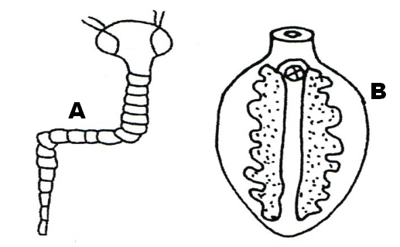

- Identify the specimen (1mark)
……………………………………………………………………………………………………………………………………………………………………………………………………………………
- State the intermediate host of A and B (1mark)
……………………………………………………………………………………………………………………………………………………………………………………………………………………
- State the final host of A and B (1mark)
……………………………………………………………………………………………………………………………………………………………………………………………………………………
- Explain any three control measures of A (3marks)
……………………………………………………………………………………………………………………………………………………………………………………………………………………

- Study the diagram below and answer the questions that follow
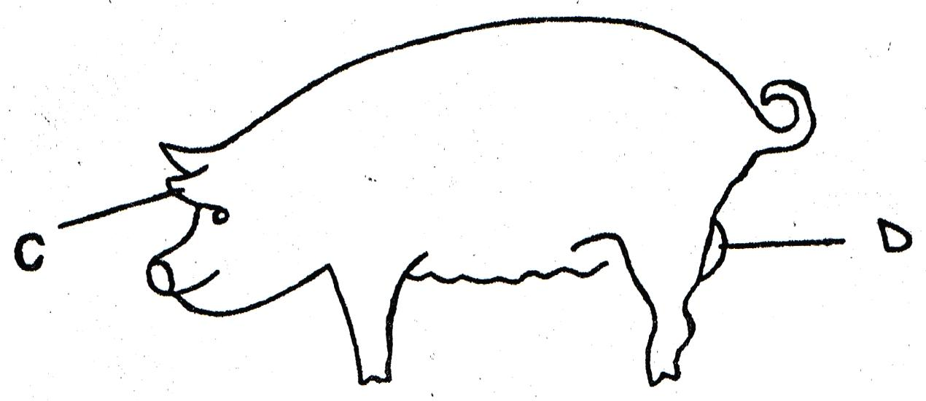

- Name the operation usually carried out on part C (1mark)
……………………………………………………………………………………………………………………………………………………………………………………………………………………
- Why is the activity in (a) above necessary? (1mark)
……………………………………………………………………………………………………………………………………………………………………………………………………………………
- Give two ways of carrying out the operation named in (a) (2marks)
……………………………………………………………………………………………………………………………………………………………………………………………………………………
- Name the routine management practice carried out in part D (1mark)
……………………………………………………………………………………………………………………………………………………………………………………………………………………
- Name the method used in carrying out the routine management practice carried out on part D
(1mark)
……………………………………………………………………………………………………………………………………………………………………………………………………………………

SECTION C. 40 MARKS.
Answer any two questions from this section.
- Describe the measures used to control livestock diseases in the farm and give disease controlled in each case (20marks)
- (a) Describe the management of piglet from birth up to winning (10marks)
(b) Describe the factors considered when siting farm structures in the farm (10marks)
- (a) Outline any ten general methods of maintaining farm tools, equipment, implements and machines
(10marks)
(b) Describe the lifecycle of a two host tick (7marks)
(c) Name any three tick borne diseases (3marks)
………………………………………………………………………………………………………………………………………………………………………………………………………………………………
………………………………………………………………………………………………………………………………………………………………………………………………………………………………
………………………………………………………………………………………………………………………………………………………………………………………………………………………………
………………………………………………………………………………………………………………………………………………………………………………………………………………………………
………………………………………………………………………………………………………………………………………………………………………………………………………………………………
………………………………………………………………………………………………………………………………………………………………………………………………………………………………
………………………………………………………………………………………………………………………………………………………………………………………………………………………………
………………………………………………………………………………………………………………………………………………………………………………………………………………………………
………………………………………………………………………………………………………………………………………………………………………………………………………………………………
………………………………………………………………………………………………………………………………………………………………………………………………………………………………
………………………………………………………………………………………………………………………………………………………………………………………………………………………………
………………………………………………………………………………………………………………………………………………………………………………………………………………………………
………………………………………………………………………………………………………………………………………………………………………………………………………………………………
………………………………………………………………………………………………………………………………………………………………………………………………………………………………
………………………………………………………………………………………………………………………………………………………………………………………………………………………………
………………………………………………………………………………………………………………………………………………………………………………………………………………………………
………………………………………………………………………………………………………………………………………………………………………………………………………………………………
………………………………………………………………………………………………………………………………………………………………………………………………………………………………
………………………………………………………………………………………………………………………………………………………………………………………………………………………………
………………………………………………………………………………………………………………………………………………………………………………………………………………………………
………………………………………………………………………………………………………………………………………………………………………………………………………………………………
………………………………………………………………………………………………………………………………………………………………………………………………………………………………
………………………………………………………………………………………………………………………………………………………………………………………………………………………………
………………………………………………………………………………………………………………………………………………………………………………………………………………………………
………………………………………………………………………………………………………………………………………………………………………………………………………………………………
………………………………………………………………………………………………………………………………………………………………………………………………………………………………
………………………………………………………………………………………………………………………………………………………………………………………………………………………………
………………………………………………………………………………………………………………………………………………………………………………………………………………………………
………………………………………………………………………………………………………………………………………………………………………………………………………………………………
………………………………………………………………………………………………………………………………………………………………………………………………………………………………
………………………………………………………………………………………………………………………………………………………………………………………………………………………………
………………………………………………………………………………………………………………………………………………………………………………………………………………………………
………………………………………………………………………………………………………………………………………………………………………………………………………………………………
………………………………………………………………………………………………………………………………………………………………………………………………………………………………
………………………………………………………………………………………………………………………………………………………………………………………………………………………………
………………………………………………………………………………………………………………………………………………………………………………………………………………………………
………………………………………………………………………………………………………………………………………………………………………………………………………………………………
………………………………………………………………………………………………………………………………………………………………………………………………………………………………
………………………………………………………………………………………………………………………………………………………………………………………………………………………………

