NAME ……………………………………………. ADM NO …………………………..
SCHOOL …………………………………………… SIGNATURE …………………..………
DATE ……..…………………...
231/1
BIOLOGY
PAPER 1
(Theory)
OCTOBER/NOVEMBER 2013
2 HOURS

KILUNGU DISTRICT FORM FOUR ENTRANCE EXAMINATIONS:

Kenya Certificate of Secondary Education (K.C.S.E)

231/1
BIOLOGY
PAPER 1
(Theory)
OCTOBER/NOVEMBER 2013
2 HOURS

INSTRUCTIONS TO CANDIDATES:

- Write your name and ADM. Number in the spaces provided above.
- Sign and write date of examination in the spaces provided above.
- Answer ALL questions in the spaces provided.
- All workings must be clearly shown where necessary.
- This paper consists of 8 [ Printed pages.
Candidates should check the question paper to ensure that all the papers are printed as indicated and no questions are missing

FOR EXAMINERS USE ONLY:
Question | Maximum Score | Candidates Score
1 – 30 | 80

© 2013 Kilungu District Form four Entrance Examination
231/1
Biology (Theory)
Paper 1

1. Which organelle would be very abundant in:-
(a) Palisade cell (1 mark)
………………………………………………………………………………………………………………
………………………………………………………………………………………………………………
(b) Sperm cell ( 1mark)
…………………………………………………………………………………………………………………..…………………………………………………………………………………………………............
2. Photosynthesis takes place in two stages. Name the part of the chloroplast where:-
(a) Light stage occurs (1 mark)
………………………………………………………………………………………………………………
(b) Dark stage occurs
………………………………………………………………………………………………………………
(c) How is dark stage dependant on the light stage of photosynthesis? (2 marks)
………………………………………………………………………………………………………………
………………………………………………………………………………………………………………
………………………………………………………………………………………………………………
………………………………………………………………………………………………………………
3. Name the part of a flower that develops into:-
(a) Seed (1mark)
………………………………………………………………………………………………………………
(b) Fruit ( 1mark)
………………………………………………………………………………………………………………
4. State two reasons why fruit and seed dispersal is important to the plants. ( 2 marks)
……………………………………………………………………………………………………………...
………………………………………………………………………………………………………………
………………………………………………………………………………………………………………
………………………………………………………………………………………………………………
5. Below is the internal structure of a bean seed.
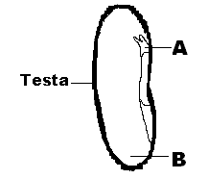
(i) Name the parts labelled:- (2 marks)
A. ………………………………

B……………………………….
(ii) State the function of part B. (1 mark)
……………………………………………………………………………………………………………...
………………………………………………………………………………………………………………
(iii) State two differences between a bean seed and a maize grain. ( 2marks)
………………………………………………………………………………………………………………
………………………………………………………………………………………………………………
……………………………………………………………………………………………………………...
………………………………………………………………………………………………………………
………………………………………………………………………………………………………………
6. State one disadvantage of taking a diet without roughage for many days. (1 mark)
………………………………………………………………………………………………………………
………………………………………………………………………………………………………………
7. The scientific name of a human being is Homo Sapiens.
(a) Name the above method of naming organisms. (1mark)
………………………………………………………………………………………………………………
………………………………………………………………………………………………………………
(b) Give two advantages of using the above method of naming organisms, instead of using vernacular
names. (3 marks)
………………………………………………………………………………………………………………
………………………………………………………………………………………………………………
………………………………………………………………………………………………………………
………………………………………………………………………………………………………………
………………………………………………………………………………………………………………
………………………………………………………………………………………………………………
8. The equation below shows what happens in cellular respiration.
C₆H₁₂O₆ + 6O₂ 6CO₂ + 6H₂O + Energy
- Name the type of respiration shown and where it occurs in the cell. ( 2marks)
……………………………………………………………………………………………………………………………………………………………………………………………………………………..............
- Determine respiratory quotient of the process. ( 2marks)
……………………………………………………………………………………………………………………………………………………………………………………………………………………...............
……………………………………………………………………………………………………………………………………………………………………………………………………………………..............
- What food substrate is broken down in the above respiration? (1 mark)
……………………………………………………………………………………………………………………………………………………………………………………………………………………...............
9. Explain how sweating helps in cooling the body during a hot day. (2 marks)
……………………………………………………………………………………………………………………………………………………………………………………………………………………...............
……………………………………………………………………………………………………………………………………………………………………………………………………………………...............
10. Name the tissues in a dicotyledonous plant responsible for:-
(i) Increase in length (1 mark)
……………………………………………………………………………………………………………………………………………………………………………………………………………………...............
(ii) Increase in girth (1mark)
……………………………………………………………………………………………………………………………………………………………………………………………………………………...............

11. The diagram below represents the ileum lining.
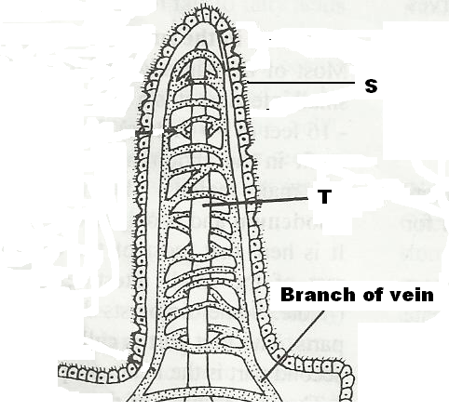

- Name the structure and its function. (2 marks)
……………………………………………………………………………………………………………………………………………………………………………………………………………………..............
- Name parts:-
S –
…………………………………………………………………………………………………………..
T –
…………………………………………………………………………………………………………
12. State three ways in which spread of HIV/AIDS can be controlled. (3 marks)
……………………………………………………………………………………………………………………………………………………………………………………………………………………...............
……………………………………………………………………………………………………………………………………………………………………………………………………………………...............
……………………………………………………………………………………………………………………………………………………………………………………………………………………..............

13. Below is the structure of a phloem tissue.
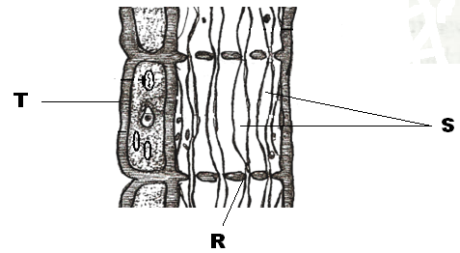

- (i) Name T _____________________ ( 1mark)
(ii) Structure R (1mark)
- State the function of structures S ( 1mark)
……………………………………………………………………………………………………………………………………………………………………………………………………………………...............
- Name one organelle abundant in structure T. ( 1mark)
……………………………………………………………………………………………………………………………………………………………………………………………………………………...............
14. State any 3 properties of enzymes. (3 marks)
…………………………………………………………………………………………………………………………………………………………………………………………………………………...............…
……………………………………………………………………………………………………………………………………………………………………………………………………………………..............
15. (a) State one advantage of heterodonts over homodonts. (1 mark)
……………………………………………………………………………………………………………………………………………………………………………………………………………………...............
- Below is a dental formula of an organism
$I\frac{0}{3}$ c $\frac{0}{1}$ pm $\frac{3}{3}$ m $\frac{3}{3}$
(i) What is the total number of teeth in the organism? (1mark)
…………………………………………………………………………………………………………………………………………………………………………………………………………………….
(ii) Name the diet of the organism, and give one reason for your answer. (2 marks)
……………………………………………………………………………………………………………………………………………………………………………………………………………………...........…………………………………………………………………………………………………………………………………………………………………………………………………………….....

16. (a) Give one difference between the term predators and parasites. ( 2 marks)
……………………………………………………………………………………………………………………………………………………………………………………………………………………
(b) Name the causative agent of amoebic dysentry and state two ways that can be used to prevent the
disease.
Causative agent (1mark)
……………………………………………………………………………………………………………………………………………………………………………………………………………………
Prevention (2 marks)
……………………………………………………………………………………………………………………………………………………………………………………………………………………
……………………………………………………………………………………………………………………………………………………………………………………………………………………
17. Complete the table below showing hormones, their site of production and the effect they have on the
animal or plant.

Name of hormone | Site of hormone production | Effect
(i) Follicle stimulating  hormone | Anterior pituitary gland
(ii) Auxins | Root apex and shoot apex
(iii) Gibberellins | All young plant tissues

18. Complete the table below showing blood groups, antigens and antibodies in various blood groups.
Blood group | Antigen (on red blood cells) | Antibodies (in plasma)
A | A
B | B
AB
0 | None

19. State two differences between open and closed circulatory systems. (2 marks)
………………………………………………………………………………………………………………………………………………………………………………………………………………………………………………………………………………………………………………………………………………………………………………………………………………………………………………………………
20. Name two nutrients that are absorbed without being digested by enzymes in humans. (2 marks)
……………………………………………………………………………………………………………………………………………………………………………………………………………………………...
21. What is the function of contractile vacuoles in amoeba?
……………………………………………………………………………………………………………………………………………………………………………………………………………………..............

22. (a) Name the part of the microscope that holds the eye-piece and revolving nose-piece. (1mark)
……………………………………………………………………………………………………………………………………………………………………………………………………………………………...
(b) How would you transport a microscope from one bench to another? (1mark)
……………………………………………………………………………………………………………………………………………………………………………………………………………………………………........................................................................................................................................................
23. State three factors that affect the rate of diffusion. (3 marks)
………………………………………………………………………………………………………………………………………………………………………………………………………………………………………………………………………………………………………………………………………………
24. Name 3 sites of gaseous exchange in a frog. (3 marks)
………………………………………………………………………………………………………………………………………………………………………………………………………………………………………………………………………………………………………………………………………………………………………………………………………………………………………………………………
25. How does nutrition as a characteristic differ in plants and animals? (2marks)
………………………………………………………………………………………………………………………………………………………………………………………………………………………………………………………………………………………………………………………………………………………………………………………………………………………………………………………………
26. Name two substances that are completely reabsorbed into the blood in the Nephrone. (2 marks)
……………………………………………………………………………………………………………………………………………………………………………………………………………………………………………………………………………………………………………………………………………………………………………………………………………………………………………………………...
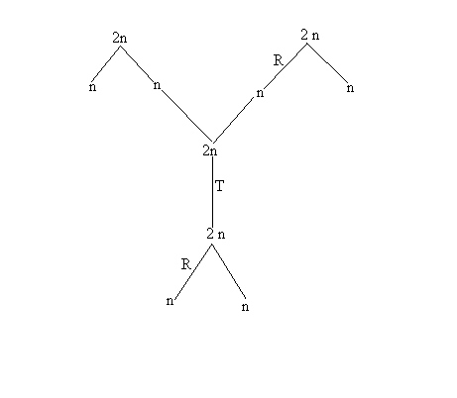
27. The chart below shows some cell divisions and the number of chromosomes involved.

- What type of cell division occurs in;-
R………………………………………………………………………………………………… (1mark)
…………………………………………………………………………………………………………
T…………………………………………………………………………………………………..(1mark)
…………………………………………………………………………………………………………
- State one significance of cell division T. (1 mark)
…………………………………………………………………………………………………………
…………………………………………………………………………………………………………

