**NAME ………………………………………… INDEX NO …….…………………..**

**SCHOOL ………………………………………… SIGNATURE …………..……....…….**

**DATE ……………….………..**

**231/2**

**BIOLOGY**

**PAPER 2**

**(THEORY)**

**OCTOBER/NOVEMBER, 2013**

**2 HOURS**

**KILUNGU DISTRICT 2013**

**FORM FOUR ENTRANCE JOINT EXAMINATION**

***Kenya Certificate of Secondary Education (K.C.S.E)***

**231/2**

**BIOLOGY**

**PAPER 2**

**(THEORY)**

**OCTOBER/NOVEMBER, 2013**

**2 HOURS**

**INSTRUCTIONS TO CANDIDATES**

* Write your name and Index Number in the spaces provided above.
* This paper consists of **two** sections. Section **A** and section **B.**
* Answer **ALL** questions in section **A** in the spaces provided. In section **B** answer question **6** (compulsory) and either question **7** or **8** in the spaces provided after question 8
* This paper consists of 10 Printed pages.

Candidates should check the question paper to ensure that all the papers are printed as indicated and no questions are missing

**For Examiners use only.**

|  |  |  |  |
| --- | --- | --- | --- |
| **Section** | **Question** | **Maximum score** | **Candidates score** |
| **A** | **1** | **8** |  |
| **2** | **8** |  |
| **3** | **8** |  |
| **4** | **8** |  |
| **5** | **8** |  |
| **B** | **6** | **20** |  |
| **7** | **20** |  |
| **8** | **20** |  |
|  | **Total score** | **80** |  |

©2013 Kilungu District Form Entrance Joint Examination

231/2

Biology (Theory)

Paper 2

1. The diagram below represents part of the mammalian circulatory system and some associated glands.

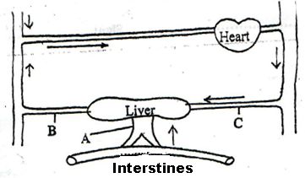

(a) Name the blood vessel A and B. (2 marks)

A……………………………………................................................................................................

B……………………………………................................................................................................

(b) State two structural differences between the blood vessel labelled A and C. (2 marks)

…………………………………………………………………………………………………………………………………………………………………………………………………………………………………………………………………………………………………………………………………………………………………………………………………………………………………….......

(c) The diagram below represents a cross-section obtained from a plant. Use to answer the question that

follow.

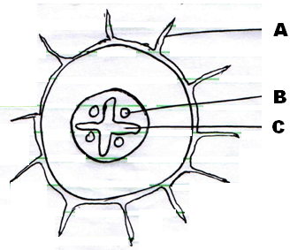

(d) (i) Identify the parts labelled A and C. (2 marks)

A - ...................................................................................................................................................

C - ...................................................................................................................................................

(ii) Explain how the part labelled A is adapted to its function. (2 marks)

……………………………………………………………………………………………………………………………………………………………………………………………………………………

2. The diagram below represents a cell at a certain stage of mitosis.

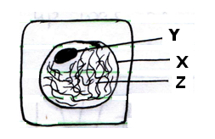

1. Identify the stage of mitosis represented by the cell. (1 mark)

……………………………………………………………………………………………………………………………………………………………………………………………………………………

1. What is the significance of the stage to a cell? ( 3 marks)

……………………………………………………………………………………………………………………………………………………………………………………………………………………

1. Identify part labelled Y and Z. ( 2 marks)

Y……………………………………………......................................................................................

Z………………………………………………...................................................................................

1. Give changes the cell undergoes in the next stage? (2 marks)

……………………………………………………………………………………………………………………………………………………………………………………………………………………

3. A group of students set up an experiment to investigate a certain physiological process. The set up was as

shown in the diagram below.

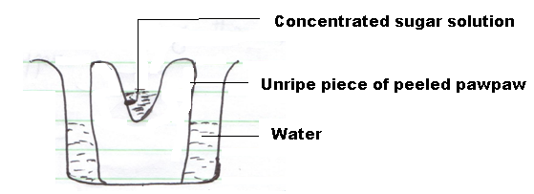

After sometime the students observed that the level of sugar solution had risen.

1. What physiological process was being investigated? ( 1mark)

……………………………………………………………………………………………………………………………………………………………………………………………………………………

1. Account for the rise in the level of sugar solution in this experiment. (3 marks)

……………………………………………………………………………………………………………………………………………………………………………………………………………………

……………………………………………………………………………………………………………………………………………………………………………………………………………………

1. (i) State the results that the students would obtain if they repeated the experiment using a piece of

boiled pawpaw. (3 marks)

……………………………………………………………………………………………………………………………………………………………………………………………………………………

…………………………………………………………………………………………………………

(ii) Give a reason for your answer. (2 marks)

……………………………………………………………………………………………………………………………………………………………………………………………………………………

…………………………………………………………………………………………………………

4. (a) Explain what is meant by “secondary growth” ( 1mark)

……………………………………………………………………………………………………………………………………………………………………………………………………………………

(b) State the role of the following in germination. ( 3 marks)

(i) Oxygen

……………………………………………………………………………………………………………………………………………………………………………………………………………………

(ii) Water

……………………………………………………………………………………………………………………………………………………………………………………………………………

(iii) Enzymes

……………………………………………………………………………………………………………………………………………………………………………………………………………………

(c) State two enzymes involved in germination. ( 2 marks)

……………………………………………………………………………………………………………………………………………………………………………………………………………………

1. The diagram below shows germination of two different seeds. Identify the types of germination shown. ( 2 marks)

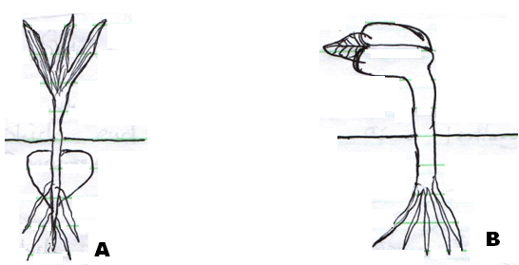

A: ................................................................................................................................................

B: ................................................................................................................................................

5. The diagram below represents a food web in a certain ecosystem.

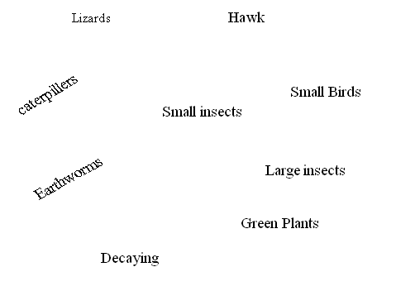

1. Name the trophic level occupied by each of the following.

(i) Caterpillars (1mark)

……………………………………………………………………………………………………………………………………………………………………………………………………………....

(ii) Small insects (1 mark)

………………………………………………………………………………………………………………………………………………………………………………………………………………

1. From the food web, construct two food chains which end with lizards as a tertiary consumer.

(2 marks)

………………………………………………………………………………………………………………………………………………………………………………………………………………………………………………………………………………………………………………………………………………………………………………………………………………………………

1. (i) Which organisms have the least biomass in this ecosystem. (1 mark)

………………………………………………………………………………………………………………………………………………………………………………………………………………

(ii) Explain the answer in (c) (i) above. ( 3 marks)

..............................................................................................................................................................................................................................................................................................................................................................................................................................................................................

**SECTION B**

**Answer question 6 (compulsory) in the spaces provided and either question 7 or 8 in the spaces**

**provided for after question 8.**

6. In an experiment, several cubes of liver of same mass were put in separate test tubes each with equal

amount of hydrogen peroxide. Each test rube was placed in a water bath at various temperatures. The

time taken for the mass of hydrogen peroxide to decrease in each test tube was determined and recorded. The results are shown in the table below.

|  |  |  |  |  |  |  |  |  |
| --- | --- | --- | --- | --- | --- | --- | --- | --- |
| Temperature  in 0C | 15 | 20 | 25 | 30 | 35 | 40 | 45 | 50 |
| Time taken for Hydrogen Peroxide to decrease (minutes) | 45 | 30 | 15 | 10 | 4 | 4 | 30 | 57 |

1. Using appropriate scale, plot a graph of the duration of reaction against temperature. (7 marks)



1. From your graph, determine the optimum temperature for the decomposition of hydrogen peroxide.

(1 mark)

.................................................................................................................................................................................................................................................................................................................................

1. Account for the changes that occur between

(i) 150C – 350C. (2 marks)

………………………………………………………………………………………………………………………………………………………………………………………………………………

(ii) 350C – 400C. (2 marks)

………………………………………………………………………………………………………………………………………………………………………………………………………………

(iii) 400C – 350C. (2 marks)

………………………………………………………………………………………………………………………………………………………………………………………………………………

1. Name the enzyme in the liver that decomposes hydrogen peroxide. ( 1mark)

………………………………………………………………………………………………………………………………………………………………………………………………………………

1. Other than temperature, state three other factors that affect enzyme controlled reactions. ( 3 marks)

……………………………………………………………………………………………………………………………………………………………………………………………………………………

…………………………………………………………………………………………………………………………………………………………………………………………………………………..

1. Name two types of enzyme inhibitors. ( 2 marks)

……………………………………………………………………………………………………………………………………………………………………………………………………………….......

7. (a) Explain how structural features in terrestrial plants affect their rate of transpiration. (13 marks)

(b) Explain how the human skin brings about cooling of the body on a hot day. (7 marks)

8. Explain how seeds and fruits are adapted to the various methods of dispersal. (20 marks)

…………………………………………………………………………………………………………………..

…………………………………………………………………………………………………………………..

…………………………………………………………………………………………………………………..

…………………………………………………………………………………………………………………..

…………………………………………………………………………………………………………………..

…………………………………………………………………………………………………………………..

…………………………………………………………………………………………………………………..

…………………………………………………………………………………………………………………..

…………………………………………………………………………………………………………………..

…………………………………………………………………………………………………………………..

…………………………………………………………………………………………………………………..

…………………………………………………………………………………………………………………..

…………………………………………………………………………………………………………………..

…………………………………………………………………………………………………………………..

…………………………………………………………………………………………………………………..

…………………………………………………………………………………………………………………..

…………………………………………………………………………………………………………………..

…………………………………………………………………………………………………………………..

…………………………………………………………………………………………………………………..

…………………………………………………………………………………………………………………..

…………………………………………………………………………………………………………………..

…………………………………………………………………………………………………………………..

…………………………………………………………………………………………………………………..

…………………………………………………………………………………………………………………..

…………………………………………………………………………………………………………………..

…………………………………………………………………………………………………………………..

…………………………………………………………………………………………………………………..

…………………………………………………………………………………………………………………..

…………………………………………………………………………………………………………………..

…………………………………………………………………………………………………………………..

…………………………………………………………………………………………………………………..

…………………………………………………………………………………………………………………..

…………………………………………………………………………………………………………………..

…………………………………………………………………………………………………………………..

…………………………………………………………………………………………………………………..

…………………………………………………………………………………………………………………..

…………………………………………………………………………………………………………………..

…………………………………………………………………………………………………………………..

…………………………………………………………………………………………………………………..

…………………………………………………………………………………………………………………..

…………………………………………………………………………………………………………………..

…………………………………………………………………………………………………………………..

…………………………………………………………………………………………………………………..

…………………………………………………………………………………………………………………..

…………………………………………………………………………………………………………………..

…………………………………………………………………………………………………………………