NAME …………………………..……………….. DATE …………………………

INDEX NO. ……….……….…………………...…..… SIGNATURE ……………..…………..

233/2
CHEMISTRY
PAPER 2
(THEORY)
OCTOBER/NOVEMBER 2013
TIME: 2 HOURS.

KILUNGU DISTRICT 2013
FORM FOUR ENTRANCE EXAMINATION

Kenya Certificate of Secondary Education.
233/2
CHEMISTRY
PAPER 2
(THEORY)
TIME: 2 HOURS.

INSTRUCTIONS TO CANDIDATES.
- Write your name and index number in the spaces provided above.
- Sign and write the date of exam in the spaces provided above.
- Answer ALL the questions in the spaces provided.
- Mathematical tables and silent electronic calculators may be used.
- All working MUST be clearly shown where necessary.
- This paper consists of 10 printed pages.
Candidates should check to ensure that all pages are printed as indicated and no questions are missing

FOR EXAMINER’S USE ONLY.

Questions | Maximum score | Candidates score
1 | 10
2 | 10
3 | 10
4 | 13
5 | 13
6 | 12
7 | 13
Total score | 80

© 2013, Kilungu District Form Four Entrance Examination
233/2
Chemistry (theory)
Paper 2
1. 5 grammes of potassium chlorate were added to two boiling tubes A and B, 2 grammes of Copper (II)
Oxide was then added to B and then both tubes were heated from the same sandbath as shown below.
Glowing splints were lowered into the tubes, concurrently. During the heating, the splint in tube B
relight earlier than tube A.
A B

5g of KClO₃ + 2g of CuO
5g of KClO₃ Sandbath

Heat
- Explain why the glowing splint in B relights earlier than earlier A. ( 2 marks)
…………………………………………………………………………………………………………….....
…………………………………………………………………………………………………………….....
- The set up below was used to investigate a certain aspect about air.

Air
Burning
candle Dilute Sodium Hydroxide

(i) Draw a diagram to illustrate how it would look like at the end of the experiment. (2 marks)
…………………………………………………………………………………………………………….....
…………………………………………………………………………………………………………….....
……………………………………………………………………………………………………………….
…………………………………………………………………………………………………………….....
(iii) Name two gases remaining at the end of the experiment. (2 marks)
……………………………………………………………………………………………………………….
…………………………………………………………………………………………………………….....
(iv) State why dilute Sodium Hydroxide solution was used in the experiment. (1mark)
……………………………………………………………………………………………………………….
…………………………………………………………………………………………………………….....
(c) The diagram below shows how acidic and basic oxides fit into the general family of oxides.
Acidic
Oxides
Basic
Oxides

(i) State the name given to the type of oxides that would be placed in the shaded area. (1 mark)
……………………………………………………………………………………………………………….
(ii) Write the formula of the two such oxides. (1mark)
………………………………………………………………………………………………………………
2. (a) Two reagents that can be used to prepare chlorine gas are Potassium – Manganate (VII) and
concentrated Hydrochloric acid.
(i) Write an equation for the reaction. (1mark)
…………………………………………………………………………………………………………….....
…………………………………………………………………………………………………………….....
(ii) Give the formula of another reagent that can be reacted with concentrated hydrochloric acid to
produce chlorine gas. (1 mark)
…………………………………………………………………………………………………………….....
…………………………………………………………………………………………………………….....
(iii) Describe how chlorine gas could be dried in the laboratory. (2 marks)
…………………………………………………………………………………………………………….....
…………………………………………………………………………………………………………….....
(b) In an experiment, dry chlorine gas was reacted with aluminium as shown below.
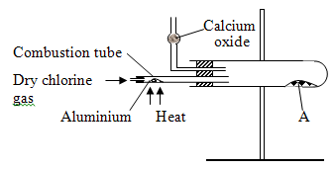
(i) Name substance A (1mark)
…………………………………………………………………………………………………………….....
(ii) Write an equation for the reaction that took place in the combustion tube.
…………………………………………………………………………………………………………….....
…………………………………………………………………………………………………………….....
(iii) When 0.84g of aluminium reacted completely with chlorine gas. Calculate the volume of chlorine gas
used. Molar gas volume is 24dm³, Al = 27.0 (3 marks)
…………………………………………………………………………………………………………….....
…………………………………………………………………………………………………………….....
…………………………………………………………………………………………………………….....
…………………………………………………………………………………………………………….....
(iv) Give a reason why calcium oxide is used in the setup (1 mark)
…………………………………………………………………………………………………………….....
…………………………………………………………………………………………………………….....
…………………………………………………………………………………………………………….....
…………………………………………………………………………………………………………….....
3. The grid below represents part of the periodic table. Study it and answer the questions that follow. The
letters do not represent the actual symbols of the elements.
A |  |  |  |  |  |  |  |  | K
B | D |  |  |  |  |  |  | I
 |  |  |  | F |  | H |  |  | L
C | E |  |  |  |  |  |  | J

- (i) Which letter represents a non metal that is least reactive? ( 1mark)
……………………………………………………………………………………………………………………………………………………………………………………………………………………
(ii) Why are elements D and E referred to as alkali earth metals? (1mark)
…………………………………………………………………………………………………………….....
…………………………………………………………………………………………………………….....
- How does the atomic radius of F and H compare? ( 2 marks)
……………………………………………………………………………………………………………………………………………………………………………………………………………………
- Select two letters representing a pair of elements that would react most explosively. ( 1mark)
……………………………………………………………………………………………………………………………………………………………………………………………………………………
- Write an equation showing how D forms its ions. (1 mark)
……………………………………………………………………………………………………………………………………………………………………………………………………………………
- Write the formulae of
(i) Bromide of D ( ½ mark)
…………………………………………………………………………………………………………….....
…………………………………………………………………………………………………………….....
(ii) Sulphate of C ( ½ mark)
…………………………………………………………………………………………………………….....
…………………………………………………………………………………………………………….....
- What type of bonding exists between.
(i) E and I ( ½ mark)
…………………………………………………………………………………………………………….....
…………………………………………………………………………………………………………….....
(ii) G and I ( ½ mark)
…………………………………………………………………………………………………………….....
…………………………………………………………………………………………………………….....
- Explain why the melting point of J is higher than that of I ( 2 marks)
……………………………………………………………………………………………………………………………………………………………………………………………………………………

4. (a) The diagram below was set up to study the products formed when a candle is burnt.

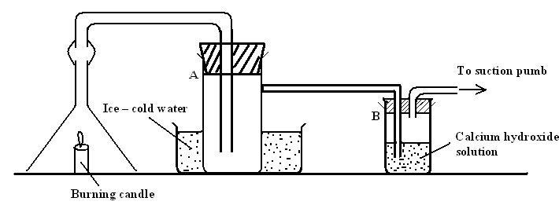
(i) State what would be observed in test tube B (1mark)
…………………………………………………………………………………………………………….....
…………………………………………………………………………………………………………….....
(ii) State and explain what would be observed if the suction pump is switched off. (2 marks)
…………………………………………………………………………………………………………….....
…………………………………………………………………………………………………………….....
(iii) Describe how the identity of the product that is formed in test tube A can be confirmed. (2 marks)
…………………………………………………………………………………………………………….....
…………………………………………………………………………………………………………….....
(b) 0.115g of Sodium metal was dropped in a trough full of water.
(i) State and explain what was observed than the production of a hissing sound. (2 marks)
…………………………………………………………………………………………………………….....
…………………………………………………………………………………………………………….....
…………………………………………………………………………………………………………….....
…………………………………………………………………………………………………………….....
(ii) Calculate the volume of the gas produced at r.t.p (Na = 23, molar gas volume = 24dcm³ at r.t.p)
(2 mark)
…………………………………………………………………………………………………………….....
…………………………………………………………………………………………………………….....
- Dry hydrogen gas was passed over heated Copper (II) Oxide as shown below.
Copper (II) Oxide V

Dry hydrogen
Excess hydrogen burns

Heat

- (i) Write down the equation for the reaction that takes place in the combustion tube. ( 1 mark)
….………………………………………………………………………………………………………
…………………………………………………………………………………………………………
(ii) Name another gas that would play the same role as hydrogen if passed in the combustion tube
above. (1mark)
………...………………………………………………………………………………………….....
………...………………………………………………………………………………………….....
(iii) Describe how the purity of the product formed by the burning at V can be confirmed. (2 marks)
………...………………………………………………………………………………………….....
………...………………………………………………………………………………………….....
5. (a) The diagram below was used to prepare a gas X in the laboratory. Study it and answer the questions
that.

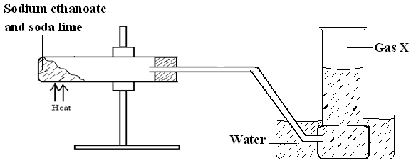

(i) Name gas X (1 mark)
………...………………………………………………………………………………………….....
(ii) Write an equation to show the production of gas X. (1mark)
………...………………………………………………………………………………………….....
(b) Study the scheme diagram below and answer the questions that follow.
Ethanol
C₂H₆
Ethene
[-CH₂-CH₂-]_{n}
CH₃CH₂Cl
Step I
Step IV
Step II
Step III

(i) Name the catalyst that is suitable to carry out the reaction in Step I. (1 mark)
………...………………………………………………………………………………………….....
………...………………………………………………………………………………………….....
(ii) Name the process that takes place in Step II. (1mark)
………...………………………………………………………………………………………….....
………...………………………………………………………………………………………….....
(iii) State the conditions necessary for the reaction in Step III to occur. (1mark)
………...………………………………………………………………………………………….....
………...………………………………………………………………………………………….....

(iv) Write down the equation for the reaction that takes place in Step IV (1 mark)
………...………………………………………………………………………………………….....
………...………………………………………………………………………………………….....
(c) Other than using burning, describe how you would distinguish between ethane and ethyne. (3 marks)
………...………………………………………………………………………………………….....
………...………………………………………………………………………………………….....
………...………………………………………………………………………………………….....
………...………………………………………………………………………………………….....
(d) (i) What are isomers? ( 1mark)
………...………………………………………………………………………………………….....
………...………………………………………………………………………………………….....
(ii) Draw and name all structures of all the isomers of the compound with molecular formula C₄H₈
(3 marks)
………...………………………………………………………………………………………….....
………...………………………………………………………………………………………….....
………...………………………………………………………………………………………….....
………...………………………………………………………………………………………….....
………...………………………………………………………………………………………….....
………...………………………………………………………………………………………….....
5. (a) The scheme below shows the industrial manufacture of sulphuric (VI) acid. Study it and answer the
questions that follow.

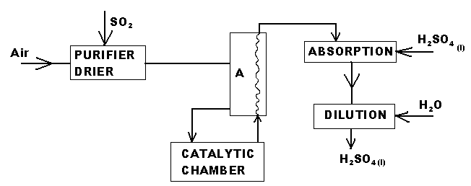

(i) Name the chamber A. (1mark)
………...………………………………………………………………………………………….....
………...………………………………………………………………………………………….....
(ii) Explain why concentrated Sulphuric (VI) acid is used in the absorption chamber and not water.
(1mark)
………...………………………………………………………………………………………….....
………...………………………………………………………………………………………….....

(iii) Write down the equation for the reaction that takes place at the absorption chamber (1mark)
………...………………………………………………………………………………………….....
………...………………………………………………………………………………………….....
(iv) Name two catalysts that can be used in the catalytic chamber. (1mark)
………...………………………………………………………………………………………….....
………...………………………………………………………………………………………….....
………...………………………………………………………………………………………….....
………...………………………………………………………………………………………….....
(b) Sulphuric (VI) acid is used in making fertilizers. What volume of ammonia gas will be required to
make 25kg of ammonium sulphate? (N = 14, H = 1.0, S = 32, O = 16.0
molar gas volume at r.t.p = 24.0dm³) ( 3 marks)
………...………………………………………………………………………………………….....
………...………………………………………………………………………………………….....
………...………………………………………………………………………………………….....
………...………………………………………………………………………………………….....
(c) State and explain what is observed when concentrated Sulphuric (VI) acid is placed in a test tube
containing.
(i) Cane sugar ( 2 marks)
………...………………………………………………………………………………………….....
………...………………………………………………………………………………………….....
………...………………………………………………………………………………………….....
………...………………………………………………………………………………………….....
(ii) Sulphur and the mixture is warmed (2 marks)
………...………………………………………………………………………………………….....
………...………………………………………………………………………………………….....
………...………………………………………………………………………………………….....
………...………………………………………………………………………………………….....
(iii) State two harmful effects Sulphur (IV) Oxide has on the environment. (1 mark)
………...………………………………………………………………………………………….....
………...………………………………………………………………………………………….....
………………………………………………………………………………………………………..
………………………………………………………………………………………………………..
7. (i) What do you understand by the word allotropy? ( 1mark)
………...………………………………………………………………………………………….....
………...………………………………………………………………………………………….....
(ii) Diamond and graphite are naturally occurring allotropes of carbon. Explain why graphite conducts
electricity while diamond does not ( 1mark)
………...………………………………………………………………………………………….....
………...………………………………………………………………………………………….....
………...………………………………………………………………………………………….....
………...………………………………………………………………………………………….....
(iii) Name one synthetic allotrope of carbon (1mark)
………...………………………………………………………………………………………….....
………...………………………………………………………………………………………….....
(b) The diagram below shows part of the set up that can be used to prepare Carbon (IV) Oxide in the
Laboratory
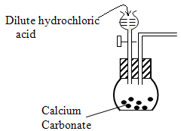
(i) Write down the equation for the reaction that takes place inside the flat bottomed flask. (1 mark)
………...………………………………………………………………………………………….....
………...………………………………………………………………………………………….....
(ii) Complete the diagram to show how a reasonably pure sample of the gas is collected. (3 marks)

(c) The diagram below shows the main stages of the Soway process.

Brine
NH₄Cl _{(aq)}
and
NaHCO₃ (S)
Step I
Step II
Substance A
NH₄Cl (aq)
NaHCO₃
Na₂CO₃ (S)
Step III
Carbon (IV)
Oxide

(i) Name the substance A (1 mark)
………...………………………………………………………………………………………….....
………...………………………………………………………………………………………….....
(ii) Write the equation for the reaction that takes place in Step III ( 1mark)
………...………………………………………………………………………………………….....
………...………………………………………………………………………………………….....
(iii) Name the process in Step II ( 1 mark)
………...………………………………………………………………………………………….....
………...………………………………………………………………………………………….....

(c) A mixture contains 12.39g of both Sodium Hydrogen Carbonate and Sodium Carbonate. When the
mixture was heated to constant mass 1 dm3 of Carbon (IV) Oxide was produced at r.t.p. Calculate the percentage composition of Sodium Carbonate in the mixture. (2 marks)
(Na = 23, H = 1.0, C = 12.0, O = 16.0)
………...………………………………………………………………………………………….....
………...………………………………………………………………………………………….....
………...………………………………………………………………………………………….....
………...………………………………………………………………………………………….....

