312/ 1
GEOGRAPHY
PAPER 1
OCTOBER/NOVEMBER 2013
2 ¾ Hours

KILUNGU DISTRICT FORM FOUR ENTRANCE JOINT EXAMINATION-2013

Kenya Certificate of Secondary Education (K.C.S.E)

312/ 1
GEOGRAPHY
Paper 1
OCTOBER/NOVEMBER 2013
2 ¾ Hours

INSTRUCTION TO CANDIDATES
This paper consists of two sections A & B.
Answer ALL questions in section A. In section B Answer QUESTION 6 and ANY OTHER TWO questions.
All answers must be written in the answer sheets provided.
This paper consists of 3 printed pages.
Candidates should check the question paper to ensure that all the pages are printed as indicated and no questions are missing.

©2013 Kilungu District Form Four Entrance Joint Examination
312/ 1
Geography
Paper 1

SECTION A (25 MARKS)
Answer all the questions in this section.
- (a) State two theories associated with the origin of the earth and solar system (2marks)
(b) State three effects of the revolution of the earth (3marks)

- (a) Give two components of soil (2marks)
(b) The diagram below shows a simple soil profile. Name the horizontal A, B and C (3marks)
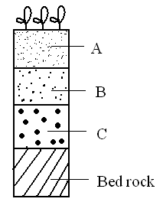
- (a) Give two ways through which minerals occur (2marks)
(b) Explain two factors influencing the exploitation of minerals (4marks)

- (a) Give three processes through which the atmosphere is heated (3marks)
(b) State two factors that influence insolation received by earth (2marks)

- (a) Differentiate between Earthquakes and Earth tremors (2marks)
(b) State two human causes of Earth quakes (2marks)

SECTION B
Answer questions 6 and any other 2 questions from this section.
- (a) Study the map of Nkubu (1:50,000) sheet 1222/2 provided and answer the following questions:
- Measure the length of Mitunguu – Meru all – weather ( loose service) road in the North – East corner
of the map. Give your answer in KMs. (2marks)
- Calculate the area of the forest to the West of Easting 40. Give your answer in square KM.
(2marks)
- Give two man-made features found on Grid square 4186 (2marks)
- Give six figure grid reference of a trigonometrical station (other) to the East of Rune swamp
(2marks)
(b) Draw a rectangle measuring 12cm by 8cms to represent the area bounded by Easting 54 and 60 and Northings 95 and 99.
On it show the following features
- A swamp
- River Mariaria
- Quarry
- Meru – Mitunguu road (5marks)

(c) (i) Citing evidence from the map. Give three economic activities carried out in the area covered by the
map (3marks)
(ii) Explain two factors which have influenced the distribution of settlement in the area covered by the
map (4marks)
(iii) Describe the relief of the area covered by the map (5marks)

- (a) (i) Define mass wasting (2marks)
(ii) Name three forms of slow mass wasting (3marks)
(b) State two conditions which may influence occurrence of landslides (2marks)
(c) Explain four factors which cause soil creep (8marks)
(d) Explain five effects of mass wasting on physical and human environment (10marks)

- (a) (i) Define term Artesian basin (2marks)
(ii) State four factors influencing the development of Karst scenery (4marks)
(b) (i) Give four underground features in Karst scenery (4marks)
(ii) Describe briefly how the following features in Karst scenery are formed:
- Polge (3marks)
- Doline (3marks)
(c) (i) Give three sources of ground water (3marks)
(ii) Explain three significance of resultant features in limestone areas to human activities
(6marks)
- (a) What is river capture? (2marks)
(b) (i) State three types of meanders at a lower course of a river (3marks)
(ii) State three factors influencing the rate of river erosion (3marks)
(c ) (i) Give three processes of river erosion (3marks)
(ii) Describe four processes through which a river transports its load (8marks)
(d) Explain three negative influences of rivers on human activities (6marks)

- (a) (i) Give two ways through which ice moves outwards from the area of accumulation (2marks)
(ii) State three factors influencing glacial erosion (3marks)
(b) (i) The diagram below shows types of moraine carried by glacier. Name the parts labeled W, X, Y.
(3marks)
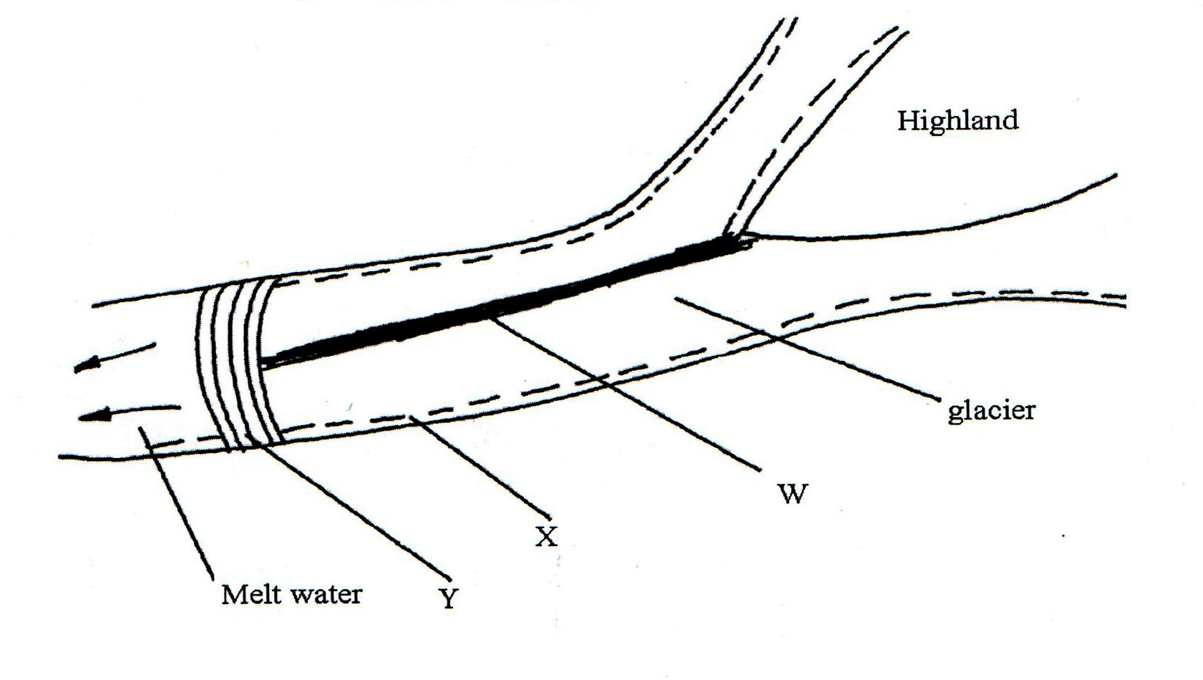
(ii) Describe two ways through which glacial erosion takes place (4marks)
(c) Explain three positive significance of glaciations to human activities (6marks)
(d) Students of Kusumek Sec. School are to carry out a field study on snowcapped Mt. Kenya
(i) State two ways in which the students would prepare themselves for the field study
(2marks)
(ii) Give three methods of recording the data collected (3marks)
(iii) State three problems they are likely to face in the course of field study (2marks)

