Name: …………………………………………………………… Index No. ……………………………
Date: ………………………………............................................ Candidate’s Sign. …………..............

233/2
CHEMISTRY
PAPER 2
SEPT 2013
TIME: 2 HOURS

Kenya Certificate of Secondary Education (K.C.S.E.)

Chemistry
Paper 2

INSTRUCTIONS TO CANDIDATES:
- Write your name and index number in the spaces provided above
- Sign and write the date of examination in the spaces provided.
- Answer all the questions in the spaces provided.
- All working must be clearly shown where necessary.
- Mathematical tables and electronic calculators can be used.

For Examiners Use Only
Question | Maximum score | Candidate’s score
1 | 11
2 | 10
3 | 10
4 | 10
5 | 7
6 | 10
7 | 12
8 | 10
Total | 80

This paper consists of 8 printed pages. Candidates should check to ascertain that all pages are printed as indicated and that no questions are missing.
- The chart below is part of the periodic table. Study it and answer the questions that follow. (The letters are not the actual symbols of the elements)
X |  |  |  |  |  | D |  |  | J
 | Y |  |  |  | A |  |  | G |  | Q
R |  |  |  |  |  |  | E |  | L
T | W

- Identify the letter representing the
- Most electropositive element. Give a reason for your answer. (1mk)
…………………………………………………………………………………………………………………
…………………………………………………………………………………………………………………
- Element that forms ions that have charges of -3 ( 1mk)
………………………………………………………………………………………………………………..

- Element that has the highest tendency to form covalent compounds (1mk)
………………………………………………………………………………………………………………..

- Element that has the least tendency to form compounds, explain ( 2mks)
………………………………………………………………………………………………………………..
………………………………………………………………………………………………………………..

- Compare the atomic radii of R and E. Explain (2mks)
………………………………………………………………………………………………………………..
………………………………………………………………………………………………………………..

- Compare the reactivity of J and L. Explain ( 2mks)
………………………………………………………………………………………………………………..
………………………………………………………………………………………………………………..

- Compare the melting point Y and A. Explain ( 2mks)
………………………………………………………………………………………………………………..
………………………………………………………………………………………………………………..

- Write down the formular of the compound formed when R reacts with J ( 1mk)
………………………………………………………………………………………………………………..
………………………………………………………………………………………………………………..
- State the name given to the elements belonging to the group containing Y and W (1mk)
………………………………………………………………………………………………………………..
………………………………………………………………………………………………………………..
- (a) State two differences between chemical reactions and Nuclear reactions. (2mks)
………………………………………………………………………………………………………………..
………………………………………………………………………………………………………………..
234
90
(b) Below is a radioactive decay starting from Tn

Step V
Step IV
Step III
218
83
218
82
222
84
226
86
Step II
Step I
230
88
234
90
Th Ra Rn Ro Pb Bi

- Identify the particles emitted in Steps II and V (2mks)
Step II …………………………………………
Step V………………………………………….
(ii) Write the nuclear equation for the reaction that take place in step III (1mk)
………………………………………………………………………………………………………………..
………………………………………………………………………………………………………………..
144
54
(c) A radioactive isotope Xe emits two alpha particles followed by three beta particles. State the mass number and atomic number of the final product obtained. ( 2mks)
Mass number =
Atomic number =
(b) State two uses of radioisotopes (2mks)
………………………………………………………………………………………………………………..
………………………………………………………………………………………………………………..
O
||
(e) R – OSO₃⁻Na⁺ and R – C- O⁻ Na⁺ are cleansing agents
………………………………………………………………………………………………………………..
………………………………………………………………………………………………………………..
(i) Which one of the two is suitable for use while washing using hard water? ( 1mk)
………………………………………………………………………………………………………………..
………………………………………………………………………………………………………………..

(ii) Which one of the two pollutes the environment when used? (1mk)
………………………………………………………………………………………………………………..
………………………………………………………………………………………………………………..

(iii) State one advantage of hardwater over softwater (1mk)
………………………………………………………………………………………………………………..
………………………………………………………………………………………………………………..
(iv)A sample of water requires 20cm³ of soap solution to form lather before boiling it. It then requires 4.0cm³ of soap solution to form lather after boiling it. State the type of hardwater in this kind of water. (1mk)

………………………………………………………………………………………………………………..
………………………………………………………………………………………………………………..

- (a) The set up below was used to electrolyse copper (II) sulphate solution using graphite electrodes

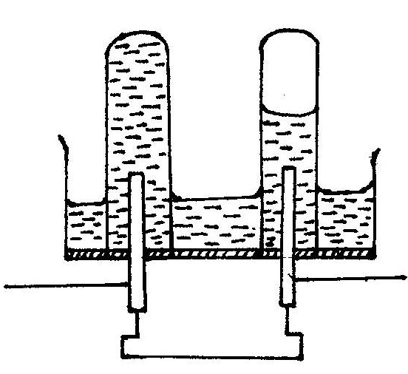

Gas R
A
B

Identify
(i) gas R (1mk)
………………………………………………………………………………………………………………..
………………………………………………………………………………………………………………..
(ii)The cathode (1mk)
………………………………………………………………………………………………………………..
………………………………………………………………………………………………………………..

(iii)State the observations made in the electrolyte and on the electrodes after a long time (2mks)
………………………………………………………………………………………………………………..
………………………………………………………………………………………………………………..

(iv) Write the equation for the half reaction at the electrode A (1mk)
………………………………………………………………………………………………………………..
………………………………………………………………………………………………………………..

(v) A current of 0.5 A was passed through the solution for 2 ½ hours, calculate the mass of product
at electrode B (Cu=63.5, s = 32.0, O = 16.0, H = 1.0 1 faraday = 96500 coulombs)
………………………………………………………………………………………………………………..
………………………………………………………………………………………………………………..

(b) The reaction below is an example of a chemical reaction in a state of balance
2CrO₄²⁻_{(aq)} +2H⁺_{(aq)} Cr₂O₇²⁻_{(aq)} + H₂O_{(l)}
yellow orange
State and explain the observations made when a few drops of dilute nitric (v) Acid are added the mixture
2mks)
………………………………………………………………………………………………………………..
………………………………………………………………………………………………………………..

(c) Nitrogen reacts with hydrogen as shown below
N_{2 (g)} + 3H_{2(g)} 2NH_{3(g)} ΔH = - 92.5kJmole⁻¹
………………………………………………………………………………………………………………..

(i)State the effect of increasing temperature beyond the equilibrium one on the equilibrium position. (1mk)
………………………………………………………………………………………………………………..

(ii) State the meaning of the negative sign on the ΔH value. (1mk)
………………………………………………………………………………………………………………..
………………………………………………………………………………………………………………..
4. The set up below was used to prepare and collect dry sample of hydrogen chloride gas
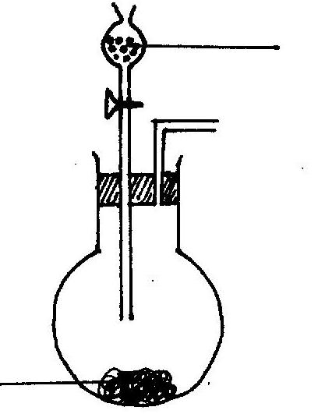
Liquid L

T

- Complete the diagram to show how dry hydrogen chloride gas is collected. (2mks)
………………………………………………………………………………………………………………..
………………………………………………………………………………………………………………..
- Name
(i) Liquid L (1mk)
………………………………………………………………………………………………………………..
(ii)Solid T (1mk)
- State the property of liquid L that makes suitable for use in this experiment. (1mk)
………………………………………………………………………………………………………………..
………………………………………………………………………………………………………………..
- Write a balanced equation for the reaction.
- In the round bottomed flask above. (1mk)
………………………………………………………………………………………………………….
……………………………………………………………………………………………………………
- Between iron filings and hydrogen chloride gas. (1mk)
……………………………………………………………………………………………………………

- Between iron filings and chlorine gas. (1mk)
……………………………………………………………………………………………………………

- Calculate the mass solid T required to produce 336litres of hydrogen chloride gas at stp (1mole of gas = 22.4 litre, H = 1.0, Cl = 35.5, Na = 23, S =32.0, O=16.0). (3mks)

- State one major use of hydrogen chloride gas (1mk)
………………………………………………………………………………………………………………..

5. (a) Name the major ore from which aluminium is extracted. (1mk)
………………………………………………………………………………………………………………..
(b) Name the method used to extract Aluminmium from its ore. (1mk)
………………………………………………………………………………………………………………..

(c) Write the chemical formular for the major component of the major ore from which aluminium is extracted (1mk)
………………………………………………………………………………………………………………..

(d) Name two impurtuties are removed from from the major ore of aluminium (2mks)
………………………………………………………………………………………………………………..
………………………………………………………………………………………………………………..
(e) Explain how the impurities are removed from the major ore of aluminium. (3mks)
………………………………………………………………………………………………………………..
………………………………………………………………………………………………………………..
(f) State the use of cryolite in the extraction of aluminium from its ore. (1mk)
………………………………………………………………………………………………………………..

(g) Explain why the electrodes used are supposed to be replaced after sometime. (1mk)
………………………………………………………………………………………………………………..

(h) State one major use of aluminium. (1mk)
………………………………………………………………………………………………………………..

6. (a) State how burning can be used to distinguish between propane and propyne. (2mks)
………………………………………………………………………………………………………………..
………………………………………………………………………………………………………………..

(b) Draw the structural formula of the fourth member of the homologous series of propyne. ( 1mk)

(c) Study the flowchart below and answer the questions that follow
KOH _{(aq)}

W
C
Propanoic acid
Gas B
Conc.H2So4 heat
Process Y
Sodalime Heat
Gas D

Propan-l-ol

Polymer E

- Name the (i) Process Y ………………………………………………………….…… . (1mk)
(ii) Substance C ……………………………………………………………. (1mk)
(iii)Substance D…………………………………………………………….. (1mk)
(iv)Polmer E …………………………………………………………………. (1mk)
(v)Gas B…………………………………….………………………………… (1mk)
(vi) Process W …………………………………………………………… (1mk)
- Write an equation for the combustion of propan-l-ol. (1mk)
………………………………………………………………………………………………………………..
- State two uses of E (2mks)
………………………………………………………………………………………………………………..
………………………………………………………………………………………………………………..

7. (a) Given are the bond energies for certain bonds.

Bond | Bond energy kJ/mol-1
H-H  H-Cl  Cl-Cl | 436  431  242

Calculate molar heat of formation of hydrogen chloride gas ( 2mks)

(b) Represent the reaction H_{2(g)} + Cl_{2(g)} 2HCl_{(g)} (a) on the energy level diagram (2mks)

Energy kJmole⁻¹

Reaction Path

(c) When 0.8g of ammonium nitrate is added to 100cm3 of water at 23.5ºC stirred, a final temperature
of the solution obtained is 21.5ºC.
(i) State whether the reaction is exothermic or endothermic. (1mk)
………………………………………………………………………………………………………………..

(ii) Calculate the molar heat of solution of ammonium nitrate salt. (2mks)
………………………………………………………………………………………………………………..

