NAME …………………………………….. DATE ……………………….…………………..……

ADMN NO. …………….……….……..…..… CANDIDATE’S SIGNATURE ………..…..………..

443/2
AGRICULTURE
PAPER 2 (THEORY)
OCTOBER / NOVEMBER 2013
TIME: 2 HOURS

KATHIANI SUB - COUNTY
FORM FOUR ENTRANCE EXAMINATION

Kenya Certificate of Secondary Education

443/2
AGRICULTURE
PAPER 2 (THEORY)
TIME: 2 HOURS

INSTRUCTIONS TO CANDIDATES
- Write your name and index number in the spaces provided above.
- This paper has THREE sections: A , B and C
- Answer ALL the questions in section A and B and any TWO questions in section C
- ALL answers MUST be written in the spaces provided.
- Do not remove any pages from this booklet.

FOR EXAMINER’S USE ONLY

 | Questions | Maximum score | Candidate’s score
A | 01-16 | 30 marks
B | 17-21 | 20 marks
C | 22  23  24 | 40 marks
 |  | Total score

This paper consists of 8 printed pages.
Candidates should check to ensure that all pages are printed as indicated and no questions are missing

SECTION A – 30 MARKS
Answer all questions in the spaces provided

- Give two qualities of creep feed. (1mark)
…………………………………………………………………………………………………………………….......
…………………………………………………………………………………………………………………….......
- Differentiate between:
- Curative and prophylactic drugs (2 marks)
…………………………………………………………………………………………………………………….......
…………………………………………………………………………………………………………………….......
- Isolation and quarantine (2 marks)
…………………………………………………………………………………………………………………….......
…………………………………………………………………………………………………………………….......
- (a) Name two livestock diseases that are both bacterial and zoonotic. (1mark)
…………………………………………………………………………………………………………………….......
…………………………………………………………………………………………………………………….......
(b) Name two viral diseases in livestock. (1mark)
…………………………………………………………………………………………………………………….......
…………………………………………………………………………………………………………………….......
- List four reasons for identification in livestock. (2marks)
…………………………………………………………………………………………………………………….......
…………………………………………………………………………………………………………………….......
…………………………………………………………………………………………………………………….......
…………………………………………………………………………………………………………………….......
- Identify two preparations done on ewe before mating. (1mark)
…………………………………………………………………………………………………………………….......
…………………………………………………………………………………………………………………….......
- List five methods of dehorning. (2½ marks)
…………………………………………………………………………………………………………………….......
…………………………………………………………………………………………………………………….......
…………………………………………………………………………………………………………………….......
…………………………………………………………………………………………………………………….......
…………………………………………………………………………………………………………………….......
- State three methods of fish harvesting (1½ marks)
…………………………………………………………………………………………………………………….......
…………………………………………………………………………………………………………………….......
…………………………………………………………………………………………………………………….......
- Name two nutritional diseases in livestock. ( 1mark)
…………………………………………………………………………………………………………………….......
…………………………………………………………………………………………………………………….......
- Differentiate between mothering ability and prolificacy. (2 marks)
…………………………………………………………………………………………………………………….......
…………………………………………………………………………………………………………………….......
…………………………………………………………………………………………………………………….......
- (a) Which livestock disease is transmitted by the following ticks.
(i) Blue tick (1mark)
…………………………………………………………………………………………………………………….......
(ii) Brown ear tick (1mark)
…………………………………………………………………………………………………………………….......
(b) Which of the two ticks named above is a one-host tick (1mark)
…………………………………………………………………………………………………………………….......
…………………………………………………………………………………………………………………….......
- State any four disadvantages of nomadic pastoralism. (2marks)
…………………………………………………………………………………………………………………….......
…………………………………………………………………………………………………………………….......
- Distinguish between Epistasis and heterosis. (2 marks)
…………………………………………………………………………………………………………………….......
…………………………………………………………………………………………………………………….......
- State three control measures of water snails in a farm. (1½ marks)
…………………………………………………………………………………………………………………….......
…………………………………………………………………………………………………………………….......
…………………………………………………………………………………………………………………….......
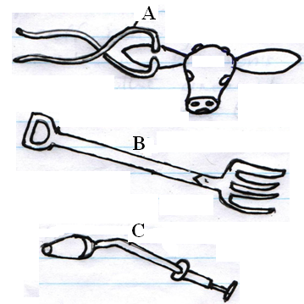
- Identify the following farm tools. ( 1½ marks)

- Name two methods used by farmers to prevent piglet anaemia. (1mark)
…………………………………………………………………………………………………………………….......
…………………………………………………………………………………………………………………….......
- State two disadvantages of in-breeding in dairy cattle production. (2 marks)
…………………………………………………………………………………………………………………….......
…………………………………………………………………………………………………………………….......
SECTION B – 20
Answer all the questions in the spaces
- Explain the term production ration as used in livestock production. (1 mark)
…………………………………………………………………………………………………………………….......
…………………………………………………………………………………………………………………….......
- A farmer wanted to prepare a 200kg of calf rearing ration containing 20% DCP. Using Pearson’s Square Method compute the amount of sunflower (10% DCP) and maize meal (35% DCP) the farmer would require to prepare the ration. (Show your working) (4 marks)
…………………………………………………………………………………………………………………….......
…………………………………………………………………………………………………………………….......
…………………………………………………………………………………………………………………….......
…………………………………………………………………………………………………………………….......
- Below is a digestive system of poultry. Study it and answer the questions below.
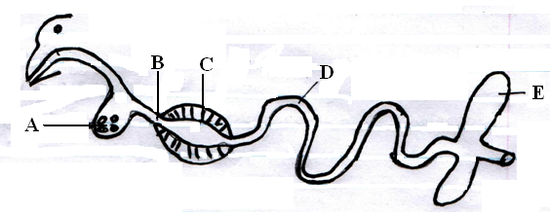
Fill in the table below.
PART | IDENTIFY | FUNCTION
A
B
C
D
E
( ½ x 10 = 5 mks)
NB: If identification is wrong, reject the function

- The diagram below shows the reproductive system of a cow. Study it and answer the questions that follow.
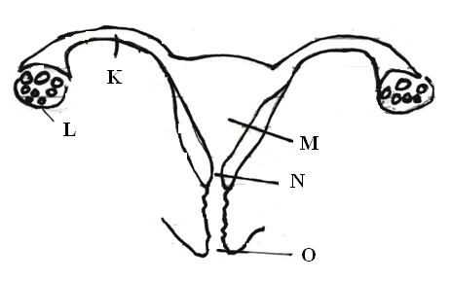

PART | IDENTIFY | FUNCTION
K
L
M
N
O
( ½ x 10 = 5 marks)
- Below is a diagram illustrating a bee-hive. Study it carefully and answer the questions that follow.
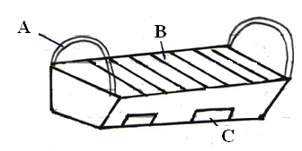

- Identify the type of bee-hive. (1½ marks)
…………………………………………………………………………………………………………………….......
- Name the parts labelled A, B and C. (1½ marks)
…………………………………………………………………………………………………………………….......
…………………………………………………………………………………………………………………….......
…………………………………………………………………………………………………………………….......
- State three advantages of the above bee-hive compared to the traditional log-hive. ( 3 marks)
…………………………………………………………………………………………………………………….......
…………………………………………………………………………………………………………………….......

SECTION C – 40 MKS
Answer any two questions
- (a) Describe the procedure followed when using hypodermic syringe and needle to administer drugs to cattle.
(3 marks)
(b) Outline six reasons for maintaining livestock in good health. (6 marks)
(c) Discuss coccidiosis under the following headings.
(i) Causal organism (1mark)
(ii) Livestock species attacked (2 marks)
(iii) Symptoms of attack (4marks)
(iv) Control measures (4 marks)
- (a) Discuss the importance of farm fence. ( 10 marks)
(b) State the factors considered when siting farm structures. (10 marks)
- (a) Give the factors that contribute to the distribution of livestock in Kenya. (4 marks)
(b) What is the importance of keeping animals on the farm. (6 marks)
(c) Outline the rearing practices carried out to one-day lamb until serving time. (10 marks)
…………………………………………………………………………………………………………………….......
…………………………………………………………………………………………………………………….......
…………………………………………………………………………………………………………………….......
…………………………………………………………………………………………………………………….......
…………………………………………………………………………………………………………………….......
…………………………………………………………………………………………………………………….......
…………………………………………………………………………………………………………………….......
…………………………………………………………………………………………………………………….......
…………………………………………………………………………………………………………………….......
…………………………………………………………………………………………………………………….......
…………………………………………………………………………………………………………………….......
…………………………………………………………………………………………………………………….......
…………………………………………………………………………………………………………………….......
…………………………………………………………………………………………………………………….......
…………………………………………………………………………………………………………………….......
…………………………………………………………………………………………………………………….......
…………………………………………………………………………………………………………………….......
…………………………………………………………………………………………………………………….......
…………………………………………………………………………………………………………………….......
…………………………………………………………………………………………………………………….......
…………………………………………………………………………………………………………………….......
…………………………………………………………………………………………………………………….......
…………………………………………………………………………………………………………………….......
…………………………………………………………………………………………………………………….......
…………………………………………………………………………………………………………………….......
…………………………………………………………………………………………………………………….......
…………………………………………………………………………………………………………………….......
…………………………………………………………………………………………………………………….......
…………………………………………………………………………………………………………………….......
…………………………………………………………………………………………………………………….......
…………………………………………………………………………………………………………………….......
…………………………………………………………………………………………………………………….......
…………………………………………………………………………………………………………………….......
…………………………………………………………………………………………………………………….......
…………………………………………………………………………………………………………………….......
…………………………………………………………………………………………………………………….......
…………………………………………………………………………………………………………………….......
…………………………………………………………………………………………………………………….......
…………………………………………………………………………………………………………………….......
…………………………………………………………………………………………………………………….......
…………………………………………………………………………………………………………………….......
…………………………………………………………………………………………………………………….......
…………………………………………………………………………………………………………………….......
…………………………………………………………………………………………………………………….......
…………………………………………………………………………………………………………………….......
…………………………………………………………………………………………………………………….......
…………………………………………………………………………………………………………………….......
…………………………………………………………………………………………………………………….......
…………………………………………………………………………………………………………………….......
…………………………………………………………………………………………………………………….......
…………………………………………………………………………………………………………………….......
…………………………………………………………………………………………………………………….......
…………………………………………………………………………………………………………………….......
…………………………………………………………………………………………………………………….......
…………………………………………………………………………………………………………………….......
…………………………………………………………………………………………………………………….......
…………………………………………………………………………………………………………………….......
…………………………………………………………………………………………………………………….......
…………………………………………………………………………………………………………………….......
…………………………………………………………………………………………………………………….......
…………………………………………………………………………………………………………………….......
…………………………………………………………………………………………………………………….......
…………………………………………………………………………………………………………………….......
…………………………………………………………………………………………………………………….......
…………………………………………………………………………………………………………………….......
…………………………………………………………………………………………………………………….......
…………………………………………………………………………………………………………………….......
…………………………………………………………………………………………………………………….......
…………………………………………………………………………………………………………………….......
…………………………………………………………………………………………………………………….......
…………………………………………………………………………………………………………………….......
…………………………………………………………………………………………………………………….......
…………………………………………………………………………………………………………………….......
…………………………………………………………………………………………………………………….......
…………………………………………………………………………………………………………………….......
…………………………………………………………………………………………………………………….......
…………………………………………………………………………………………………………………….......
…………………………………………………………………………………………………………………….......
…………………………………………………………………………………………………………………….......
…………………………………………………………………………………………………………………….......
…………………………………………………………………………………………………………………….......
…………………………………………………………………………………………………………………….......
…………………………………………………………………………………………………………………….......
…………………………………………………………………………………………………………………….......
…………………………………………………………………………………………………………………….......
…………………………………………………………………………………………………………………….......
…………………………………………………………………………………………………………………….......
…………………………………………………………………………………………………………………….......
…………………………………………………………………………………………………………………….......
…………………………………………………………………………………………………………………….......
…………………………………………………………………………………………………………………….......
…………………………………………………………………………………………………………………….......
…………………………………………………………………………………………………………………….......
…………………………………………………………………………………………………………………….......
…………………………………………………………………………………………………………………….......
…………………………………………………………………………………………………………………….......
…………………………………………………………………………………………………………………….......
…………………………………………………………………………………………………………………….......
…………………………………………………………………………………………………………………….......
…………………………………………………………………………………………………………………….......
…………………………………………………………………………………………………………………….......

