NAME:…………………………………………………………………………………...…………
SCHOOL:…………………………………………………………………………………………..
A.D.M NO:……………………………………….. DATE:………………………………………
SIGNATURE:……………………………………

312/2
GEOGRAPHY
END TERM2-2014
PAPER 2

EDUCATOR EXAM SERIES
FORM THREE

Answer All Questions

1. Name three patterns of human settlements. (3mks)
2. i) List any two products from Jua kali industry in Kenya exported to other countries.
(2mks)
ii) Name two renewable sources of energy used in Kenyan industries. (2mks)
3. a) Name three surfaces that are reclaimed in Kenya. (3mks)
b) Identify the method of reclamation used in each surface mentioned in 3(a) (3mks)
4. Explain how the following practices help in soil conservation
i) Mulching (2mks)
ii) Terracing (2mks)
5. a) Describe how deep-shaft mining takes place. (5mks)
b) Name three products from an oil refinery other than petrol. (3mks)
SECTION B
Answer question 6 and any other two questions in this section.
6. The table below shows milk yield in kilograms per dialy cow in Denmark between 1990 and 1995.
Year | 1990 | 1991 | 1992 | 1993 | 1994 | 1995
Yields in kg | 5243 | 6693 | 7398 | 7610 | 7792 | 7946
(a) (i) Draw a divided circle of radius 3-5cm to represent the milk yield in Denmrk,
Show all your calculations (2mks)
(ii) State two advantages of using the divided circle to represent data (2mks)
(iii) Name two other methods, apart from the divided circle, that could be used to represent the above data. (2mks)
(b) (i) Explain three physical factors that have favoured farming in Denmark (6mks)
(ii) State three problems facing dairyFarmers in Kenya (3mks)
(c) Explain two reasons why beef farming is more developed in Argentina than in Kenya. (4mks)
7 (a) (i) State any two forms in which minerals occur (2mks)
(ii) Name any three places where limestone is mined in Kenya (3mks)
(b) Explain how the following factors influence the exploitation of a mineral
(i) Market (2mks)
(ii) The quality of ore (2mks)
(iii) Technology (2mks)
(c) (i) Name two provinces in south Africa where gold is mined (2mks)
(ii) Explain three problems facing gold mining in south Africa (6mks)
(d) Describe the processing of diamond in south Africa.

8 (a) (i) Apart from oil, name two sources of non-renewable energy. (2 mks)
(ii) List three advantages of solar energy. (3 mks)
(b) Explain four problems encountered in mineral exploitation in Kenya. (8 mks)
(c) Explain the effects of over-relience on oil as a source of energy. (8 mks)
(d) State four methods the Government of Kenya uses to manage and conserve her energy resources. (4 mks)

9 a) i) define the term forestry. (1 mark)
ii) Give three differences between natural forest and planted forests.(3 marks)
b) Explain FOUR causes of forest depletion in Kenya today. (8 marks)
c) i) From the map below, give the names of the forests marked A, B ad C
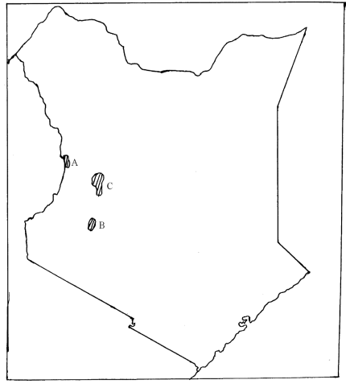

ii)State FOUR measures that are being undertaken by the Kenya Government to conserve forests. (4 marks)
d)Explain THREE factors favouring the exploitation of softwoods inCanada(6mks)
End

