NAME: …………………………………………………..…………… ADM. NO: ……….……………..

DATE……………..………………
CLASS ……………………………

231/2
BIOLOGY
PAPER 2 (THEORY)
OCT 2014
TIME: 1HR 45 MINS

SUNSHINE END YEAR EXAMINATION 2014
Kenya Certificate of Secondary Education (K C.S.E)

BIOLOGY
PAPER 2

INSTRUCTIONS
Write your name, and Adm.number in the spaces provided above.
This paper consists of two sections; A and B.
Answer all the questions in Section A in the spaces provided.
In section B, answer question 6(compulsory) and either question 7 or 8 in the spaces provided after question 8.

For Examiner’s Use only:-
SECTION | QUESTION | MAXIMUM SCORE | CANDIDATE’S SCORE
A | 1  2  3  4 | 8  8  8  8
B | 6  7  8 | 20  20  20
TOTAL SCORE |  | 80
SECTION A (32) MKS
1. The graph below show the effect of temperature on an enzyme catalysed reaction.
•
•
•
X
B
C
A
D
Rate of
Reaction
Temperature

- Account for the shape of the curve between.
(i) A and B. (3 marks)
………………………………………………………………………………………………………………………………………………………………………………………………………………………………………………………………………………………………………………………………………………………………………………………………………………………………………………………………………………………………………………………………………………………………………………………………………………......
(ii) C and D. (2 marks)
…………………………………………………………………………………………………………………………………………………………………………………………………………………………………………………………………………………………………………
(b) What does the point marked X represent? (1 mark)
……………………………………………………………………………………………………………………………………………………
(c)Apart from temperature, state two other factors that affect the rate of enzyme controlled reaction. (2 marks)
…………………………………………………………………………………………………………………………………………………………………………………………………………………………………………………………………………………………………………
2. The figure below was used to demonstrate a certain physiological process in germinating Seeds.
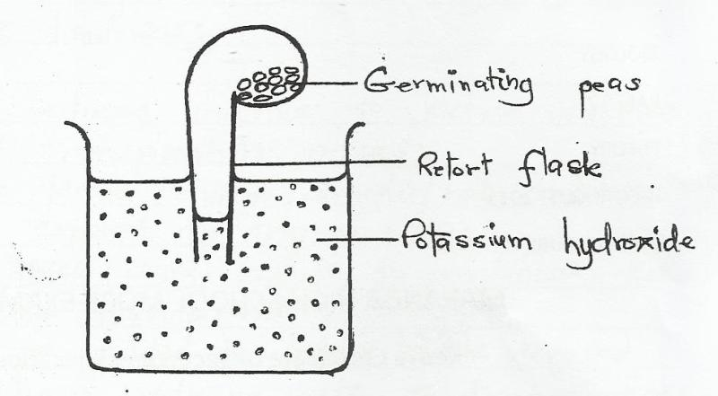

(a)What observations would be made in the set-up at the end of the experiment? (2mks) ……………………………………………………………………………………………………………………………………………………………………………………………………………………………………………………………………………………………………………………………………………………………………………………………………………………………………………………………………………………………………..
(b)i. Suggest what would happen in the set-up if the seeds were mixed with pyrogallic acid (1mk) …………………………………………………………………………………………………………………………………………………………………………………………………………………………………………………………………………………………………………………………………..
(ii) Explain your answer in b (i) above. (2mks) ………………………………………………………………………………………………………………………………………………………………………………………………………………………………………………………………………………………………………………………………………………………………………………………………………………………………………………………………………………………………………
(c) What chemical change is taking place in the germinating peas? (2mks) ……………………………………………………………………………………………………………………………………………………………………………………………………………………………………………………………………………………………………………………………………………………………………………………………………………………………………………………………………………………………………..
(d) Suggest a control experiment for this set-up.(1mk) …………………………………………………………………………………………………………………………………………………………………………………………………………………………………………………………………………………………………………………………………..
3. In an experiment to compare the basal metabolic rate of some animals, the amount of oxygen consumed per unit body weight in a given period of time was determined. The table below shows the results of the investigations.
Animal | Body weight(Kg) | Oxygen consumed (g/hr.)
Buffalo | 546 | 47
Man | 58 | 203
Rabbit | 3 | 318
Rat | 0.1 | 700
Mouse | 0.02 | 1510

(a) Comment on the volume of oxygen consumed by the buffalo and the mouse. (1mk) …………………………………………………………………………………………………………………………………………………………………………………………………………………………………………………………………………………………………………………………………..
(b) Account for the above comparison for:
(i) Buffalo (2mks) ……………………………………………………………………………………………………………………………………………………………………………………………………………………………………………………………………………………………………………………………………………………………………………………………………………………………………………………………………………………………………..
(ii) Mouse (2mks) ……………………………………………………………………………………………………………………………………………………………………………………………………………………………………………………………………………………………………………………………………………………………………………………………………………………………………………………………………………………………………..
(c) What is Basal metabolic Rate (BMR)? (1mk) …………………………………………………………………………………………………………………………………………………………………………………………………………………………………………………………………………………………………………………………………..
(d) Explain how high temperature increases the rate of diffusion. (2mks) ……………………………………………………………………………………………………………………………………………………………………………………………………………………………………………………………………………………………………………………………………………………………………………………………………………………………………………………………………………………………………..
4 (A) what is multiple allelism? (1mk) ……………………………………………………………………………………………………………………………………………………………………………………………………………………………………………………………………………………………………………………………………
(b) A pure breeding black male mouse was mated with a pure breeding brown female mouse. All the offspring had black coat colour.
(i) Explain the appearance of black coat colour in the offspring. (1mk) …………………………………………………………………………………………………………………………………………………………………………………………………………………………………………………………………………………………………………………………………..

(ii) If the black parental mouse was mated with a mouse that is heterozygous for coat colour, work out the genotypic ratio of offspring. Show your working (5mks)

(iii) State two disorders in human beings that are as a result of chromosomal mutations. (2mks)
……………………………………………………………………………………………………………………………………………………………………………………………………………………………………………………………………………………………………………………………………
SECTION B (40MKS)
Answer question 6(COMPULSORY) in the spaces provided. Answer either question 7 or 8 in the spaces provided after question 8.
6. An investigation was conducted to compare water loss from twigs of two species of plants Q and L. The apparatus shown below was used for this investigation. The twigs had equal leaf surface.

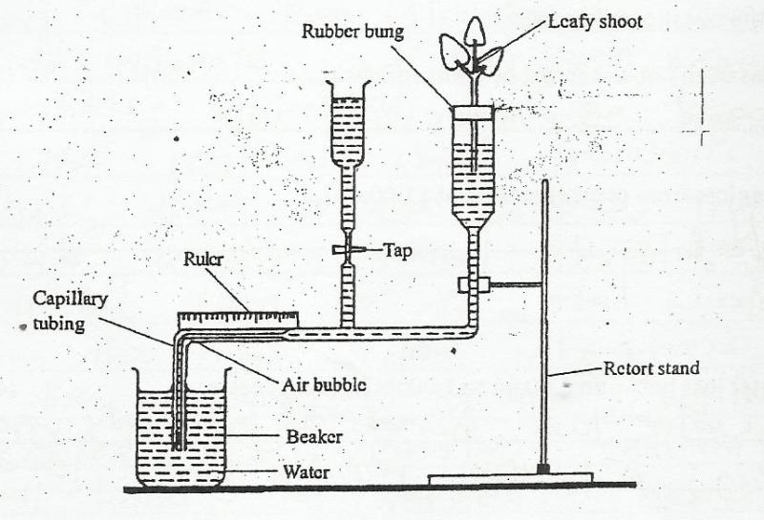

The results of the investigation were recorded in the table below.

Time of the day | 6am | 8am | 10am | 12noon | 1pm | 2pm | 3pm | 4pm | 6pm | 8pm | 12 midnight
Water loss gh⁻¹ species Q | O | 4 | 20 | 40 | 55 | 36 | 26 | 20 | 2 | O | O
Water loss gh⁻¹ species L | 8 | 20 | 39 | 131 | 198 | 182 | 130 | 81 | 45 | 12 | 12

(a) Plot a graph of water loss gh⁻1 against time for the two plants. (7mks)
(b) Name the apparatus used in the above investigation (1mk)
………………………………………………………………………………………………………………………………………………………………….
(c)State TWO precautions that were taken in setting up this experiment.(2mk) ……………………………………………………………………………………………………………………………………………………………………………………………………………………………………………………………………………………………………………………………………………………………………………………………………………………………………………………………………………………………………..
(d) Which of the plant species is likely to be adapted to arid conditions? Give reason. (2mks) ……………………………………………………………………………………………………………………………………………………………………………………………………………………………………………………………………………………………………………………………………………………………………………………………………………………………………………………………………………………………………..
(e) Use the graph to answer the questions that follow:
(i) At what time of the day was 60gh⁻¹ of water lost by plant species? (1mk) ………………………………………………………………………………………………………………………………………………………………….
(ii) What was the rate of water loss from plant species Q at 11.00am? (1mk) ………………………………………………………………………………………………………………………………………………………………….

(f) Account for the rate of water loss between 6.00am to 1.00pm by plant species L. (4mks) …………………………………………………………………………………………………………………………………………………………………………………………………………………………………………………………………………………………………………………………………………………………………………………………………………………………………………………………………………………………………………………………………………………………………………………………………………………………………………………………………………………………………………………………………………………………………………………………………………………………………………...
(g) Suggest how the stomata of species Q are structurally adapted to water loss. (2mks) …………………………………………………………………………………………………………………………………………………………………………………………………………………………………………………………………………………………………………………………………..
7. a) State five differences between aerobic and anaerobic respiration. (5mrks)
b) Discuss the application of anaerobic respiration in industry and at home (15mks)
8 a) Define the term secondary thickening (2marks)
b Briefly describe how secondary thickening occurs in woody plants (14marks)
c) i) State two ways in which growth in plants is different from that in animals (2marks)
ii) State how ecdysis affects the growth of insects (2marks

