233/2
CHEMISTRY
PAPER 2
END YEAR EXAMS – OCT. 2014
TIME: 2HRS

Name…………………………………………………………….…Adm No………. Class……

INSTRUCTIONS

- Write your name and admission number on the spaces provided
- Answer your questions on the spaces provided
- All working must be shown clearly where necessary
- silent electronic calculators may be used

FOR EXAMINERS USE ONLY

80

- (a) Give the systematic names of the following compounds.
(i) CH₃CH₂CH₂OH (1mk)
………………………………………………………………………………………………………
(ii) CH₃CH₂COOH (1mk)
………………………………………………………………………………………………………

(b) Study the information in the table below and answer the questions that follow.
No. of carbon atoms per molecule | Relative molecular mass of hydrogen
2 | 28
3 | 42
4 | 56

(i) Write the general formula of the hydrocarbons in the table. (1mk)
……………………………………………………………………………………………………….……………………………………………………………………………………………………
(ii) Predict the relative molecular mass of the hydrocarbon with 5 carbon atoms. (lmk)
……………………………………………………………………………………………………….……………………………………………………………………………………………………
(iii) Determine the molecular formula of the hydrocarbon in (ii) and draw its structural formula. (2mks)
……………………………………………………………………………………………………….……………………………………………………………………………………………………...….…………………………………………………………………………………………………...…….………………………………………………………………………………………………...

(c) Study the scheme given below and answer questions that follow.
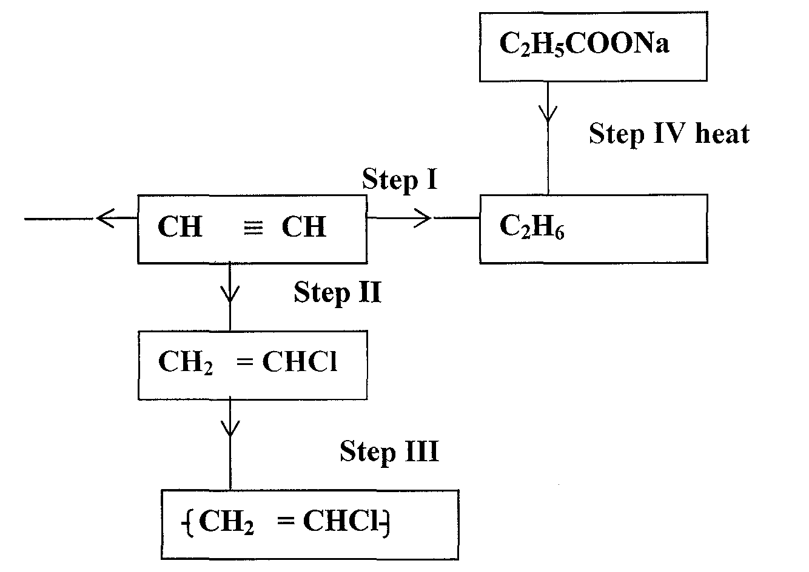
(i) Name the reagent used in
Step I (l mk)
………………………………………………………………………………………………………
Step II (1 mk)
………………………………………………………………………………………………………
Step III (1 mk)
………………………………………………………………………………………………………
(ii) Write an equation for complete combustion of CH ≡ CH (1 mk)
………………………………………………………………………………………………………
(iii) Explain one disadvantage of the continued use of items in step III. (1 mk)
………………………………………………………………………………………………………
- The diagram below represents the extraction of sulphur by the frasch process.
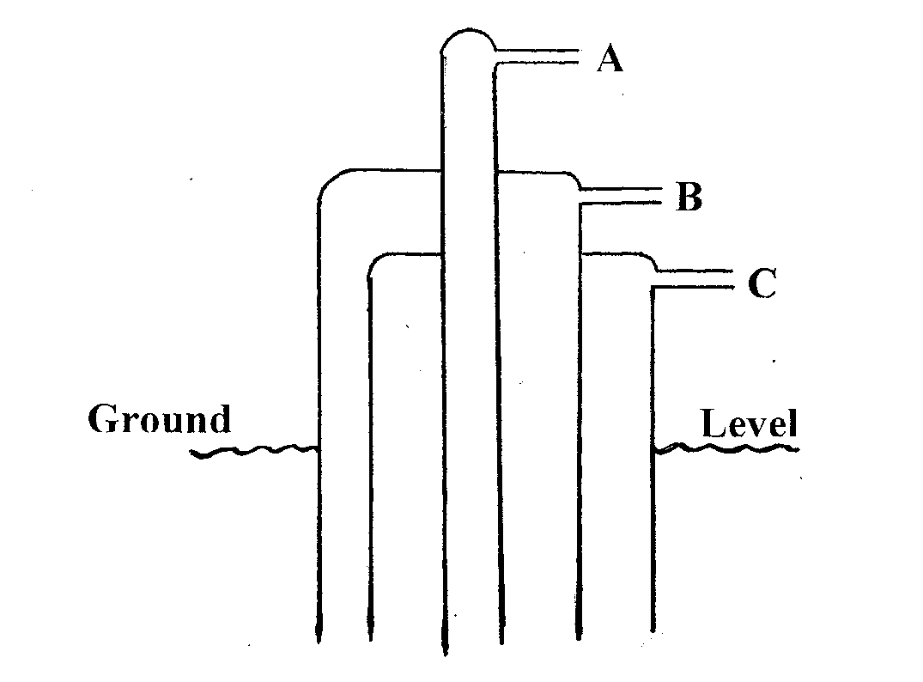
(i) Identify and state the use of the substances that pass through tubes A and C. (2mks)
A………………………………………………………………………..
C………………………………………………………………………..
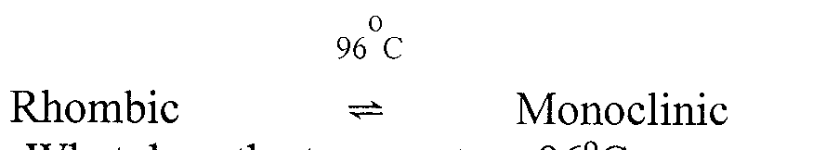
(ii) Rhombic and monoclinic are Allotropes of sulphur. They are inter convertible as shown below.

I. What does the temperature 96°C represent. (1mk)
………………………………………………………………………………………………………
II. State the differences in crystalline appearances between rhombic and monoclinic crystals. (lmk)
………………………………………………………………………………………………………
(b) The following scheme represents the steps followed in the contact process, study it and answer the questions which follow.
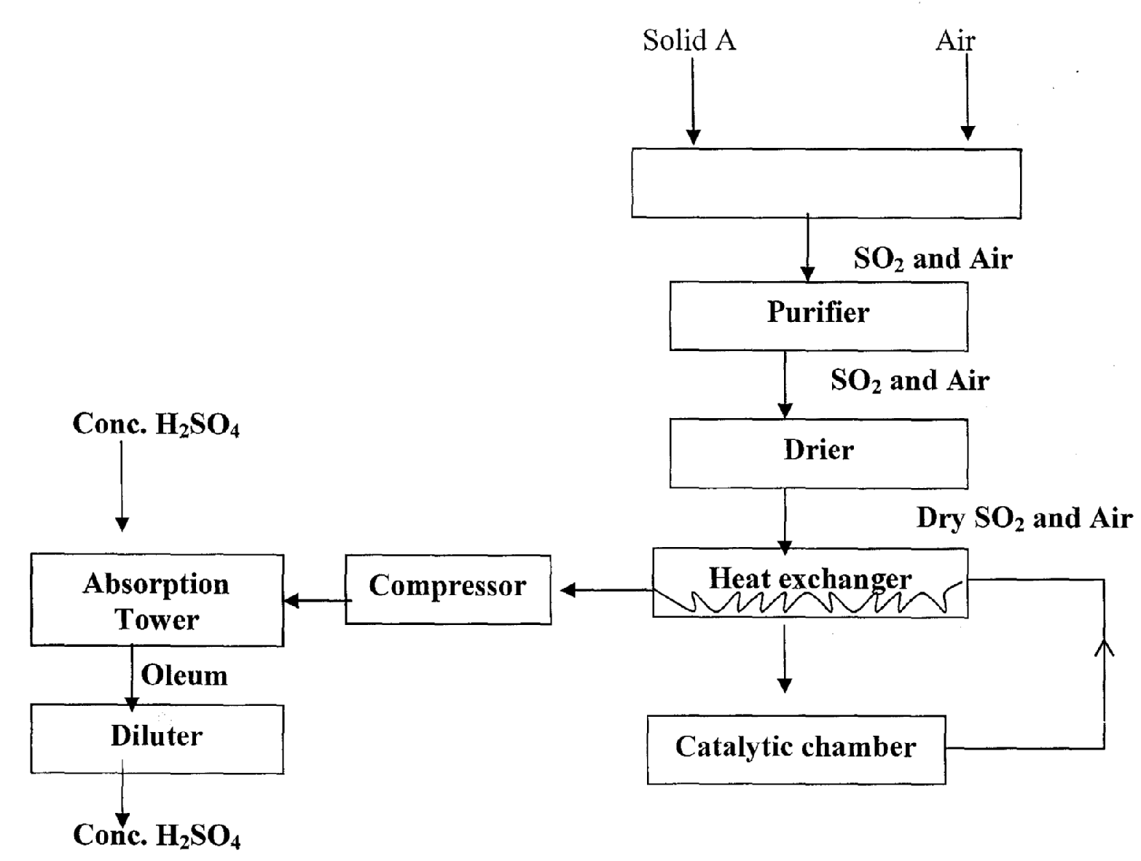

(i) Name two possible identities of solid A. (lmk)
……………………………………………………………………………………………………….……………………………………………………………………………………………………...
(ii) Name two impurities removed by the purifier. (1mk)
……………………………………………………………………………………………………….……………………………………………………………………………………………………

(iii) Why is it necessary to remove impurities? (lmk)
……………………………………………………………………………………………………….……………………………………………………………………………………………………
- The grid below represents part of the periodic table. Study it and answer the questions that follow. The letters are not the actual symbols of the elements.

Y | R |  |  |  |  | Q | X
 | V |  | W |  |  |  |  | U

(a) Select an element whose oxide is amphoteric. (1mk)
………………………………………………………………………………………………………

(b) On the grid indicate with letter J the position of element J which is in period 3 and forms a stable ion J²⁻. (1mk)

(c)Draw a dot-cross diagram to show bonding in the compound consisting of elements V and X only. (2mks)

(d)Write an equation to show the formation of an ion by R. (1mk)
………………………………………………………………………………………………………

(e)Which is the least reactive element? Give a reason for your answer. (2mks)
……………………………………………………………………………………………………….……………………………………………………………………………………………………...
(f)Write an equation for the reaction that occurs when element Y is placed in water. (1mk)

………………………………………………………………………………………………………

(g)How does the atomic radius of W compare with that of V? Explain. (2 marks)
……………………………………………………………………………………………………….……………………………………………………………………………………………………...
(h)Name the chemical family to which elements R and V belong. (1 mark)
………………………………………………………………………………………………………
- A form two student was asked to prepare a sample of copper (II) sulphate crystals using the procedure below.
- Measure 100cm³ of 2M sulphuric (VI) acid then warm. Add excess copper (II) oxide powder.
- Filter the resulting mixture.
- Heat the filtrate and leave it overnight.

- Why was the acid heated before the start of the reaction? (1mk)
……………………………………………………………………………………………………….……………………………………………………………………………………
- Why was excess copper (II) oxide used. (1mk)
………………………………………………………………………………………………………
- What was observed when copper (II) oxide was added to the warm acid? (2mks)
……………………………………………………………………………………………………….……………………………………………………………………………………………………
- Write and equation for the reaction that took place in (c) above. (1mk)
…………………………………………………………………………………………………………….………………………………………………………………………………………………...
- Give reasons for carrying out the following processes.
- Filtration of the mixture. (1mk)
……………………………………………………………………………………………………….……………………………………………………………………………………………………...
….…………………………………………………………………………………………………...
- Heating the filtrate and leaving it overnight. (2mks)
………………………………………………………………………………………………………….…………………………………………………………………………………………………...
….…………………………………………………………………………………………………...

- Explain how dry crystals of copper (II) sulphate are finally obtained. (1mk)
……………………………………………………………………………………………………….……………………………………………………………………………………………………...
- State and explain the observations that would be made when concentrated sulphuric (IV) acid is added to the crystals formed in (f) above in a test tube. (2mks)
……………………………………………………………………………………………………….……………………………………………………………………………………………………...

- Write the formula of the complex ion formed with excess ammonia solution is added to copper (II) sulphate solution. (1mk)
………………………………………………………………………………………………………
- Explain why it would not be possible to prepare copper sulphate salt by reaction of dilute sulphuric (IV) acid with copper metal? (1mk)
……………………………………………………………………………………………………….……………………………………………………………………………………………………...
- (I) Sulphuric (VI) acid was electrolysed using inert electrodes as shown on the diagram below
2M H₂SO₄

Gas K
Gas L

(a) Write the equations for the reactions taking place on the electrodes (2mks)

Anode:………………………………………………………………………………………………

Cathode: ……………………………………………………………………………………………

(b) How can gas K be identified? (1mk)
………………………………………………………………………………………………………………………………………………………………………………………………………………
(c) Explain the difference in the volumes of the gases produced at the electrode? (2mks)
………………………………………………………………………………………………………………………………………………………………………………………………………………
(d) Give two reason why electroplating is a necessity. (2mks)
………………………………………………………………………………………………………………………………………………………………………………………………………………
(II)During electrolysis of a metal sulphate, 0.18g of the metal was deposited when a current of 3.2A passed for 10 minutes.
(a) Calculate the quantity of electricity used in Faradays (1F=96000C) (1mk)

(b) If the metal ion has the formula M³⁺, calculate the R.A.M of metal M. (2mk)

(c) When the same quantity of electricity of electricity was passed through a nitrate salt of metal Z of R.A.M 108, 2.16g of Z was deposited.
(i) Find the formula of the ion of metal Z. (2mk)

(ii) Write the formula of the carbonate of element Z (1mk)

- I. Give any two apparatus that are used for each of the following.

- Measuring mass. (1mk)
......................................................................................................................................................
…………………………………………………………………………………………………..
- Sources of heat. (1mk)

…………………………………………………………………………………………………..
…………………………………………………………………………………………………..
- Measuring exact volume. (1mk)

…………………………………………………………………………………………………..
…………………………………………………………………………………………………..
II . (a)What is a drug? (1mk)

…………………………………………………………………………………………………..
…………………………………………………………………………………………………..
(b) Drugs are either natural or artificial. Give two examples of artificial drugs. (1mk)

…………………………………………………………………………………………………..
…………………………………………………………………………………………………..
…………………………………………………………………………………………………..
…………………………………………………………………………………………………..

(c)What do the following terms mean?

(i) prescription (1mk)

…………………………………………………………………………………………………..
…………………………………………………………………………………………………..
(ii) drug abuse (1mk)

…………………………………………………………………………………………………..
…………………………………………………………………………………………………..
(d) State the two effects of tobacco / nicotine on a smoker. (2mks)

…………………………………………………………………………………………………..
…………………………………………………………………………………………………..
…………………………………………………………………………………………………..
- (a) Define the term matter. (1 mk)

…………………………………………………………………………………………………..
…………………………………………………………………………………………………..
(b) State the three states of matter. (3 mks)

…………………………………………………………………………………………………..
…………………………………………………………………………………………………..
…………………………………………………………………………………………………..
- Name the apparatus one can use to: (3mks)
- Hold a rest-tube containing hot water.
…………………………………………………………………………………………………..
- Scoop a small amount of table salt from a container.
…………………………………………………………………………………………………..
- Support a burette during an experiment.
…………………………………………………………………………………………………..
- With the aid of diagrams, distinguish between:
- Around-bottomed flask and a flat-bottomed flask. (2 mks)

- Oxygen is obtained on large scale by fractional distillation of air as shown on the flow chart below.
Process A
B
Condensation chamber
Process C
Compressor 200 atm
-200 ⁰C
Oxygen
-186⁰C
X
-183⁰C

Y
-196⁰C
Air Dust free CO₂
Air free air

Air free of
Water vapour

- (i) Identify processes. (2 mks)

A

C

(ii) Identify gases: (1 mk)

X

Y

- Explain why Carbon (IV) oxide and water are removed before liquefiction of air. (1 mk)

- State 2 uses of oxygen. (2 mks)

- The diagram below shows a set up used to investigate the process of rusting. Study it and answer the questions that follow.

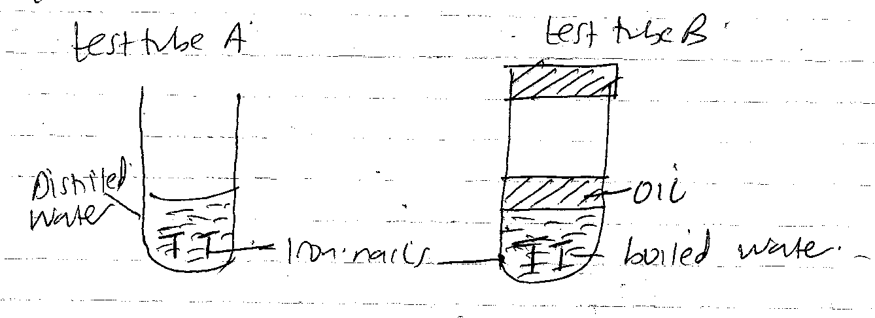
State and explain the observation made on the iron nails in test tube B at the end of the experiment. (3 mks)

- Name 2 conditions that accelerate rusting. (2 mks)

