NAME -----------------------------------------CLASS -----------ADM NO -------------
SIGNATURE ------------------------------------DATE ----------------
232/3
FORM 3 PHYSICS PRACTICAL
OCT. 2014
END OF TERM 3
TIME 1 ½ HOURS

- You are provided with the following apparatus.
i)A convex lens
ii)A meter rule
iii) A candle
iv)A lens holder
v)A screen
Set up the apparatus as in the diagrams below.
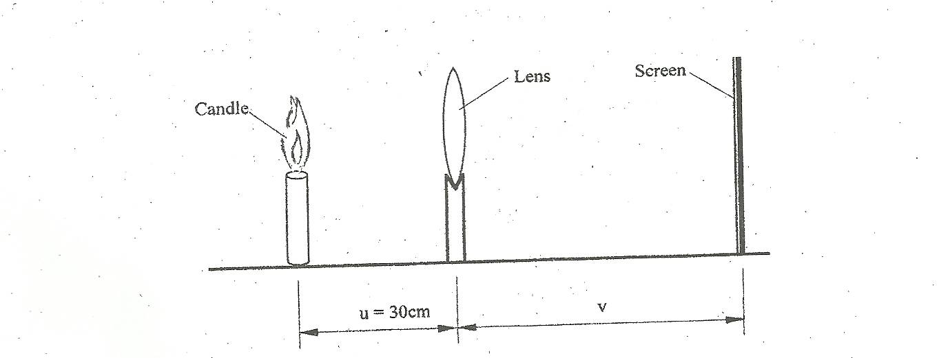

With object distance u set at 30cm, move the screen to and fro until a clear image is formed on it.
i)Measure and record your image distance
V = --------------------------------------------------------------------------- cm (1mk)

ii)Calculate the value of K from the expression k = $\frac{uv}{u+v}$

K = -------------------------------------------------------------------------- (1mk)

iii)Now vary the object distance to 100cm and again measure the image distance V and record in the table below.
Object distance u ( cm ) | 100 | 90 | 80 | 70 | 60 | 50
Image distance V (cm)
Magnification m = v/u

b)i)Plot a graph of magnification m ( y – axis) against image distance (V) (5mks)

ii)Calculate the slope of your graph. (2mks)

iii)Determine the reciprocal of the slope. (1mk)

iv)What is the intercept on the x –axis. (1mk)

